Data on Minnesota Exports for Fourth Quarter 2023 – Published May 2024
For More Information: Mary Haugen (mary.haugen@state.mn.us)

Minnesota Exports Fall 14% in Fourth Quarter
- Minnesota exports of goods (including agricultural, mining and manufactured products) were valued at $6.2 billion in the fourth quarter of 2023, representing a decrease of 14% (or down $974 million) since the fourth quarter of 2022.
- The state’s fourth quarter trend was most impacted by the 80% drop in mineral fuel, oil –
without which the state’s exports would have been unchanged from the fourth quarter of 2022.
- U.S. exports of goods fell 1% in the fourth quarter, as states were split between growth and declines.
- Overall, between 2022 and 2023, state exports slipped 8%, while U.S. exports fell 2%.

Figure 1. Gains in Exports for Half of States
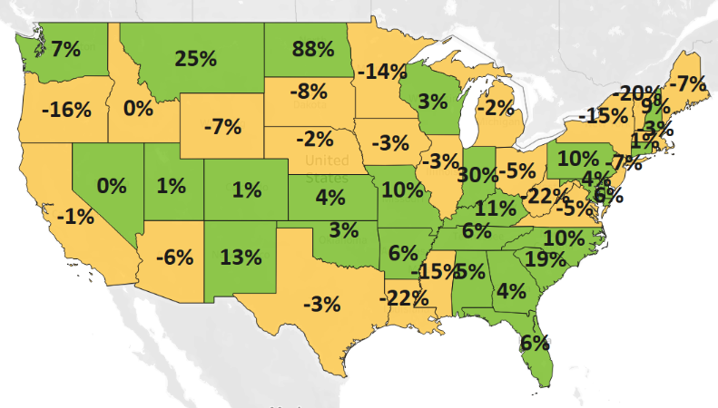
Decline 0% Growth
MN: -14%
U.S.: -1%

Widespread Weaker Demand Across Major Regions, Some Bright Spots
- Minnesota’s exports dropped 12% to North America ($2.6 billion) as gains to Mexico (up 9%) were outweighed by the persistent large declines in mineral fuel, oil exports (down $558 million) to Canada,
- Demand tumbled across Asia ($1.6 billion, down 18%) as sales dropped to top markets such as to Korea, China, Taiwan and Japan. Thailand (up 42%) and Cambodia (up 224%) stood out as growth markets in Asia.
- Sales of Minnesota goods also fell to the European Union ($1 billion, down 25%) and the Caribbean, Central and South America ($328 million, down 11%). European countries such as Italy, Germany and Spain; and Latin American countries such as Uruguay, Costa Rica and Chile, suffered the largest declines in their regions.
- Other growth regions included Africa ($110 million, up 139%) and the Australia-Pacific ($179 million, up 32%).

Figure 2. Export Trends for Minnesota’s Top 10 Markets, Fourth Quarter 2023
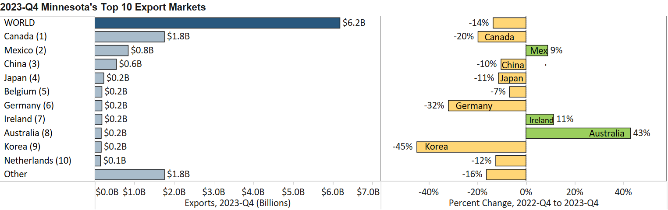

Vehicles, Cereals, Medical Products and Aircraft Grow Strongly

- Despite significant declines in four top 10 export products, some core export areas still performed strongly – led by vehicles (up 41%), cereals (up 53%), optic, medical goods (up 5%) and aircraft, spacecraft (up 46%).
- Sales of mineral fuel, oil sank $990 million (down 80%) to $251 million –driven by trends in the dominant market, Canada (down 70%), but also in Korea, Spain, Italy, Taiwan and France, where exports fell 100% – representing losses of $50 million to $120 million in each of these markets.
- Sales of vehicles surged to Canada (up $82 million, Australia (up $59 million), Ukraine (up $11 million), Saudi Arabia (up $10 million) and South Africa (up $9 million). Segments such as large passenger (10+) vehicles (up 415%), special purpose vehicles (up 208%) and tractors (up 187%) fueled these gains.
- Exports of cereals (mainly corn (maize) and wheat) made robust strides to Canada (up 223%), Algeria ($44 million, up from none), Morocco ($16 million, up from none), offsetting losses to Yemen, Italy and Mexico.
- Optic, medical goods grew strongly to Asia (up 14%), driven by markets such as China, Korea and Taiwan. Ireland and France in the EU, as well as Australia and Mexico, also showed solid gains. Medical, surgical instruments (up 40%) and various analytical, measuring, and testing instruments contributed the most gains.

- Aircraft, spacecraft exports tend to be volatile. Exporters made notable inroads in Germany (up $14 million), Canada (up $14 million), Turkey (up $11 million), and Japan (up $11 million) – offsetting large declines to Portugal, Mexico, and Australia. These exports were largely civilian aircraft, engines and parts.
- Strong gains in exports of miscellaneous chemicals ($140 million, up 22%) were driven by China ($75 million, up 30%) and its demand for diagnostic and lab reagents.
Figure 3. Markets for Aircraft, Spacecraft

Figure 4. Export Trends for Minnesota’s Top 10 Products, Fourth Quarter 2023
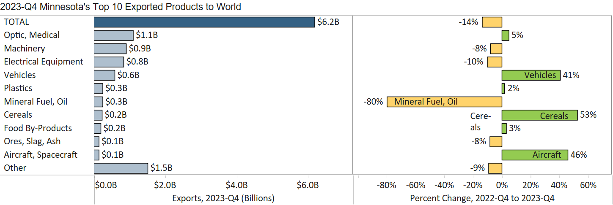
Minnesota Export Statistics reports track the state’s trends in exports of goods and is prepared for the Minnesota Trade Office by DEED’s Economic Analysis Unit (Thu-Mai Ho-Kim). The quarterly and annual reports primarily cover export data based on the Harmonized Tariff System (Schedule B), collected by the Foreign Trade Division, Census Bureau, U.S. Dept of Commerce and accessed through USA Trade Online (Census Bureau) and Trade Data Monitor (TDM). Historical reports are available on DEED’s website at “Export and Trade Statistics” (http://mn.gov/deed/data/export-stats/).

