Annual Data on Minnesota Exports for 2019 – Published March 2020
For More Information: Eric Lightner, 651-259-7149

State Exports Fall 2% to $22 Billion in 2019

- Minnesota exports (including agricultural, mining and manufactured products) were valued at $22 billion in 2019, representing a decrease of 2% between 2018 and 2019. U.S. exports slid 1%.
- Minnesota ranked 21st highest in exports among U.S. states in 2019, down from 20th in 2018.
- In 2019, the state exported about 1,050 different products (4-digit HS codes) to 207 countries.
- Exports of goods supported more than 118,000 jobs in Minnesota (2016). State manufactured exports dropped 2% to $21 billion in 2019.
Figure 1. Exports Drop from 29 States in 2019
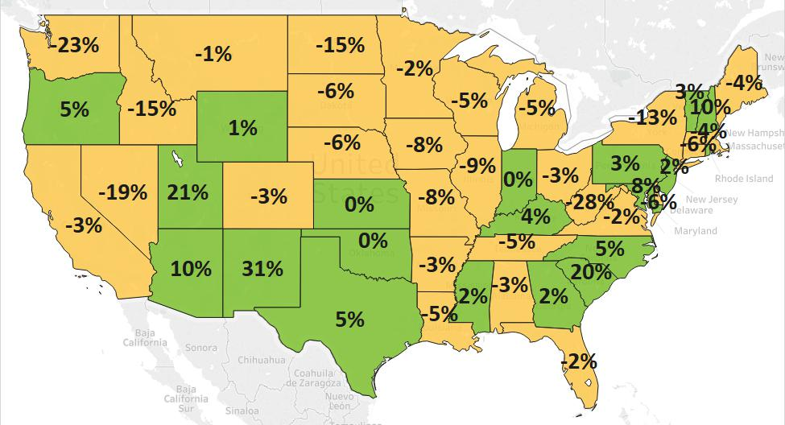
MN: -2%
U.S.: -1%
Decline 0% Growth

State Exports Increase to Europe, Africa and Australia – Countering Decline to Asia
- Disruptive U.S. trade tariffs, foreign countermeasures and uncertain trade policies impacted trade in 2019.
- Exports to Asia sank 5% between 2018 and 2019, to $8 billion. Exports to China tumbled the most, with combined demand for electrical equipment, soybeans, machinery and plastics shrinking by $205 million.
- Sales to North America were unchanged: the 4% gain to Mexico balanced the 2% dip to Canada.
- Exports were stable to the EU and grew 10% to other European markets (such as Turkey, Uzbekistan and Kazakhstan). Solid growth to Germany, Italy and France masked declines to the U.K., Poland and Belgium.
- Australia leaped into the state’s top 10 markets, as the Philippines (down 9%) dropped from 10th to 14th. Otherwise, there was minimal change in the rankings of the state’s other top 10 markets.
- Outreach in Morocco, Egypt, South Africa and Tunisia shaped trends in Africa ($225 million, up 26%).
- Other strong performers included Costa Rica (up 22%) in Central & South America ($944 million, down 13%) and Saudi Arabia (up 14%) in the Middle East ($416 million, down 4%).
Figure 2. Exports and Trends for Minnesota’s Top 10 Markets, 2019
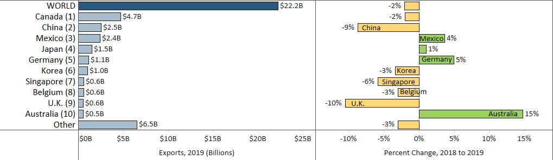

Mineral Fuels, Optic/Medical, Pharmaceuticals, Glass and Ammunition Lead Gains
- Optic/medical goods sales surged to China and Europe (including to France, Turkey, the Netherlands and Ireland). Increased exports of orthopedic/artificial body parts, medical/surgical instruments and testing instruments countered lower measuring and regulating instruments, optical fibers and breathing equipment exports.
- Pharmaceutical demand jumped 7%, propelled by China ($250 million, up 10%) and the Netherlands ($29 million, up 208%). High-growth segments included blood products and drugs.
Figure 3. Top Exported Optic/Medical Products

- Canada ($280 million, up 142% - mainly light oils) steered growth in mineral fuels ($320 million, up 106%).
- Almost 60% of glass goods ($154 million, up 26%) were shipped to Canada (up 24%) and Mexico (up 124%). Multi-walled glass units ($79 million, up 33%) and glass fibers ($34 million, up 28%) drove growth.
- Australia ($25 million, up 148%) fueled much of the increase in arms/ammunition ($103 million, up 38%).
- Other fast-growing areas were fats/oils (up $26 million, due to Mexico), wood pulp (up $23 million, due to Indonesia), fertilizers (up $15 million, due to Canada) and other edibles (up $15 million, due to Canada).
- Four of the top five products dragged exports down, with each plummeting by $90 million to $200 million. Demand for electrical equipment weakened the most, particularly to China, Germany and the U.K., and for product segments such as integrated circuits, telecommunications equipment and electric capacitors.
- More sales of centrifuges/filters and road construction machinery to Australia, and dairy equipment to Canada, provided relief against slumping sales of heating, spraying and pumping machinery to China.
- Large losses in plastics to Mexico, Poland, Brazil and China hindered strong gains to Germany and Costa Rica. Demand for primary polymers & resins and various plastic sheets & film faltered, in contrast to 2018.
- Passenger and special vehicles sales lost ground in Canada, while vehicle parts gained traction in Mexico.
- Oil seeds, misc. grain exports plunged $89 million, as sales of soybeans (down $57 million – driven by China) and soybean meal (down $29 million, in part due to Morocco and Colombia) contracted.

Figure 4. Exports and Trends for Minnesota’s Top 10 Products, 2019
Minnesota Export Statistics is the most current resource available for tracking the state’s trends of exports of goods and is prepared for the Minnesota Trade Office (MTO) by the Department of Employment and Economic Development’s (DEED) Economic Analysis Unit (by Thu-Mai Ho-Kim). The quarterly and annual statistics reports primarily cover export data based on the Harmonized Tariff System (Schedule B), collected by the U.S. Department of Commerce (USDOC) and distributed by IHS Markit. Reports are available on DEED’s website at “Export and Trade Statistics” (http://mn.gov/deed/data/export-stats/). Additional Notes: The U.S. Department of Agriculture (USDA) publishes alternate annual agricultural export estimates based on different methodology. USDA estimated that Minnesota exported $6.9 billion in agricultural and related food products in 2017, ranking fifth highest among all states. Data on services exports are limited. The Coalition of Services Industries, a national industry group, estimated Minnesota services exports at $11 billion in 2017. DEED estimated Minnesota’s services exports at $14 billion for 2019, based on pro-rating U.S. services exports data, using the state’s GDP industry shares.

