Annual Data on Minnesota Exports for 2020 – Published February 2021
For More Information: Jen Gates 651-358-0300

State Exports Valued at $20 Billion in 2020, Down 10% Since 2019

- Minnesota exports (including agricultural, mining and manufactured products) were valued at $20 billion in 2020. This was 10% lower than in 2019 – a drop resulting from weak economic conditions arising from the pandemic. U.S. exports slid 13%.
- Minnesota ranked 21st highest in exports among U.S. states in 2020, unchanged from 2019.
- State manufactured exports dropped 9% to $19 billion in 2020. Exports of goods supported more than 119,000 jobs in Minnesota (2019).
- Minnesota conducted $48 billion in total trade with 212 countries in 2020, down 7% since 2019. With $28 billion in imports in 2020, the state ran a trade deficit of $8 billion.
Figure 1. Six States Increased Exports in 2020
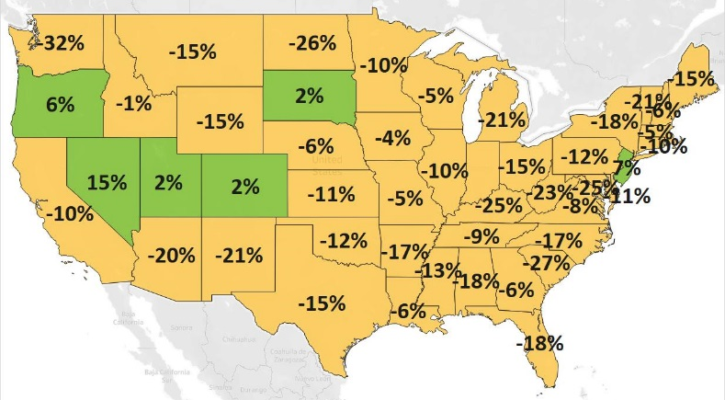
MN: -10%
U.S.: -13%
Decline 0% Growth

Despite Overall Decline in Exports, Sales Grew to Selected Markets
- Minnesota exports sank to all regions due to pandemic-related economic disruptions. Demand shrank the most in Asia (down $594 million), North America (down $416 million) and Europe (down $805 million).
- Among the state’s Top 10 markets, exports increased only to Canada (up 2%), fueled by mineral fuels, oils.
- With gains exceeding $10 million, robust markets included Taiwan (up 40%), Malaysia (up 10%), Switzerland (up 11%) and Vietnam (up 10%). Notable emerging markets also helped diversify exports: Slovakia ($64 million, up 813%; ranked 31st, up from 73rd) – driven by iron ore; Algeria ($22 million, up 170%; ranked 49th, up from 71st) and Ecuador ($36 million, up 39%) – driven by wheat; and Cambodia ($16 million, up 101%; ranked 52nd, up from 70th) – driven by food by-products and furs.
Figure 2. Exports and Trends for Minnesota’s Top 10 Markets, 2020
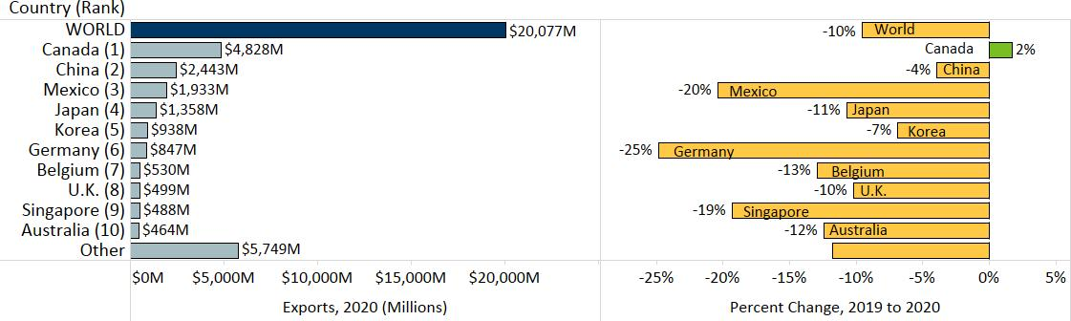

Mineral Fuels & Oils, Meat, Dairy & Eggs, and Precious Metals Bolster Exports
- Global sales of the state’s top exports dropped sharply: optic & medical, machinery, electrical equipment, vehicles, pharmaceuticals and aircraft slumped a combined $2 billion in 2020.
- Major products mitigating these declines included mineral fuels, oils (up 230%) and meat (up 33%).
- Mineral fuels, oils demand jumped almost $740 million, to over $1 billion. Growth was almost entirely propelled by Canada and petroleum-based light oils.
Figure 3. Top Markets for Meat Exports

- Meat exports grew vigorously to China ($180 million, up 289%) and Japan ($76 million, up 72%). Fresh chilled or frozen pork ($353 million) surged 50% and accounted for about three-quarters of meat exports.
- Dairy, eggs ($155 million, up 31%) were largely shipped to China ($52 million, up 75%), Mexico ($34 million, up 10%) and Canada ($16 million, up 49%). Whey ($101 million, up 51%) primarily spurred gains.
- Precious metals, gemstones ($82 million, up 62%) strengthened, based on sales of precious metal waste ($40 million, up 40%) and coins ($15 million, up 417%). Japan ($41 million, up 54%) was a main buyer.
- Although exports of major products faltered overall, selected markets generated gains. Vehicles gained traction in Switzerland (up $21 million), India (up $7 million), UAE (up $4 million) and Algeria (up $3 million). Strong opportunities in optic, medical goods were found in Taiwan, Australia and the UK, while machinery performed well in Singapore (up 51%), the Philippines (up 53%) and Ireland (up 136%). Taiwan, Malaysia, Switzerland and UAE were among the growing markets for electrical equipment.
- Exporters made inroads with iron ores to Slovakia, growing exports by $57 million (up from none in 2019).
- Other products with solid performances included railway equipment ($27 million, up 131% - steered by Brazil and Mexico); oil seeds, misc. grains ($172 million, up 9% - bolstered by China, Japan, Canada and Korea); vegetables ($66 million, up 14% - supported by the UK and Mexico); and prepared meat, fish ($107 million, up 7% - led by the Philippines).

Figure 4. Exports and Trends for Minnesota’s Top 10 Products, 2020
Minnesota Export Statistics is the most current resource available for tracking the state’s trends of exports of goods and is prepared for the Minnesota Trade Office (MTO) by the Department of Employment and Economic Development’s (DEED) Economic Analysis Unit (by Thu-Mai Ho-Kim). The quarterly and annual statistics reports primarily cover export data based on the Harmonized Tariff System (Schedule B), collected by the U.S. Department of Commerce (USDOC) and distributed by IHS Markit. Reports are available on DEED’s website at “Export and Trade Statistics” (http://mn.gov/deed/data/export-stats/). Additional Notes: The U.S. Department of Agriculture (USDA) publishes alternate annual agricultural export estimates based on different methodology. USDA estimated that Minnesota exported $6.4 billion in agricultural and related food products in 2019, ranking fourth highest among states. Data on services exports are limited. DEED estimated Minnesota’s services exports at $12 billion for 2020, based on pro-rating U.S. services exports data, using the state’s GDP industry shares.
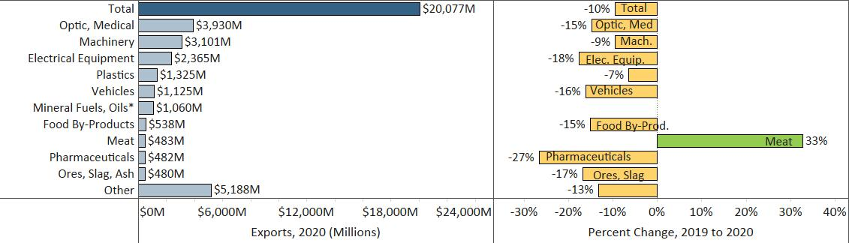
*The trend for Mineral Fuels, Oils (up 230%) was not shown to minimize chart distortion.

