Data on Minnesota Exports for Fourth Quarter 2020 – Published February 2021
For More Information: Jen Gates 651-358-0300

State Export Slide 10% in Fourth Quarter
- Minnesota exports (including agricultural, mining and manufactured products) were valued at $5.0 billion in the fourth quarter of 2020, falling by 10% (or $566 million) since the fourth quarter of 2019.
- U.S. exports of goods fell 5% during this period. A larger number of states had positive or flat export growth compared to the previous two quarters.
- Minnesota manufactured exports contracted 11% to $4.7 billion in the fourth quarter of 2020. U.S. manufactured exports sank 8%.
- For the year, Minnesota exports fell 10% between 2019 and 2020, while U.S. exports dropped 13%.
Figure 1. Exports Increase or Flat in 23 States
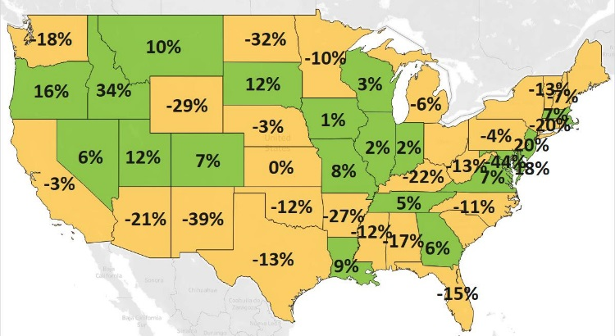
MN: -10%
U.S.: -5%
Decline 0% Growth

Exports Increase to Smaller Regions, Selected Countries – Despite Widespread Declines
- The state’s exports fell to its top three regional markets, which accounted for 87% of exports. Sales sank 7% to North America, 11% to Asia and 19% to the European Union. Markets with the largest declines included Canada (down $124 million), Germany (down $97 million), Japan (down $94 million), Korea (down $62 million), Singapore (down $55 million) and France (down $51 million).
- With regional export growth of 15%, the outlook brightened in European markets not in the European Union (led by Switzerland and Norway) and the Middle East (led by Saudi Arabia, Kuwait and UAE). Exports also surged to Taiwan (up $31 million), Indonesia (up $10 million) and Ecuador (up $10 million).
- Minnesota businesses expanded sales to two Top 10 markets: China (up 2%) and the U.K. (up 2%).

Figure 2. Export Trends for Minnesota’s Top 10 Markets, Fourth Quarter 2020
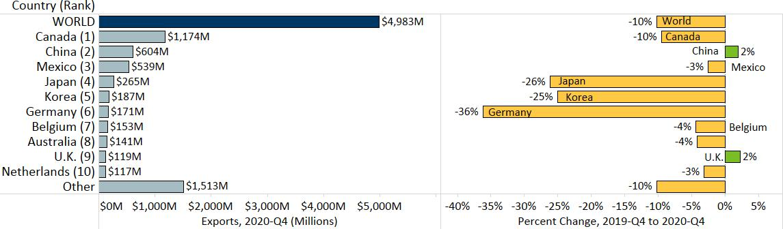

Gains in Machinery, Vehicles, and Meat Help Offset Widespread Declines
- Signaling resilience, exports of three of the state’s top 10 products increased: machinery (up 4%), vehicles (up 4%) and meat (up 10%).
- However, large losses persisted for other major products, such as in optic, medical (down $187 million), mineral fuels, oils (down $74 million), plastics (down $56 million) and aircraft, spacecraft (down $52 million).
- Slumping demand for mineral fuels, oils and ores, slag, and ash in Canada – the dominant market for these products – triggered their overall declines.
Figure 3. Minnesota Vehicles Exports, by Segment

- Global sales of machinery began to rebound, fueled by markets such as the Philippines ($41 million, up 152%), Singapore ($37 million, up 93%) and Australia ($44 million, up 41%). Sales of machinery for making semiconductors ($80 million, up 234% - boosted by Philippines and Australia) and spraying equipment ($64 million, up 19% - strengthened by Canada, Belgium, Australia and China) grew vigorously.
- Exports of vehicles gained traction in Switzerland ($15 million, up from $295,000), India ($7 million, up from $77,000), Germany ($10 million, up 138%) and Saudi Arabia ($8 million, up 209%). High-growth segments included specialty vehicles such as snowmobiles and ATVs (particularly in Switzerland and Canada), vehicle parts (including in India and Mexico), and fire-fighting vehicles (especially to Saudi Arabia).
- Robust growth in demand for meat continued, primarily propelled by China ($49 million, up 82%) and Japan ($19 million, up 82%). Frozen and fresh, chilled pork ($86 million, up 11%) spurred exports.
- Other food and agricultural products initiating strong comebacks were oil seeds, misc. grain (up 47%), dairy, eggs (up 25%), prepared meat, fish (up 38%), vegetables (up 69%) and beverages (up 22%).
- Exporters made notable inroads of ores, slag, ash in Slovakia and of arms, ammunition in Taiwan.
- Other products bolstering the state’s exports included precious metals ($19 million, up 52%; i.e. metal waste), aluminum ($30 million, up 14%), animal hides, skins ($16 million, up 17%) and rubber ($20 million, up 11%).

Figure 4. Export Trends for Minnesota’s Top 10 Products, Fourth Quarter 2020
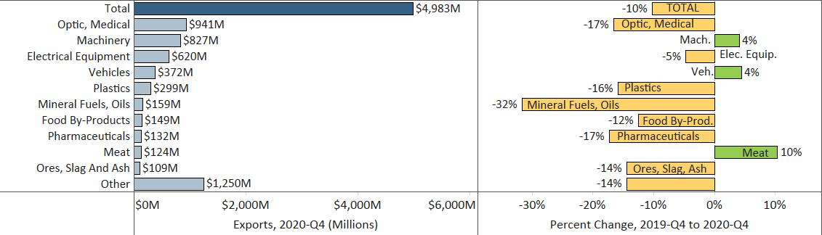
Minnesota Quarterly Export Statistics is the most current resource available for tracking the state’s export trends in manufactured and other goods, and is prepared for the Minnesota Trade Office (MTO) by the Department of Employment and Economic Development’s (DEED) Economic Analysis Unit (Thu-Mai Ho-Kim). The quarterly and annual statistics reports primarily cover export data based on the Harmonized Tariff System (Schedule B), collected by the U.S. Department of Commerce (USDOC) and distributed by IHS Markit. Reports are available on DEED’s website at “Export and Trade Statistics” (http://mn.gov/deed/data/export-stats/).

