Annual Data on Minnesota Exports for 2021 – Published in March 2022
For More Information: Alicia Cordes-Mayo (alicia.cordes-mayo@state.mn.us, 763-406-9965)

State Exports Rebound to $24 Billion in 2021, Up 17% Since 2020

- Minnesota exports (including agricultural, mining and manufactured products) were valued at about $24 billion in 2021. The state’s exports rebounded from the weak pandemic-related global economic conditions of 2020, jumping 17% in 2021 (and 6% above 2019). U.S. exports jumped 23% since 2020 (up 7% over 2019).
- The state ranked 22nd in exports among all states.
- State manufactured exports were about $22 billion in 2021, up 15% since 2020 (and 4% over 2019). Exports of goods supported more than 112,000 jobs in Minnesota in 2020.
Figure 1. Widespread Export Gains in 2021
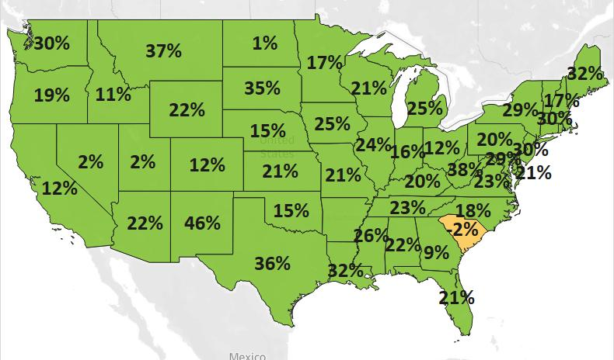
MN: +17%
U.S.: +23%
Decline 0% Growth

- Minnesota conducted $56 billion in total trade with 212 countries in 2021. Total trade grew 16% since 2020 (up 8% since 2019). With $32 billion in imports, the state ran a trade deficit of $9 billion in 2021.

North American Markets Drove Export Growth in 2021
- Minnesota exports strongly rebounded to North America ($9 billion), gaining 33% since 2020 (and 26% over 2019). Export growth was more moderate in Asia ($7.7 billion, up 8%) and in Europe ($4.8 billion, 11%); exports recovered to 2019 levels in Asia but fell short in Europe (down 7%).
- Many markets rallied to overcome the challenges of 2020. Demand significantly strengthened in Canada (up $1.7 billion), Mexico (up $522 million), the Philippines (up $451 million; up from 15th largest in 2020), China (up $235 million), India (up $105 million, 17th; due to railway equipment), Ireland (up $102 million; due to medical products) and Taiwan ($98 million, 12th). Sales to these markets surpassed 2019 levels.
Figure 2. Exports for Minnesota’s Top 10 Markets in 2021, with Trends Since 2020 and 2019
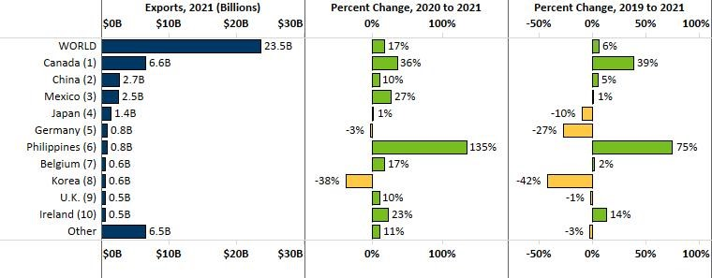

Machinery, Electrical Equipment and Mineral Fuel & Oil Had Largest Export Gains
- Surging global sales of machinery (up $1 billion), mineral fuel, oil (up $751 million) and electrical equipment (up $747 million) fueled Minnesota’s overall recovery in exports in 2021 and pushed these exports over their 2019 levels.
- Growth in machinery was led by machines for making semiconductors (up 369%; fueled by an increase of $592 million to the Philippines), centrifuges, filters (up 23%), construction equipment (up 42%), spraying machines (up 17%) and liquid pumps (up 18%). Canada and China were high-growth markets.
Figure 3. Top Exported Machinery Products

- Electronic integrated circuits (up 67%; driven by China) and semiconductors (up 69%; boosted by Japan, China and Canada) generated significant export growth in electrical equipment.
- Mineral fuel, oil exports leaped 70% to $1.8 billion – propelled by Canada and petroleum-based light oils.
- Optical, medical goods struggled in 2021. Demand was robust for optical inspection instruments and medical, surgical instruments, but tumbled for unmounted optical elements, mainly to Korea and China.
- Exports of plastics (down 10%) slumped due to a prolonged decline in sales of self-adhesive plastic plates, sheets (down 62%), despite strong growth in polyethers, polyesters (up 21%) and tubes, pipes (up 67%).
- Exports of cereals (mainly corn – up 297%, driven by Canada); oil seeds, misc. grain (primarily soybeans – up 109%, driven by Mexico); and food by-products grew vigorously to North American markets.
- Solid growth in meat (primarily pork) occurred in Japan (up 62%) and Mexico (up 55%). Dairy, eggs ($192 million, up 24%; largely whey and milk, cream) made inroads in China (up 35%) and Mexico (up 38%).
- Vehicles gained traction from specialty vehicles ($164 million, up 48%; driven by Canada, Belgium) and passenger vehicles (including ATVs, snowmobiles) ($332 million, up 12%; largely destined for Canada).

Figure 4. Exports for Minnesota’s Top 10 Products in 2021, With Trends Since 2020 and 2019
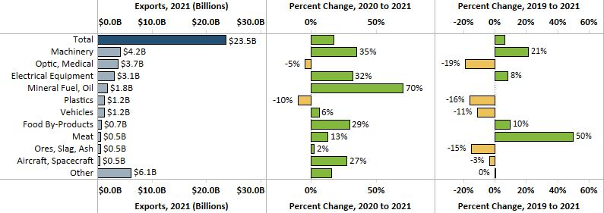
Minnesota Export Statistics is the most current resource available for tracking the state’s trends of exports of goods and is prepared for the Minnesota Trade Office (MTO) by the Department of Employment and Economic Development’s (DEED) Economic Analysis Unit (by Thu-Mai Ho-Kim). The quarterly and annual statistics reports primarily cover export data based on the Harmonized Tariff System (Schedule B), accessed from WISERTrade: State HS Database, where data are from the U.S. Census Bureau, Foreign Trade Division. Reports are available on DEED’s website at “Export and Trade Statistics” (http://mn.gov/deed/data/export-stats/). Additional Notes: The U.S. Department of Agriculture (USDA) publishes alternate annual agricultural export estimates based on different methodology. USDA estimated that Minnesota exported $7.2 billion in agricultural and related food products in 2020, ranking fourth highest among states. Data on services exports are limited. DEED estimated Minnesota’s services exports at $12 billion for 2020, based on pro-rating U.S. services exports data, using the state’s GDP industry shares.
Note: Positive change rate of 468% for Mineral Fuel, Oil between 2019 and 2021 was omitted to minimize chart distortion.

