Data on Minnesota Exports for Second Quarter 2021 – Published September 2021
For More Information: Jen Gates 651-358-0300

Exports in Rebound Mode, Jump 29% in the Second Quarter
- Minnesota exports of goods (including agricultural, mining and manufactured products) jumped 29% to $6 billion in the second quarter of 2021. Recovering markets generated $1.3 billion more in the state’s sales, compared to second quarter of 2020.
- U.S. exports of goods increased 51% between the second quarters of 2020 and 2021. All states had positive export growth during this period.
- Compared to the pre-pandemic second quarter of 2019, the state’s exports were up 5%, which matched U.S. export growth of 5% for this period.
- Minnesota’s manufactured exports jumped 29% between the second quarters of 2020 and 2021, while U.S. manufactured exports increased 46%.
- Between the first half of 2020 and 2021, Minnesota exports grew 10%, while U.S. exports grew 23%.

Figure 1. Exports Increase from All States, 2021-Q2
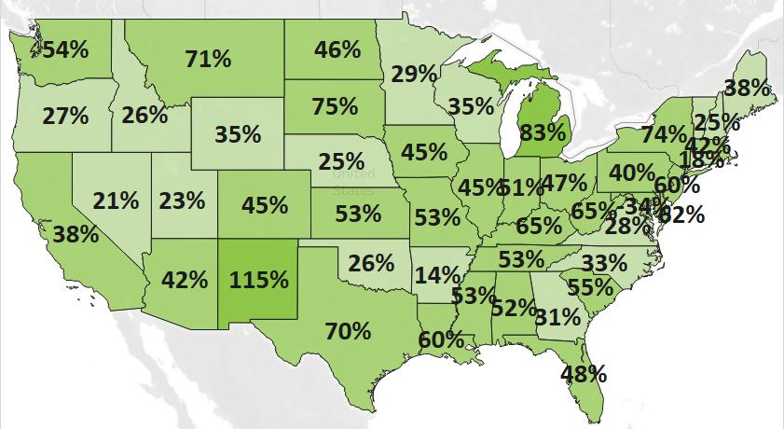
MN: 29%
U.S.: 51%
0% 115%

Note: Exports from Washington DC dropped 34%.

Exports Strengthen to All Regions – Strongest Performances in North America, Europe
- Reversing much of the past year’s second quarter trends, the state’s exports increased 66% to North America – the state’s top regional market, 33% to Europe and 30% to Central and South America. Sales to markets in North America and the European Union reached or exceeded their levels in 2019.
- Asia (up 2%), Australia-Pacific (up 2%), the Middle East (up 3%), and Africa (up 4%) had modest growth.
- Many of the state’s Top 10 markets drove export growth this quarter. Exports also grew vigorously to other markets such as the Philippines (up 43%), Indonesia (up 100%), Costa Rica (up 67%), Switzerland (up 60%) and the Czech Republic (up 176%).

Figure 2. Export Trends for Minnesota’s Top 10 Markets, Second Quarter 2021
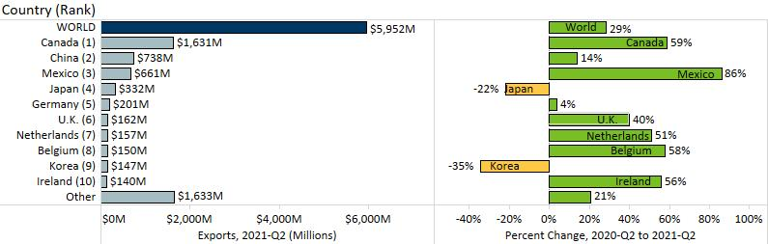

Resurging Demand for Machinery, Electric Equipment, Vehicles and Mineral Fuels
- Many products continued to display signs of recovering export growth this quarter. Exports of eight of the state’s top 10 products grew between the second quarters of 2020 and 2021. Six of these grew above their 2019 levels: machinery, electrical equipment, mineral fuels/oils, food by-products, meat and oil seeds/misc. grains.
- Machinery exports were propelled by machinery used to make semiconductors (up 219%) sold to the Philippines (up $66 million). Markets such as Canada, Mexico, U.K., China and the Czech Republic; and segments such as filters/centrifuges, construction machinery and spraying equipment fueled export gains.
Figure 3. Trends in MN Exports of Top Products, 2020-Q2 vs. 2021-Q2

- Electrical equipment sales surged to China (up 163%), Canada (up 88%), Mexico (up 58%) and Germany (up 58%). Sales were uplifted by integrated circuits (up 81%), diodes/transistors (up 72%) and capacitors (up 67%).
- As the dominant market, Canada ($389 million, up 122%) steered demand for mineral fuels, oils.
- About 75% of vehicles exports were sent to Canada (up 66%) and Mexico (up 114%), driving growth. Fruitful inroads were made in Jamaica (up $6 million), South Africa (up $5 million), Switzerland (up $4 million) and Russia (up $3 million). Special purpose, smaller vehicles, snowmobiles and parts boosted growth.
- Moderate growth in optic, medical (up 6%) concealed dynamic gains in medical, surgical instruments (up 54%) and orthopedic, body parts (up 54%), but sinking sales in optical fiber (down 81%, largely due to Asia). Ireland, Belgium, the Netherlands, Canada and Costa Rica (ranked 9th for optic, medical) bolstered sales.
- Food and agricultural products with export gains of $12 million or more during this period were oil seeds, misc. grains (up 200%), food by-products (up 45%), beverages (up 86%), meat (up 9%), and dairy, eggs (up 30%).

Figure 4. Export Trends for Minnesota’s Top 10 Products, Second Quarter 2021
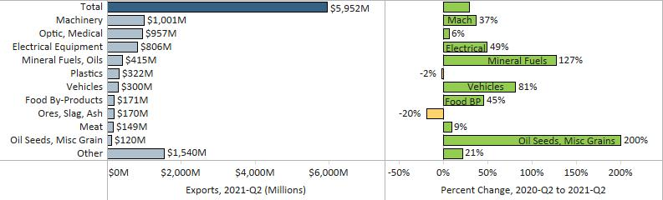
Minnesota Quarterly Export Statistics is the most current resource available for tracking the state’s export trends in manufactured and other good. The report is prepared for the Minnesota Trade Office (MTO) by the Department of Employment and Economic Development’s (DEED) Economic Analysis Unit (Thu-Mai Ho-Kim). The quarterly and annual statistics reports primarily cover export data based on the Harmonized Tariff System (Schedule B), collected by the U.S. Department of Commerce (USDOC) and distributed by IHS Markit. Reports are available on DEED’s website at “Export and Trade Statistics” (http://mn.gov/deed/data/export-stats/).

