Annual Data on Minnesota Manufactured Exports for 2022 – Published in March 2023
For More Information: Alicia Cordes-Mayo (alicia.cordes-mayo@state.mn.us, 763-406-9965)

State Exports Reach Record High: $27 Billion in 2022, Up 16%
- Minnesota exports (including agricultural, mining and manufactured products) were valued at over $27 billion in 2022. The state’s exports continued their growth streak from 2021, jumping 16% in 2022. U.S. exports grew 18% between 2021 and 2022. These growth rates are robust, even with average U.S. inflation of 6.5% in 2022.
- The state ranked 21st highest in export value and 15th highest in export growth rate among states.
- State manufactured exports reached $24 billion, up 12% since 2021. Exports of goods supported an estimated 117,900 jobs in Minnesota in 2021.
Figure 1. Widespread Strong Growth in 2022
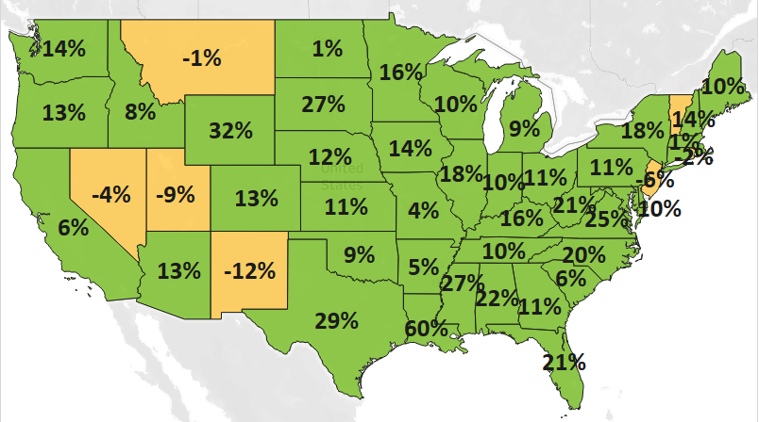
MN: +16%
U.S.: +18%
Decline 0% Growth

- Minnesota conducted $70 billion in total trade with 215 countries in 2022. Total trade grew 25% since 2021. With nearly $43 billion in imports (up 31%), the state ran a trade deficit of about $15 billion in 2022.

North American Markets Drove Export Growth in 2022
- Minnesota exports to North America grew to nearly $11.8 billion and gained $2.7 billion (or up 30%) over 2021. Exports also strongly increased to the European Union ($4.8 billion, up 26%); the Caribbean, Central America and South America ($1.2 billion, up 22%) and the Middle East ($447 million, up 30%).
- The state’s exports fell to Asia (down 2%), Africa (down 7%) and the Australia-Pacific region (down 1%).
- Markets contributing the most to growth in 2022 were Canada ($9 billion, up $2.3 billion), Mexico ($2.8 billion, up $349 million), the Netherlands ($777 million, up $239 million), Korea ($794 million, up $211 million) and Spain ($232 million, up $158 million, 23rd largest).
Figure 2. Exports for Minnesota’s Top 10 Markets in 2022
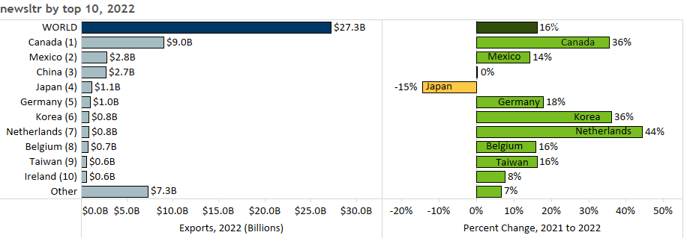

Mineral Fuel & Oil, Electrical Equipment and Cereals Lead in Export Gains
- Surging global sales of mineral fuel, oil (up $1.8 billion), electrical equipment (up $681 million) and cereals (up $618 million) contributed the most to Minnesota’s export gains in 2022.
- Mineral fuel, oil exports doubled to $3.6 billion – propelled by Canada and petroleum products.
- High-growth markets for electrical equipment included Canada (up 38%), Germany (up 49%) and Singapore (up 50%). Key segments were integrated circuits ($1.1 billion, up 13%) and electric generators ($312 million, up 109%).
Figure 3. Electrical Equipment Exports

- Canada ($774 million, up 197%) was the main market for cereals. Emerging markets for wheat were Yemen ($79 million, up from none) and Indonesia ($51 million, up from none).
- After struggling in 2021, exports of optical, medical goods recovered (to 2020 levels) and grew 6%. Swelling demand for orthopedic/artificial body parts ($809 million, up 52%) and stronger markets – including Netherlands (up 44%), Costa Rica (up 33%) and Germany (up 25%) – helped to fuel growth.
- China ($219 million, up 494%) spurred export growth in misc. chemicals ($460 million, up 147%), driven by a spike in demand for composite diagnostic or laboratory reagents ($202 million, up 977%).
- Other products that gained over $50 million in exports in 2022 included vehicles ($1.4 billion, up 18% - bolstered by vehicle parts and passenger vehicles), iron and steel products ($438 million, up 33% - boosted by demand in North America) and food by-products ($748 million, up 8%). As the primary market, Canada uplifted beverages, spirits ($208 million, up 37%) and fertilizers ($350 million, up 105%).
- Exports of machinery dropped 8%. While sales grew strongly to markets including Mexico, China and Canada, they plunged 91% to the Philippines – largely due to machines for making semiconductors.

Figure 4. Exports for Minnesota’s Top 10 Products in 2022
Minnesota Export Statistics tracks the state’s trends in exports of goods and is prepared for the Minnesota Trade Office by DEED’s Economic Analysis Unit (by Thu-Mai Ho-Kim). The quarterly and annual reports primarily cover export data based on the Harmonized Tariff System (Schedule B), collected by the Foreign Trade Division, Census Bureau, U.S. Dept of Commerce and accessed through USA Trade Online (Census Bureau) and Trade Data Monitor (TDM). Historical reports are available on DEED’s website at “Export and Trade Statistics” (http://mn.gov/deed/data/export-stats/). The U.S. Department of Agriculture (USDA) publishes alternate agricultural export data based on different methodology. USDA estimated that Minnesota exported $9.4 billion in ag and food products in 2021 and ranked fourth highest among states. Data on services exports are limited; Minnesota exported an estimated $12 billion in services in 2019, according to the Coalition of Services Industries. Jobs supported by exports are estimated by the International Trade Administration, U.S. Dept of Commerce.
