Data on Minnesota Exports for First Quarter 2022 – Published May 2022
For More Information: Alicia Cordes-Mayo (alicia.cordes-mayo@state.mn.us, 763-406-9965)

State Exports Show Solid 13% Growth in the First Quarter
- Minnesota exports of goods (including agricultural, mining and manufactured products) were valued at $6.1 billion in the first quarter of 2022, representing a gain of 13% (or up $676 million) over the first quarter of 2021.
- U.S. exports of goods rose 18% during in the first quarter, with 39 states and Washington D.C. having positive export growth rates over the first quarter of 2021.
- Minnesota’s manufactured exports increased 8% to $5.5 billion in the first quarter of 2022, while U.S. manufactured exports jumped 15%.
Figure 1. Exports Grow from Majority of States
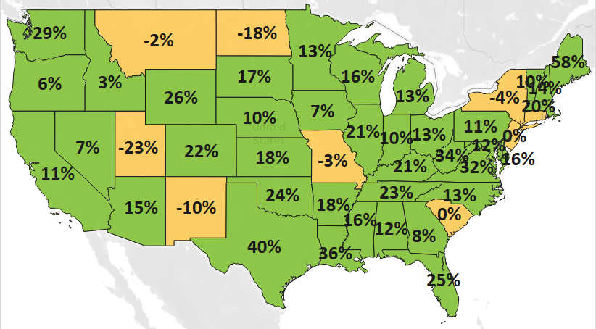
MN: +13%
U.S.: +18%
Decline 0% Growth

North American and Asian Markets Drive Export Growth
- Minnesota’s exports increased 28% to North America – largely driven by Canada (up 35%). State exports were flat to Asia, with strong gains in China (up 25%), Singapore (up 40%), Thailand (up 24%) and Malaysia (up 27%) offsetting steep declines in the Philippines (down 70%), Japan (down 15%) and Taiwan (down 24%).
- Exports grew 8% to the European Union (led by growth to the Netherlands and Belgium), 29% to the Middle East (as wheat exports surged by about $26 million to Yemen), and 2% to Central and South America (boosted by increased demand in Colombia (up 61%), Costa Rica (up 6%), and Chile (up 23%)).
- Among regions, exports declined only to the Australia-Pacific region (down 13%), as exports tumbled to Australia (down 12%) and New Zealand (down 18%).

Figure 2. Export Trends for Minnesota’s Top 10 Markets, First Quarter 2022
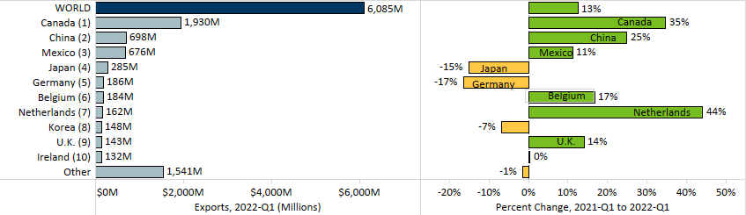

Cereals, Electrical Equipment, Fertilizers and Chemicals Are Among Growth Markets

- Exports of many products performed strongly into 2022. Five of the state’s top 10 products grew in the first quarter – electrical equipment (up 31%), optic, medical (up 5%), cereals (up 579%), plastics (up 7%) and meat (up 2%).
- Electrical equipment sales surged to China (up 65%), Thailand (up 78%), Germany (up 65%) and Canada (26%). Leading growth segments included integrated circuits ($306 million, up 46%), insulated wire ($59 million, up 105%) and switches ($66 million, up 45%).
- As the dominant buyer, Canada propelled the state’s growth in exports of cereals (up almost $330 million, mainly corn) and fertilizers (up $78 million).
Figure 3. Top Markets for Electrical Equipment

- China ($47 million, up 497%), Mexico ($9 million, up 377%) and Italy ($7 million, up 907%) spurred demand for miscellaneous chemicals (largely consisting of diagnostic or laboratory reagents).
- Optic, medical exports gained traction in China (up 30%) and the Netherlands (up 63%) but slipped in Taiwan (down 30%), Canada (down 10%) and Australia (down 29%). Medical, surgical instruments (up 7%) and optical fiber bundles (up 53%) countered depressed demand for navigational instruments (down 82%).
- Sales of meat gained strongly in Japan (up 116%) but fell sharply in China, Canada and Australia.
- The state’s top 3 markets for plastics – Canada (up 31%), Mexico (up 43%) and the Netherlands (up 30%) – bolstered exports against sharp declines to Germany, China, and Thailand. Miscellaneous polymers (up 37%), polyethers, other primary forms (up 18%) and plastic containers (up 44%) generated the most growth.
- Sales of machinery slumped to the Philippines (down $90 million), Germany (down $24 million) and Japan (down $12 million), while those of food by-products slid to Mexico (down $34 million) and Korea (down $6 million).

Figure 4. Export Trends for Minnesota’s Top 10 Products, First Quarter 2022
Minnesota Quarterly Export Statistics is the most current resource available for tracking the state’s export trends in manufactured and other goods. The report is prepared for the Minnesota Trade Office (MTO) by the Department of Employment and Economic Development’s (DEED) Economic Analysis Unit (Thu-Mai Ho-Kim). The quarterly and annual statistics reports primarily cover export data based on the Harmonized System (Schedule B), accessed from WISERTrade - State HS Database, based on data collected by the U.S. Census Bureau, Foreign Trade Division. Reports are available on DEED’s website at “Export and Trade Statistics” (http://mn.gov/deed/data/export-stats/).
