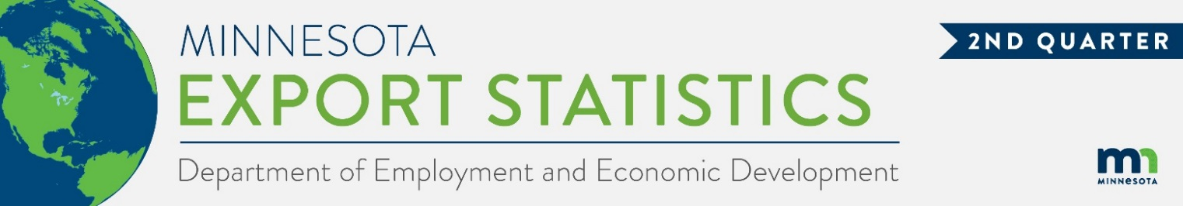
Data on Minnesota Exports for Second Quarter 2022 – Published September 9, 2022
For More Information: Alicia Cordes-Mayo (alicia.cordes-mayo@state.mn.us, 763-406-9965)

State’s Second Quarter Exports Soar to Record High $6.7 Billion
- Minnesota exports of goods (including agricultural, mining and manufactured products) jumped 12% to $6.7 billion in the second quarter of 2022 – a record high for state quarterly exports.
- U.S. exports of goods increased 22% between the second quarters of 2021 and 2022. Exports grew from 42 states during this period.
- Minnesota’s manufactured exports grew to $6.0 billion, gaining 10% between the second quarters of 2021 and 2022, while U.S. manufactured exports increased 17%.
- For the year-to-date, Minnesota exports were up 12%, while U.S. exports grew 20%.
Figure 1. Exports from 42 States Increased
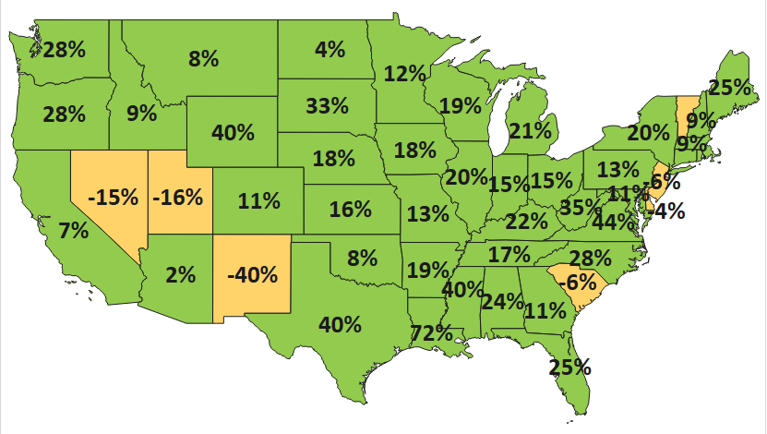
MN: 12%
U.S.: 22%

Decline 0% Growth

Canada and Markets in the European Union Drive Gains in Exports
- The state’s exports increased 29% to North America – the state’s top regional market, driven by Canada (up 42%); and grew 8% to markets in the European Union – led by gains in Germany (up 14%), Portugal ($18 million, up 742%), Ireland (up 11%) and Belgium (up 10%).
- Exports to Asia slipped 4%. Exports were robust in Thailand (up 36%), Korea (up 19%) and India (up 35%) but slumped in the Philippines (down $76 million), Japan (down $60 million) and China (down $29 million).
- Businesses made significant inroads in Central and South America (up 22%) and in the Middle East (up 23%). Key Central and South American markets were Costa Rica (up 24%), Brazil (up 33%) and Honduras (up $15 million); while notable Middle Eastern markets were Yemen (up $13 million) and Israel (up 38%).
- Outreach increased to the Australia-Pacific region ($122 million, up 8%) and Africa ($50 million, up 10%).

Figure 2. Export Trends for Minnesota’s Top 10 Markets, Second Quarter 2022
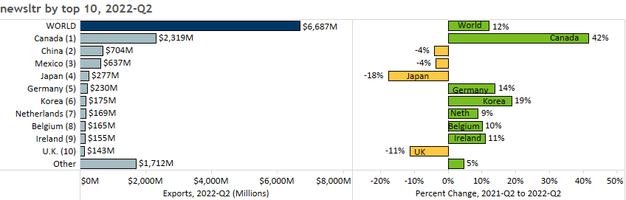

Cereals, Mineral Fuel and Electrical Equipment Surge in Second Quarter
- Solid growth in exports of mineral fuels, oils (up 69%, or up $287 million), cereals (up 394%, or up $246 million), and electrical equipment (up 13%, or up $105 million) boosted state exports this quarter.
- Demand in Canada spurred exports of mineral fuels, oils (up $253 million to Canada, largely light oils, including motor fuels) and cereals (up $264 million to Canada, largely corn (maize)). Canada’s market share for each of these products was about 90%. Among other markets for cereals, exports fell $23 million to Mexico but rose $12 million to Yemen.
Figure 3. Top Electrical Equipment Segments

- Electrical equipment surged to major markets such as Germany (up 40%), Canada (up 15%), Thailand (up 25%) and Switzerland (up 33%). Integrated circuits (up 12%), electrical switches (up 27%) grew the most.
- A spike in demand for diagnostic/lab reagents and kits (up $65 million) – particularly by China (up $44 million) and Italy (up $14 million) – fueled strong export growth of miscellaneous chemicals ($112 million, up 158%).
- Iron/steel products (up 47%, led by Canada and Mexico), food by-products (up 20%, driven by starch/sugar by-products) and aircraft/spacecraft (up 31%, consisting of civilian aircraft parts) performed well.
- Markets for machinery rallied. Growing markets (such as China, Canada, Belgium and Mexico) offset sliding markets (mainly the Philippines, as demand for machines to manufacture semiconductors fell $78 million).
- Among optic, medical segments, orthopedic, artificial body parts (up 35%) and misc. optical/medical machines (up 23%) balanced medical, surgical instruments (down 10%) and optical fibers (down 29%). Costa Rica (up 34%), Ireland (up 12%) and Taiwan (up 17%) mitigated adverse trends in China, Japan and Belgium.
- Mexico (down $67 million) dragged down oil seeds, misc. grain ($61 million, down 49%), while China (down $32 million) and Italy (down $15 million) most impacted pharmaceuticals ($49 million, down 55%).

Figure 4. Export Trends for Minnesota’s Top 10 Products, Second Quarter 2022
Minnesota Quarterly Export Statistics is the most current resource available for tracking the state’s export trends in manufactured and other goods. The report is prepared for the Minnesota Trade Office (MTO) by the Department of Employment and Economic Development’s (DEED) Economic Analysis Unit (Thu-Mai Ho-Kim). The quarterly and annual statistics reports primarily cover export data based on the Harmonized System (Schedule B), accessed from WISERTrade - State HS Database, based on data collected by the U.S. Census Bureau, Foreign Trade Division. Reports are available on DEED’s website at “Export and Trade Statistics” (http://mn.gov/deed/data/export-stats/)
