Data on Minnesota Exports for Third Quarter 2022 – Published November 2022
For More Information: Alicia Cordes-Mayo (alicia.cordes-mayo@state.mn.us, 763-406-9965)

State Exports Surpass $7 Billion in Third Quarter, Jumping 28%
- Minnesota exports of goods (including agricultural, mining and manufactured products) surged to $7.3 billion in the third quarter of 2022 – an historic high. Exports increased 28% – or up $1.6 billion – between the third quarters of 2021 and 2022.
- U.S. exports of goods grew 23% in the same period. Reflecting robust growth in global demand, exports made gains in 41 states.
- Minnesota manufactured exports expanded by 21% to $6.4 billion during this period, while U.S. manufactured exports were up 18%.
- For the January to September period, the state’s exports of goods grew 18% over 2021, while U.S. exports grew 21%.
Figure 1. Exports Increase from 41 States
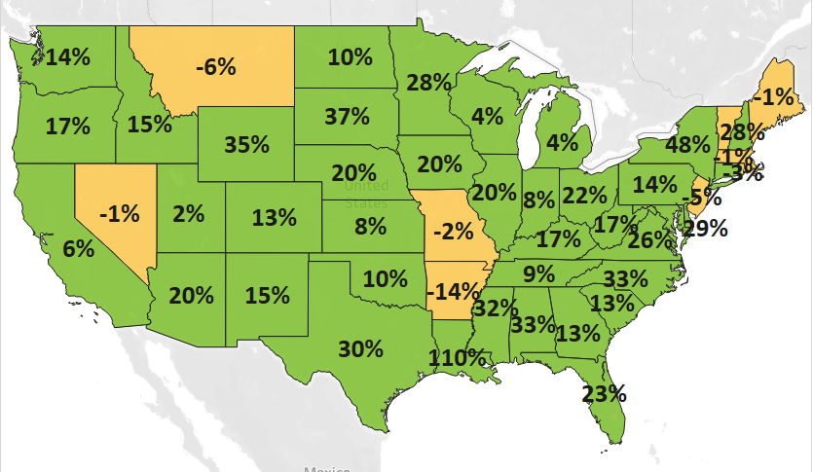
MN: 28%
U.S.: 23%
Decline 0% Growth

Demand Strengthened Across Global Regional Markets
- Strong demand conditions propelled exports to new heights, fueled by markets in North America ($3.2 billion, up 46%) and the European Union ($1.4 billion, up 49%). Exports to Asia grew 4% to $1.9 billion.
- Top markets such as Canada (up $926 million), the Netherlands (up $152 million), Mexico (up $87 million) and Germany (up $67 million) made the most notable gains. Other fast-growing smaller markets included Spain ($87 million, up $71 million) and Lithuania ($65 million, up $61 million).
- In Asia, solid gains in Korea (up 40%), Indonesia (up 74%), Taiwan (up 26%) and Singapore (34%) helped offset declines to China (down 3%), Japan (down 13%) and the Philippines (down 63%).
- The state’s exports robustly expanded in the Caribbean, Central America and South America ($290 million, up 13%), the Middle East ($104 million, up 25%) and Africa ($52 million, up 30%).

Figure 2. Export Trends for Minnesota’s Top 10 Markets, Third Quarter 2022
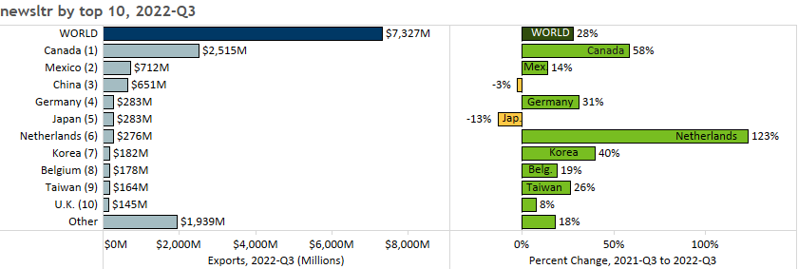

Mineral Fuels, Electrical Equipment, Cereals and Vehicles Help Fuel Record Growth
- Exports of many of the state’s top products grew strongly. Mineral fuel, oil (up 188%), electrical equipment (up 32%), cereals (up 315%) and vehicles (up 44%) fueled growth, mitigating against declines in pharmaceuticals (down 52%), machinery (down 3%), oil seeds, misc. grains (down 21%) and dairy, eggs (down 35%).
- Global sales of misc. chemicals ($122 million, up 175%), optic, medical ($978 million, up 7%), fertilizers ($84 million, up 96%) and beverages ($59 million, up 146%) also gained significant traction.
Figure 3. Top Export Segments for Vehicles

- As the primary market, Canada drove export growth of mineral fuel, oil (such as motor fuel), beverages (largely, spirits) and fertilizers. Mineral, fuel oil sales more than doubled to Canada ($909 million, up 112%) and made inroads in emerging markets, such as the Netherlands, Lithuania and Spain.
- Sales in cereals were driven by corn (maize) to Canada, and wheat to Indonesia, Italy and Yemen.
- Electrical equipment exports surged to markets such as Canada, Germany, Mexico and Malaysia; and for products such as electric generators, integrated circuits, and diodes/transistors.
- Mexico (up 95%) and Canada (up 38%) drove growth in vehicles exports and accounted for 82% of these sales.
- Export growth of misc. chemicals – particularly diagnostic/lab reagents – was driven by China (up 737%).
- Among optic, medical products, strong strides in orthopedic, artificial body parts (up 53%) and measuring instruments (up 16%) helped mitigate sharp declines in medical, surgical instruments and optical fibers.
- Growth in machinery segments such as additive manufacturing equipment ($13 million, up from none), engine parts (up 111%), lifting equipment parts (up 40%) and cleaning/filling equipment (up 46%) were outmatched by the plunge in machinery for making semiconductors (down $116 million) to the Philippines.

Figure 4. Export Trends for Minnesota’s Top 10 Products, Third Quarter 2022
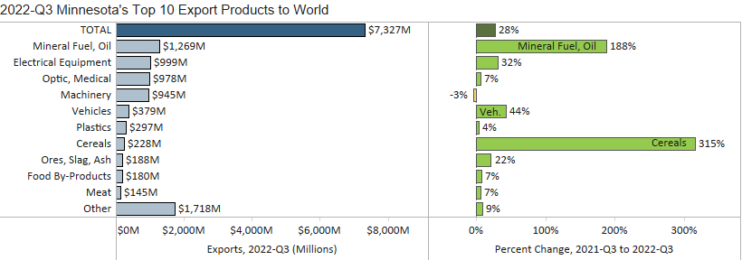
Minnesota Quarterly Export Statistics is the most current resource available for tracking the state’s export trends in manufactured and other good. The report is prepared for the Minnesota Trade Office (MTO) by the Department of Employment and Economic Development’s (DEED) Economic Analysis Unit (Thu-Mai Ho-Kim). The quarterly and annual statistics reports primarily cover export data based on the Harmonized Tariff System (Schedule B), collected by the U.S. Department of Commerce (USDOC) and accessed through Trade Data Monitor. Reports are available on DEED’s website at “Export and Trade Statistics” (http://mn.gov/deed/data/export-stats/).

