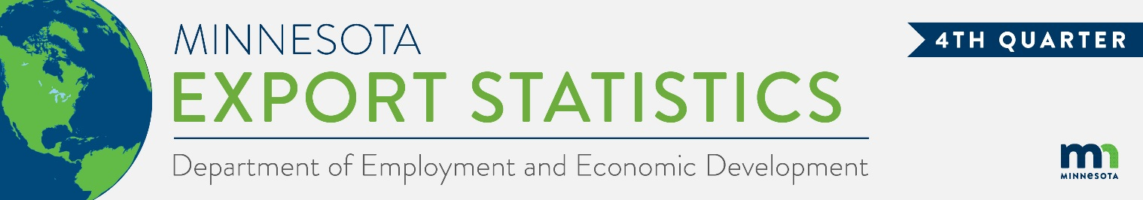
Data on Minnesota Exports for Fourth Quarter 2022 – Published March 2023
For More Information: Alicia Cordes-Mayo (alicia.cordes-mayo@state.mn.us, 763-406-9965)

State Exports Surpass $7 Billion in Fourth Quarter, Gaining 12%
- Minnesota exports of goods (including agricultural, mining and manufactured products) reached $7.2 billion in the fourth quarter of 2022 – making it the second consecutive quarter of over $7 billion in exports. Exports increased 12% – or up $781 million – between the fourth quarters of 2021 and 2022.
- U.S. exports of goods grew 8% in the same period, with exports from 37 states growing over 2021.
- Minnesota manufactured exports expanded by 8% to $6.2 billion during this period, while U.S. manufactured exports were up 7%.
- For the year, the state’s exports of goods grew 16% over 2021, while U.S. exports grew 18%.
Figure 1. Exports Increase from 37 States
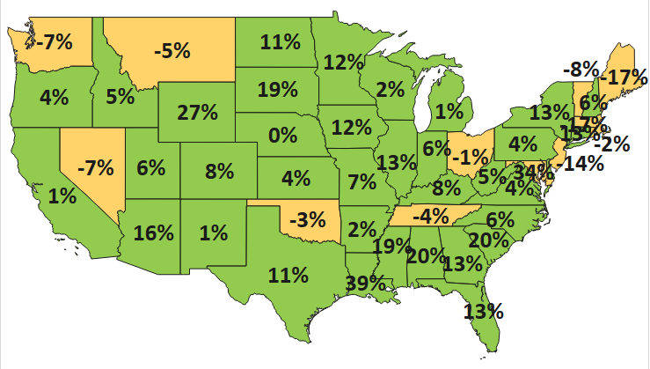
MN: 12%
U.S.: 8%
Decline 0% Growth

Markets in the Americas and the EU Generate Strongest Export Growth
- Strong market conditions in North America ($3 billion, up 18%), the European Union ($1.3 billion, up 39%) and the Caribbean, Central America and South America ($366 million, up 48%) propelled growth.
- The state’s sales struggled in Asia ($1.9 billion, down 9%) and tumbled to Africa ($46 million, down 42%).
- The state’s top four markets this quarter had the largest gains: Canada (up $247 million), Mexico (up $211 million), Korea (up $143 million), and Germany (up $88 million). Emerging markets included Spain ($99 million, up 319%), Uruguay ($55 million, up from $2 million) and Yemen ($29 million, up from $114,000).
- In Asia, solid gains in Korea (up 98%), Taiwan (up 69%) and Malaysia (up 25%) helped offset sharp persisting declines to the Philippines (down 83%), China (down 13%) and Japan (down 13%).
- The state’s exports robustly expanded in the Middle East ($129 million, up 32%) and European countries outside the EU ($241 million, up 8%), and grew moderately to the Australia-Pacific ($133 million, up 3%).

Figure 2. Export Trends for Minnesota’s Top 10 Markets, Fourth Quarter 2022
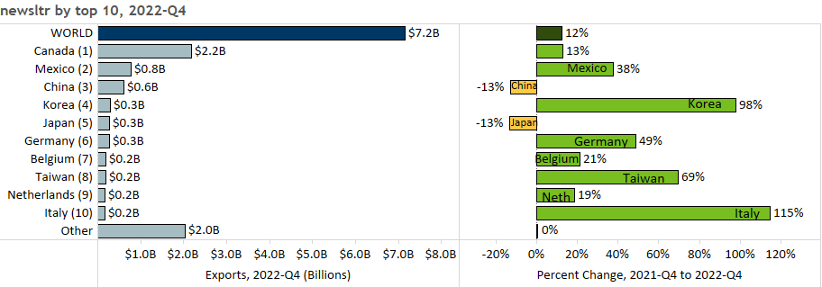

Global Sales of Mineral Fuel and Oil Drove the State’s Export Growth
- Some of the state’s top products such as mineral fuel, oil (up 130%), optic, medical (up 14%), electrical equipment (up 13%), and vehicles (up 30%) fueled export growth, which helped to offset declines in others such as machinery (down 19%), cereals (down 45%), plastics (down 16%) and pharmaceuticals (down 51%).
- Global sales of misc. chemicals ($119 million, up 118%), fertilizers ($90 million, up 80%), iron and steel products ($111 million, up 34%) and food by-products ($195 million, up 15%) also made strong gains.
Figure 3. Top Markets for Mineral Fuel, Oil

- With a market share of 64%, Canada (up 54%) drove export growth of mineral fuel, oil (such as motor fuel). However, increases in demand – ranging from $50 million to $120 million – for these products from largely new markets (Korea, Spain, Italy, Taiwan, Uruguay and France) generated the largest gains.
- Surging electrical equipment exports to markets such as Canada (up 44%), the Philippines (up 104%) and Germany (up 27%) and Indonesia (up 1,026%) offset the sharp decline to China (down 24%).
- Mexico ($145 million, up 179%) and Canada ($194 million, up 16%) drove export growth of vehicles.
- The strongest performing optic, medical export markets included Germany, the Netherlands, Belgium, Costa Rica and Korea. Orthopedic, artificial body parts ($282 million, up 113%) was the highest growth segment.
- China accounted for half of misc. chemicals exports; growth was driven by diagnostic/lab reagents.
- Taiwan (up 492%) and Ireland (up 343%) contributed the most to increased sales of food-by products.
- Remarkable growth in some machinery segments – such as centrifuges, filters (up 14%), engine parts (up 167%), specialized equipment (up 22%) and spraying equipment (up 18%) was crowded out by disruptive trends in machinery for making semiconductors (down $290 million, mainly to the Philippines).

Figure 4. Export Trends for Minnesota’s Top 10 Products, Fourth Quarter 2022
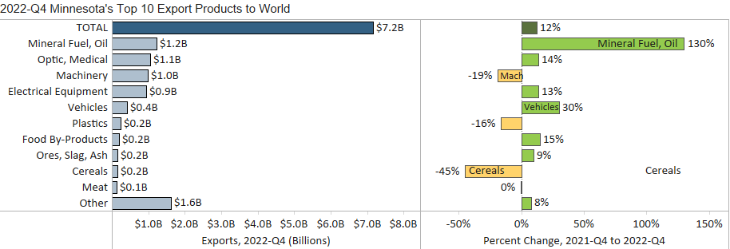
Minnesota Export Statistics tracks the state’s trends in exports of goods and is prepared for the Minnesota Trade Office by DEED’s Economic Analysis Unit (by Thu-Mai Ho-Kim). The quarterly and annual reports primarily cover export data based on the Harmonized Tariff System (Schedule B), collected by the Foreign Trade Division, Census Bureau, U.S. Dept of Commerce and accessed through USA Trade Online (Census Bureau) and Trade Data Monitor (TDM). Historical reports are available on DEED’s website at “Export and Trade Statistics” (http://mn.gov/deed/data/export-stats/).

