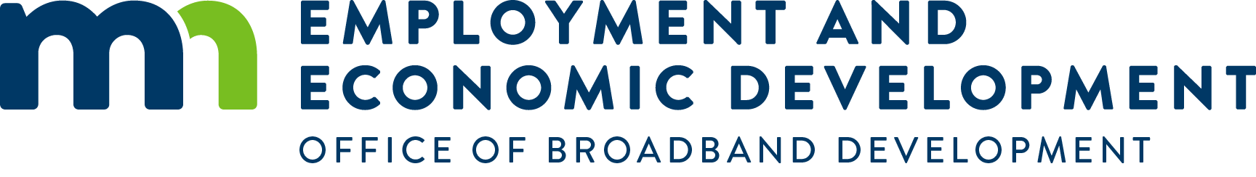

FY 2024 Border to Border Broadband 2023 Grant Round 9 Funding Summary
# of Projects: 16 Grant $ Awarded: $ $33,302,177 # of Passings: 7,246

Applicant | Project | Grant Award Amount
Albany Mutual Telephone Association | AMTA - Stearns Phase 2 | $7,123,175
Arvig | Arvig - Naytahwaush Area | $326,111
Consolidated Telephone Company | CTC - RD9 Clinton Twp | $2,292,790
East Central Energy | ECE Mille Lacs South | $4,885,809
Easton Telephone Company | Bevcomm (Easton) Rural MN Lake | $435,838
Federated Telephone Cooperative | Federated Tel - W Kandiyohi | $8,202,000
Gardonville Cooperative Telephone | Gardonville - Douglas Cty | $223,521
Hanson Communications | Hanson - Chippewa Cty W | $2,081,494
Hanson Communications | Hanson - Comfrey FTTP | $395,138
Mediacom LLC | Esquagama Lake | $961,102
Mediacom LLC | Mediacom - Oakhill/Spring Valley | $33,863
Meeker Cooperative Light & Power Association | Meeker Fahlun | $590,709
Midco | Midco North Central | $801,700
Red River Communications | Red River - Rural Hawley | $970,411
Savage Communications Inc | SCI - East Central MN | $3,563,817
Spectrum Mid-America, LLC | Spectrum-Mower County | $414,699
16 | Totals | $33,302,177
*Grant awards rounded to nearest dollar

Grant Round 9 Border to Border Broadband Grant Awards
Number of applications | 38
Total amount originally applied for | $70.2M
Amount awarded | $33.3M
Number of projects awarded
Breakdown by region:

Central | 3 | projects - | $15,572,801
Northland | 2 | projects - | $3,253,892
Northwest | 1 | projects - | $326,111*
Southern | 4 | projects - | $1,279,538
Southwest | 3 | projects - | $10,874,204
Twin Cities | 1 | projects - | $801,700
West Central | 2 | projects - | $1,193,932
*Project proposes to serve Tribal area with support and binding agreement with the Tribe
Local/private match | $44.5M
Total number of locations served | 7,246
Unserved locations | 4,490
Underserved locations | 2,756
Households to be served | 6,008
Businesses to be served | 424
Farms to be served | 799
Community anchor institutions to be served | 15
Challenges submitted | 41
Number of challengers | 12
Number of projects challenged | 25
Number of challenges resulting in partial or non-funding | 6

Fy 2024 LOWer population DENSITY 2023 Grant round 9 Funding Summary
# of Projects: 8 Grant $ Awarded: $19,729,816 # of Passings: 1,668

Applicant | Project | Grant Award Amount
Arvig | Arvig-Mower-County | $3,129,412
Arvig | Arvig-Stearns-County | $910,537
Bevcomm Inc | Bevcomm-Waseca-County-Fiber | $4,385,444
Garden Valley Telephone Company | Garden-Valley-Telephone-Rural-East-Grand-Forks | $1,050,465
Nuvera Communications, Inc | Nuvera-White-Rock | $1,884,429
Upsala Cooperative Telephone Assoc. dba Sytek | Sytek-Swanville-North-Moose-Lake | $3,689,967
Wikstrom Telephone Company | Wiktel-NW-MN-Broadband-RD9 | $3,066,630
Woodstock Telephone Company | Woodstock-Comm-Hatfield-FTTH | $1,612,932
8 | Total | $19,729,816

Grant Round 9 Lower Population Density Grant Awards
Number of applications | 31
Total amount originally applied for | $85.5M
Amount awarded | $19.7M
Number of projects awarded
Breakdown by region:
Central | 2 | projects - | $4,600,504
Northland | 0 | projects - | $0
Northwest | 2 | projects - | $4,117,095
Southern | 3 | projects - | $9,399,286
Southwest | 1 | projects - | $1,612,932
Twin Cities | 0 | projects - | $0
West Central | 0 | projects - | $0

Local/private match | $6.5M
Total number of locations served | 1,668
Unserved locations | 1,497
Underserved locations | 171
Households to be served | 1,043
Businesses to be served | 182
Farms to be served | 438
Community anchor institutions to be served | 5
Challenges submitted | 23
Number of challengers | 6
Number of projects challenged | 21
Number of challenges resulting in partial or non-funding | 0

For more information, contact deed.broadband@state.mn.us or call 651-259-7610.
OBD website: http://mn.gov/deed/broadband

