Data on Minnesota Exports for First Quarter 2024 – Published June 2024
For More Information: Mary Haugen (mary.haugen@state.mn.us)

Minnesota Exports Signal Rebound, Growing 2% in First Quarter
- Minnesota exports of goods (including agriculture, mining and manufacturing) were valued at $6.7 billion in the first quarter of 2024, representing an increase of 2% (or up $133 million) since the first quarter of 2023. The state’s exports had last shown growth in the first quarter of 2023.
- Although the state’s sales of mineral fuel and oil continued to decline, the drop was less severe.
- U.S. exports of goods were unchanged between the first quarters of 2023 and 2024. More states had gains (28) than had declines (22).

Figure 1. More States Have Gains Than Declines
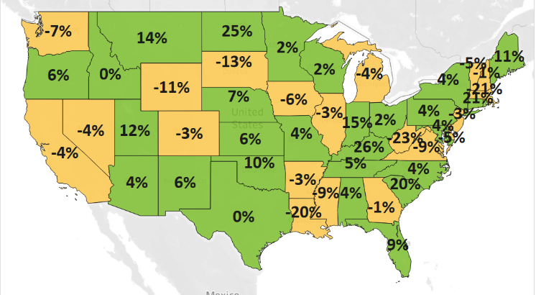
MN: +2%
U.S.: 0%
Decline 0% Growth

Exports Show Signs of Recovery in North America and Asia
- Minnesota’s exports gained a modest 1% to North America ($3.0 billion), bolstered by robust growth to Mexico (up 20%). Overall exports to Canada continued to slide, dragged down by the drop in mineral fuel, oil.
- Exports to Asia ($1.8 billion, up 7%) reversed course, swelling to Thailand (up 74% – mainly due to integrated circuits), Taiwan (up 24%), Korea (up 13%) and India (up 37%) and countering weakness in China and Japan.
- Sales of Minnesota goods strengthened to the Caribbean, Central and South America ($349 million, up 12%), Australia-Pacific ($154 million, up 27%) and the Middle East ($127 million, up 9%). Brazil, Colombia, the Dominican Republic, El Salvador, Australia and the United Arab Emirates spurred growth in these regions.
- Exports to the EU fell 6%, as sales buckled to Sweden (down 52%), Spain (down 36%), Germany (down 16%) and the Netherlands (down 10%). However, sales gained traction in Ireland (up 22%) and France (up 25%).
- The downward trend in exports to Africa ($44 million, down 13%) concealed the strong gains to South Africa (up $4.5 million) and Morocco (up $3.6 million) that offset some losses to Ethiopia (down $14.5 million).

Figure 2. Export Trends for Minnesota’s Top 10 Markets, First Quarter 2024
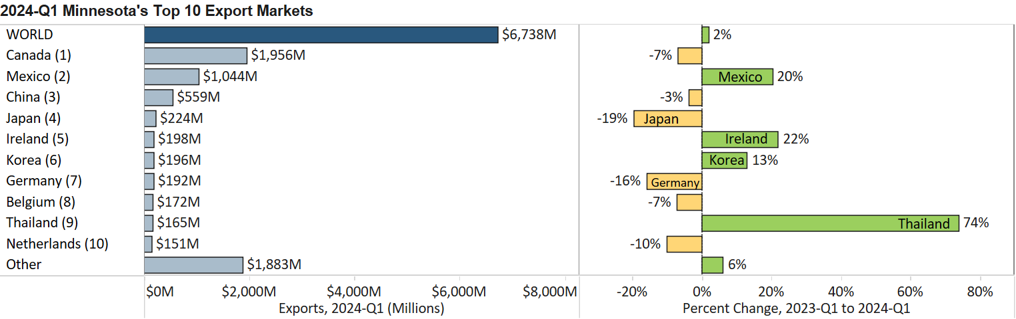

Medical Products, Vehicles, Plastics and Aircraft Lead in Export Gains
- Over half of the state’s top 10 exported products had moderate to strong performances in the first quarter. Optic, medical (up 12%), vehicles (up 26%), plastics (up 18%) and aircraft, spacecraft (up 33%) led in gains.
- Higher optic and medical exports were fueled by markets in Asia (up $98 million – led by Korea, Taiwan and China) and North America (up $33 million – led by Mexico). Growing need for measuring instruments ($164 million, up 62%) and medical, surgical instruments ($451 million, up 10%) drove growth.
- Sales of vehicles and vehicle parts surged to core markets – such as Mexico ($191 million, up 38%) and Canada ($222 million, up 17%) – and emerging markets, such as Australia ($28 million, up 202%), South Africa ($9 million, up 317%) and Poland ($8 million, up 318%).
Figure 3. Markets for Optic, Medical Goods

- Growth in exported aircraft and aircraft parts were propelled by Canada ($25 million, up 112%), Nepal ($10 million, up from none), Germany ($23 million, up 75%) and Brazil ($13 million, up 265%).
- Demand for plastic goods rebounded, driven by markets in North America (up 25%) and the EU (up 46%). Increased sales of tubes, pipes ($56 million, up 68%), self-adhesive sheets, film ($36 million, up 41%) and natural polymers ($9 million, up from $93,000) boosted exports the most.
- Nearly 90% of food-by products were sold to North America ($119 million, up 18%) and Asia ($72 million, up 52%). Canada and Mexico, the dominant markets, made solid gains. Inroads into Thailand ($11 million, up 97%), Vietnam ($6 million, up 116%) and Japan ($8 million, up 62%) resulted in high-growth performances.
- Mexico uplifted sales of sugar ($46 million, up 126%) but shrank those of cereals ($140 million, down 32%).

Figure 4. Export Trends for Minnesota’s Top 10 Products, First Quarter 2024
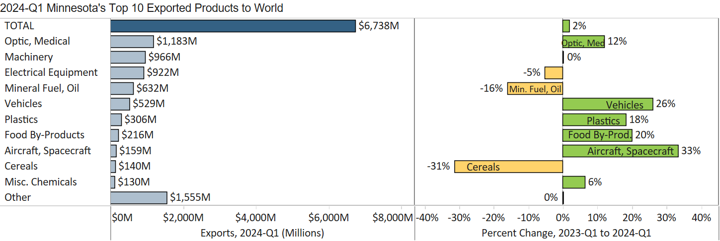
Minnesota Export Statistics reports track the state’s trends in exports of goods and is prepared for the Minnesota Trade Office by DEED’s Economic Analysis Unit (Thu-Mai Ho-Kim). The quarterly and annual reports primarily cover export data based on the Harmonized Tariff System (Schedule B), collected by the Foreign Trade Division, Census Bureau, U.S. Dept of Commerce and accessed through USA Trade Online (Census Bureau) and Trade Data Monitor (TDM). Historical reports are available on DEED’s website at “Export and Trade Statistics” (http://mn.gov/deed/data/export-stats/).

