Navigating the Customization Tools for Checklists
You will need to log in to your site administration page using your master administration log in or your staff log in username and password.

Edit the Introduction and Documentation
From the blue Mega menu, hover over the “Customize” tab and click on “Create, Edit, and Export Checklist.”
The landing page allows the users to edit the introductory message, add supporting documents and import site checklists.

Introductory Message
This section allows you to add a custom message to students or use the message that has been provided. To add your own message or documents, click on “Edit” and type in your site specific message. You can also choose where or if to show the default introductory message. Once complete, click on “Update.”

Supporting Documents
This section allows you to add supporting documents. To add supporting documents, click on “Edit” then click on “Add Supporting Documents.” Use the “Browse” button to find the document you want to upload, enter a sequence number (based on the number of items already uploaded) and a file description. Next click on “Upload” then click on “Done.”

Steps to Create and Edit a Checklist

Create Your Checklist
To begin to create and edit your site specific checklist, it is recommended that you first duplicate one of the default checklists, and edit from the duplication. To do this, choose the checklist you want to work on and click on “Duplicate.”
Your new, site specific checklist will appear on the same screen under the “Site Checklist” heading. To start making changes to your checklist, begin by clicking on “Edit.”
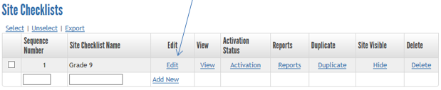

Edit Your Checklist
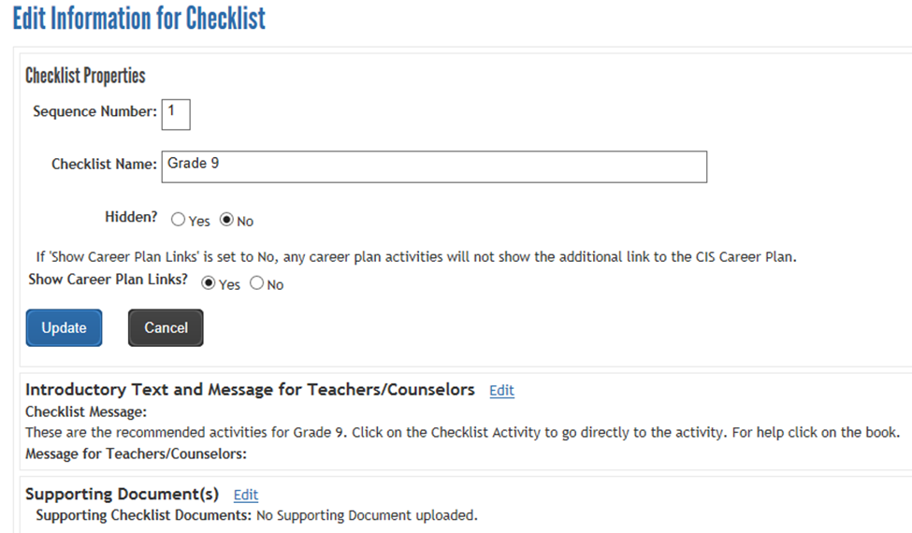
There are multiple steps to creating a customized checklist:

Step 1: Set the Checklist Properties
First, set the Sequence Number and Site Checklist Name. If you wish to link to various components in MCIS, keep “Show Career Plan Links” checked as “Yes.”

Step 2: Set the Introductory Text and Message for Teachers/Counselors
You can edit an introductory message for each individual checklist or use the existing message. See the beginning of this document for further instructions.

Step 3: Supporting Document(s)
You can edit and add supporting documents for each individual checklist. See the beginning of this document for further instructions.

Step 4: Edit the Checklist Activities
Start to edit the checklist by clicking on “Edit” for each checklist entry or click on “Delete” if you no longer want that item on your site specific checklist.
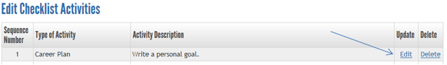
Example: you want to keep the item, “Write a personal goal” but would like to make it a required checklist item. First, click on “Edit.” Then on the next page, scroll to uncheck the box marked “Optional.” Then click the “Update” button at the bottom of the page and click on “Return to Edit Checklist.”
Continue with the same process of editing or deleting each entry. Follow the instructions on each screen and be sure to click on “Update” on the bottom of each entry and click on “Return to Edit Checklist.”

Add Items to Your Checklist
Step 1: Scroll to the bottom of the checklist you are working on. Enter a sequence number in the space provided. To allow you to expand your checklists, you can skip a few sequence numbers instead of one at a time (ex: 1, 5, 8, 10). Then make a selection from the drop down menu. Then click “Add New.”
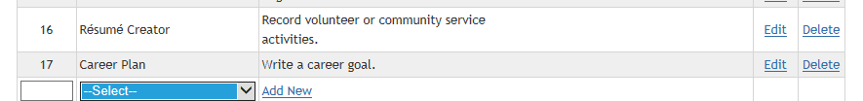

Activity types
- Career Plan: generates a pop-up for reflection boxes and Experiential Learning. Multiple reflections may be selected. Worksheets from the Career Plan can be embedded in the Help Message box in the activity.
  - From the Career Plan, find the worksheet you want. Right click and click on “Copy Link Location.” Paste to a separate sheet/document to have available for the next steps. If you wish to include both the pdf and Word version of the worksheet, you will need to copy the link location for both.
  - Once you have those, you can return to the administrative side and start the activity. In the Help Message, use the template below to write the code. You can type an introduction and an outro to the activity (italics), typing the title of the worksheet (blue text after), html (purple text – don’t change) and url (black text – paste the links you got from “Copy Link Location”).
  - To add one worksheet:
Complete the worksheet <i><b>Introduction to the World of Work [<a href="https://materials.intocareers.org/CareerPlan/Activities/Introduction%20to%20the%20World%20of%20Work.pdf"target="_blank"><img src="../images/acrobat.gif" width="16" height="16" border="0" alt="Download pdf"></a>] [</i></b><a href="https://materials.intocareers.org/CareerPlan/Activities/Introduction%20to%20the%20World%20of%20Work.docx" target="_blank"><img src="../images/word.gif" width="16" height="16" border="0" alt="Download doc"></a>]. Save your worksheet in My Files and Links (see “How to Save Worksheets” document).
  - To add two worksheets:
Complete the worksheet <i><b>Introduction to the World of Work [<a href="https://materials.intocareers.org/CareerPlan/Activities/Introduction%20to%20the%20World%20of%20Work.pdf"target="_blank"><img src="../images/acrobat.gif" width="16" height="16" border="0" alt="Download pdf"></a>] [</i></b><a href="https://materials.intocareers.org/CareerPlan/Activities/Introduction%20to%20the%20World%20of%20Work.docx" target="_blank"><img src="../images/word.gif" width="16" height="16" border="0" alt="Download doc"></a>] and <i><b>Research My Options [<a href="https://materials.intocareers.org/CareerPlan/Activities/Research%20My%20Options.pdf"target="_blank"><img src="../images/acrobat.gif" width="16" height="16" border="0" alt="Download pdf"></a>] [</i></b><a href="https://materials.intocareers.org/CareerPlan/Activities/Research%20My%20Options.docx" target="_blank"><img src="../images/word.gif" width="16" height="16" border="0" alt="Download doc"></a>]. Save your worksheet in My Files and Links (see “How to Save Worksheets” document).
- Course Planner: directs students to the Course Planner for a chosen grade level. Additional criteria – choosing a school year and minimum number of courses – will need to be selected in order for the activity to show as complete.
- Sorts/Assessments: directs students to a sort or assessment.
- Content Saved: directs students to the overview of information files in MCIS.
- Content FAQ’s: directs students to the overview of information files in MCIS.
- Resume Creator: directs students to the Resume Creator topics where they can complete different parts of their resume. This can be done topic by topic or all at once.
- Standardized Tests: directs students to the Resume Creator so they can record their standardized test scores.
- Application Tracker: directs students to different sections of the Application Tracker for students to keep track of deadlines for schools and scholarships they want to apply for.
- Entrance Exams: directs students to the Application Tracker so they can record their scores for entrance exams.
- Custom Activity: you can use this activity to direct students to areas of MCIS that cannot be directly linked to through checklists – like directions to the Graduation Requirements section on the Personal Learning Plan. You can also link to website outside of MCIS such your school website.
Follow the instructions on the page. You must fill in an activity description, a short label and a help message.
Step 2: If you want to make the activity optional, check the “Optional” box. If you want to make the activity required, leave the “Optional” box unchecked.
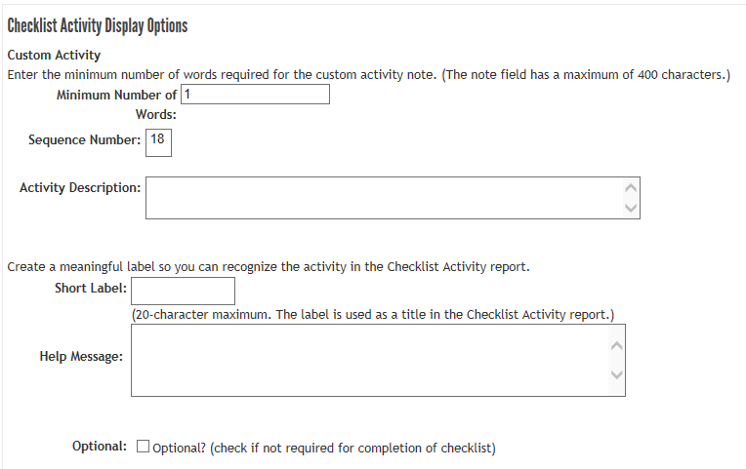
When complete, click on “Update” and “Return to Edit Checklist.” Continue this process for each item you want to add to your checklists. After you have entered all checklist items, it is suggested to go back and verify the sequence numbers are in the order you want the student to see or complete them.

Activate Checklists
Checklists can be activated by the Entire Site, by Group or by Graduation Year. If you are creating grade level checklists, is suggested that you activate checklists for the Entire Site. This allows students to work up and/or down a grade level.
Step 1: Hover over “Customize” on the blue Mega menu and click on “Create, Edit and Export Checklist.” For each site checklist, click on “Activation.”
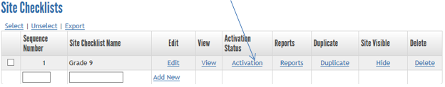
On this page, you will be activating this checklist for all students in your school.
Step 2: Find the section labeled “Activation by Entire Site,” click on the drop down menu under site name under select the option listed.
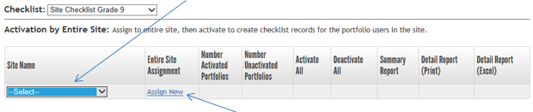
Once you have made your selection, click on “Assign New.” Next, click on “Activate,” this will activate the checklist for all students. Repeat this process for each checklist.
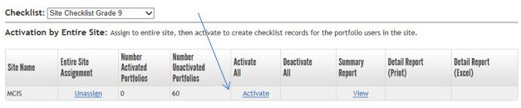
Note: activation will take place overnight. You will be able to verify the checklist is active the next day by toggling to the student side and clicking on “Checklists” from the “Plan” or “My Portfolio” tab.

Hide Checklists
This is the final step once all site specific checklists are activated. Once you have activated your site specific checklist, you can hide the default checklists. This will remove the default checklist from the student view so they only see the ones that have been assigned to them. This is an optional step.
From the blue Mega menu, hover over “Customize” and click on “Create, Edit and Export Checklist.” From the list of default checklists at the bottom of the page, click on “Hide.”
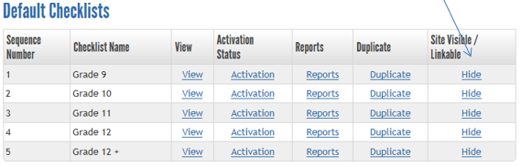
For more information, please contact MCIS at mcis.team@state.mn.us – 651-582-8321 or 800-599-6247.

