Navigating the Course Planner Tools
You will need to log in to your site administration page using your site administration username and password.
There are two ways in which you can load your courses into MCIS. You can load courses individually or upload them using an Excel spreadsheet. Whichever option you choose, begin on the blue Mega menu, hover over “Customize” and click “Create and Edit Course Plan Content.”

Enter Courses Individually
To enter courses individually, begin by selecting “Add Courses” from the left side “Maintain Site Data Tables” header. Then select the subject you would like to begin with.
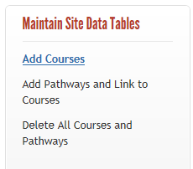
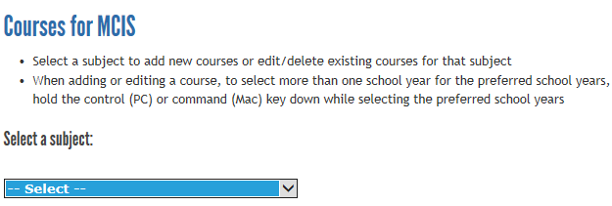
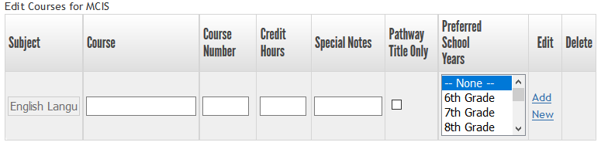
Enter all of your courses, making sure to click “Add” after each entry. Continue the process for each subject area. Adding courses individually will instantly upload to the live site. At any time you can toggle over to the live site and check your work in the Course Planner.

Enter Courses Using Excel
To enter courses using an Excel spreadsheet, begin by selecting “Export Courses” from the “Export/Import” header near the bottom of the page. Select one of the spreadsheets to export to start entering your schools data. Make sure to include data in all required fields, then save the spreadsheet for importing.
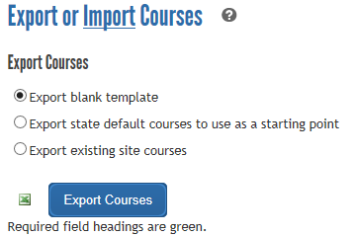 (Click the “?” to view detailed Export/Import instructions)
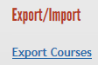

Using the Template
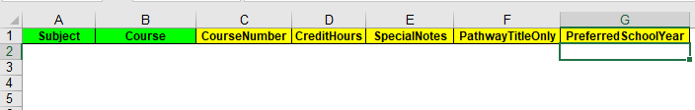
- Subject (required) is a drop down menu of subject titles. Select the subject title for each row. The subject titles are defined by the Minnesota Department of Education Graduation Standards and cannot be changed. Entering a subject that is not a state-defined subject will cause an import error.
- Course (required) is a text box. You can enter or cut and paste the titles of your courses (up to 150 characters). A maximum of 50 characters will display in the students Personal Learning Plan.
- CourseNumber (optional) is a text box. Enter the course numbers for your courses (e.g., Math 101), up to 20 characters.
- CreditHours (optional) is a text box. Enter credit hours for your courses (e.g., 4, audit), up to 10 characters.
- SpecialNotes (optional) is a text box. Enter any special notes for your courses, up to 100 characters. A maximum of 50 characters will display in the students Personal Education Plan.
- PathwayTitleOnly (optional) is a text box.
- PreferredSchoolYear (optional) is a text box. Enter a comma-separated list of school year numbers that a course will generally be taken (e.g., “9,10” means the course is generally taken in Freshman or Sophomore years).
Note: do not delete or rearrange the columns. Use plain text (no bold, italics, etc) with no line breaks for your entries. Don’t forget to save your spreadsheet.

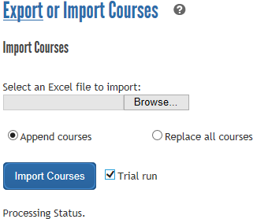

Import Courses
- Select the “Import Courses” link on the left sidebar menu.
- Attach the course file spreadsheet you created from the template provided.
- Select either “Append Courses” (the default) to add courses for the first time or to add additional courses to your site OR “Replace all courses” which will delete and replace all courses for your site with the ones you upload. If you choose to “Replace all courses” it is a best practice to export the courses that are currently in your site to have as a backup.
- Check the “Trial Run” box, then click “Import Courses” to make sure you do not have any mistakes. The trial run will list any errors, give you a preview of the order in which each course will display and allow you to make changes to the spreadsheet before importing. If you have errors, reference the status codes sheet and correct them.
- When all errors have been corrected, uncheck the “Trial run” box and click on “Import Courses” to upload the courses to the site. Uploading courses this way will publish overnight.

Note: if one or more records fail validation (error in the “Status” column), no courses will be imported. If validation passes, but duplicate course records are found, the course data is imported up to the first duplicate course or other data error (the remaining records are not imported).

Career Pathways
In order to create Pathways, you must first have courses loaded in your site. Once you have all the courses loaded in to you site, you can go about creating pathways.
- From the left side menu, find the “Export/Import” header click on “Export Pathways.” Start by exporting the Pathways template or exporting existing Pathways.
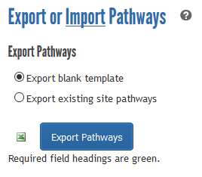
- If using the blank template, fill in the green required fields in the spreadsheet (SchoolYear, PathwayName and Requirements). If using existing data, make any necessary additions or changes. Save the file.
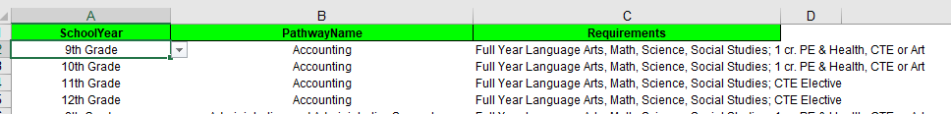
- Once your file is saved, you are ready to import the file to your site.
- From the left menu, find the “Export/Import” header and click on “Import Pathways.”
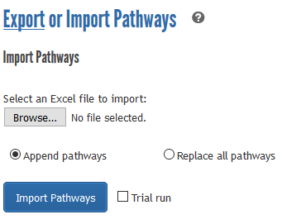
- Click on “Browse” to add the file you saved in step two. Then select “Append pathways” to add new or changed pathways OR select “Replace all pathways” to delete any pathways currently in your site and replace them with the pathways in your spreadsheet. Check the box for “Trial run” to make sure the information in the file is formatted correctly and will upload successfully. If there are any import errors, it will show a summary of those errors along with an error code sheet so you know what to correct. Continue with trial runs until all errors are corrected, then uncheck the “Trial run” box and import your pathways.
- Once your pathways have been imported, you need to connect the courses to the pathways.
- From the left menu, find the “Export/Import” header and click on “Export Courses in Pathways.”
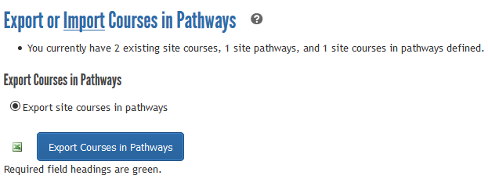
- Once the file has been exported, complete all pathways by selecting from the drop down menus and follow the same format as the example below. Complete the green required fields in the spreadsheet (columns A, B, and C) and save.
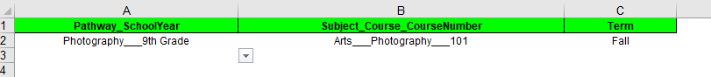
- From the left menu, find the “Export/Import” header and click on “Import Courses in Pathways.”
- Click the “Browse” button to add the file you saved. Then select “Append” to add new or changed pathways OR select “Replace all pathways” to delete any pathways currently in your site and replace them with the pathways in your spreadsheet. Check the box for “Trial run” to make sure the information in the file is formatted correctly and will upload successfully. If there are any import errors, it will show a summary of those errors along with an error code sheet so you know what to correct. Continue with trial runs until all errors are corrected, then uncheck the “Trial run” box and import your pathways.

For more information, please contact MCIS at mcis.team@state.mn.us – 651-582-8321 or 800-599-6247.

