# Navigating Curriculum Tools

Begin by logging in to MCIS with your site administration or staff username and password. Click the “Go to CIS” button at the top of the page to view the student side of MCIS. Scroll to the very bottom of the page to the footer and click on “Curriculum” under the “MCIS Resources” heading.

You can look for curriculum using the curriculum sort feature. The main sorting categories are:

* CIS Component (such as an assessment, resume creator, course planner or financial aid sort)
* Curriculum Objective (which includes subject areas, common course standards, American School Counselor Association (ASCA) domains and ASCA mindset and behaviors)

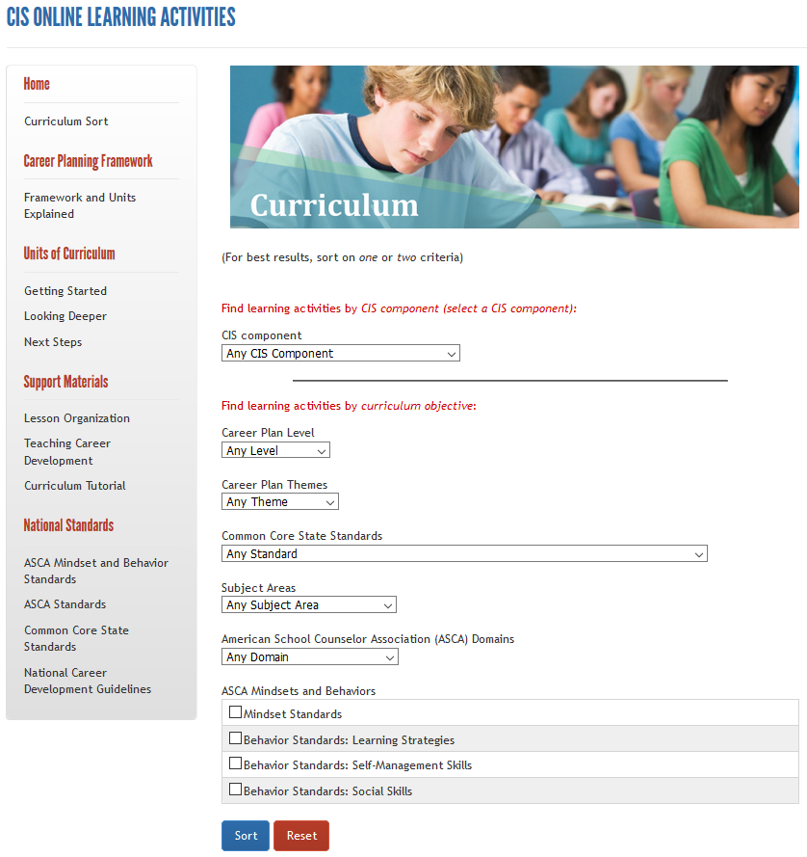

Once you have selected your category and created your sort specifications, click on “Sort” and you will be brought to a results page displaying the different options available based on your search criteria.

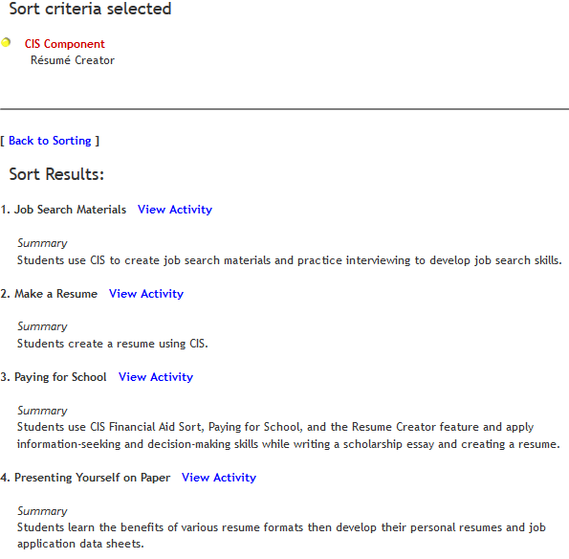

Click on “View Activity.” You will be shown a complete lesson plan with instructions, a power point presentation, time required and goals and standards for the lesson.

## Example

This is an example of what is provided for each of the different curriculum units.

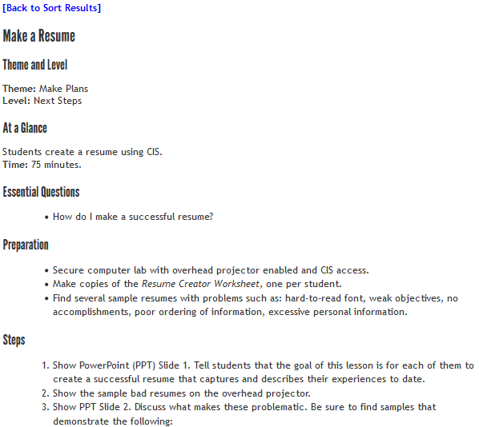

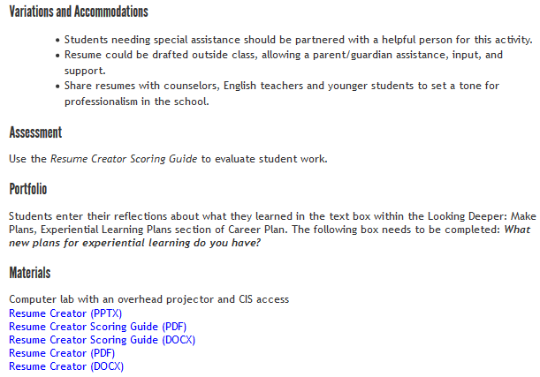

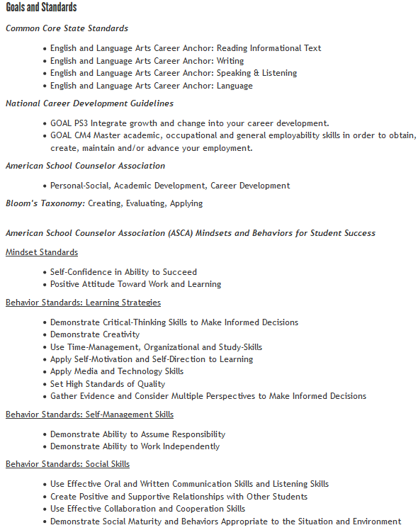

For more information, please contact MCIS at [mcis.team@state.mn.us](mailto:mcis.team@state.mn.us) – 651-582-8321 or 800-599-6247.