DISABILITY EMPLOYMENT INITIATIVE (DEI)

Quarterly Narrative Report

Grantee Name: Minnesota Round 7 youth DEI Partners for Youth
Address: 332 Minnesota St. Ste. E200
City/State/Zip: St. Paul, MN 55101
Grant Number : MI29688
Date Report Submitted: 2/13/2018
Report Period: 1/1/2018-3/31/2018

Summary of Grant Progress: Describe the status of your state’s implementation of the grant against the DEI workplan. Include major activities that address grant requirements (e.g., Integrated Resource Teams, Asset Development, Customized Employment, Self-Employment, Blending and Braiding Resources, or Guideposts to Success, as applicable). If grantees have nothing to report, that should be specified.

Integrated Resource Teams (IRTs) are an integral part of service delivery for all three implementation sites. Rural MN Concentrated Employment Program (RMCEP) has completed IRTs with 88% of their DEI enrollees. Integrated Resource Team members have included: work training supervisor, School IEP or 504 team members, Youthbuild counselors, parents or extended families, foster parents, Probation Officers, PCAs, county case managers, VRS, multiple Mental Health agencies (therapist), local ABE, Ticket to Work practitioner, coach, kinship partner (from church), among others. Staff in all three implementation sites have become more accustomed to working with the youth to schedule IRT meetings rather than solely relying on IEP meetings to serve as IRTs. This shift has allowed all parties involved to better address the needs of youth and ensure that the IRTs are solutions driven. Central Minnesota Jobs and Training Services (CMJTS) will be working with employment counselors to implement IRTs with participants in all of their core programs as the IRTs have been identified as a best practice and model for quality service delivery.
All three implementation sites continue to embed the Guideposts for Success Framework into service delivery. For example, The youth manager and DRC at Southwest Minnesota Private Industry Council (SWPIC took the time to understand how the WIOA elements, Pre-ETS Activities and the Guideposts For Success all go together and used this to create a plan that can be used for any participant regardless of what program or funding stream they are enrolled in. The DRC shared this document with the other DRCs in Minnesota so that they could help their teams understand how they all work together to ensure the success of our participants. The State Lead also shared this document with Kirk Lew at the U.S. DOL who noted that the document was unique among DEI projects around the country and stated that it was a great example of the practical implementation of the Guideposts for Success and the 14 WIOA elements.
The Pacer Center, Minnesota’s State-level technical Assistance provider for the Round 7 Youth DEI is drafting an Individual Learning Plan (ILP) Guide that is Guidepost-informed. The guide also focuses on applying the Guideposts for Success to the development of a youth’s Person Learning Plan (Minnesota’s version of an Individual Learning Plan). The second draft of the PACER’s publication, Guide on Incorporating the Guideposts for Success into MN’s Personal Leaning Plan Process, will include additional examples of how expanding Integrated Resource Team (IRT) membership to include outside agency representatives with expertise in a range of Guideposts areas can contribute to successful IRT employment outcomes. This quarter PACER staff met with the DRCs of all three MN DEI regions to gather information to be incorporated into specific scenarios that provide concrete examples of crossover activities that relate to the Guideposts for Success, key elements of Personal Learning Plans, and WIOA program components. This change is being made to be responsive to the feedback from WIOA youth counselors that they are looking for concrete examples rather than theoretical background and historical context. In addition, PACER staff reviewed the updated NCWD publication, Promoting Quality Individualized Learning Plans throughout the Lifespan: A Revised and Updated ‘ILP HOW TO GUIDE 2.0’ to ensure that the MN DEI guide being developed reflects the most current thinking on the subject. Appropriate changes are being incorporated. A final version of the guide is expected to be published this summer.
Guideposts. The data shows that:
82% - Participated in activities related to Guidepost 1 (School-Based Preparatory Experiences);
95% - Participated in activities related to Guidepost 2 (Career Preparation and Work-Based Learning Experiences);
70% - Participated in activities related to Guidepost 3 (Youth Development and Leadership);
80% - Participated in activities related to Guidepost 4 (Connecting Activities);
69% - Participated in activities related to Guidepost 5 (Family Involvement and Supports).

All three sites have actively blended and braided funds to support the outcomes of youth with disabilities in the DEI project. Today date, 39% of youth are co-enrolled in either WIOA Youth or Adult. Similarly, 51% of youth are co-enrolled in the Minnesota Youth Program (MYP). The MYP is Minnesota’s state funded workforce development program for youth which mirrors many aspects of the WIOA program. The PACER is leveraging other funding opportunities to deliver an additional parent/family workshop in RMCEP area this year. SWPIC has utilized their Pre-ETS Career Advisor that they hired as part of the Pre-ETS grant they received to reach and assist even more youth with disabilities. The Pre-ETS Career Advisor and DRC have coordinated efforts to provide comprehensive services to many youth with disabilities.
Year 2 PACER parent trainings on career pathway options for MN students with disabilities and employment–focused transition planning have been scheduled in the SWPIC workforce development area on June 6th and in the RMCEP area on May 10th. (Note: PACER is leveraging funding from another project in order to deliver a second training within the RMCEP area this year.) The date for a third parent training in the CMJTS area is still being finalized.
PACER staff have drafted a new handout for parents on “What is a Workforce Center?” It has been reviewed by both DEED staff and DEI DRCs. Currently in the publications process, the new PACER publication will be utilized as a handout at all future DEI parent trainings and also be available on PACER’s website to interested parties. It will also be made available to DEED and implementation sites for broader dissemination. A generic version of this document, “What is an American Job Center?” Will be posted on PACER’s National Parent Center on Transition and Employment website and will also be shared with NDI.

Development and Implementation of Effective Practices and Program Model Strategies: Identify any innovative strategies the state has undertaken or implemented to achieve DEI objectives. If grantees have nothing to report, that should be specified.

The DRC at SWPIC attended a PACER sponsored event for parents that was unrelated to our partnership through DEI. The event was regarding IEPs for transition age youth. The DRC attended because understanding the IEP is important to their work. The DRC had the opportunity to share what they do through DEI and PACER and had several special education teachers and parents interested in the services that SW MN PIC provides to youth with disabilities.

Four Career Pathway trainings were sponsored in the SWPIC area. Those trainings included: Basic and Advanced Welding (5 youth participated in Basic Welding and 5 youth participated in Advanced Welding); A CNA cohort (5 youth participants); as well as SWPIC’s newest Career Pathway - Electrical Controls (5 youth participants). This is an excellent example of how SWPIC blends and Braids resources as this class was funded by DEED Youth At Work, Pathways to Prosperity and Disability Employment Initiative. Youth at Work and Pathways to Prosperity are both state-funded competitive grant opportunities.

CMJTS provided DRC Level I Training to their internal staff and the Round V grant recipients, Anoka and Southwest PIC. Their agency will be providing DRC Level II training to our Ticket to Work team in June. The DRC Level I and Level II trainings were originally developed by the Alaska DEI project and enhanced with a focus on Minnesota Specific resources.
Key Issues and Technical Assistance Needs: Identify any specific barriers, lessons learned, or opportunities during implementation of DEI strategies in your state. If grantees have nothing to report, that should be specified.

No technical assistance needs have been identified at this time. Now that RMCEP and SWPIC are established ENs as part of the ADEN, technical assistance regarding Ticket to Work has shifted to the experts at ADEN.

Significant Activities, Accomplishments, and Success Stories: Describe significant activities, accomplishments, and/ or success stories on the implementation of the Career Pathway elements or how different systems are working together to benefit the customer. If grantees have nothing to report, that should be specified.

Highlights from the most recent data (1/1/-2017 - 3/31/201):

168 total participants served. This is higher than expected after the first year and Minnesota is still on track to achieve its goal of serving at least 300 youth over the course of the grant.

37% - Female Participants
30% - Youth of Color (3% Increase from previous reporting period)
51% - Basic Skills Deficient
21% - Youth from Families Receiving Public Assistance (This is bolstered by Minnesota’s TANF Youth Innovation Project. This is an interagency project between Minnesota’s Departments of Employment and Economic Development and Human Services.)
13% - Dropouts
9% - Youth receiving SSI or SSDI
8% - Youth Offenders
6% - Foster Youth
2% - Homeless/Runaway Youth

51% co-enrolled in the Minnesota Youth Program
39% co-enrolled in WIOA Youth/Adult

RMCEP met the American Dream Employment Network’s first year goal of 10 Active Tickets by the end of the first quarter. There are several people who are potential Ticket clients. In January, the DRC provided a presentation on Ticket to Work to RMCEP’s Youth Council members. RMCEP is now listed on the SSA national website as an Employment Network which has generated at several new inquiries. The MN Disability Linkage Line is also referring people to RMCEP based on this listing. See the accompanying attachment for a success story from RMCEP. The participant is also participating in the Ticket to Work program.

To date CMJTS has a Ticket revenue of $97,000. CMJTS currently has 25 ticket holders and they have a plan in place to increase the number of tickets assigned to their Employment Network. The Ticket to Work team will be meeting in June to discuss best practices and implement the DRC Level II training.

SWPIC signed its contract with American Dream Employment Network in January of 2018. The DRC has completed all required ADEN training and officially received certification as a Work Incentives Practitioner. SWPIC can now officially begin assigning tickets. Three additional staff members have also gone through ADEN training and suitability clearance so that they can also assist individuals receiving SSI and SSDI in returning to work.

RMCEP is invested in programs and partnerships serving diverse populations, especially New to America projects reaching and responding to the needs of refugees and immigrants. Funds were recently carved out of a Minnesota Family Investment Program (public assistance) grant to focus on New Americans and New to America residents of the Fargo Moorhead area.

The State Lead organized a quarterly meeting with the three implementation sites. That meeting was held on March 6th at Blind Inc. Blind Inc. is a service provider for Minnesota’s State Services for the Blind. Blind Inc. provided a tour of their facility and provided information to the DRCs and PACER staff on how the services provided at Blind Inc. could be utilized to support youth in the workforce centers. In addition, to learning about how the DEI project could better support youth with visual impairments, the DRCs were able to work through challenges they were facing as well as share the best practices that have come out of the DEI projects.

Southwest Minnesota Private Industry Council visited the Minnesota State Capitol on April 24, 2018 to participate in the Youth Intervention Programs (YIP) Rally Day. The SWPIC Rural Career Counselor, Disability Resource Coordinator, Youth Employment Specialist, and one youth DEI participant spent the day interacting with lawmakers talking to them about the importance of Youth Intervention programs in the community. The photo below from Left to Right shwos: Holden (youth participant), David (Rural Career Counselor), Hannah (Youth Employment Specialist), Leah Hastad (DRC) and Representative Chris Swedzinski.
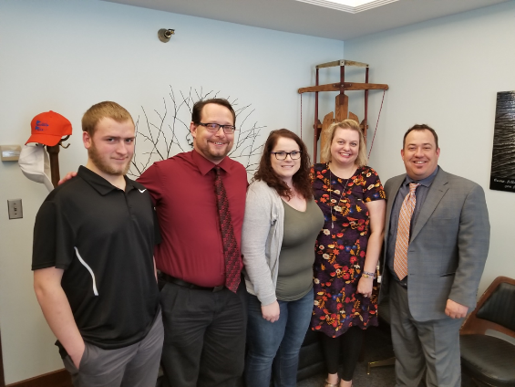

SUCCESS STORY:
Abigail Whiting, who enrolled into my program last fall and had trouble holding a job due to her autism and unable to communicate appropriately. We got her enrolled, did some career assessments and placed her at a couple of different worksites that didn’t quite work out for her. We finally found a worksite, Fun and Friends, that is an after school care program for elementary kids. It was uncomfortable for her at first, but the staff were wonderful with coaching her and after a while she got into the routine and would show up and just do her job without being told.

She even trudged through the snow a mile from her house to work EVERYDAY in the winter just to make it to work as she started to enjoy it so much. We assisted with behind the wheel training and she was finally able to obtain her license. When she found a car she could buy with her money saved up, we also assisted with some tires and repairs so she now has a reliable car to get to work.

She was hired on officially at Fun and Friends as of March 19th and they are very excited to be able to keep her. She does very well with the kids and her interpersonal and communication skills with other staff, kids, and her supervisors have improved a lot.

SUCCESS STORY:
Isabelle (Belle) Nielsen is a senior at Marshall Area Technical Education Center (MATEC). Belle has several health disabilities. When the DRC met Belle, she had done volunteer work with Special Olympics and at the MATEC Daycare. She was also creator and editor of the MATEC newsletter. She had not been employed, but had applied and interviewed at businesses around Marshall. She was interested in gaining part time employment but had been unsuccessful in her attempts so far.

Belle began a work experience at Avera Morningside Heights, I long term care facility in Marshall, MN as a dietary aid in January of 2018. “Belle took a lot of pride in her work and made lasting connections with many of the residence at Avera Morningside Heights” said Leah Hastad. Hastad has been working with Belle as a resource coordinator and career counselor since Belle began working with Southwest Minnesota Private Industry Council in April of 2017.

Belle’s skills in sign language interpretation and lip reading helped her to connect with one resident in particular who could not talk due to trach tube. Belle was able to read her lips and have full conversations with this resident. She also encouraged them to eat their pureed food and would make a special coffee if they ate well, which encouraged them to eat more then they typically would. “It is obvious that Belle will be sincerely missed by many of the residents when she goes off to college this summer” added Hastad.

Belle will graduate in May 2018 and plans to attend Southeast community college in Lincoln, NE to study sign language interpretation and Special Education.
Short-term Grant Goals (three - six months): Describe plans and activities covering the next three to six months that address the workplan and objectives of the grant.
CMJTS will be enrolling 20 youth in to the DEI project in the next three to six months. Newly hired youth staff have recently completed training and will begin increasing their caseloads. In doing so, CMJTS will be on track to meet their goal of serving 100 youth by the end of the DEI grant. These enrollments will also increase the number of IRTs
The State Lead is coordinating an in-person quarterly meeting for June 6, 2018. This meeting will allow the three DEI sites to share best practices as well as to discuss any challenges that they may be facing. The meeting will also have Emily Saed, the Executive Director of the Minnesota Foundation for Student Organizations (MNFSO), deliver a Poverty Training. The topics covered in this training will include: Poverty Competencies for Leaders, Oral & Written Communication Skills, Educating Students in Poverty A-Z, Strategies to Break Poverty Barriers, The Meaning of Poverty in America, Types of Poverty, and Building Relationships & Navigating. Emily Saed will also be working with the DRCs to identify strategies to improve connections between employment counselors and advisors of Career and Technical Education Student Organizations such as: Future Farmers of America (FFA), Business Professionals of America (BPA), and SkillsUSA.
A Livestream in-service training for workforce development professionals is scheduled for May 7, 2018. Presenters Renelle Nelson and Jennifer Thomas, from PACER’s Inspiring Opportunities, Children’s Mental Health and Emotional and Behavioral Disorders Project will highlight strategies that can be used to work effectively with transition-age youth (age 14-24) with mental health challenges. Promotional information was sent to the State Lead, DRCs as well as NDI to share with colleagues who are workforce development youth professionals. It is also being promoted on PACER’s website and workshop e-blasts. See flyer below: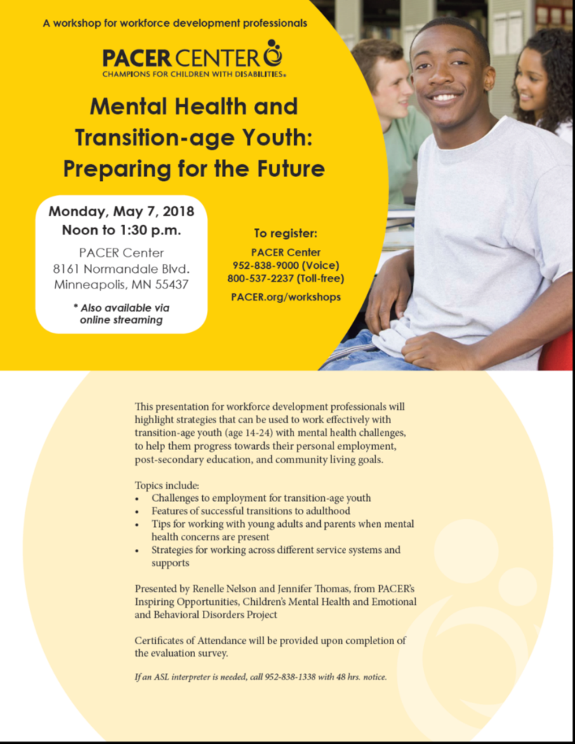
PACER staff have scheduled a Livestream parent training workshop focusing on “Career Path Options for MN Youth with Disabilities” on June 21, 2018. The training will be broadcast live as well as archived so that families around the state who cannot attend the DEI Project’s local parent training will be able to access similar information on career pathways. Local experts who usually speak at local parent trainings are being replaced by statewide experts. Representatives from the Minnesota Department of Education (Special Education as well as Career Technical Education), Vocational Rehabilitation Services, and MN WorkForce Center Youth programs will be presenting. Cory Schmid, the DEI State Lead will be presenting on the Youth programs. In addition to the Livestream audience, the event will be open to parents who wish to attend the training at PACER Center in person.

