SFY 2021 SciTech Internship Program at the Minnesota Technology Association
Progress Report
11/1/2021

Minnesota Department of Employment and Economic Development
Employment and Training Programs Division
332 Minnesota Street, Suite E200
St. Paul, MN 55101
Nancy Waisanen/Larry Eisenstadt
Nancy.Waisanen@state.mn.us
Larry.Eisenstadt@state.mn.us
mn.gov/deed
As requested by Minnesota Statute 3.197: This report cost approximately $492 to prepare, including staff time, printing and mailing expenses.
Upon request, this material will be made available in an alternative format such as large print, Braille or audio recording. Printed on recycled paper.

Contents
Contents 3
Background 4
Program Overview 4
Recruitment Strategies 5
Placements 7
Participant Data 7
Expenditure Data 10
SciTech Success Stories 11
Interns Gain DevNet Certification with Procellis Technology 11
Working on the Wheel of Progress: a Berd Spokes Internship 13

Background
The 2019 Minnesota Legislature (Laws of Minnesota, 2019, Chapter 7, Section 1, Subdivision 3(v)) appropriated $875,000 annually for State Fiscal Years (SFYs) 2020 and 2021 to the Minnesota Technology Association (MnTech) to connect college students in STEM majors (science, technology, engineering, and mathematics) with paid internships in small to mid-sized Minnesota based companies (250 or fewer employees worldwide). The legislation directed the Department of Employment and Economic Development (DEED) to grant funds to MnTech to support SciTech, a program of internships in Science, Technology, Engineering, and Math (STEM). In receiving these funds, the program had to work towards increasing the participation of women and other underserved populations in STEM occupations.
The SFY 2021 allocation available to MnTech was $831,250 after DEED retained five percent of the appropriation for administrative purposes.
To be eligible for the internship program, participants must be Minnesota residents or physically attending college in Minnesota, at least 18 years of age, in good academic standing (2.5 or greater GPA), and currently enrolled in a STEM degree program at a two or four-year college. SciTech works with technical and community college students with at least 24 credits completed at the time of application, and college juniors and seniors with at least 60 credits completed at time of application. Up to 15 percent of participants may be graduate students engaged in STEM studies.
Participating companies receive from MnTech a 50 percent reimbursement of the intern’s wages, capped at $2,500 per intern.

Program Overview
To serve the student participant, MnTech uses its allocation to offer:
- An online application form;
- An online searchable job board that is updated daily;
- Personal support for any questions;
- Resources for interviewing tips, resume help, and job search tips;
- Recruitment of companies that offer hands-on internships in STEM fields;
- Screening of business applications to ensure positions meet program criteria;
- Notification of new job postings; and

To serve the business participants, MnTech offers:
- An online application;
- Recruitment and prescreening of student applicants to make sure they meet program criteria;
- An online search of intern candidates;
- Personal support for any questions;
- Resources for how to host a quality internship;
- Targeted recruiting of candidates as needed;
- Highlighting new job postings to students each week.
MnTech leverages established relationships with its STEM partners in higher education and student organizations to reach underrepresented student populations. An example of this kind of partnership is MnTech’s involvement with the North Star STEM Alliance (NSSA), which seeks to double the number of minority students attaining STEM degrees in the next 5 years. SciTech conducted four workshops with NSSA to recruit NSSA members and help students prepare for their internship search. MnTech staff have also participated in job fairs and other events with more than twenty student groups including the Society of Women Engineers, National Society of Black Engineers, MSTEM (Minorities in STEM), and AISES (American Indian Scientist and Engineers Society) and has expanded its visibility on social media sites.

Recruitment Strategies
In detailing its recruitment efforts, MnTech uses the following strategies to diversity its intern population. It uses these efforts to increase the involvement of women and members of the BIPOC community:
- Posting information about the program on college job boards statewide.
- Meeting one on one with students at multiple virtual career fairs at colleges around the state, including diversity career fairs.
- Communicating with campus career centers to make sure they know SciTech (the intern program of MnTech) is a resource to students at their respective colleges. We target our outreach here also, reaching out to colleges with greater diversity in their student population such as the Minneapolis Community and Technical College, St. Paul College, Metro State University, and Augsburg University.
- Attending career fairs at Augsburg University, St. Catherine University, Macalester College, University of St. Thomas, St. Olaf, Carleton, Concordia College – Moorhead, St. Mary's University, Dunwoody, Minneapolis Community & Technical College, St. Paul College, Normandale Community College, Inver Hills CC, Anoka Ramsey CC, Central Lakes College, Metro State University, Mankato State University, St. Cloud State University, Winona State, Moorhead State, University of North Dakota (large population of Minnesota residents), University of Minnesota – Crookston, Duluth, Rochester and Twin Cities.

- Targeted outreach to STEM student groups, with particular emphasis on students underrepresented in STEM. This includes groups such as the Society of Women Engineers, Society of Hispanic Professional Engineers, National Society of Black Engineers, the Society of Asian Scientists and Engineers, and many others.
- Outreach to these student groups includes both financial sponsorship as well as presentations to group members about SciTech.
- We partner every year with the Louis Stokes North Star STEM Alliance (LSNSSA) to promote SciTech to students of color who attend 15 different alliance colleges including the University of Minnesota, private colleges, two-year schools and tribal colleges. LSNSSA is working to double the number of students of color graduating with a STEM degree every five years. We attend LSNSSA events several times a year to promote SciTech.
- In fall 2020 and winter 2021, SciTech conducted four job search workshops to recruit LSNSSA member students and provide job search training. Topics included how to create an elevator pitch, how to answer interview questions using the STAR method, how to research companies before applying to a job and before an interview, and tips on creating resumes and using LinkedIn. These workshops were recorded and shared with SciTech students via links in our weekly New Jobs emails.
- SciTech recruits’ employers to post internship opportunities on the SciTechMN.org job board. Each week, emails are sent out to all students in the program listing the new jobs posted that week. The email also includes links to job search articles and blog posts on what other students have done to find an internship. We also provided links to workshop recordings and short videos that walk students through different aspects of the job search process. We respond to students’ questions one on one through phone calls and emails. We also offered virtual office hours but students.
- SciTech also held two employer webinars focused on diversity, equity and inclusion. The events featured DEI professionals who provided information and resources on how to create get beyond barriers and move forward with DEI and how to create a culture of belonging at their companies. Recordings were shared with all SciTech employers.
While SciTech recruiting is dependent on the STEM pipeline of women and students of color entering the college systems in Minnesota, our recruiting of BIPOC students outperforms the current pipeline. (See attached graphic and page 8 of our 2020PY report. This is the most recent information we have for the STEM pipeline).

Placements
During the SFY2021, 248 interns were placed throughout the state, with 36 percent of companies located in the suburbs, 37 percent located in the cities of Minneapolis and St. Paul, and 27 percent in Greater Minnesota.
The median size of a company hiring a SciTech intern in SFY2021 was 24 employees.
To date, the industry breakdown of the hiring companies for SFY2021 was:
Industry | Number of Hiring Companies
IT/Computer Technology | 63
Biotechnology and Life Sciences | 59
Engineering Services | 55
Mining, Materials, Manufacturing and Processing | 47
Aerospace/Defense | 14
Fuels, Energy, and Energy Management | 7
Agriculture, Food and Forestry | 3

Participant Data
SciTech recruited 1,585 applicants, which was up slightly from SFY2020. The placement goal for SFY2021 was 200 internships, but through careful budget management SciTech was able to place 248 interns. The gender breakdown of interns placed is as follows:

Gender | Number of Interns | Percentage of Interns
Female | 75 | 30%
Male | 173 | 70%
Total | 248 | 100%

The following data describes the race/ethnicity of the hires:
Ethnicity | Number of Interns | Percentage of Interns
White | 180 | 72%
Racial/Ethnic Minority | 68 | 28%
Total | 248 | 100%
SciTech seeks to increase the number of women and students of color participating in the program. Sixty-one percent of applicants (on par with SFY2020) and 47 percent of hires were women and students of color. The percentage of hires in these underrepresented groups went up 5 percent over the 2020SFY.
Based on the permanent addresses of the interns, 37 percent came from the suburbs, 31 percent came from Greater Minnesota, 16 percent came from Minneapolis/St. Paul, and 16 percent came from out of state.

Interns came from the following colleges or universities during this period:
College/University | Number of Interns | Percentage of Interns
University of Minnesota | 111 | 45%
MN State Colleges/Universities | 65 | 26%
MN Private Colleges | 35 | 14%
MN For Profit Colleges | 2 | 1%
Out of State Colleges* | 35 | 14%
Total | 248 | 100%
*SciTech will serve Minnesota residents who attend out of state colleges to keep these students within the State.

Expenditure Data
Expenditures from January 1, 2021 through September 30, 2021:
Budget Category | Budget | Expenditures
Administration | $24,519 | $18,640
Internship Work Experience | $554,493 | $552,122
Direct Services Project Staff | $232,034 | $169,712
Transportation/Travel | $750 | $21
Contract/Consulting | $19,454 | $13,627
Other Activities | $0 | $0
Total | $831,250 | $754,122

SciTech Success Stories
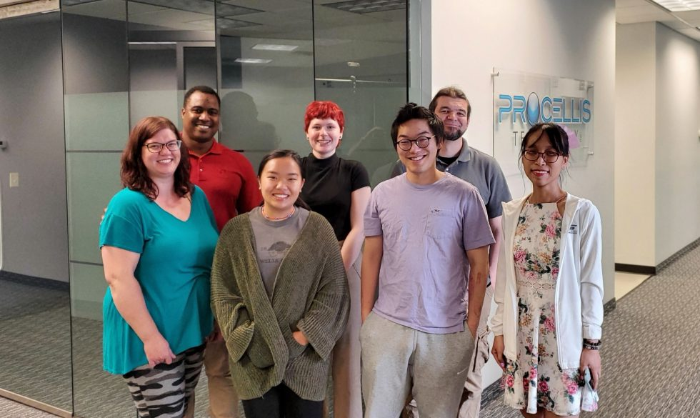

Interns Gain DevNet Certification with Procellis Technology

As an information solutions company, Procellis Technology provides IT and IoT support for small businesses and the public sector. They’re dedicated to two things: improving their customer’s outcomes and strengthening their team with professional development.

“We believe in continual improvement, so we’re constantly investing in everyone, every staff member, to make sure they’re on top of their game with technology, which in turn gives better results to the client,” explained Procellis’ CEO Damian Young.

This is the company’s first year hosting an internship program of this scale, having hired six STEM students through the SciTech Internship Program. So, when Young considered how to manage so many interns, he decided to set a goal for them: to become a full software automation team. To do this, Procellis invested in their students and with courses and teamwork, helped get everyone DevNet certified.

“I think that’s probably the best thing we’re able to offer our interns,” Young said. “They’re getting to take with them a certification that has significant value and shows that they are capable.”

Rockstar collaboration
Procellis’ newly certified DevNet team consisted of Julia Ha, a computer science major at Normandale Community College, Nate Haleen, an information technology major at Inver Hills Community College, David Kong, a computer science major at the University of Minnesota, Halley Paulson, a computer and data science major at the University of Minnesota-Morris and Shouayee Vue, a computer science major at Macalester.

Though their internships relied heavily on collaboration, each student gained unique experiences as well. Ha learned about API and automation. Haleen spent most of his time working within IT, strengthening his programming abilities. Paulson worked IoT development. And Vue, after recently completing a course specializing in IoT is now in talks with some of Procellis’s partners about automating their workflow.

“There was so much collaboration. And collaboration on that level is absolutely amazing!” Young said proudly. “I’m impressed that they accomplished something so advanced. They’re all rockstars.”

Building confidence on the job
Looking back on this experience, each student had their own takeaway.

“The teamwork has been awesome,” said Ha. “My background isn’t in networking, so at first it felt a little overwhelming. But as I went along, I realized that each person has different strengths to contribute to the team.”

“My greatest achievement is whenever I’m in a lab environment and something’s not working but then I finally get it to work,” Haleen said. “There’s this adrenaline rush and I’m like, ‘I do know how to do this.’”

“I didn’t feel knowledgeable enough before this,” Paulson admitted. “I was surprised about how well I understand certain things and I can actually explain things properly to people to help them understand it.”

“This is nothing like what I imagined; this opportunity has been much better!” Vue said enthusiastically. “I’ve been so lost in trying to find my place in this career. I’m super grateful to be able to have guidance, support from the whole company, and given the chance to grow.”

More information and success stories can be found at the SciTech website at: https://scitechmn.org/

Working on the Wheel of Progress: a Berd Spokes Internship

Whether you’re an avid cyclist or not, most of us have significant memories around riding a bike. Wayde Charging Hawk, a mechanical engineering major at the University of St. Thomas, fondly remembers the times he spent biking with his grandfather. And Allison Horner, the CTO of Berd Spokes, is currently teaching her five-year-old how ride and is looking forward to putting their product on her son’s wheels.

For many, bicycles play a part in the happy and even cherished moments of our lives, and the team at Berd want to ensure that your bike is the best it can be for those important times.

Fundamentally, Berd Spokes is an advanced technology and materials company. Based in Hopkins, Minnesota, their premier product is a hybrid polymer bicycle spoke that’s stronger and less than half the weight of your typical metal spoke. Previously, each unit was hand made one at a time, but Berd recently transitioned to an automated manufacturing process as part of their goal to minimize the time of overall production.

Improving together
Charging Hawk secured a spring internship with Berd Spokes through the SciTech Program and has been fully immersed in the company for the last several weeks. Since he began, he’s already updated a few of their previous mechanism designs in SolidWorks and created new ones of his own. Charging Hawk got the chance to work with Berd’s manufacturing process on day one and he’s currently helping Horner improve their cutting technique to make it easier and more efficient.

“At a small company like this, I can sit him down with the machines so he can experience the process and look for ways to improve it,” Horner said.

In this fast-paced, hands-on environment, Charging Hawk is always learning. One of his favorite takeaways so far was learning how to use a 3D printer for rapid prototyping.

“We moved over from the old rapid prototyping material onto a straight, aluminum block and screwed into that using sliders with less friction that allow for faster movement,” he said. “Now you can visibly see the difference that it makes and how much faster it is. That’s the coolest thing I’ve been working on.”

The measure of success
Before Charging Hawk came to Berd Spokes, Horner and her team were working toward a goal set by a National Science Foundation project: to come up with a way to cut ten seconds off the manufacturing time of each spoke.

“Wayde is only a fraction of the way through his internship, and the work he’s done has already saved us over 20 seconds,” Horner said proudly. “Wayde is an excellent employee that has the type of curiosity that you need. He’s made significant contributions to the company.”

“It’s been a phenomenal experience and a lot of learning on the fly” said Charging Hawk. “It was exactly what I was looking for.”

UPDATE: Charging Hawk has accepted a fulltime position with Berd that will begin after he finishes his final semester at the University of St. Thomas in the fall of 2021.

