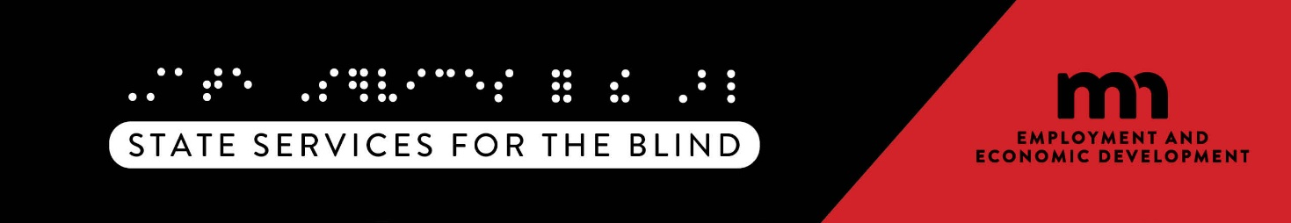

New P/T Contracts

Overview

The VR program provides Adjustment to Blindness (ATB) and employment related services for individuals with disabilities. While VR program state-staff provide some services directly, the VR program also partners with businesses and organizations in local communities throughout the state to provide services.

VR Program

What is SSB?

State Services for the Blind (SSB) is a division in Minnesota's Department of Employment and Economic Development (DEED). The agency's mission is to empower the growth of the Minnesota economy, for everyone. The DEED-SSB division administers several programs and projects, the largest of which is the Vocational Rehabilitation (VR) program. The mission of the programs and projects within the SSB division is to facilitate the achievement and personal independence by Minnesotans who are blind, low vision, or DeafBlind.

What is the Vocational Rehabilitation Program?

The Vocational Rehabilitation (VR) program provides specialized, one-on-one employment services for individuals with blindness, DeafBlindness, and low vision, including a variety of counseling, guidance, training, job skills, job placement and follow-up services. This includes pre-employment transition services for youth and a full range of employment services for adults. Additionally, the VR program can provide one-on-one or group training in the skills of blindness that may needed in order to participate in employment related services. This training is known as Adjustment to Blindness (ATB) training,

How Does the VR Program Work with Community Partners?

* + SSB partners with organizations and businesses located in communities across the state that provide employment services and refers to these providers as "Community Partners."
  + SSB collaborates with Community Partners to help Minnesotans with disabilities achieve their goals for competitive, integrated employment, and career development outcomes.
  + SSB staff may provide some of the ATB or employment related services an individual in the program needs, directly, and in many cases, a person in the VR program may also receive services through a VR program Community Partner.

How can my organization or business become a Community Partner and start to provide services?

* + A Community Partner must have a Professional/Technical Master Contract (P/T Contract) with the VR program to provide services as a Community Partner for an individual or groups in the VR program.
  + The P/T Contract is the mechanism that contains the ATB and employment related services structure, expectations, purchases, and pricing. The first step in becoming a Community Partner providing employment related services or adjustment to blindness training is to complete an application. Current Requests for Proposals and applications can be found on DEED’s [Competitive Grants and Contracts page](https://mn.gov/deed/about/contracts/open-rfp.jsp).
  + Some ATB and employment related services require Community Partners to meet certifications required by SSB. SSB’s [Required Certification](https://mn.gov/deed/ssb/vendors/guide/certifications/) webpage provides detailed information on fulfilling these requirements.

What does a business or organization need to become a VR Community Partner?

* + To be a Community Partner with the VR program, your organization must be committed to providing services and supports for individuals exploring, finding, and keeping competitive, integrated employment.
  + Review of potential providers includes an assessment of the VR program's service needs, an assessment of the provider's capacity to deliver the service(s), and an assessment of proposed rates for each service.
  + If the partner application is approved, the next step is a negotiation of services and rates. Upon approval of the partner application and successful negotiation of services and rates, DEED-SSB will work to execute a state P/T Master Contract with the Community Partner.

How does my business or organization receive business and bill for services provided?

* + When an individual needs services outside what VR program staff will provide, the VR program staff person will offer individuals a choice of Community Partners who can provide services to support their needs.
  + Once an individual in the program chooses a Community Partner, VR staff will provide individual referral information to the Community Partner.
  + Community Partner staff and SSB staff work closely together to coordinate services for the individual.
  + After a referral is made, SSB staff create an "Authorization" for purchase of the service. After the Community Partner receives the referral and authorization, the services can begin.
  + SSB offers templates for invoices and reports to assist with accurate and timely billing that complies with SSB policies for payment of these contracted services.

Together, we have an opportunity to empower Minnesotans with disabilities to achieve their goals for employment, independent living, and community integration.

**Minnesota Department of Employment and Economic Development**

**State Services for the Blind**

2200 University Avenue West Suite 240 St. Paul, MN 55114 Phone: 651-539-2300