Why State Service for the Blind
and Why Now?

“I thought about teaching music or teaching braille, or maybe I’ll be a scientist - or a writer.”
Blind Minnesota High School Student and SSB Customer
Reality | Myth
1. After high school, blind or visually impaired students can go to college, trade school or get a job. | 1. Blind or visually impaired people do not have career choices.
2. On or after a student’s 14th birthday students may apply to SSB. | 2. All persons who are blind are served automatically.
3. SSB’s Workforce Development Unit is an eligibility program. Not every applicant will meet federal guidelines for admission to the program. | 3. Everyone qualifies if they are termed blind, legally blind or low vision.
4. SSB is a resource until the student graduates from high school. The student’s school district is the primary sup- port until then. | 4. SSB pays for computers, other devices or classes at any time.
5. SSB wants to be at IEP meetings to get to know students and become familiar with their interests, talents, abilities, capabilities and priorities. | 5. SSB does not need to be at IEP meetings. Families can just “check-in” before graduation.
6. The application process is simple. One form, several easy questions. It is accessible and can be sent to families in various formats. | 6. It is hard to apply and there is a big packet to complete. It is all in print and is not accessible.
7. Teachers of students who are blind or low vision are experts in the classroom. Questions about careers and post-secondary school can be answered by calling 800-652-9000. | 7. Teachers will tell SSB what the students need and SSB will obtain it.
8. Students can choose their career, job or educational goals that will lead to a job. SSB will offer vocational assessments and other assessments to insure the student is making an informed choice the Federal Rehabilitation Act can support. From the assessments an individual employment plan is developed. | 8. Students do not need to decide on a job goal until later.
9. There are federal guidelines, policies and procedures that SSB counselors must follow. SSB services are tailored to meet the individual vocational needs/goals. Services must be in the plan. | 9. SSB can do whatever is asked by the student and a good counselor will just say, “yes”.
10. SSB administers a federal work program designed to help students find employment. | 10. SSB can provide housing, clothing, healthcare and other social work services.

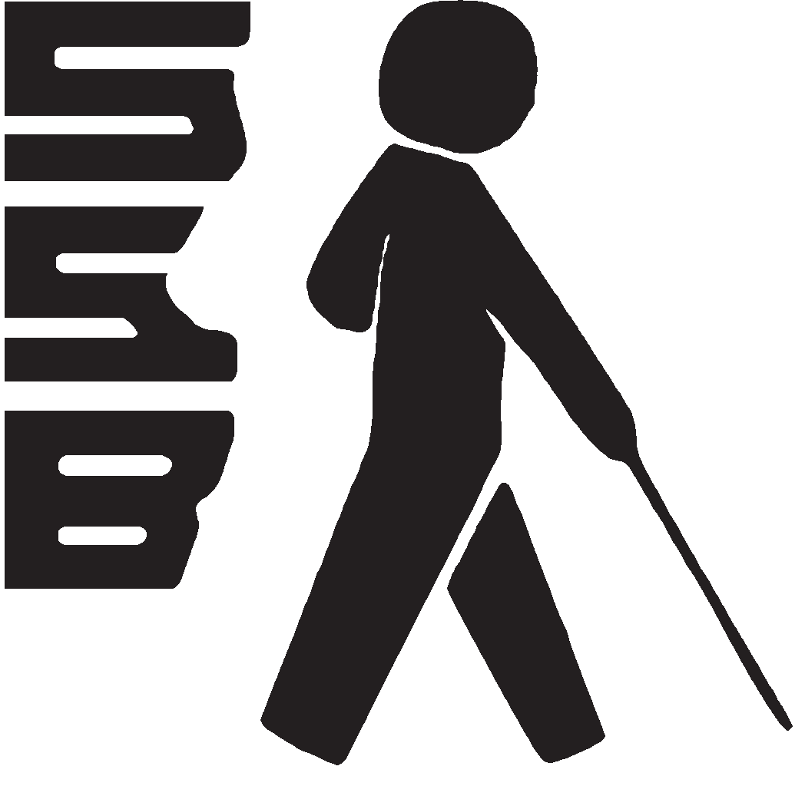
“What’s in it for me?” - If you are interested in working and gaining financial independence after high school, apply to SSB for services. The sooner the better! Whether you want a job or a career development, SSB is an important resource.

