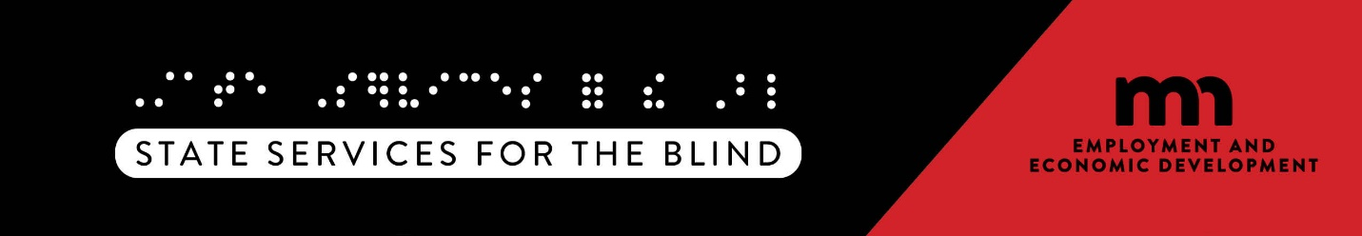

Scholarships

American Council for the Blind
Council of Citizens with Low Vision International
Learning Ally's National Achievement Awards
Lighthouse Guild
Melvin and Sally Mooty Scholarship - Courage Kenny
Microsoft Disability Scholarship
National Federation for the Blind - National
National Federation for the Blind - Minnesota
Team See Possibilities

Minnesota Department of Employment and Economic Development
State Services for the Blind
2200 University Avenue West Suite 240 St. Paul, MN 55114 Phone: 651-539-2300

