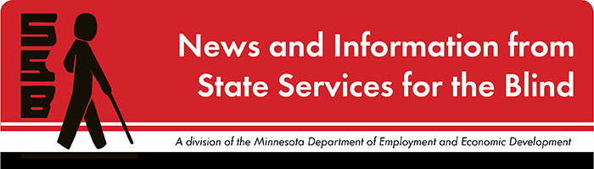

The Spectacle
-Dare to stand out
January 2022

Just for Fun
To kick-start your imagination for New Year’s resolutions, Realbuzz offers a list of unusual resolutions to welcome in the new year.
- Get Your Photo Taken In Five Interesting Places
- Learn A Decent Party Trick
- Break A Record
- Make A New Friend A Month
- Learn Something You Never Learned As A Child
- Develop a good relationship with your body
- Try a new food each week
- Do Something Nice For Others Every Day
- Make the unusual usual

Upcoming and Ongoing
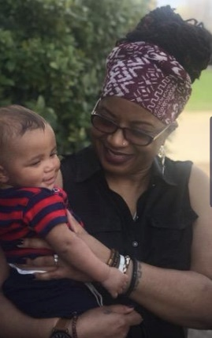
Meet Robin Padilla, new SSB Counselor
I am Robin Padilla, a new Pre-ETS counselor with SSB. I graduated from the University of Maryland obtaining my master’s degree in Rehabilitation Counseling. I completed my Rehabilitation Counseling internship experiences with state vocational rehabilitation agencies in Texas and Pennsylvania. I have provided services in the disability field for over 20 years. Thirteen of those years I worked as a Rehabilitation Counselor managing general population and Deaf/HOH/Deaf-blind caseloads of adults and transitioning youth. I have prior experience providing support services in non-profit, private industry, education, and I am a veteran of the U.S. Navy. I enjoy traveling, reading, writing poetry, and spending quality time with my family.

“Bring Your A Game”
We are excited to host a monthly series that connects Alexa games to job and work skills. On January 4, we’ll be starting the New Year off with healthy habits. And on February 1, we’ll use “Wayne’s Investigation” to work on problem-solving skills. To sign up for this free program, email Sheila.koenig@state.mn.us

College Success Program
SSB is partnering with the College Success Program to offer mentorship, meet ups, learning, and advocacy. Students finishing high school are paired with recent college graduates who are blind, low vision, or DeafBlind. Please email sheila.koenig@state.mn.us with questions or to register.

Year-Round Programs for Students
BLIND, Incorporated and Duluth Center for Vital Living offer opportunities for students to build skills and connect with peers throughout the school year. Check out these programs and let your student’s SSB counselor know if your student is interested in attending.

SSB Communication Center
The Communication Center is here to put your books into accessible formats that work for you. Custom audio, e-text, DAISY markup, and Braille - we can do it! The Communication Center is Minnesota’s Accessible Reading Source – we’re here for you. Email us at ssb.audioservices@state.mn.us

PACER
PACER Center “enhances the quality of life and expands opportunities for children, youth, and young adults with all disabilities and their families so each person can reach his or her highest potential. PACER operates on the principles of parents helping parents, supporting families, promoting a safe environment for all children, and working in collaboration with others.” For upcoming webinars and workshops, visit https://www.pacer.org/workshops/

Disability Hub MN
“Disability Hub MN is a free statewide resource network that helps you solve problems, navigate the system and plan for your future. We can help you create your best life, your way.” https://disabilityhubmn.org/

APH ConnectCenter
Empowers people toward greater independence and lifelong success by providing curated information and resources to assist children, parents, job seekers, adults, and older people who are blind or visually impaired. Check out the ConnectCalendar to see upcoming opportunities.

Blind Abilities Podcasts
Check out Blind Abilities on the web at http://www.BlindAbilities.com. You can also download the app or use the Blind Abilities Alexa skill on your Alexa device just by saying, “Alexa, enable Blind Abilities.”
Here are just some of the people and topics featured on Blind Abilities recently:
- Just Human: The Quest for Disability Wisdom, Respect and Inclusion is a new book by Dr. Arielle Silverman, Research Specialist at AFB. Her new book is a combination of a memoir divided into chronological segments with lessons learned for students, parents and teachers to take from and learn themselves.
- Be sure to check out the latest iPhone101/QuickBytes
- Blind Abilities Choice Awards 2021! Submit your choice for the top apps, top games, top productivity apps/software for 2021. Send us your choices on Twitter @BlindAbilities or email us at Info@BlindAbilities.com

If you know of a student that would be interested in sharing their achievements on their journey, Blind Abilities would like to include their perspectives on future shows. Send a note to mailto:info@blindabilities.com

Fast Forward: Potential and Possibilities
Rachel Hastings
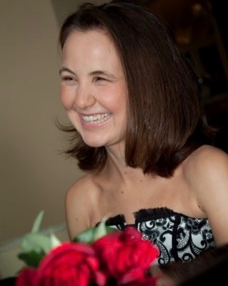
I have been working in senior living communities as a music therapist for five years and love it. I am currently working at Mount Olivet Care View Home as the director of music therapy. I have been helping to spearhead the development of a music therapy department at Mount Olivet. I’m working side-by-side with another board certified music therapist and facilitate both group and 1:1 music therapy sessions. Basically, we use musical interventions to help our residents meet nonmusical goals (i.e. socialization, cognition, relaxation). Our music therapy sessions include musical games such as music bingo, trivia, word games and name that tune. We also do a lot of reminiscing with our residents; we will play a list of a resident’s favorite songs and ask that resident to talk about why each song has meaning to them. We also do a lot of singing and instrument playing; we currently have a choir and a bell chimes group. It is a very rewarding job.
One of my favorite hobbies is long-distance running. I began running when I was fourteen just to get in shape and fell in love with it three months after I started. I ran on the track team my sophomore year of high school and ran my first road race, a half marathon, at the age of nineteen. Because my vision is too poor for me to run alone outside, I either run on my treadmill or with a sighted guide outdoors. I’ve made many friends through sighted running guides, and my mom was actually my first sighted running guide. I’ve now run four marathons and six half marathons and look forward to many more races to come.
The most important tool I use on the job is a desk top computer with a screen reader (my reader is called JAWS). Being able to use a computer with JAWS has been a major part of my success both in college and in the workplace. Depending on the severity of a person’s vision impairment (with mine being severe, unable to read print), I would say being able to use a computer with a screen reader is absolutely essential.
Another tool I use quite a bit is my Perkins brailler. Although seemingly out of date, the Brailler has allowed me to give presentations to residents and other staff members. We also have a resident who is blind and reads Braille. So being able to provide this resident with brailled resources has been a blessing.
Another mode of assistive technology I would recommend is a laptop with a Braille display. The Braille display is a device that hooks up to a laptop computer via a USB port. All text on the computer screen is converted into Braille.
First of all, be willing to learn technology. Start now! Don’t simply rely on large print and/or Braille books. It’s very important to know how to use a computer as there are low vision programs available for all levels of vision loss. I did not have a good attitude whatsoever about using a laptop; I love Braille so much and still do. but it’s possible to do both. And I wouldn’t have been able to be nearly as successful in college if I hadn’t learned to use my laptop. It was a beautiful thing to be able to carry around one laptop versus a stack of books.
Additionally, learn basic life skills (cleaning, cooking, grocery shopping, and mobility). The summer before my senior year of high school, I attended a summer transition program (STP). STP is a two-week camp held on a college campus for college bound high school students. During STP, we learned how to accomplish each skill listed above. We made shopping lists; we each took turns cooking a meal; we were responsible for keeping our dorms clean; we planned routes; and we worked on our cane skills and took the bus to job shadowing appointments. But there was plenty of fun to go along with the work. We went on all kinds of adventures … Valley Fair, audio described plays and movies, out to restaurants and ice cream shops, and even shopping at MOA. I would recommend STP to all college bound high school students. I still talk to a couple of the people I met there, so there is a chance of lifelong friendships to form.

Tech Tidbits
The latest version of NVDA is available. Version 2021.3 is here as a free update with better support for Microsoft Office, and several other features and fixes. The next time you start NVDA while connected to the Internet, it should ask to download and install the update.

For anyone looking for an accessible holiday themed game for IOS, Christmas Lords and Knights is a VoiceOver accessible medieval building/strategy game. Just search for Christmas Lords and Knights on the IOS App Store.

Building BRIDGEs

As students navigate the world of high school and begin thinking about the future, we offer services and resources that provide a foundation for success. Each of the core areas of our BRIDGE framework highlights an essential component that teenagers need in order to succeed after high school:

- Basic Skills
- Role Models
- Initiative
- Discovery
- Goal Setting
- Experiences

“Teaching Children to Take Initiative” is a resource that defines initiative and offers ways to teach initiative to children and young people. Taking initiative is a skill that everyone continuously works on. We take initiative by stepping up, stepping outside of comfort zones, and just noticing a problem that needs solving. It’s a skill that’s essential for students to develop at an early age and practice over time.

“The Strength of a Champion” showcases Randi Strunk, a triathlete from Minnesota. She has completed triathlons, marathons, and the ironman. Sometimes students don’t know how they can participate in sports and physical activity. It is helpful to connect with others and learn about the techniques they use. Randi’s story offers both hope and practicality in an inspiring, personal way.

Breaking Down Barriers to a Meaningful Adult Life | National Center on Deaf-Blindness (nationaldb.org) Read the remarkable story of a young man who’s overcome seemingly impossible odds to become a successful college graduate, teacher, business owner, and passionate advocate for those in the deaf-blind community.

NABS Now Podcast “Setting Yourself Apart: Building Soft Skills” This episode is all about soft skills. Building on our previous conversations about careers, we discuss why soft skills are important and how to gain them. We also offer tips for marketing your soft skills to schools and employers. It’s a must listen for anyone who wants to stand out in an application pool, since soft skills are what can set you apart.

Looking Ahead in High School
Thinking about what comes after high school is an important skill. The links below offer steps to take to prepare and plan for life after graduation.
Freshman
Sophomore
Junior
Senior

Ideas?
We are always looking for ideas you’d like to see featured in this newsletter. Please email sheila.koenig@state.mn.us with any suggestions or brainstorms.

