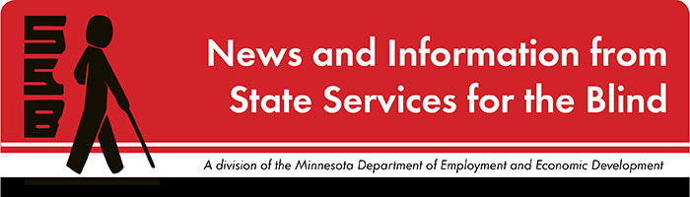

The Spectacle
-Dare to stand out
November 2022

Just for Fun
Often the month of November is the time we take to think about all that we’re thankful for. Practicing gratitude can be a game-changer: it has far-reaching effects, from improving our mental health to boosting our relationships with others. The article “How to Practice Gratitude” offers insights into the effects of gratitude and how to practice it daily. Some of the suggestions include:
- Keeping a gratitude journal
- Sharing gratitude with others
- Focusing awareness on the senses
- Using a language of abundance

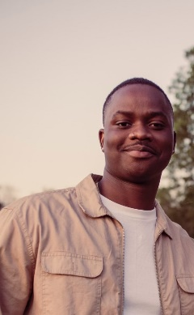
Meet Our New Metro Pre-ETS Counselors
Sam Bannerman
Sam earned his master’s degree in Rehabilitation and Addictive Counseling from St. Cloud University. He brings experience as an Employment Counselor at Jewish Family and Children’s Services, experience as an intern at DEED Vocational Rehabilitation Services, and a passion and momentum for serving young people.
Deanna Langton
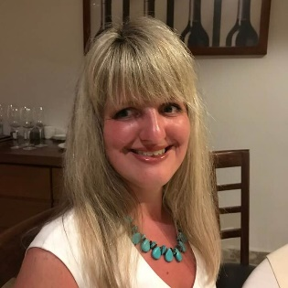
Deanna has worked as a counselor at Vocational Rehabilitation Services for 13 years, specializing in the area of mental health diagnosis. Outside of work, Deanna enjoys walking around the lakes, listening to live music, shopping, and enjoying local restaurants.

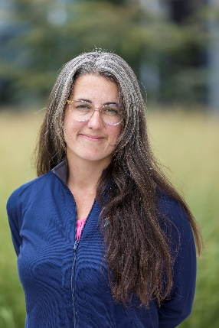
Kate Larson
Kate earned her Master of Science in Clinical Mental Health Counseling at the University of Wisconsin, Stout. She comes to us with experience as a Career Counselor and Internships Director at Macalester College, work in student affairs at the University of Minnesota, work as a licensed professional clinical counselor, and a commitment to providing access and opportunities for young people. Apart from the formal stuff, in no particular order, she enjoys the following: making messy art with her 8-year-old, trail running, questionable punctuation, watching soccer, and hanging with loved ones.

Upcoming and Ongoing

A Note from SSB Counselors
Hi, students! We sure hope that the beginning of this school year has been a smooth one for you! It’s the time of year that we double-check our records and make sure that we have the most current information about you. This helps us coordinate meetings with you, your family, your school, and your teachers. Please reach out and let us know if anything has changed since last year. We wish you all the best in the year ahead!

College 101
Are you interested in attending college to gain education and training needed to meet your employment goals? Do you have questions about what the transition to college will look like and what skills are needed to be successful in higher academics? If so, please consider joining State Services for the Blind at this College 101 webinar to learn more about preparing for college!
What: SSB is hosting a College 101 webinar for prospective blind, visually impaired, and DeafBlind college students to learn from current college students the skills needed for success in higher education. Please join us for the conversation and feel free to ask questions you might have about college.
Who: This is open for any prospective college student in high school or recently graduated from high school. A small group of current college students will serve as panelists to discuss their experiences at college and answer questions.
When: Monday, November 28th from 6:00 PM – 7:30 PM
Where: Zoom! Please click here to register.
If you have any questions, please contact Shane DeSantis at shane.desantis@state.mn.us or 651-358-5205.

Year-Round Programs for Students
BLIND, Incorporated and Duluth Center for Vital Living offer opportunities for students to build skills and connect with peers throughout the school year. Check out these programs and let your student’s SSB counselor know if your student is interested in attending.

SSB Communication Center
The Communication Center is here to put your books into accessible formats that work for you. Custom audio, e-text, DAISY markup, and Braille - we can do it! The Communication Center is Minnesota’s Accessible Reading Source – we’re here for you. Email us at ssb.audioservices@state.mn.us

PACER
PACER Center “enhances the quality of life and expands opportunities for children, youth, and young adults with all disabilities and their families so each person can reach his or her highest potential. PACER operates on the principles of parents helping parents, supporting families, promoting a safe environment for all children, and working in collaboration with others.” For upcoming webinars and workshops, visit https://www.pacer.org/workshops/

Disability Hub MN
“Disability Hub MN is a free statewide resource network that helps you solve problems, navigate the system and plan for your future. We can help you create your best life, your way.” https://disabilityhubmn.org/

APH
APH ConnectCenter empowers people toward greater independence and lifelong success by providing curated information and resources to assist children, parents, job seekers, adults, and older people who are blind or visually impaired. Check out their webinar page to see upcoming opportunities and archived webinars.
Parents – feel free to check out their ParentConnect support group below if you are interested!
ParentConnect: a family support group offered in partnership with The Chicago Lighthouse’s Virtual Parent Support Group.
Description: APH FamilyConnect and The Chicago Lighthouse are pleased to offer this virtual support group for parents and families of children who are blind or visually impaired. These monthly sessions are for families to connect with and learn from each other about the joys, challenges, and adventures of raising children with visual impairments and blindness. These sessions are open to families on an ongoing basis.
Click here to see the upcoming schedule.

Blind Abilities Podcasts
Check out Blind Abilities on the web at http://www.BlindAbilities.com. You can also download the app or use the Blind Abilities Alexa skill on your Alexa device just by saying, “Alexa, enable Blind Abilities.”
Here are just some of the people and topics featured on Blind Abilities recently:
- Meet Matt Carson: Musician, singer/songwriter, producer
- Get a blindness perspective on tech, white cane safety day, and more
- Learn about Job interview follow-up and disclosing your disability
- Join Wellness Wednesdays for tips to stay healthy in mind and body
If you know of a student that would be interested in sharing their achievements on their journey, Blind Abilities would like to include their perspectives on future shows. Send a note to mailto:info@blindabilities.com

Tech Tidbits
In September and October, both Apple and Google released new models of their phones. Apple released the iPhone 14 series, including the 14, 14 Plus, 14 Pro, and Pro Max. The iPhone 14 Plus may be a good choice for low vision users wanting a larger screen at a lower cost, as the 14 Plus has a 6.7-inch screen. Google released the Google Pixel 7 and 7 Pro in mid-October. The pixel line is a great Android phone, especially for a clean version of Android. Pixel phones typically get Android updates faster than other Android models too.

Apple has also released IOS 16, which includes several new features, including some accessibility improvements. Some users may be interested in the new Eloquence voice. Visit www.applevis.com to learn more about the new accessibility features, and bugs introduced in IOS 16.

Freedom Scientific has released the full versions of Jaws, ZoomText, and Fusion 2023. These new versions are typically released every October or November. Visit www.freedomscientific.com for more information and the latest version downloads.

Building BRIDGEs

As students navigate the world of high school and begin thinking about the future, we offer services and resources that provide a foundation for success. Each of the core areas of our BRIDGE framework highlights an essential component that teenagers need in order to succeed after high school:

- Basic Skills
- Role Models
- Initiative
- Discovery
- Goal Setting
- Experiences
“Painting Blind with Visually-Impaired Visual Artist John Bramblitt” is an article from 2019 and is still a good example of how often people who are blind, low vision, or DeafBlind find creative ways to nourish their interests and skills. “John Bramblit is a visually impaired visual artist based in Denton, Texas. To put it bluntly, he’s blind, but he’s also a painter. Bramblitt paints by raising lines on the surface of a canvas and altering the consistency of paint so he can ‘feel’ the colors. He’s worked with internationally acclaimed museums like the Guggenheim and the Metropolitan Museum of Art to run popular workshops that teach people to see the world as he does and paint using their senses and imagination.”

4to24 App Now Available for Apple and Android Devices: The National Research and Training Center on Blindness and Low Vision out of Mississippi State University has created an app for students and parents. It aims to prepare youth for future employment and independence by providing targeted resources and suggesting age-appropriate activities to build skills and confidence.
“The Best $34.32 I Ever spent: My White Cane” Qudsiya Naqui tells us about the struggles and triumphs she’s felt while accepting her vision loss—specifically, she reflects about the various attitudes she’s held toward using a cane. Her message is one of empowerment and capability.

“The Key to Independence: 8 Life Skills for Teens” offers a summary of skills teens need in order to live independently. This website from Positive Action offers suggestions to teachers and parents to help students become equipped with some essential independent living skills.

Looking Ahead in High School
Thinking about what comes after high school is an important skill. The links below offer steps to take to prepare and plan for life after graduation.
Freshman
Sophomore
Junior
Senior

Ideas?
We are always looking for ideas you’d like to see featured in this newsletter. Please email sheila.koenig@state.mn.us with any suggestions or brainstorms.

