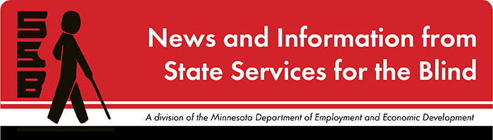

The Spectacle
-Dare to stand out
November 2023

Just for Fun
It’s the November issue of “The Spectacle”, and that means that winter is coming soon! Maybe you find yourself being less active in winter; maybe school stress starts to build up; or maybe you just get a little bored! Here’s a list of Fifty Fun Winter Activities for Teens. The list includes things to do outdoors, things to do inside, things to do when you’re bored, and things to do to build life skills! Maybe there’s something new here to try?

Upcoming and Ongoing

A Note from SSB Counselors
Hello, students! We hope your school year is off to a great start and you’re looking forward to the holidays and any traditions you recognize this time of the year. At SSB, we are continuing to plan various activities throughout the year so please keep in touch and be on the lookout for opportunities. If there is any subject or training area you would like SSB to address, please let us know and we are happy to look into any recommendations!

College 101 Event
Are you interested in attending college to gain the education and training needed to meet your employment goals? Do you have questions about what the transition to college will look like and what skills are needed to be successful in higher academics? If so, please consider joining State Services for the Blind at this College 101 webinar to learn more about preparing for college!
What: SSB is hosting a College 101 webinar for prospective blind, visually impaired, and DeafBlind college students to learn from current college students the skills needed for success in higher education. Please join us for the conversation and feel free to ask questions you might have about college.
Who: Any prospective college student in high school or who recently graduated from high school as well as parents. A small group of current college students will serve as panelists to discuss their experiences at college and answer questions.
When: Monday, December 4th from 6:00 PM – 7:30 PM
Where: Zoom! Please click here to register.
If you have any questions, please contact Shane DeSantis at shane.desantis@state.mn.us or 651-358-5205.

SSB Communication Center
The Communication Center is here to put your books into accessible formats that work for you. Custom audio, e-text, DAISY markup, and Braille - we can do it! The Communication Center is Minnesota’s Accessible Reading Source – we’re here for you. Email us at ssb.audioservices@state.mn.us

PACER
PACER Center “enhances the quality of life and expands opportunities for children, youth, and young adults with all disabilities and their families so each person can reach his or her highest potential. PACER operates on the principles of parents helping parents, supporting families, promoting a safe environment for all children, and working in collaboration with others.” For upcoming webinars and workshops, visit Pacer's workshops website.

Disability Hub MN
“Disability Hub MN is a free statewide resource network that helps you solve problems, navigate the system, and plan for your future. We can help you create your best life, your way.” This website has a variety of resources that can guide topics such as disability benefits through the DB101 website, information on housing resources through their HB101 website, and a plethora of employment and transition resources for individuals with disabilities. Visit the Disability Hub website here to learn more.
Youth in Transition Toolkit – This toolkit will introduce you to Minnesota's transition framework. Explore tools and resources you can use with youth to plan for their best lives.

Minnesota Disability Law Center
The Minnesota Disability Law Center (MDLC) provides free civil legal assistance to individuals with disabilities statewide, regardless of age or income, on legal issues related to their disabilities.
Young adults with disabilities have the right to live, work, and interact in the community. These rights come from a mix of federal and state laws and policies, including the Americans with Disabilities Act (ADA), the Workforce Innovation and Opportunity Act (WIOA), and Minnesota's Olmstead Plan. MDLC helps youth with disabilities transitioning into adulthood understand their rights and find the resources they need to thrive. Their Into Adulthood: Your Guide to Disability Access guide outlines programs, services, and contacts that may be helpful for youth with disabilities ages 14-24 as they move beyond high school to live and work independently for the first time.

APH
APH CareerConnect is “an employment information resource offered by the American Printing House for the Blind for job seekers who are blind or visually impaired. CareerConnect provides employment information, career exploration tools, and job-seeking guidance for individuals with vision loss and the professionals who work with them.” Visit their website at aphcareerconnect.com to learn more. Upcoming webinars can be found at aphconnectcenter.org/webinars/ Archived APH webinars can be found on the APH ConnectCenter YouTube page.

Blind Abilities Podcasts
Check out Blind Abilities on the web at http://www.BlindAbilities.com. You can also download the app from the IOS app store, Google Play store, or use the Blind Abilities Alexa skill on your Alexa device just by saying, “Alexa, enable Blind Abilities.”
Here are some of the people and topics featured on Blind Abilities recently:
- From Braille Notetakers to Book Players. An Assistive Technology Journey Spanning Through the Decades. Meet Gilles Pepin, Founder and Chairman of the Board at Humanware Inc.
- Wellness Wednesday: Being Perfect, not Making mistakes, and Proving Yourself is exhausting – A General Look at Blindness Awareness, Interdependence, Grieving and Rebuilding
- Timecrest – A Game with Personality and Accessibility. Meet Justin Ng, Co-founder of Sneaky Crab – A Developer Building in Accessibility from the Ground Up!
If you know of a student who would be interested in sharing their achievements on their journey, Blind Abilities would like to include their perspectives on future shows. Send a note to mailto:info@blindabilities.com

Calling all Mentors!
SSB is working on creating more mentorship opportunities for visually impaired, blind, and DeafBlind students fourteen and older statewide. Please let Shane DeSantis know if you are interested in becoming a mentor or a mentee.

Hadley Resources
Hadley has a wealth of training opportunities across six different areas: Daily Living, Adjusting to Vision Loss, Recreation, Technology, Braille, and Working! Signup is required to access full content, but everything is free! Check out their website at https://hadley.edu/.

Tech Tidbits
It's that time of year again. Jaws, ZoomText, and Fusion version 2024 were released on October 26, 2023. Users with current SMA's or an annual subscription can download the new versions.
The Be My Eyes app, available for both IOS and Android, is starting to release an exciting new feature called Be My AI. This new feature can give very descriptive information about pictures taken with the phone's camera, as well as describing images from mail messages, websites, social media apps, and even personal photos. Once Be My AI has described the picture, the user can then ask additional questions to get even more information. This feature is being gradually rolled out to existing and new users of Be My Eyes. Download the app for free from the IOS App Store, or the Google Play Store.
For a study break, several blind-accessible games have been recently released. Forza Motorsport is one such game and is the latest in XBOX's simulation racing series. It is playable to blind players via screen narration, several additional audio cues and optional gameplay assists. There is a bit of a learning curve, but this is the full racing experience that sighted players enjoy, now accessible to blind players. Forza Motorsport is available on both XBOX Series S/X and for Windows PCs via the XBOX app. It's also available for free to Game Pass and Game Pass Ultimate subscribers.

Fast Forward: Potential and Possibilities
Nimer Jaber
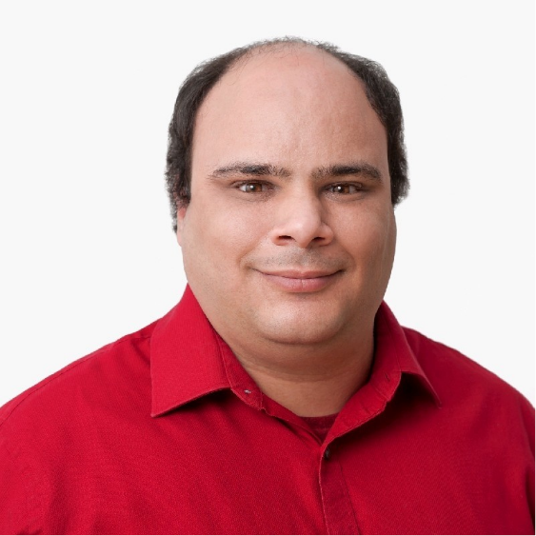
Hi, my name is Nimer (pronounced Nimmer to screen reader users.) I am an Israeli Arab. My name, in Arabic, means Tiger. I am now a U.S. citizen and have been living in the U.S. for more than 20 years. I love the outdoors, and my weekends are usually spent on a trail, near the water, skydiving, at my Jujutsu dojo, or pretty much anywhere other than sitting behind a desk. I balance all that adventurism by spending most of my week sitting behind a desk at Google. I am totally blind.

From a young age, I aspired to be in the military, not behind a desk. At some point, I had to come to the realization that my lack of vision did not make military work a realistic option for me. I started playing around with computers, initially taking them apart to discover how to put them back together. I became good at tech and eventually became an instructor of assistive technology.

I've been working on and off for the Lighthouse Center for Vital Living in Duluth for the past 12 years or so. While at the Lighthouse, I attended conferences to meet others in my field and to get the opportunity to play with new tech. At one of these conferences, I met a couple of individuals from Google. I ended up volunteering by contributing to the efforts to improve the Chromevox screen reader when it was rewritten. After this, I became recognized at Google as someone with skills in the AT field. When an opportunity opened up, I grabbed it and in 2019, left the Lighthouse to pursue an opportunity with Google. Of course, I still love teaching and did not stay gone for long... I am now still working at Google, and working at the Lighthouse part-time teaching assistive technology.

I use many different technologies to do my job. Braille is important for me to be able to deliver effective presentations. I also work on the Android accessibility team, on TalkBack and Braille. To that end, I use a variety of Braille displays. I also use multiple screen readers on multiple platforms, including Orca on Linux, Chromevox on Chrome OS, JAWS, Narrator, and NVDA on Windows, Voiceover on Mac and iOS, and TalkBack on Android. I find it crucial to know multiple screen readers, as ultimately, my employer cares about my ability to do my job, and there is no perfect screen reader. Being able to have multiple tools in my toolkit can mean the difference between being able to accomplish a task or facing serious struggles.

One of the biggest barriers I face as a blind person, if not the biggest, is the lack of access to information. So many appliances are touchscreen appliances with no built-in accessibility. So many signs in the world are not accessible. Even if they were brailled, Braille has the unfortunate problem of being undiscoverable, unless you're walking around feeling every object you encounter to determine whether there is a Braille sign. So many transit systems are difficult to use because of a lack of information about upcoming stops, which platform you're on, and so on. I work to solve these problems by working on the accessibility of the most used mobile platform in the world. If that platform is easier to use and access, apps that provide band-aid solutions to the lack of information problem can provide workarounds, and potentially make life much easier. I challenge you, students, to work out how you're going to contribute to problems you encounter, and how you are going to make your impact. I also challenge you to always keep moving forward, always keep finding ways around the barriers, always keep working toward solutions, and never give up. Life isn't always easy... it isn't for anyone. However, your attitudes will make the difference between coming out on top or giving up. I would also encourage you to put as many tools in your toolboxes as you can, as you may need them. I encourage you to speak up when something isn't working for you, be firm and use the word no when something won't work for you and don't allow others' negativity and lowered expectations to shape your life. If you want to do something, go out in the world and do it. Have realistic expectations but be willing to stretch those expectations as well. Finally, I'd encourage you to live your life. Your job isn't to play the part of a blind person, it's to live your life, reach for your dreams, and find contentment. You don't have to enter a blindness field of work, you don't have to teach other blind people, you don't have to hide your cane because your parents are embarrassed by you using it, and you don't need to take whatever job your rehab counselor encourages you to take. Find your own path. You can be equally as successful if you spend years going to college as if you didn't spend years going to college. There is more than one path you can follow to accomplish your goals.

Building BRIDGEs

As students navigate the world of high school and begin thinking about the future, we offer services and resources that provide a foundation for success. Each of the core areas of our BRIDGE framework highlights an essential component that teenagers need in order to succeed after high school:

- Basic Skills
- Role Models
- Initiative
- Discovery
- Goal Setting
- Experiences

In the News and miscellaneous resources

- 4to24 App Available for Apple and Android Devices: The National Research and Training Center on Blindness and Low Vision out of Mississippi State University has created an app for students and parents. It aims to prepare youth for future employment and independence by providing targeted resources and suggesting age-appropriate activities to build skills and confidence.

- “The Key to Independence: 8 Life Skills for Teens” summarizes skills teens need to live independently. This website from Positive Action offers suggestions to teachers and parents to help students become equipped with some essential independent living skills.

- Braille Brain! is a free website-based, self-paced curriculum to help people who already have literacy skills learn braille. Braille Brain can be especially useful for parents, paraeducators, students in university-level TVI programs, people who lose sight later in life, and others who want to improve their braille skills. The curriculum is based on Ashcroft’s Programmed Instruction: UEB and starts with the basics of braille, going through uncontracted and contracted UEB braille. No account is needed to access this curriculum, making it quick and easy to use.

- Check out a new four-episode miniseries All the Light We Cannot See on Netflix! Aria Mia Loberti is a blind actor from Rhode Island and plays the lead role of Marie-Laure Leblanc. All the Light We Cannot See is based on the book written in 2014. Check out this Aria Mia Loberti article to learn more about her background and journey into acting.

- Sam Seavey with The Blind Life. Sam has a website called theblindlife.net and a YouTube page youtube.com/c/theblindlife where he engages in a variety of topics about blindness. “With more than 50,000 subscribers and over 700 informative videos, Sam helps people worldwide living with vision loss, offering tips for managing daily tasks, reviewing assistive devices, and hosting informative interviews with key stakeholders in the visually impaired community.”

Looking Ahead in High School
Thinking about what comes after high school is an important skill. The links below offer steps to take to prepare and plan for life after graduation.
Freshman
Sophomore
Junior
Senior

Ideas?
We are always looking for ideas you’d like to see featured in this newsletter. Please email shane.desantis@state.mn.us with any suggestions or brainstorms.

