SFY 2023 Ujamaa Place Direct Appropriation
Final Report
12/26/2023

Minnesota Department of Employment and Economic Development
Employment and Training Programs Division
180 E. 5th St., Suite 1200
St. Paul, MN 55101
Larry Eisenstadt, DEED Grant Manager, Larry.Eisenstadt@state.mn.us
Christopher Crutchfield, Ujamaa Place CEO and President, Chris_Crutchfield@ujamaaplace.org
mn.gov/deed
As requested by Minnesota Statute 3.197: This report cost approximately $400 to prepare, including staff time, printing and mailing expenses.
Upon request, this material will be made available in an alternative format such as large print, Braille or audio recording. Printed on recycled paper.

Contents
Contents 3
Introduction 4
Theory of Transformation 4
FOUNDATIONAL ELEMENTS: 4
PROGRAM ELEMENTS THAT LEAD TO PARTICIPANT OUTCOMES: 4
ULTIMATE OUTCOMES: 5
Justice Impacted Participants 5
RATE OF RECIDIVISM: 5
Key Findings 5
Annual Data Summary Report 6
Participant Demographic and Outcome Data 7
Demographic Data 8
Program Services, Activities, and Other Related Assistance 10
Indicators of Performance 11
Expenditure Data 11
Future Allocations 12
Success Stories 12

Introduction
The Minnesota State Legislature appropriated $380,000 ($400,000 minus $20,000 for DEED administration) during the 2021 Legislative Session for SFY 23 to Ujamaa Place, https://www.revisor.mn.gov/laws/2021/1/Session+Law/Chapter/10.
Ujamaa Place opened its doors in 2010 with the mission of helping participants “achieve brotherhood, stability, and personal success” (Ujamaa Place Annual Report 2022). Ujamaa Place provides “holistic transformation opportunities for young Black men experiencing inequity at the intersection of race and poverty” (Ujamaa Place Annual Report 2022).

Theory of Transformation
Ujamaa Place’s program is based on the “Theory of Transformation” which uses a three-level service approach to accomplish to accomplish its goal. Participants move from the “Foundational Elements” to “Ultimate Outcomes.”

FOUNDATIONAL ELEMENTS:
Thematic threads integrated throughout every aspect of the Ujamaa Place experience. Included in this level are the following:
- Empowerment and Spirituality
- African American Culture
- High Context Coaching
- Community of Men

PROGRAM ELEMENTS THAT LEAD TO PARTICIPANT OUTCOMES:
Interacting determinants of self-transformation. Included in this level are the following:
- Academia and Employment Skill Development
- Climbing the Education Ladder
- Building Employment Skills
- Volunteering in the Community
- Life Skills Development
- Cultivating Life Skills
- Defining Connection to Family and Children
- Fulfilling Basic Needs
- Establishing a Home
ULTIMATE OUTCOMES:
Participant outcomes produced as a result of the Ujamaa experience. Included in this level are the following:
- Stable Housing Situation
- Increase Education Attainment
- Secure and Retain a Job
- Connect to Family and Children
- Eliminate Contact with the Penal System

Justice Impacted Participants
Most participants are justice-impacted, meaning they have been or are at risk of being incarcerated, have had a sibling, parent, or extended family member involved in the justice system or have in some other way been affected by law enforcement to the point that such involvement has altered their life.
Recidivism is one of the most fundamental concepts in criminal justice. It refers to a person’s relapse into criminal behavior, often after the person receives sanctions or undergoes intervention for a previous crime. (Source: National Institute of Justice)

RATE OF RECIDIVISM:
National Average: 68%
Minnesota: 35% -37%
Ujamaa Place Participants: 4% - 6%
Participants are empowered to be change agents in their communities. They show up at the Capitol and advocate on issues directly impacting them and their communities i.e. the restoration of voting rights for ex-offenders, investment in historically under-resourced communities.

Key Findings
(from Ujamaa Place 2022 Annual Report)
- Ujamaa Place men are unemployed, homeless and have a connection to the criminal justice system.
- There is a direct connection between educational attainment and homelessness.
- At program enrollment, Ujamaa Place men are reading. writing, and doing math at a 4th to 8th grade level.
- All Ujamaa Place men are basic skills deficient upon program enrollment.
- 17% came from the foster care system.

Annual Data Summary Report
Mission Statement: Ujamaa Place provides holistic transformation for young African American men experiencing inequity at the intersection of race and poverty. We help them achieve brotherhood, stability, and personal success.
Annual Data Highlights
- Active Cumulative Enrollment: 1,412 compared to PY 22: 1,264 (+11%)
- New enrollments: CY 119 compared to PY 22 159 (-26%)
- Unique enrollment: CY 254 compared to PY 22: 275 (-8%)
- 88% of Ujamaa Men enrolled in the Theory of Transformation are from the Greater Saint Paul area (Ramsey County) at the time of enrollment.
Ujamaa Place has three scattered housing sites in Saint Paul, with a total of 32 rooms. The demand far exceeds the supply. It is estimated that Ujamaa Place would require a facility approximately 18,000 sq. ft. in size to meet its demand for housing, plus programming all under one roof.
Data Methodology
Coaches use data to support participants throughout their transformation journey. Coaches track all activities, tasks, milestones and services used in the ClientTrack data system that is customized to measure performance based on completion of program requirements outlined in each participant’s Individual Transformation Plan (ITP). Ujamaa Place data is analyzed on a quarterly and annual basis.
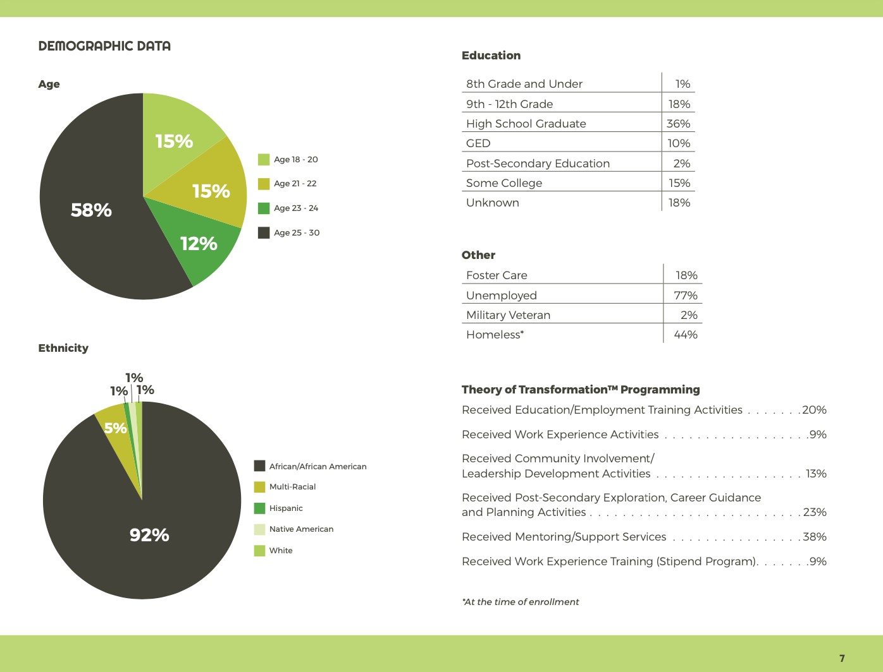

Participant Demographic and Outcome Data
The grant period for SFY 2023 funds ran from September 1, 2022 through August 31, 2023. The participant data for this period follows. The total counts are unduplicated data.

Demographic Data
Participants Served |  | Q3 2022 (Sept. only) | Q4 2022 | Q1 2023 | Q2 2023 | Q3 2023 (Aug. only) | TOTAL
Gender | A. Male | 116 | 392 | 330 | 340 | 234 | 1412
 | B. Female | 0 | 0 | 0 | 0 | 0 | 0
Age | A. 14 - 15 | 0 | 0 | 0 | 0 | 0 | 0
 | B. 16 – 17 | 0 | 0 | 0 | 0 | 0 | 0
 | C. 18 – 20 | 13 | 39 | 48 | 46 | 32 | 178
 | D. 21 – 22 | 21 | 63 | 56 | 57 | 38 | 235
 | E. 23 – 24 | 15 | 51 | 50 | 54 | 40 | 210
 | F. 25 – 30 | 67 | 239 | 176 | 183 | 124 | 789
Ethnicity / Race | A. Hispanic/Latino | 1 | 3 | 3 | 3 | 2 | 12
 | B. American Indian or Alaska Native | 1 | 2 | 2 | 2 | 2 | 9
 | C. Asian | 1 | 1 | 2 | 3 | 0 | 7
 | D. Multi-Racial | 6 | 23 | 16 | 16 | 10 | 71
 | E. Black or African American | 106 | 358 | 303 | 311 | 216 | 1294
 | F. White | 0 | 5 | 4 | 5 | 0 | 14
Education Level | A. 8th grade and under | 2 | 2 | 2 | 2 | 2 | 10
 | B. 9th Grade – 12th Grade | 22 | 75 | 59 | 64 | 46 | 266
 | C. High School graduate or equivalent | 37 | 152 | 102 | 104 | 72 | 467
 | D. GED | 11 | 42 | 28 | 27 | 16 | 124
 | E. Unknown | 29 | 59 | 103 | 105 | 68 | 364
 | F. Post-Secondary Education | 1 | 2 | 2 | 2 | 4 | 11
 | G. Some College | 14 | 60 | 34 | 36 | 26 | 170
Other Demographics | A. Limited English Proficient | N/A | N/A | N/A | N/A | N/A | N/A
 | B. Individuals From Families Receiving Public Assistance | 3 | 10 | 3 | 2 | 6 | 24
 | C. Foster Youth | 21 | 69 | 52 | 55 | 36 | 233
 | D. Individuals with a Disability | 12 | 45 | 60 | 52 | 28 | 197
 | E. High School Drop-Out | 22 | 75 | 59 | 64 | 46 | 266
 | F. Youth Offender | 18 | 114 | 153 | 162 | 112 | 559
 | G. Pregnant or Parenting Youth | 18 | 115 | 79 | 85 | 22 | 319
 | H. Basic Skills Deficient | 116 | 392 | 330 | 340 | 234 | 1412
 | I. Homeless or Runaway Youth | 17 | 57 | 24 | 50 | 36 | 184
 | J. Not Employed at Program Enrollment | 85 | 314 | 228 | 117 | 82 | 826
 | K. Veteran | 2 | 7 | 8 | 12 | 4 | 33

Program Services, Activities, and Other Related Assistance
Participants Served | Q3 2022 (Sept. only) |  | Q4 2022 | Q1 2023 | Q2 2023 | Q3 2023 (Aug. only) | TOTAL
A. Received Education or Job Training Activities |  | 32 | 30 | 52 | 42 | 78 | 234
B. Received Work Experience Activities |  | 3 | 26 | 16 | 74 | 10 | 129
C. Received Community Involvement and Leadership Development Activities |  | 7 | 63 | 14 | 7 | 10 | 101
D. Received Post-Secondary Exploration, Career Guidance and Planning Activities |  | 30 | 134 | 16 | 50 | 68 | 298
E. Received Mentoring Activities |  | 35 | 131 | 113 | 117 | 74 | 470
F. Received Support Services |  | 35 | 131 | 113 | 117 | 74 | 470

Indicators of Performance
Participants Served | Q3 2022 (Sept. only) |  | Q4 2022 | Q1 2023 | Q2 2023 | Q3 2023 (Aug. only) | TOTAL
A. Attained Work Readiness or Education Goals |  | 8 | 9 | 19 | 16 | 24 | 76
B. Received Academic Credit or Service Learning Credit |  | 0 | 0 | 0 | 0 | 0 | 0
C. Obtained High School Diploma, GED, Remained in School, Obtained a Certificate or Degree, or Dropout – Returned to School |  | 0 | 1 | 0 | 0 | 2 | 3
D. Entered Post Secondary Education, Vocational/Occupational Skills Training, Apprenticeship, Military, Job Search or Employment |  | 10 | 56 | 40 | 111 | 18 | 235
E. Successful Completion Rate |  | 100% | 100% | 100% | 100% | 100% | 100%

Expenditure Data
Ujamaa Place expenditures from September 1, 2022 through August 31, 2023:
Budget Category | Expenditures
Administration (up to 10% allowed) | $38,000
Contracted Services (construction training) | $24,000
Participant Wages and Fringe Benefits | $0
Direct Staff Services | $180,000
Support Services | $138,000
Total | $380,000

Future Allocations
Ujamaa Place’s SFY 2024 and SFY 2025 appropriations are $1,500,000 per year ($1,425,000 for Ujamaa Place; $75,000 for DEED administration).

Success Stories
Each Ujamaa Man has a unique story based on his real-life experience. Hear directly from Ujamaa Men how their lives have been impacted by the Theory of Transformation program model.
Wesley Sims
https://ujamaaplace.org/ujamaa-man-wesley-sims/
Nathaniel Israel
https://ujamaaplace.org/nathaniel-israel/
Kavon McNeal
https://ujamaaplace.org/kavon-mcneal/

