Data on Minnesota Exports for First Quarter 2020 – Published May 2020
For More Information: Eric Lightner, 651-259-7149

Exports Gain in 5% in First Quarter
- Minnesota exports (including agricultural, mining and manufactured products) were valued at $5.6 billion, increasing 5% (or about $278 million) between the first quarters of 2019 and 2020.
- U.S. exports of goods slid 3% during this period. Although exports dropped from 24 states, they grew or were unchanged for the remaining states and the District of Columbia.
- Minnesota manufactured exports jumped 6% to $5.5 billion in the first quarter of 2020, while U.S. manufactured exports dipped 5%.
Figure 1. Exports Up in 21 States; Flat in 6 States, DC
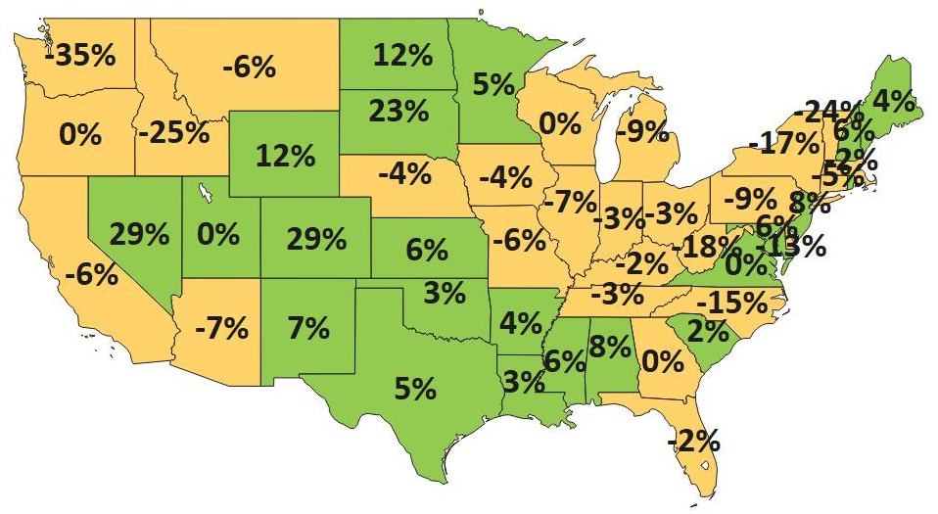
MN: +5%
U.S.: -3%
Decline 0% Growth

Canada and Markets in Asia and Latin America Help Bolster Minnesota Exports
- North American exports surged 21%. Export growth of 43% to Canada – primarily due to mineral fuels – overshadowed a 15% decline to Mexico – as sales of machinery, iron/steel goods and plastics sank.
- Exports increased moderately by 4% to Asia. Strong gains to Korea (up 17%), Taiwan (up 44%), Japan (up 7%) and Thailand (up 21%) masked struggling sales to China (down 5%) and the Philippines (down 22%).
- Exports to Europe contracted 9% to $1.3 billion, as sales shrank in Turkey (down 63%), the U.K. (down 13%), Germany (down 5%), Switzerland (down 22%) and France (down 8%). Ireland (up 10%) and Poland (up 25%, ranked 24th) were bright spots among larger European markets.
- Exports rebounded in Central and South America ($235 million, up 6%), supported by key markets such as Brazil ($66 million, up 32%), Costa Rica ($62 million, up 20%) and Peru ($13 million, up 43%).
- Minnesota sales slumped to the Australia-Pacific region ($127 million, down 10%), the Middle East ($88 million, down 16%) and Africa ($41 million, down 6%), as exports reversed course in Australia (down 11%), South Africa (down 32%), Saudi Arabia (down 32%) and Israel (down 18%).

Figure 2. Exports and Trends Among Minnesota’s Top 10 Markets, First Quarter 2020
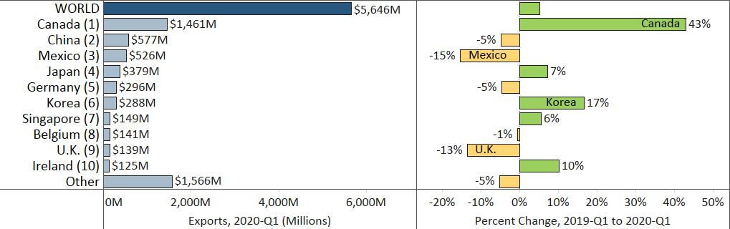

Mineral Fuels, Meat, Plastics, Aircraft and Precious Metals Lead in Gains
- Exports of mineral fuels (up 1,874%) were volatile, spiking to $515 million to Canada.
- Global sales of meat leaped 53% to $121 million, propelled by China (up 625%) and Japan (up 45%). Fresh, chilled or frozen pork ($91 million, up 72%) steered growth and accounted for 75% of the state’s meat exports.
- Demand for plastics expanded 8%, driven by the Netherlands (up 162%), China (up 21%), Germany (up 10%) and Costa Rica (up 149%), and despite a drop of 28% to Mexico. Primary polyester resins and adhesive plastic sheets, film jumped the most.
Figure 3. Minnesota’s Major Markets for Meat

- Robust sales of civilian aircraft and parts in China, Korea and Mexico lifted aircraft exports by 19%.
- Outreach in Germany and Taiwan led to stone, plaster, cement exports increasing 10% to $106 million.
- Among food segments, Mexico generated export growth for dairy, eggs ($36 million, up 33%) and fats, oils ($23 million, up 64%). Sales of food by-products ($146 million, up 5%) had solid traction in markets such as Indonesia (up 127%), Korea (up 78%) and Thailand (up 59%), but slipped in Japan, Chile and Vietnam.
- China (up 43%), Japan (up 36%), Germany (up 65%) and Korea (up 18%) spurred gains in organic chemicals.
- Bleak sales of blood products and bandages to China, Germany and Singapore disrupted pharmaceuticals.
- Demand tumbled for electrical equipment (down $81 million – influenced by the Philippines, Turkey and Canada); machinery (down $77 million – largely due to Mexico, China and Australia); cereals (down $31 million – shaped by Canada and Japan); and vehicles (down $25 million – dragged down by Mexico).
- Also losing ground were exports of wood pulp ($41 million, down 36%) in Indonesia and India; ores, slag, ash ($17 million, down 47%) in Canada; and glass ($27 million, down 35%) in Canada and Switzerland.

Figure 4. Exports and Trends Among Minnesota’s Top 10 Products, First Quarter 2020
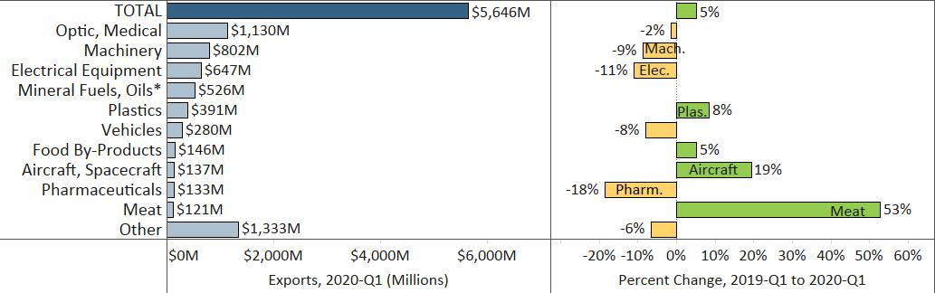
Minnesota Quarterly Export Statistics is the most current resource available for tracking the state’s manufactured export trends and is prepared for the Minnesota Trade Office (MTO) by the Department of Employment and Economic Development’s (DEED) Economic Analysis Unit (Thu-Mai Ho-Kim). The quarterly and annual statistics reports primarily cover export data based on the Harmonized Tariff System (Schedule B), collected by the U.S. Department of Commerce (USDOC) and distributed by IHS Maritime & Trade. Reports are available on DEED’s website at “Export and Trade Statistics” (http://mn.gov/deed/data/export-stats/).
*Growth in exports of mineral fuels (up 1,874%) was omitted from the chart to minimize distortion.

