Data on Minnesota Exports for Second Quarter 2020 – Published August 2020
For More Information: Rita Beatty 651-259-7534

State Exports Fall 18%, Down $1 Billion, in Second Quarter
- Minnesota exports (including agricultural, mining and manufactured products) were valued at $4.6 billion, falling by 18% (or about $1 billion) between the second quarters of 2019 and 2020.
- U.S. exports of goods fell 30% during this period, reflecting the widespread decline in economic and employment activity related to the pandemic. Exports from 48 states and the District of Columbia decreased, with only Nevada (8%) and Alaska (7%) showing positive export growth trends.
- Minnesota manufactured exports contracted 20% to $4.2 billion in the second quarter of 2020, while U.S. manufactured exports sank 30%.
- For first six months of 2020, total Minnesota exports fell 7%, while U.S. exports dropped 17%.
Figure 1. Exports from 48 States, DC Decline
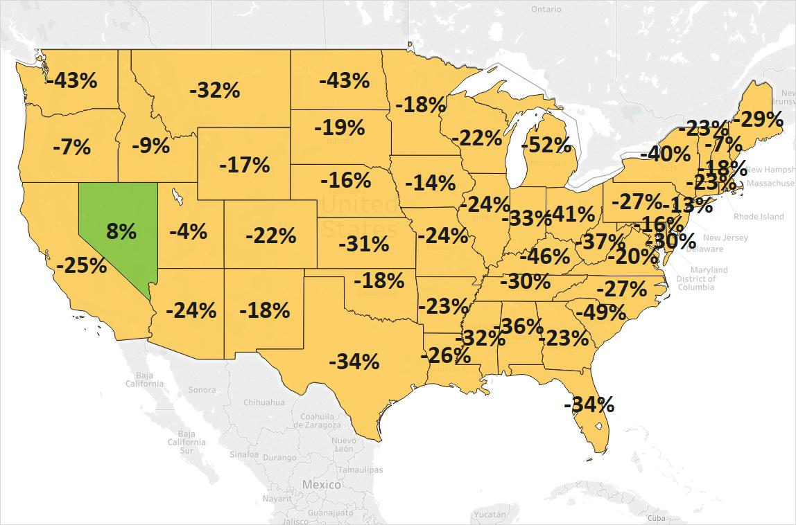
MN: -18%
U.S.: -30%
Decline 0% Growth

Exports to Major Regions Struggle, Selected Asian Markets are Among Bright Spots
- The state’s exports fell 24% to North America, the European Union, and Central and South America, and dipped 6% to Asia. Exports sank at least 30% to the Australia-Pacific area, the Middle East and Africa.
- Isolated bright spots with surging exports included Taiwan (up 56%), Malaysia (up 46%), Japan (up 3%), Thailand (up 7%) and Vietnam (up 21%) in Asia, as well as, Slovakia (up 701%) and Algeria (up 166%).
- Driven by exports of pumps and wheat, Algeria ($14 million) surpassed South Africa ($10 million, down 49%) as the state’s largest market in Africa. Sales of centrifuges and filters drove growth to Angola.
- Mexico dropped to the state’s fourth largest market, as exports to that market fell 40%. Other larger markets that dropped in rank this quarter included Belgium (down 35%, down to 13th), the Philippines (down 28%, down to 14th), Ireland (down 23%, down to 15th) and France (down 28%, down to 16th).

Figure 2. Exports and Trends Among Minnesota’s Top 10 Markets, Second Quarter 2020
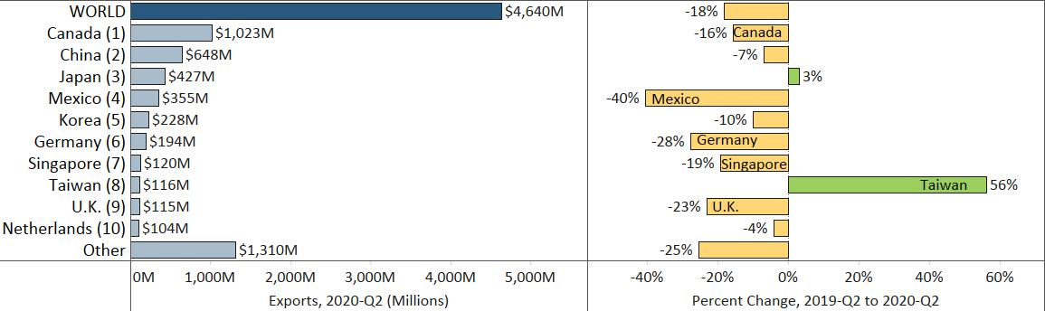

Widespread Declines for Major Exports, But Gains in Mineral Fuels, Meat, Iron Ores
- Four of the state’s major exported products, which accounted for half of exports, suffered large losses: optics, medical (down 22%), machinery (down 21%), electrical equipment (down 30%) and vehicles (down 46%). These historic declines are similar to trends during the Great Recession.
- Generalized weak demand among the state’s major markets in North America, the European Union and Asia caused exports of machinery, electrical equipment, vehicles and optics/medical to tumble.
- Also losing significant ground were exports of pharmaceuticals ($100 million, down 40%), aircraft, spacecraft ($71 million, down 43%) and food by-products ($118 million, down 22%).
Figure 3. Minnesota Export Trends: 2020-Q2 Compared to 2009-Q2 (during Great Recession)

- Taiwan was an exceptional market, with vigorous export growth for many products: optics, medical (up 66%), plastics (up 148%), stone, plaster (up 197%), electrical equipment (up 22%) and machinery (up 27%).
- Sales of machinery for making semiconductors ($39 million, up 162%) and centrifuges, filters ($84 million, up 7%) in Asia, and pumps to Ireland ($14 million, up from $205,000), performed surprisingly well.
- Sales of mineral fuels ($183 million, up 482%) fluctuated wildly, spiking 774% to Canada (to $175 million).
- Global sales of meat leaped 54% to $138 million, propelled by China (up 602%, or up $50 million) and Japan (up 96%, or up $10 million), and despite disruptions in demand in Mexico, Colombia, Korea and Canada. Fresh, chilled or frozen pork ($107 million, up 87%) fueled growth and accounted for 77% of meat exports.
- Ores, slag and ash (largely iron ores) were up 11%, bolstered by Japan ($84 million, up 40%) and Slovakia ($15 million, up from none). These gains offset the drop in these exports to Canada ($115 million, down 13%).

Figure 4. Exports and Trends Among Minnesota’s Top 10 Products, Second Quarter 2020
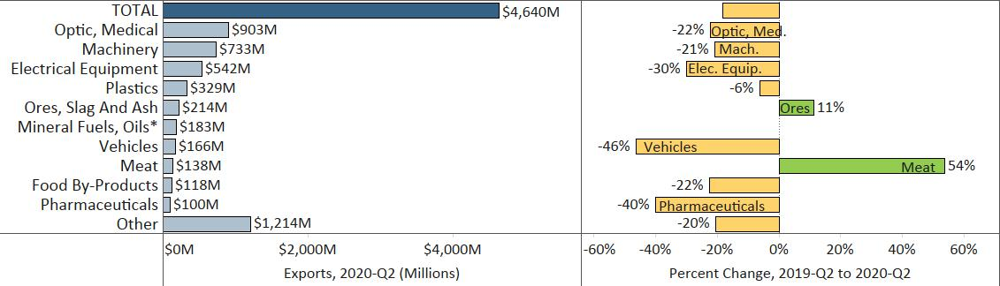
Note: To minimize chart distortion, export growth rate of 482% for mineral fuels and oils, was omitted.
Minnesota Quarterly Export Statistics is the most current resource available for tracking the state’s export trends and is prepared for the Minnesota Trade Office (MTO) by the Department of Employment and Economic Development’s (DEED) Economic Analysis Unit (Thu-Mai Ho-Kim). The quarterly and annual statistics reports primarily cover export data based on the Harmonized Tariff System (Schedule B), collected by the U.S. Department of Commerce (USDOC) and distributed by IHS Maritime & Trade. Reports are available on DEED’s website at “Export and Trade Statistics” (http://mn.gov/deed/data/export-stats/).

