Data on Minnesota Exports for Third Quarter 2020 – Published December 2020
For More Information: Rita Beatty 651-259-7534

State Export Decline Continues, Down 14%, in Third Quarter
- Minnesota exports (including agricultural, mining and manufactured products) were valued at $4.8 billion in the third quarter of 2020, falling by 14% (or $803 million) since the third quarter of 2019.
- U.S. exports of goods fell 13% during this period. Reflecting the persistent widespread impact of the pandemic, exports decreased from 43 states and the District of Columbia. Exports increased from Nevada, Oregon, New Jersey, Idaho and Missouri; and were unchanged from Utah and Iowa.
- Minnesota manufactured exports contracted 13% to $4.5 billion in the third quarter of 2020. U.S. manufactured exports sank 14%.
- For first nine months of 2020, total Minnesota exports fell 9%, while U.S. exports dropped 15%.
Figure 1. Exports Decline from 43 States and DC
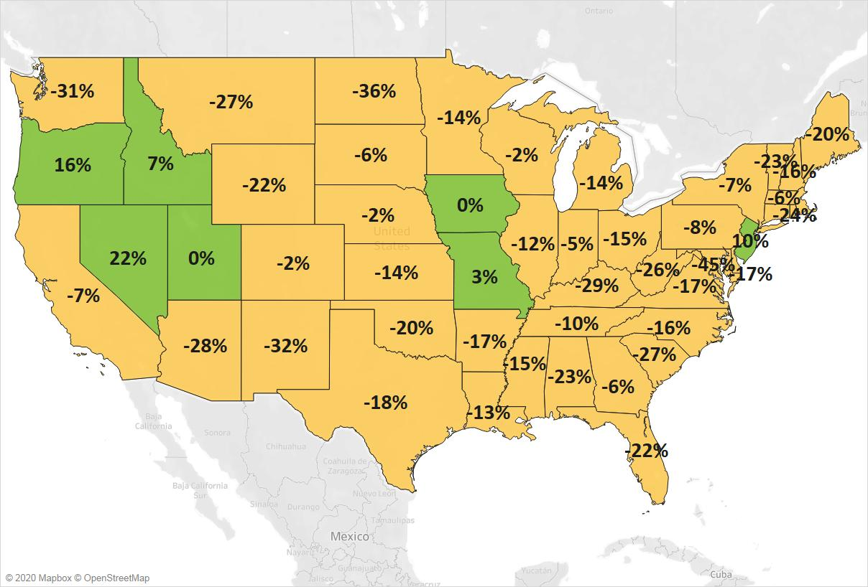
MN: -14%
U.S.: -13%
Decline 0% Growth

Global Exports Still Largely in Decline – Some Markets Show Resilience and Growth
- The state’s exports fell sharply to all regions. Exports sank 10% to North America, 18% to Asia and 14% to the European Union. These three regions accounted for 89% of the state’s exports in the third quarter.
- Major markets, such as Mexico (down $146 million), Japan ($117 million), Germany (down $93 million), France (down $51 million) and the Philippines (down $48 million), experienced sharp declines.
- Exports surged to markets such as Slovakia (up $37 million – fueled by iron ores), Taiwan (up $19 million – led by plastics and optic, medical goods), the Netherlands (up $17 million – led by plastics and electrical equipment) and Switzerland (up $13 million – driven by vehicles and electrical equipment).
- Although third quarter trends among major markets were largely negative, monthly trends showed some signs of recovery, with export gains to some markets by September, at the end of the quarter.

Figure 2. Export Trends for Minnesota’s Top 10 Markets, Third Quarter 2020
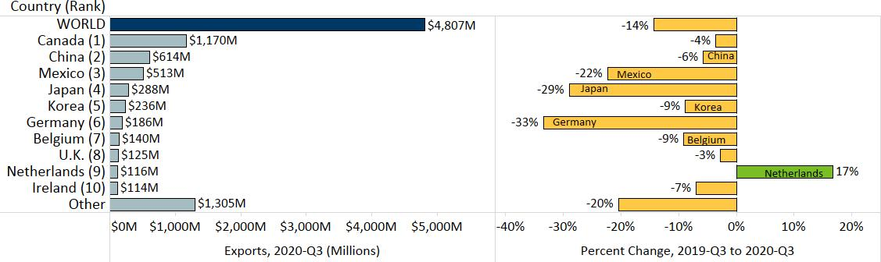

Gains in Mineral Fuels, Meat and Beverages Help Offset General Widespread Declines
- Large declines in exports continued due to generalized weak demand among the state’s major markets. The state’s top five exported products accounted for about 60% of exports. Exports of optics, medical were down 18%; machinery was down 11%; electrical equipment was down 23%; vehicles were down 18%; and plastics were down 13%. These downward trends tended to be less severe than in the second quarter.
- Also losing significant ground were ores, slag, ash ($140 million, down 38%), pharmaceuticals ($116 million, down 30%) and food by-products ($125 million, down 27%).
Figure 3. Minnesota’s Major Markets for Meat

- Global sales of meat leaped 22% to $101 million, propelled by demand in China (up 526%, or up $29 million) and Japan (up 63%, or up $8 million). These gains offset large losses in Mexico (down 40%) and Korea (down 59%). Frozen pork ($39 million, up 29%) and fresh, chilled pork ($27 million, up 77%) drove the gains.
- Canada drove growth in mineral fuels, oils ($192 million, up 544%) and beverages ($52 million, up 42% –mainly food-safe alcohols and water products). Canada accounted for over 95% of these exports.
- Despite broad declines in most product groups, selected markets and product segments had promising gains. Demand for plastics grew in markets such as the Netherlands ($26 million, up 195%) and Taiwan ($14 million, up 75%), and in segments such as polyacetals (primary polyesters) (up 147%) and tubes, pipes, hoses (up 51%).
- China (up 13%), the Netherlands (up 86%) and Switzerland (up 47%) contributed to recovering segments of electrical equipment exports, such as industrial furnaces ($25 million, up 66%), household appliances ($18 million, up 106%) and electric generators ($27 million, up 18%).

Figure 4. Export Trends for Minnesota’s Top 10 Products, Third Quarter 2020
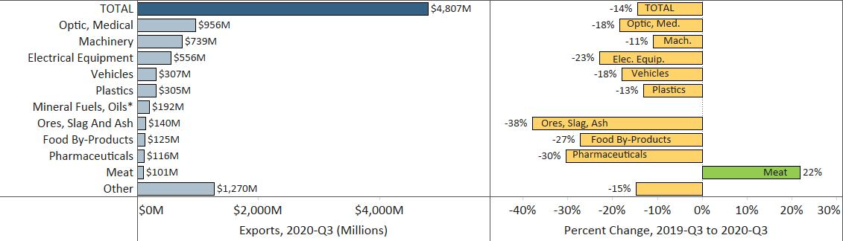
* Note: To minimize chart distortion, the export growth rate of 544% for mineral fuels and oils, was omitted.

Minnesota Quarterly Export Statistics is the most current resource available for tracking the state’s export trends in manufactured and other goods, and is prepared for the Minnesota Trade Office (MTO) by the Department of Employment and Economic Development’s (DEED) Economic Analysis Unit (Thu-Mai Ho-Kim). The quarterly and annual statistics reports primarily cover export data based on the Harmonized Tariff System (Schedule B), collected by the U.S. Department of Commerce (USDOC) and distributed by IHS Markit. Reports are available on DEED’s website at “Export and Trade Statistics” (http://mn.gov/deed/data/export-stats/).

