Data on Minnesota Exports for First Quarter 2021 – Published May 2021
For More Information: Jen Gates 651-358-0300

State Exports Dip 4% in First Quarter, Prospects for Growth Appear
- Minnesota exports of goods (including agricultural, mining and manufactured products) were valued at $5.4 billion in the first quarter of 2021, representing a drop of 4% (or $238 million) since the first quarter of 2020.
- State exports grew 6% in March 2021– interrupting the persistent monthly declines since March 2020.
- U.S. exports of goods rose 2% during in the first quarter. More than half the states had positive or flat export growth since the first quarter of 2020.
- Minnesota’s manufactured exports shrank 6% to $5.1 billion in the first quarter of 2021. U.S. manufactured exports sank 1%.
Figure 1. Exports Increase from 30 States
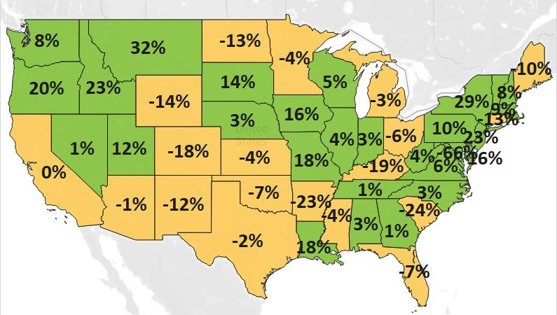
MN: -4%
U.S.: 2%
Decline 0% Growth

Sales of Minnesota Goods Resume Growth in Selected Markets
- Exports grew to many top markets in this quarter, perhaps signaling a reversal of the past year’s trends.
- The state’s exports increased 3% to North America – the state’s top regional market – boosted by growth to Mexico (up 16%). Exports slid 10% to both Asia and the European Union. Exports began to rebound in markets such as Belgium (up 12%), Taiwan (up 46%) and the Philippines (up 64%), but continued to struggle in Canada, China, Japan, Germany and Korea.
- Exports grew 1% to both the European markets outside the European Union region (led by the 64% surge in exports to Switzerland) and the Central and South American region (where Costa Rica (up 18%), the Dominican Republic (up 57%), Nicaragua (up 158%) and Guatemala (up 81%) uplifted sales).

Figure 2. Export Trends for Minnesota’s Top 10 Markets, First Quarter 2021
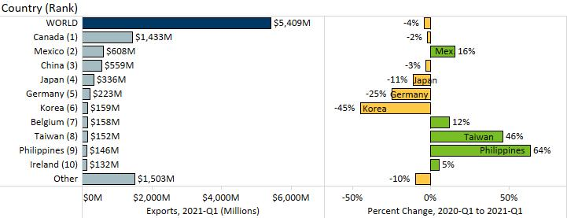

Demand Increases for Machinery, Electric Equipment, Vehicles and Food By-Products
- Many products displayed signs of export growth and early signs of recovery in March 2021.
- Exports of four of the state’s top 10 products grew in the first quarter: machinery (up 19%), electrical equipment (up 11%), vehicles (up 9%) and food by-products (up 27%).
- Machinery exports were propelled by machinery used to make semiconductors sold to the Philippines (up $104 million). Sales grew to Canada, Ireland, Taiwan and Germany, and in areas such as spraying equipment (up 23%), pumps (up 14%) and computers (up 17%).
Figure 3. Minnesota Machinery Exports, by Segment

- Electrical equipment sales surged to China (up 70%), Mexico (up 32%), Taiwan (up 91%), Canada (15%) and Japan (up 25%). Leading segments included integrated circuits (up 51%) and diodes, transistors (up 63%).
- Vehicles gained traction in Switzerland ($19 million, up from $382,000), Belgium (up 71%), Mexico (up 5%) and Russia (up 550%). Areas such as specialty vehicles (e.g. snowmobiles, ATVs) and motorcycles grew strongly.
- Canada (up 82%) and Mexico (up 90%) fueled exports of food by-products – particularly of soybean oilcake.
- Depressed demand persisted for products such as optic, medical (down 22%), plastics (down 27%), organic chemicals (down 64%) and stone, plaster, cement (down 38%).
- Slumping demand for mineral fuels, oils in Canada (down 19%) drove the overall downward trend.
- Other high growth food and agricultural products included cereals (up 305%), oil seeds. misc. grain (up 24%), beverages (up 18%), dairy, eggs (up 13%) and vegetables (up 27%). Exports of meat were unchanged.
- Global sales also jumped for art, antiques (up $32 million, driven by Japan); arms, ammunition (up 64%, driven by Taiwan and Canada); aluminum (up 33%, driven by Canada and China); and ships, boats (up 83%, driven by Canada). Canada, Malaysia and China boosted exports of iron, steel (up 65%) and copper (up 114%).

Figure 4. Export Trends for Minnesota’s Top 10 Products, First Quarter 2021
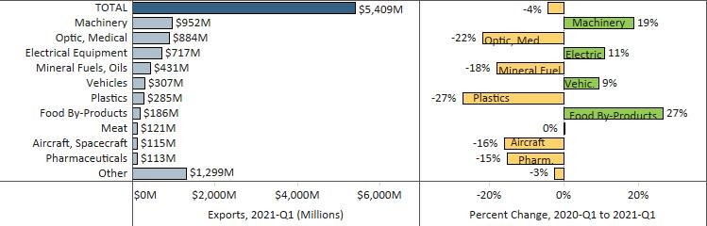
Minnesota Quarterly Export Statistics is the most current resource available for tracking the state’s export trends in manufactured and other good. The report is prepared for the Minnesota Trade Office (MTO) by the Department of Employment and Economic Development’s (DEED) Economic Analysis Unit (Thu-Mai Ho-Kim). The quarterly and annual statistics reports primarily cover export data based on the Harmonized Tariff System (Schedule B), collected by the U.S. Department of Commerce (USDOC) and distributed by IHS Markit. Reports are available on DEED’s website at “Export and Trade Statistics” (http://mn.gov/deed/data/export-stats/).

