Data on Minnesota Exports for Third Quarter 2021 – Published January 2022
For More Information: Jen Gates 651-358-0300

State Exports Continue to Recover: 19% Growth in Third Quarter
- Minnesota exports of goods (including agricultural, mining and manufactured products) were valued at $5.7 billion in the third quarter of 2021, increasing 19% (or $916 million) over the third quarter of 2020, and 2% over the third quarter of 2019.
- U.S. exports of goods grew 23% between the third quarters of 2020 and 2021. Reflecting broad-based trends of recovery, exports made gains in 47 states.
- Minnesota manufactured exports expanded 17% to $5.3 billion between the third quarters of 2020 and 2021. U.S. manufactured exports were up 20%.
- For the January to September period, state exports grew 13% in 2021 over 2020, and 3% over 2019. U.S. exports grew 23% over 2020, and 4% over 2019.
Figure 1. Exports Increase from 47 States
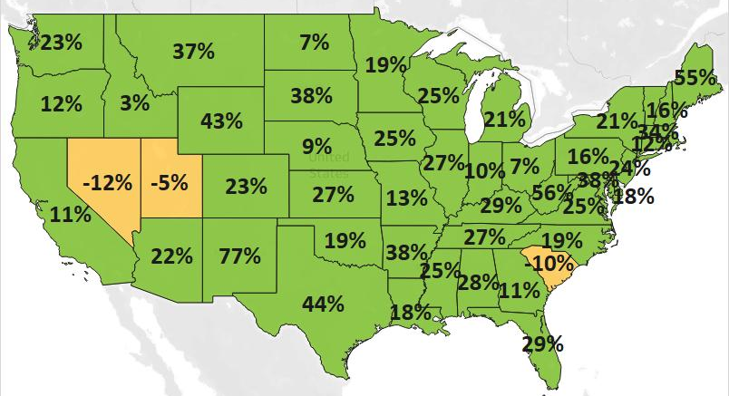
MN: 19%
U.S.: 23%
Decline 0% Growth

Widespread Strengthening Demand Across Global Regional Markets
- Global markets showed recovering conditions from the steep declines of 2020. Exports jumped 31% to North America, 12% to Asia and 10% to the European Union – which were the state’s three largest export regions and accounted for 87% of exported goods.
- Top markets such as Canada (up $406 million), Mexico (up $112 million), the Philippines (up $85 million), China (up $55 million), and Taiwan (up $38 million) made remarkable gains. Exporters made inroads in markets such as India ($66 million, up 108% – fueled by railway equipment), Indonesia ($69 million, up 42% - due to wood pulp demand) and the Czech Republic ($35 million, up 130% – driven by bulldozers).
- Exports to some other large markets – such as Korea (down 45%), Singapore (down 21%) and France (down 12%) – fell further this quarter, prolonging the downward trends from 2020.

Figure 2. Export Trends for Minnesota’s Top 10 Markets, Third Quarter 2021
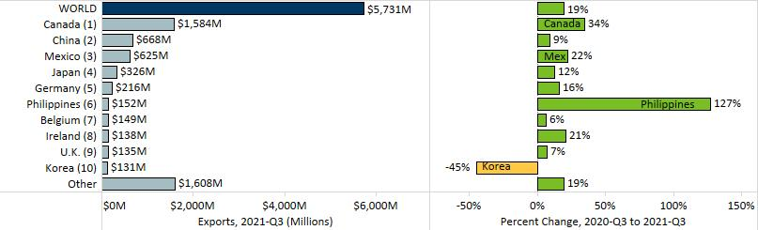

Gains in Machinery, Mineral Fuels and Electrical Equipment Drive Growth
- Positive growth trends were widespread across many products but mixed across the state’s top exports. Machinery (up 33%), electrical equipment (up 36%) and mineral fuels, oils (up 129%) bolstered the state’s exports and helped to offset persisting declines of optic, medical (down 5%), plastics (down 6%) and vehicles (down 13%).
- Also gaining significant traction were exports of oil seeds, miscellaneous grains ($102 million, up 142%), aircraft, spacecraft ($131 million, up 77%) and food by-products ($167 million, up 34%).
Figure 3. Minnesota’s Machinery Exports

- Export growth of machinery was propelled by the Philippines ($123 million, up 1,086% or up $112 million) and China ($132 million, up 50%); and by machines for making semiconductors ($164 million, up 266%) and centrifuges, filters ($188 million, up 42%).
- Canada ($429 million, up 133%) drove growth in mineral fuels, oils (largely consisting of light oils).
- Electrical equipment exports surged due to robust demand in China (up 97%), Canada (up 30%), Germany (up 42%) and Thailand (up 27%). Integrated circuits ($238 million, up 83%), electrical switches ($64 million, up 99%) and diodes and transistors ($59 million, up 69%) contributed the largest gains in exports.
- Various food and agricultural goods performed well. Canada and Mexico drove demand for food by-products and oil seeds (largely soybeans), together buying more than half of these exports. Continued strong demand for meat (mainly pork) in Japan (up 81%) and Mexico (up 106%) softened the fall in sales to China (down 29%).
- Rebounding global sales of medical, surgical instruments ($394 million, up 24%) and measuring analytical instruments ($114 million, up 45%) were overshadowed by continued shrinking sales of optical fiber ($30 million, down 83%) – mainly dragged down by China (down $52 million) and South Korea (down $79 million) – and navigational instruments ($8 million, down 74%).

Figure 4. Export Trends for Minnesota’s Top 10 Products, Third Quarter 2021
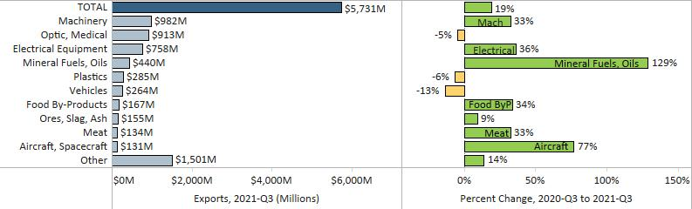
Minnesota Quarterly Export Statistics is the most current resource available for tracking the state’s export trends in manufactured and other good. The report is prepared for the Minnesota Trade Office (MTO) by the Department of Employment and Economic Development’s (DEED) Economic Analysis Unit (Thu-Mai Ho-Kim). The quarterly and annual statistics reports primarily cover export data based on the Harmonized Tariff System (Schedule B), collected by the U.S. Department of Commerce (USDOC) and distributed by IHS Markit. Reports are available on DEED’s website at “Export and Trade Statistics” (http://mn.gov/deed/data/export-stats/).

