Data on Minnesota Exports for Fourth Quarter 2021 – Published April 2022
For More Information: Alicia Cordes-Mayo (alicia.cordes-mayo@state.mn.us, 763-406-9965)

State Exports Jump 30% in Fourth Quarter
- Minnesota exports (including agricultural, mining and manufactured products) were valued at $6.4 billion in the fourth quarter of 2021, jumping 30% (or $1.5 billion) since the fourth quarter of 2020, and 16% over the (pre-Covid) fourth quarter of 2019.
- Overall U.S. exports of goods also rose strongly over the fourth quarters of 2020 (up 23%) and 2019 (up 16%). A large majority of states had export growth over the fourth quarters of both 2020 and 2019.
- Minnesota manufactured exports expanded 27% to $5.3 billion between the fourth quarters of 2020 and 2021, while U.S. manufactured exports rose 19%.
- Minnesota exports gained 17% for the year between 2020 and 2021, while U.S. exports increased 23%.
Figure 1. 41 States Increase Exports
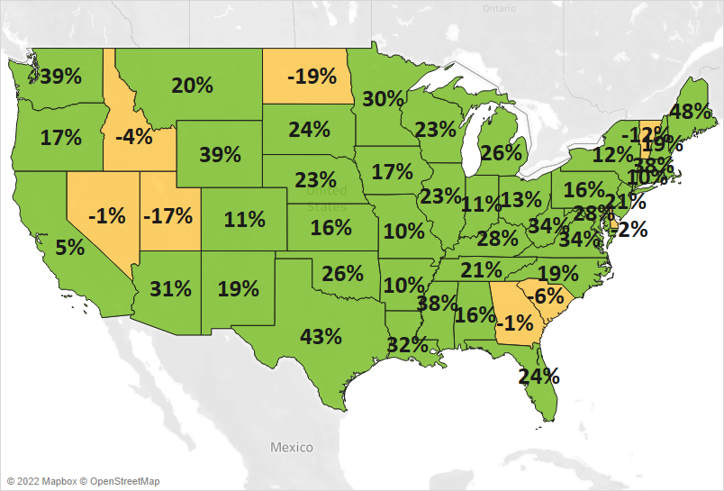
MN: +30%
U.S.: +23%
Decline 0% Growth

Renewed Demand in Markets in North America and Asia Fuels Export Gains
- Exports to the state’s main three regional markets continued to rally, driven by markets in North America (up 46%), Asia (up 32%) and the European Union (up 20%). Exports to North American and Asian markets in the fourth quarter of 2021 outperformed exports to these regions in 2019.
- Markets with the largest export gains included Canada (up $762 million), the Philippines (up $271 million), Japan (up $115 million), China (up $107 million) and India (up $68 million).
- Exports also grew to Africa ($79 million, up 43%) and Central and South America ($247 million, up 10%).
- Minnesota exports faltered in the Australia-Pacific region (down 18%), European countries outside the EU (down 7%) and the Middle East (down 12%) – where strong growth to Israel (up 60%) was offset by declines to Saudi Arabia (down 48%) and the UAE (down 19%).

Figure 2. Export Trends for Minnesota’s Top 10 Markets, Fourth Quarter 2021
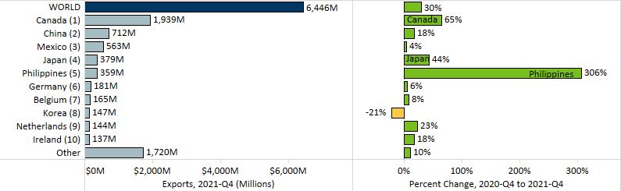

Export Recovery Led by Machinery, Mineral Fuel, Cereals and Electrical Equipment
- Minnesota exports continued to rebound from 2020, with growth across most of the state’s Top 10 products – led by machinery (up 50%), mineral fuel, oil (up 237%), cereals (up 373%) and electrical equipment (up 33%).
- Global sales of machinery surged ahead, based on machinery for making semiconductors ($373 million, up 450% – propelled by the Philippines (up $302 million)), centrifuges, filters ($181 million, up 34%) and pumping equipment ($69 million, up 26%).
Figure 3. Electrical Equipment Exports

- Fourth quarter sales of railway equipment; optic, medical goods; ores, slag, ash; and aircraft, spacecraft each grew by more than $35 million. Railway equipment exports gained traction in India – with sales growing by $45 million there, while aircraft, spacecraft sales were uplifted by France (up 305%) and Mexico (up 466%).
- As the primary market, Canada generated impressive trends in mineral fuel, oil (primarily light oils, including gasoline); fertilizers; ores, slag, ash (consisting of iron ores); and cereals (driven by demand for corn (maize)). As an emerging market for cereals, Morocco (up $26 million) also spurred sales of corn.
- Successful ventures in electrical equipment brightened the most in China ($169 million, up 62%), Canada ($93 million, up 42%), Japan ($57 million, up 87%) and Germany ($48 million, up 97%). High-growth segments included integrated circuits (up 56%), switches (up 75%), semiconductors (up 71%) and generators (up 73%).
- Japan drove the spike in meat sales (up 14%) while Indonesia led the gains in wood pulp ($67 million, up 56%).
- Demand for vehicles (down 14%) and pharmaceuticals (down 11%) buckled to levels below those in the fourth quarter of 2019. Sales of vehicles weakened in Mexico, Canada and Switzerland; while those of pharmaceuticals tumbled in numerous smaller markets, including Saudi Arabia Russia, and Australia.

Figure 4. Export Trends for Minnesota’s Top 10 Products, Fourth Quarter 2021
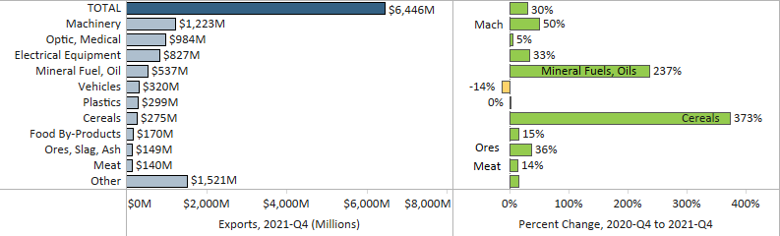
Minnesota Quarterly Export Statistics is the most current resource available for tracking the state’s export trends in manufactured and other goods, and is prepared for the Minnesota Trade Office (MTO) by the Department of Employment and Economic Development’s (DEED) Economic Analysis Unit (Thu-Mai Ho-Kim). The quarterly and annual statistics reports primarily cover export data based on the Harmonized System (Schedule B), accessed from WISERTrade - State HS Database, based on data collected by the U.S. Census Bureau, Foreign Trade Division. Reports are available on DEED’s website at “Export and Trade Statistics” (http://mn.gov/deed/data/export-stats/).

