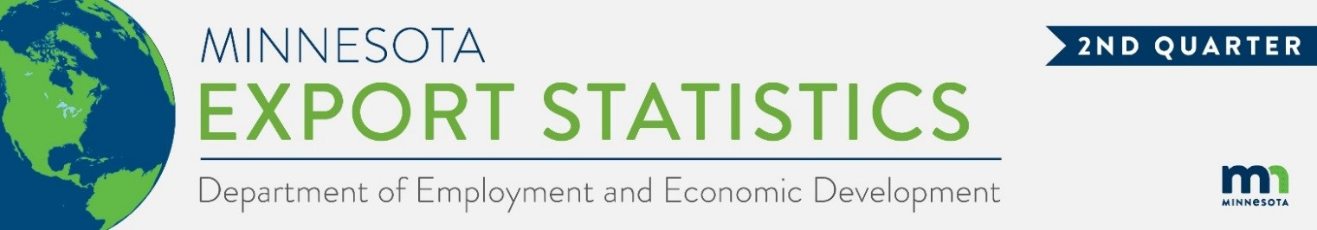
Data on Minnesota Exports for Second Quarter 2023 – Published August 2023
For More Information: Alicia Cordes-Mayo (alicia.cordes-mayo@state.mn.us, 763-406-9965)

Bright Spots of Growth Despite State Exports Sliding 9%
- Minnesota exports of goods (including agricultural, mining and manufactured products) were valued at $6.1 billion in the second quarter of 2023, representing a drop of 9% (or down $578 million) over the second quarter of 2022. This was the first quarterly decline after eight quarters of export growth. For the year to date, state exports are unchanged between 2022 and 2023.
- U.S. exports of goods fell 7% during the second quarter, as exports declined from 29 states between the second quarters of 2022 and 2023.
- Minnesota’s manufactured exports slipped by 10% to $5.4 billion in the second quarter of 2023, while U.S. manufactured exports fell 3%.

Figure 1. Exports Declined from 29 States
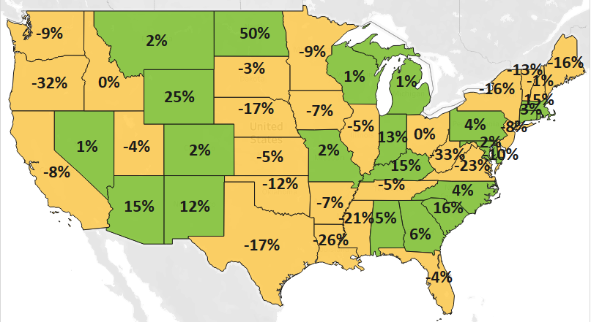
MN: -9%
U.S.: -7%
Decline 0% Growth

Export Gains in Other Regions Help Offset Declines in Canada and Asia
- Minnesota’s exports dropped sharply to North America ($2.4 billion, down 20%) with slumping demand in Canada (down 33%) offsetting robust trends in Mexico (up 26%).
- Exports buckled to Asia ($1.7 billion, down 10%) as large export declines to China, Thailand, Taiwan and Singapore overwhelmed solid gains to Malaysia and the Philippines.
- Strong growth in other world regions offered brighter outcomes. Exports grew strongly to Europe (up 10%) – led by the Netherlands and Ireland; to the Caribbean, Central and South America (up 5%); to the Australia-Pacific region (up 22%) – fueled by Australia (up 27%); and to the Middle East (up 28%)

Figure 2. Export Trends for Minnesota’s Top 10 Markets, Second Quarter 2023
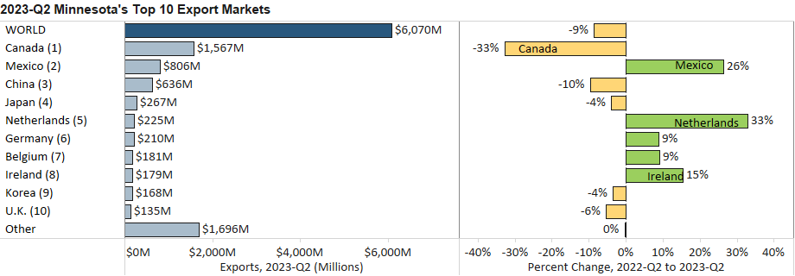

Vehicles, Optic/Medical, Ores and Aircraft Products Lead in Export Gains

- Exports of some key products performed strongly in the second quarter, and were led by vehicles (up 54%), optic, medical (up 8%), ores, slag, ash (up 29%), aircraft, spacecraft (up 21%) and pharmaceutical goods (up 27%).
- In contrast, global sales of mineral fuel, oil (down 82%), cereals (down 46%), plastics (down 17%) and food by-products (down 26%) sank significantly.
- Export growth in vehicles was driven by Canada ($248 million, up 53%); Mexico ($137 million, up 54%, led by vehicle parts); and Ukraine ($19 million, up from $28,000, mainly tanks, armored vehicles).
Figure 3. Markets for Aircraft, Spacecraft

- Optic, medical goods swelled in China (up 19%), Belgium (40%), Ireland (up 17%) and Korea (up 36%) but tumbled to Taiwan (down 41%). Medical, surgical instruments and orthopedic, other parts boosted gains.
- Ores, slag, ash (mainly iron ores) grew strongly to Canada (up 22%) and Japan (up 163%).
- Top markets for aircraft, spacecraft steered growth: Germany ($28 million, up 177%) and Australia ($21 million, up 212%). Japan (up 485%) and Saudi Arabia ($4.5 million, up from $19,000) also had notable growth.
- Drug sales (up 86%) surged to account for a third of Minnesota’s pharmaceutical exports and were largely propelled by Belgium. Blood products (up 2%) accounted for half of exports, much less than in previous years.
- High-growth markets for machinery – such as Mexico (up 33%), Saudi Arabia (up 496%) and France (up 108%)– balanced depressed demand in China (down 33%), the Czech Republic (down 85%) and the Philippines (up 68%). Growth segments included engine parts; computers and parts; and specialized machinery.
- Exports of mineral fuel, oil plunged, as sales to Canada sank (down $621 million or down 97%). A bump in sales of petroleum oils to the Netherlands ($92 million, up from none) partially countered the loss.
- Mexico (up $86 million) surpassed Canada (down $228 million) as the primary market for cereals.

Figure 4. Export Trends for Minnesota’s Top 10 Products, Second Quarter 2023
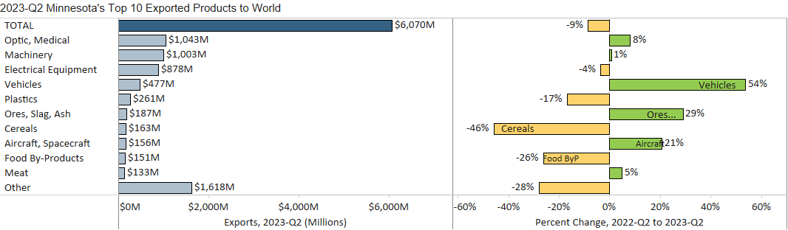
Minnesota Export Statistics reports track the state’s trends in exports of goods and is prepared for the Minnesota Trade Office by DEED’s Economic Analysis Unit (Thu-Mai Ho-Kim). The quarterly and annual reports primarily cover export data based on the Harmonized Tariff System (Schedule B), collected by the Foreign Trade Division, Census Bureau, U.S. Dept of Commerce and accessed through USA Trade Online (Census Bureau) and Trade Data Monitor (TDM). Historical reports are available on DEED’s website at “Export and Trade Statistics” (http://mn.gov/deed/data/export-stats/).

