# Memo

**Date: September 27, 2022**

**To: Energy Transition Advisory Committee**

**From: Carla Vita, Director Energy Transition**

## RE: ETAC Stakeholder Survey

**Background:**

The ETAC at the June 28, 2022 you determined that surveys from Stakeholders was needed per the recommendation of the Executive Committee. The Executive Committee along with Abby Wozniak and ETO staff developed the attached suvery. The survey was given to all ETAC members, each impacted community and county, all the MN tribal communities, those receiving ETAC packets, and many more. 53 surveys were completed.

**Goal**

Receive information from stakeholders to assist us on ETAC plan development

**Recommendations & Strategies:**

Marketing and communication is critical. Funds for marketing and communication for the impacted communities to address the following, but not limited to:

* 1. Address plant closure information
  2. Address plant closure concerns – including reliability
  3. Address confusion on the power plant closures including dates
  4. Correct incorrect information

**Key Findings:**

* Michael Child’s communication to the ETAC on the concerns was parroted with a strong response from Prairie Isanti Prairie Island Native American Community
* Lack of participation from power plant workers. Possible that the power planty workers are receiving such good information that they did not feel the need to complete the survey.
* Very little to no response from some counties that are impacted.

Note the following pages are the survey results of the 10 questions.

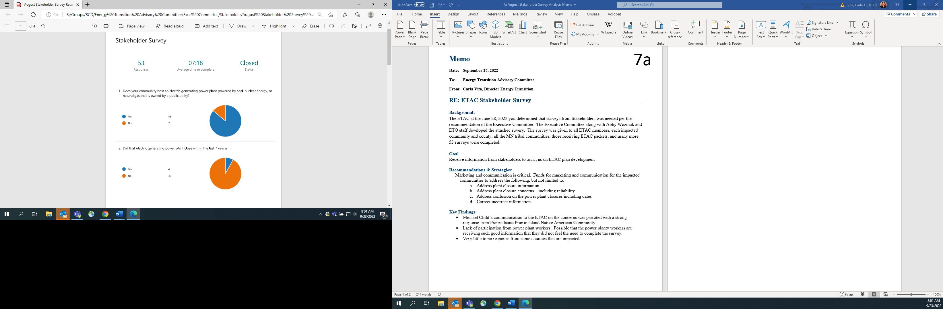

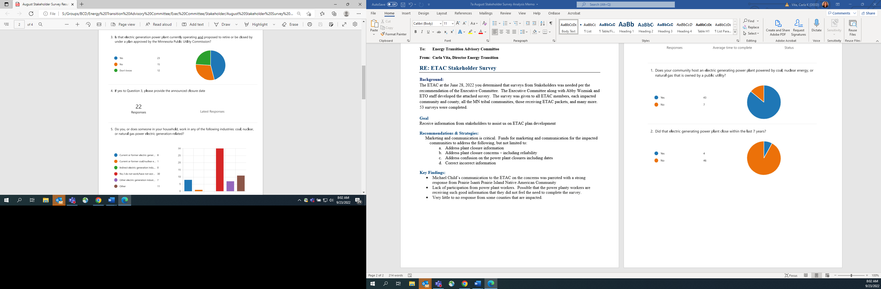

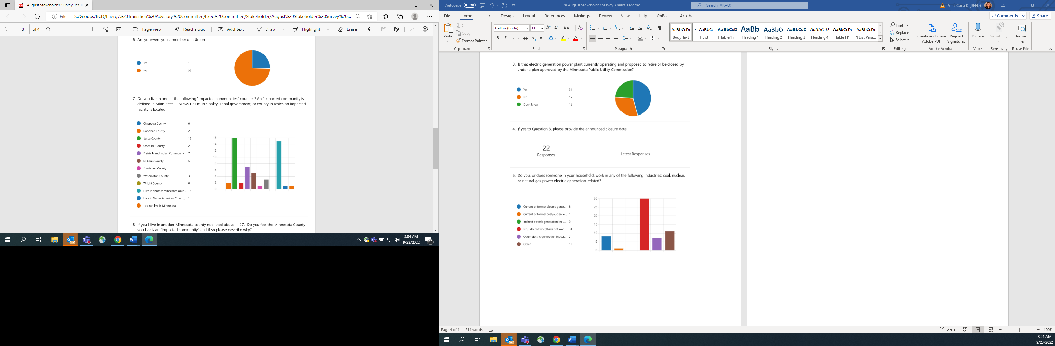

Question 8

|  |
| --- |
| **If you I live in another Minnesota county not listed above in #7.  Do you feel the Minnesota County you live is an “impacted community” and if so please describe why?** |
| All communities are impacted by the reliability and price volatility of the electric grid. Lack of reliable energy production can become extremely dangerous to life and health in a midwest winter. |
| Cook County since MN Power's coal plant is located in Schroeder. Surprised and dismayed not on Deed's impacted communited list. |
| no |
| no |
| No |
| Nuclear through SMRs is needed for reliable baseload energy and can be augmented with wind and solar at applicable times. Without this trifecta I do not find it plausible to have reliable power that we can depend on. |
| we make up the majority of the solar farms in the east metro area chisago cty |
| Yes, I work in Itasca County - and it is my primary shopping hub as well. I live on the border of Itasca County and work closely with the Boswell Energy Center |
| Yes, many people in my county work for one of the two biggest utility companies in MN. The reckless policies of this administration will continue to drive jobs away. |
| Yes, the power plant is a large payer of our local tax base. |
| Yes. Any closure of a base load power plant impacts the availability of electric power resources state-wide. The State should be investing in modern (recent) advances in nuclear power as well as renewables to satisfy future electric generation and distribution needs for the region and the MISO. |
|  |

Question 9

|  |
| --- |
| **If you live in another Native American Community not listed above in #7 please state which Community.** |
| Leech Lake |
| Saint Paul |
|  |

Question 10

|  |
| --- |
| **If you said you live in a Native American community, do you feel the Native American Community you live is an “impacted community” and if so please describe why?** |
| The Tribal jurisdiction, federally recognized, is more than a community. The coal burning plant is interdependent to the hydro system that changed the watershed of Leech Lake, costing 188,000 acres of land loss, food source loss, ceremonial and burial ground damage. The emissions of the current coal burning plant effect air quality, wild life. The history of Minnesota's energy drivers - the wood basket and water systems - is fundamental cause of the Treaty of 1855, resulting in the displacement and relocation of Minnesota's first people. |
| Hmm??? |
|  |