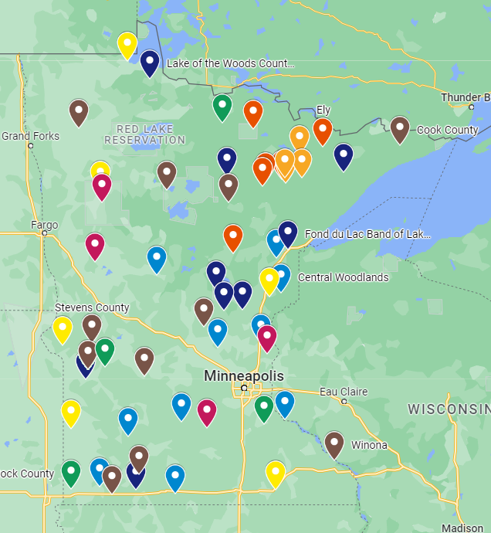
For more than 10 years, Blandin Foundation worked with eight cohorts of BBCs (64 communities in total!) to help them thrive with better broadband. Each community worked with a Blandin Broadband Coach to create and deploy a plan based on their local needs. The community used that plan to solicit local project grant applications and they decided together which projects to fund. The cohort of communities shared and learned from each other.

Blandin invested more than $4.2 million in those local broadband projects; the local communities required matched was $1.5 million – which they greatly exceeded. Together they funded more than 400 projects. Examples include Wi-Fi on school buses, teaching small business owners online marketing, getting homebound seniors to use computers to access online medical portals and friends and family around the world.

Blandin Broadband by the Numbers
$4.2 million | Investment in local community broadband projects
$1.5 million | Local match leveraged by grants
400+ | Projects funded
64 | Participating communities

But the impact of Blandin is more than the local financial investment. (And their investment is greater than represented because there were grants made that weren’t part of the cohort process as well as staff and consultant time to make it happen.) Blandin created awareness and a community centered on broadband that meant people were watching and engaging in the process of getting better broadband. In end of cohort assessments, participants consistently noted that the greatest value was the education and convening that happened within their own communities and cohorts. Blandin hosted an annual conference and maintained a daily blog deciphering the policy and technology of broadband to community leaders who found themselves needed to understand it to expand and enhance the conversation and community.

