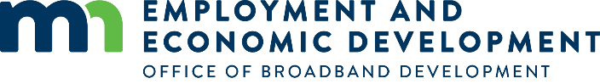
FAQs
WEBINAR: Orientation to Office of Broadband Development (OBD) Mapping & Data Resources

Can you talk more about the speed data provided by FCC and the providers? This data is not always accurate as it gives the best speeds for the service area rather than your specific location. There has been many independent speed tests done and they do not match with what the providers are reporting?
OBD is required by statute to contract with an entity to collect broadband deployment data from Minnesota providers, verify its accuracy by on the ground testing, and create state and county maps showing the availability of broadband service at various upload and download speeds throughout Minnesota. To comply with this requirement, OBD has a contract with a company called Connected Nation who works with providers to collect the data and conducts three one-week field validation trips to Minnesota. The provider submittal of data to Connected Nation is entirely voluntary and if submitted, is classified by law as nonpublic data. As noted in the webinar, some of the providers submit data at the address level, most submit data by service area, and a few submit the same census-block level data they are required to file with the FCC. There are also a few providers that do not participate and for those, Connected Nation uses the most recent publicly available Form 477 data posted by the FCC.

The data provided is a starting point for the maps. Data submitted is reviewed by Connected Nation before inclusion in the update. Once the maps are published, both OBD and Connected Nation take input from residents and communities to correct any reporting inaccuracies.

OBD acknowledges that if the data is not provided on an address-level basis, those technologies where speed can vary by distance (DSL, fixed wireless) are likely reported at an aggregate level. Again, the maps are a starting point and we encourage residents and communities to contact our office to help us get the maps clarified for specific areas and locations. With that feedback, and the upcoming reforms to the FCC broadband data collection process to move away from reporting by census block, the maps will get better.

Regarding speed test data, OBD does include links to two speed tests on our website. Speed test data can be valuable if there are a large number of results for an area. We would remind those interested in conducting a speed test to verify the speed package they have subscribed to before conducting speed tests and then to follow these instructions:
  - Run the speed test from a device plugged directly into the modem; do not run the test over wi-fi.
  - Use the same speed test tool for all tests and use the same testing site.
  - Grab a screen shot of your test results by printing/saving the page or using the snipping tool.
  - Make sure no one else is on the network when the test is being run and nothing else is being run on the computer during the test (mobile phones and tablets should be disconnected from wi-fi, computer is not connected to VPN, etc.). As you know, people are upgrading the speed that they subscribe to because of multiple users in the home being online at the same time sharing that capacity. However, for purposes of determining whether the speed received matches the speed package purchased, the test needs to be run on one device to see what the maximum speed is and not what the speed is on one device out of many devices in the home online at the same time.

Is there a way to change the speed requirements for the search to 25/3?
On the current map, you can determine whether the service is at or above 25/3 by turning on both the technology layer and the grant eligibility layer. OBD decided to use the 10/1 speeds as a layer in order to capture the Connect America Fund II investments made by the FCC during the term of the current mapping contract. We will be revisiting that for the next contract.

Is data available measuring adoption and use?
Yes. Data on Adoption and Use/Internet Subscriptions can be found in two places on the Minnesota Map and on more information can be found on the Digital Inclusion page on the Office of Broadband Development webpage at this link: https://mn.gov/deed/programs-services/broadband/adoption/

- Layer data can in the AVAILABILITY/ADOPTION STATS tab next to the ACCESS tab in the upper left layer tray. Be sure to click on the little arrow to the left of the layer name to expand the layer as there are many sub-layers located in this section. (See screen image below, red markup)
- Additional Adoption information can be found in the bottom center tray under the Information tab under Adoption. (See screen image below, yellow markup)
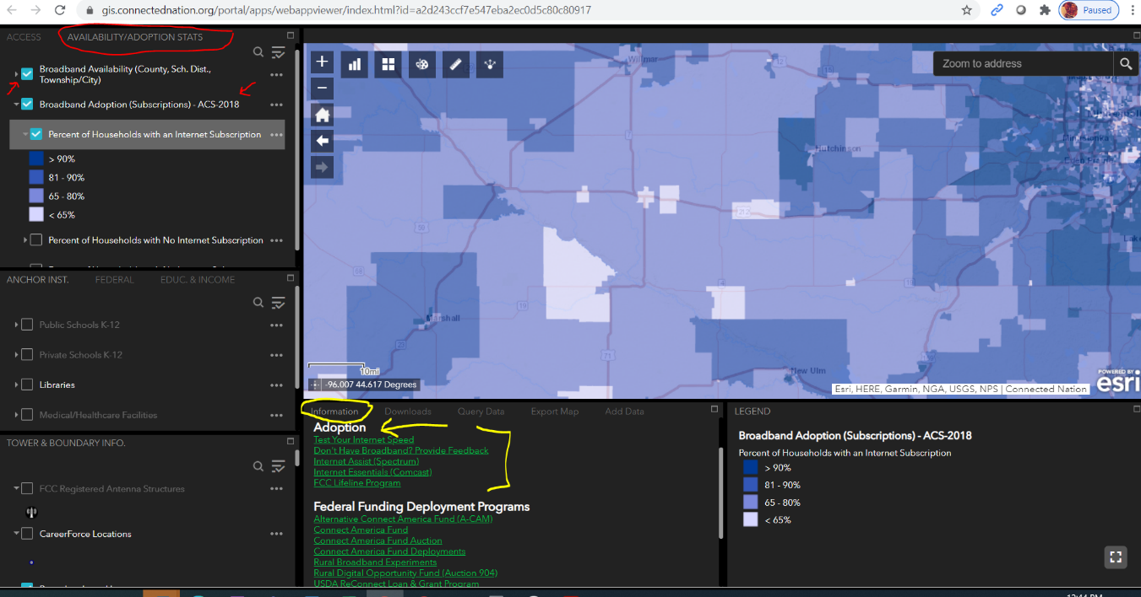

Can you show a Tribal map like Leech Lake Reservation?
Yes. The mapping section was pre-recorded so I couldn’t show this live, but I’ve included screen shots to demonstrate a great way to feature an area like the Leech Lake Reservation using the Query tool.
- Click on the Query Data tab tool located below the map in the center area of the screen.
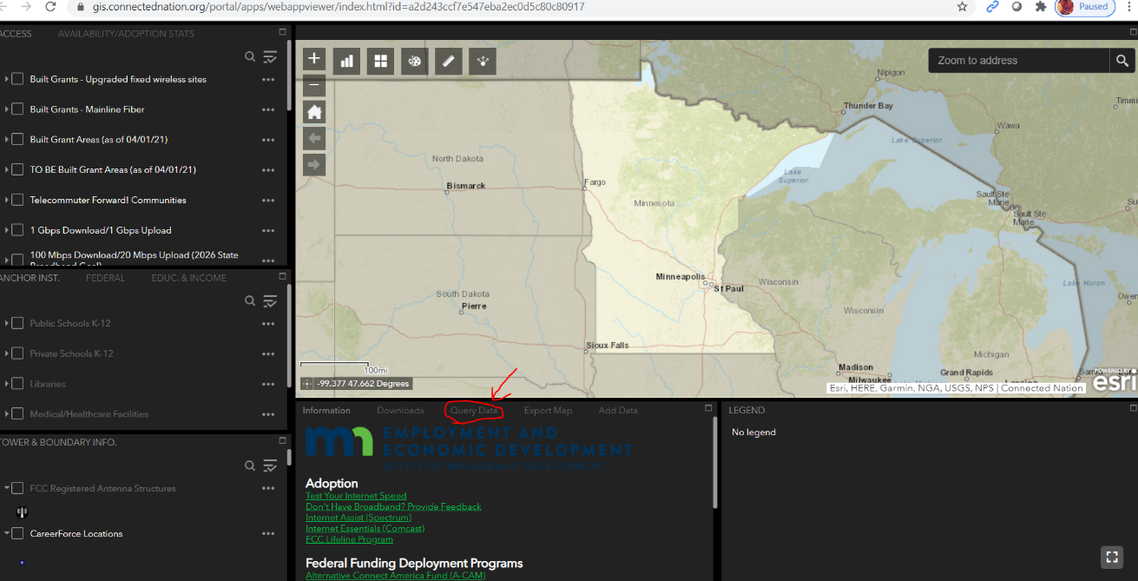
- After clicking the Query Data tab a Query option will come up. Scroll down until you see the Locate by Reservation option and click Locate by Reservation. (Note: This Query is only locating the tribal area, not the tribal area + Broadband Data. That’s OK, I’ll show you how to add other layers so you can see broadband information while Leech Lake Reservation is featured.)
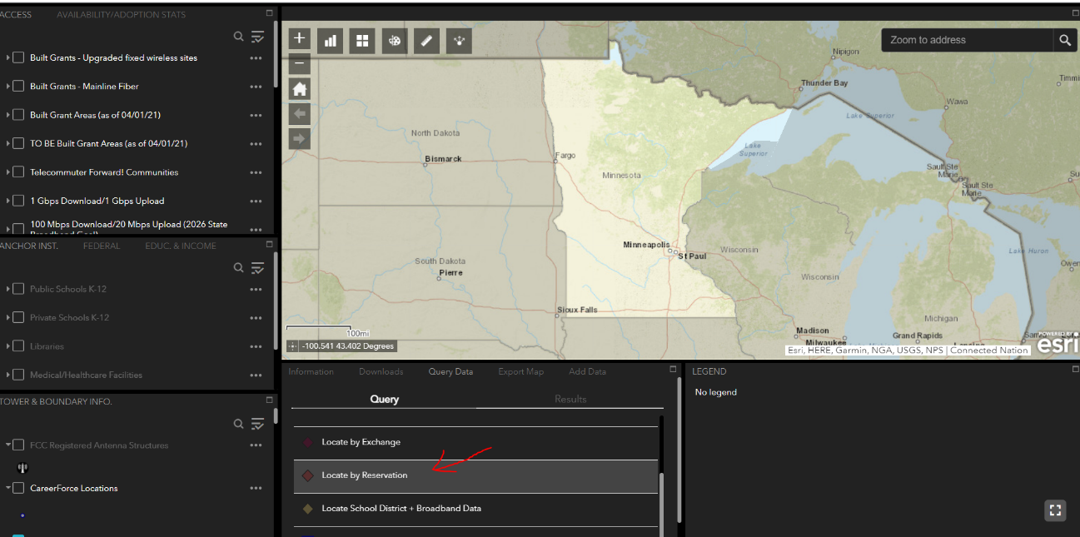

- After clicking on Locate by Reservation a Query criteria drop-down box will appear. Us the arrow indicated below to select from the drop-down choices.
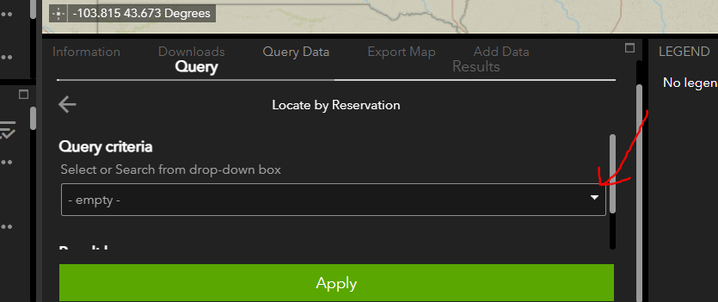

- You will notice there are two Leech Lake options in the drop down. Select Leech Lake Reservation. (Note: You can only select one at a time, but you can do additional queries to select other locations and create other layers.)
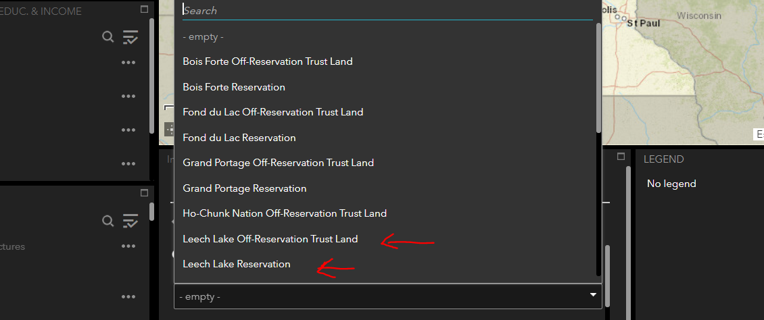
- After selecting Leech Lake Reservation, click on Apply in the green bar OR use the small scroll bar immediately to the right to edit the Result Layer Name. You can edit this name or leave it as the generic query name. Because we are creating a layer, I like to change the name to something I will easily recognize in the list of layers. For this example, I will rename the result Leech Lake Reservation.
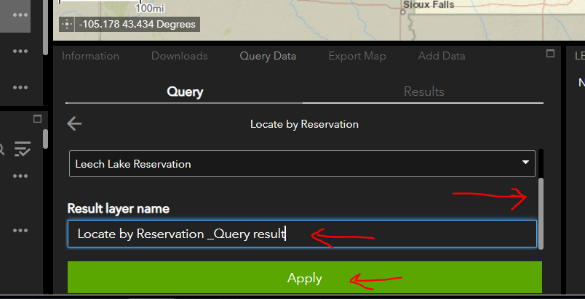
- After hitting reply the map will feature the Leech Lake Reservation and zoom to the area. You will also note that we’ve created a Leech Lake Reservation layer (or alternative name you’ve given it) in the layer section of our map.
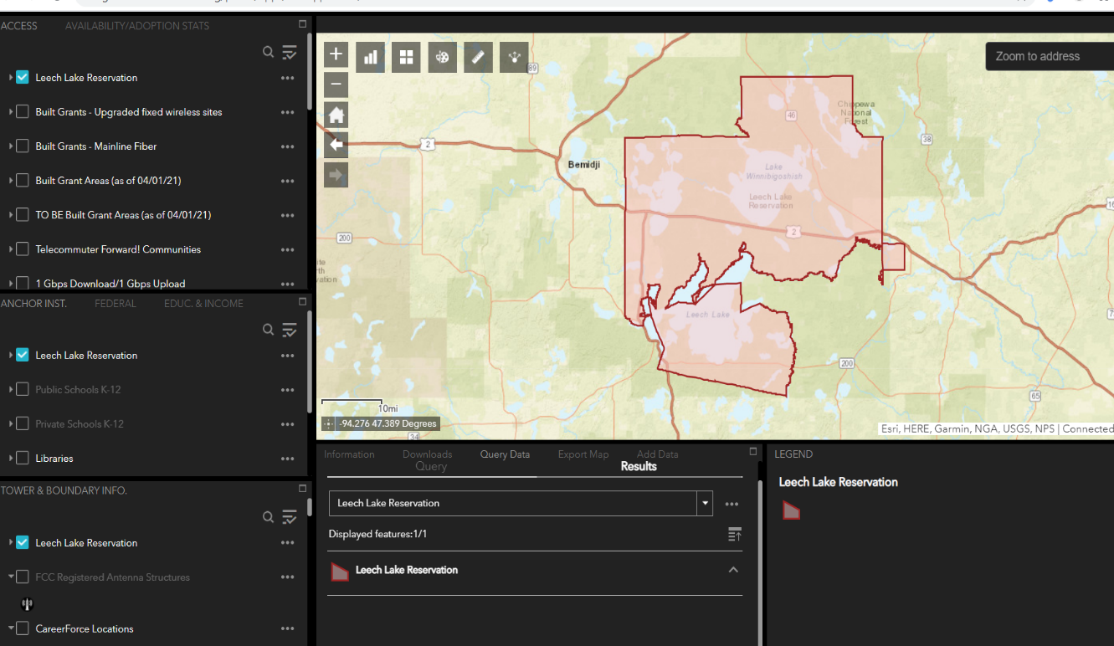
- At this point you can apply other layers and review broadband data while the focused Leech Lake Reservation area is feature. In my example screenshot below I’ve used the three dots to the left of our layer and used the transparency tool to increase the transparency of our layer to better see through it by sliding the slider toward the Transparent end. I’ve also added the 2021 Border-to-Border Grant Eligibility layer to our map by checking the box next to that layer so that you could see which areas are served and which are not within the tribal community. Note: Sometimes the lakes on the map pick up part of the applied layer color. That has happened with the pink unserved areas on part of this map.
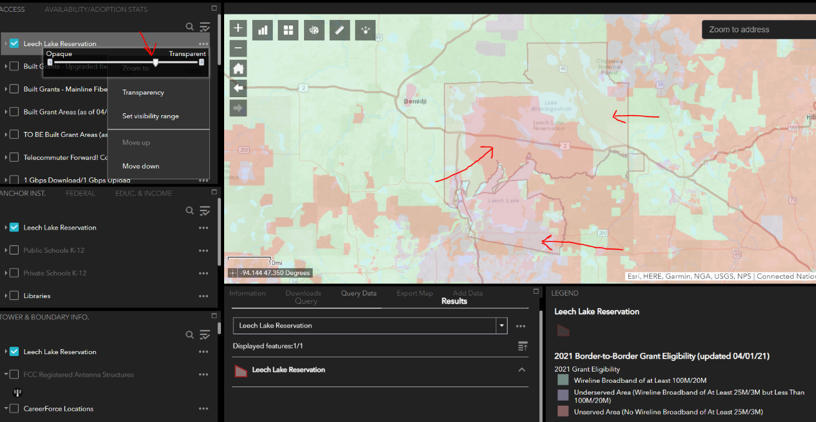
- Finally, even when I use the home button and zoom out to the default view we can easily see the area we want to feature on the map – as long as we keep the layer on. Note: As you add other layers to the map, you may need to adjust the transparency of your layer (or the other layers) depending on the layer characteristics of those you add to the map.)
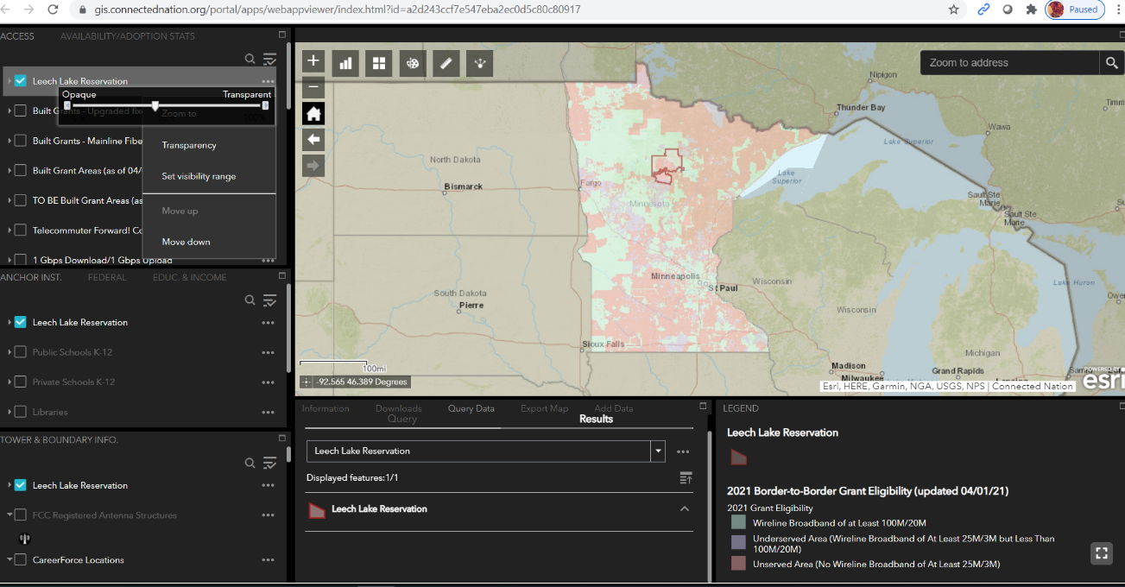

Is this training being recorded so it can be viewed at a later time?
Yes, a link to the recording will be posted to the Maps and Data page on the Office Broadband Development's website at this link: https://mn.gov/deed/programs-services/broadband/maps

Has there been any discussion about increasing the frequency of updating the data? Changes are occurring quickly?
We are not aware of any broadband mapping effort that updates more than twice a year. First, that would add to the expense of mapping, for which OBD receives no direct funding. (OBD is allowed to use a portion of the funds appropriated to the Border to Border broadband grant program to conduct the mapping—so any funds used on mapping are not available for infrastructure projects.) Second, the current bi-annual reporting fits with the current FCC broadband mapping schedule where providers are required to submit data in March and September and thus have updates prepared. Requesting more than a couple of data updates within a year from providers would likely be a burden to them and likely ignored. Third, the reporting updates the statewide maps and data. While there may be changes locally when a service is turned up, the data has not shown increases more than a few percentage points for the state as a whole with bi-annual reporting. Broadband providers do tend to make announcements via the local media when new service is available in an area and that media focus is more appropriate for new broadband availability in a specific area of the state.

Will the slide deck be provided to attendees? Thank you.
Yes, a PDF of the slide deck will be posted and available for download in an area on OBD’s Maps and Data webpage https://mn.gov/deed/programs-services/broadband/maps

Does this map work outside MN boundaries? For instance, St. Croix county in WI or Sioux Falls, SD?
No. The mapping layers in the Interactive Map are of Minnesota data only so will only populate within the state boundary of Minnesota.
Wisconsin and South Dakota have mapping resources available for their states and can be accessed via the following links:
Wisconsin Broadband Map - Public Service Commission of Wisconsin – (https://maps.psc.wi.gov/apps/WisconsinBroadbandMap/)
The South Dakota public utilities commission posts some pdf maps from the Form 477 data: https://puc.sd.gov/commission/telecom/Broadbandmaps.pdf (https://puc.sd.gov/commission/telecom/Broadbandmaps.pdf)
They can be found on the SD PUC website but there isn’t any explanation:
Telecommunications (sd.gov) (https://puc.sd.gov/telecom/default.aspx)

One of the topics listed for today’s webinar was “How communities are using local funding resources for broadband projects” – do you have time to address this?
OBD is aware that some counties and townships did award CARES Act funding for broadband infrastructure. We can post examples that we have. OBD has also prepared a Grant Application Template for communities to use as a resource if they are considering using Local Fiscal Recovery Funds from the American Rescue Plan Act for broadband infrastructure. That template will also be posted along with the other webinar resources on the Maps and Data page https://mn.gov/deed/programs-services/broadband/maps/
OBD would be happy to engage in further discussions on this topic as ARP guidance is made available; and this might best be done through the Association of Minnesota Counties, the League of Minnesota Cities or the Minnesota Townships Association.

What are the terms of the grant?
We are waiting on the Special Legislative Session to see if the Border to Border program will receive funding for a 2021 Border to Border grant round. Until we know what the funding source is and if there are any changes in legislation, we can’t comment on the specifics of a 2021 grant round. You can look at last year’s grant instructions and application located on this webpage https://mn.gov/deed/programs-services/broadband/grant-program/ to get an idea of past grant terms.
We will do another webinar launching the 2021 grant round if we receive funding.

When do you anticipate we will know more about the role of RDOF funding in moving ahead?
RDOF is an FCC program and the schedule for addressing that funding is under the FCC’s jurisdiction. Our understanding is that there are a couple of final pieces of information due in June (ETC designation and audited financial statements). We have not seen any schedule for FCC actions after they have received all the information scheduled to be filed.

