Navigating the Mega Menus
Finding information in the Minnesota Career Information System (MCIS) is easy once you know the main menu navigation. This handout is intended as a reference for those starting out with the program.

Administrative Side
The blue Mega menu on the administrative side of MCIS is separated in to five tabs.

Reports
The “Reports” tab on the administrative side is where staff or site administrators can go to run reports on what users are doing in MCIS. There are several reports to see if students are completing certain assessments, if they are saving occupations, programs of study or postsecondary institutions, what checklist activities they have completed and much more. The great thing about the “Reports” tab is that you can’t really break anything so feel free to play around with the different types reports.
For more information on reports, see the Navigating Reporting Tools document.

Portfolios & Groups
The “Portfolios & Groups” tab is where portfolio maintenance occurs. From this tab you can upload new user portfolios, transfer portfolios, reset passwords, create groups or view portfolios. Many of these tasks can be done from either the “Search Portfolios” link or from the options in the middle hyperlink column with the header, “Manage Active Portfolios.”
For more information on how to do portfolio tasks, see the Getting Started with MCIS document.
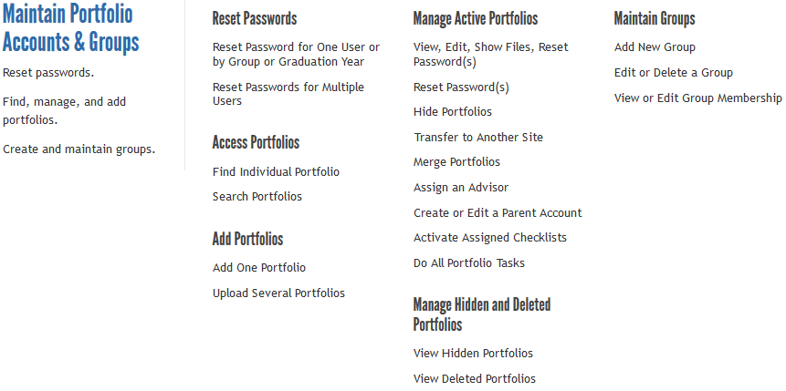

Other Accounts
Not all of the information in the “Other Accounts” tab will be visible to those who have access to the administrative side of MCIS. Only the side administrator will be able to see and use the features in the “Maintain Staff Accounts” column. We do not usually recommend creating Parent and Advisor accounts for your site as they tend to end up creating more work for you.
For more information on how to do portfolio tasks, see the Getting Started with MCIS document.
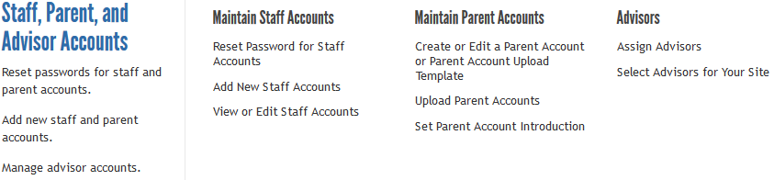

Customize
Using the “Customize” tab, staff and administrators can create and edit checklists for their site. Checklists are a great tool for implementing MCIS. They allow you to let users know which activities you want them to do in a particular order. The Course Planner, Personal Learning Plan Graduation Requirements and Privacy Options are features that can only be edited by the site administrator. Course Planner allows administrators to upload courses from your site or school to make it easier for users to keep track of which courses they are taking or plan to take and the grades they received for those courses. Graduation Requirements allow them to set how many credits students are required to take for each subject area in order to graduate from that site or school.
For more information on the Checklists, Course Planner, Graduation Requirements/ Privacy Options, see the Navigating the Customization Tools for Checklists, Navigating the Course Planner and Getting Started with MCIS documents.
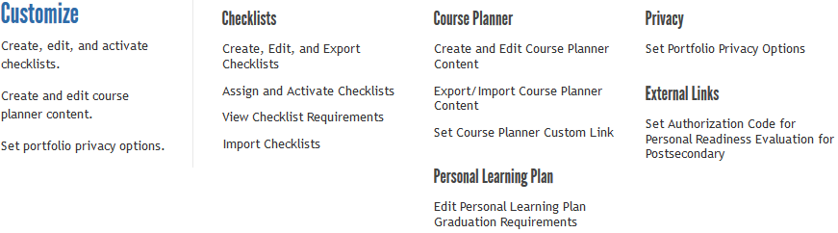

Help & Links
From the “Help & Links” tab, staff and administrators can find links to the Curriculum and Tools for Counselors & Teachers (both can also found in the footer on the student side) and links to Contact Us, should you have any questions.
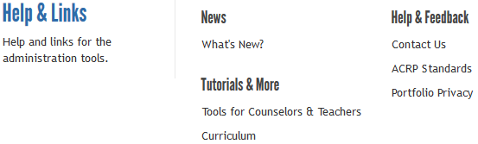

Student Side
The blue Mega menu on the Student side of MCIS is divided in to six tabs. The Career Plan, Occupations and Education have additional tabs for navigation within those information files.

Plan
The “Plan” tab is where users can access the planning tools available in MCIS. The first is the Career Plan which will take them through the career exploration process. Each of the three levels, Getting Started, Looking Deeper and Next Steps contains the same five sections that are repeated throughout each level of the career exploration process. Within each section (Know Myself, Research Options, Evaluate Options, Set Goals and Next Steps), users have access to different activities and reflection boxes. It is the reflection boxes from the career plan that are used to populate the Personal Learning Plan (PLP).
Checklists act as another guide or a syllabus for those using the program. It helps them complete the tasks that their teachers, counselors, etc. want them to see and do. The Course Planner allows them to record which classes they have taken or plan to take and what grades they received for those courses. It does not act as an official transcript.

Assessments
Taking assessments from the “Assessments” tab on the student side can help guide users to certain occupations by discovering their interest, skills and values. The results from various assessments will give students a list of occupations that they may be interested based on their results. All assessments can be taken multiple times and are stored in their portfolio. Not all assessments are available for all site types. Nearly all assessments are also available in Spanish.
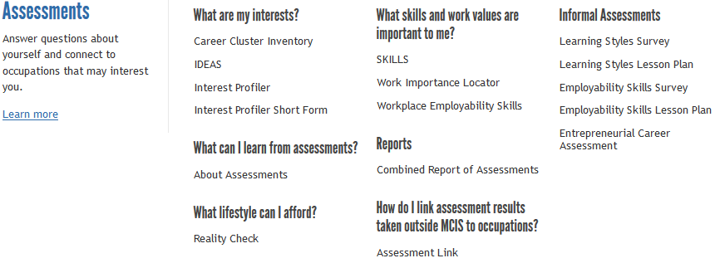

Occupations
The “Occupations” tab contains O*NET Occupational data has been re-written at either a 5th grade 8th grade reading level, depending on the version of MCIS you are using. Users are able to get a full picture of various occupations through information such as general work activities, working conditions, preparation, wages, employment and outlook and much more. This information is updated annually. Informational videos and real world interviews are also available for many of the occupations.
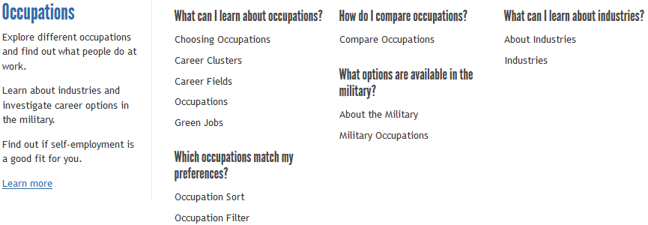

Education
The “Education” tab has perhaps the most information of the different information files in MCIS. The first section is Programs of Study. Users can learn about how to choose a program of study and search the programs of study themselves, either by looking how they are grouped by career cluster or by the name of the program. Within each program description is a wealth of information including admissions, typical course work, things to know and colleges and universities who have that program. There is also information on short-term training programs.
The Choosing a School section provides information on factors to consider when users are trying to decide where they want to go to school. There is information on Minnesota institutions, which is updated annually through surveys to the schools themselves. Information on US Colleges and Universities is also included in some versions of the program.
Other features of this file including Paying for School – information on the different ways for a user to pay for school. This includes a scholarship file with many Minnesota specific scholarships; information on the FAFSA; loans and grants; different sorts and filters for both schools and scholarships; an application tracker and a comparison tool.
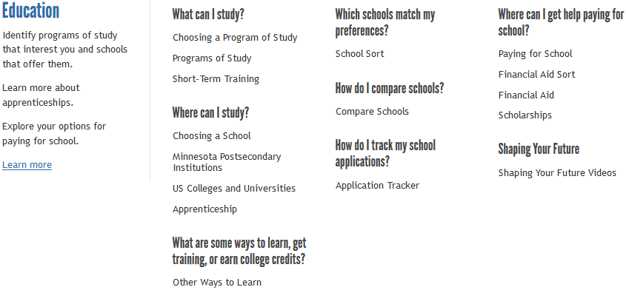

Employment
The information in the “Employment” tab can be helpful to users while they are at your site and for years after. In this file, users can learn about the Job Search process such as how to begin, what information to have readily available, help on completing applications and resumes and more. The Resume Creator helps users build their resume section by section, starting with education and training, continuing on to work history, achievements, activities and skills. Users can then create their resume using one of the default templates or customize their own. The final portion is Job Success which gives information that will help them know how to keep their job and be successful at it.
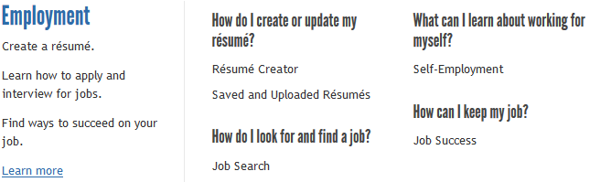

My Portfolio
The final tab on the student side is the “My Portfolio” tab. This is where all of the work users do in MCIS is stored. They can review their saved assessment results, see what programs of study or postsecondary institutions they have saved, access any saved resumes or other files and print their PLP. They can also modify elements of their PLP before printing. If your school has chosen to purchase Peterson’s packages (for the ACT, SAT, Civil Service, College Placement Skills Training), they would access them from the “My Portfolio” tab as well.
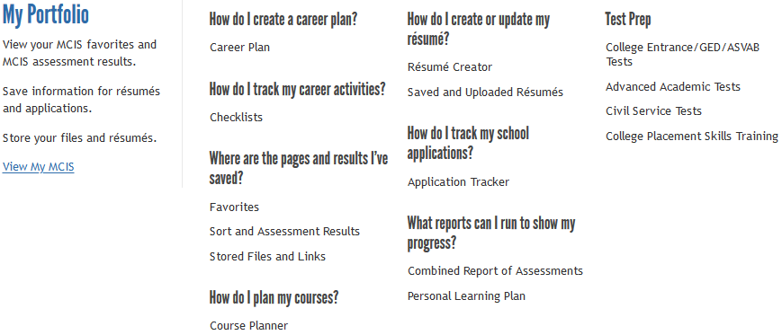

Occupations to Programs of Study to Postsecondary Institution
The final portion is to navigate in between the different information files. For example, finding an occupation and seeing which program of study is needed to work within that occupation, which postsecondary institution offers that program of study and finally learning about the institution that offers that program.
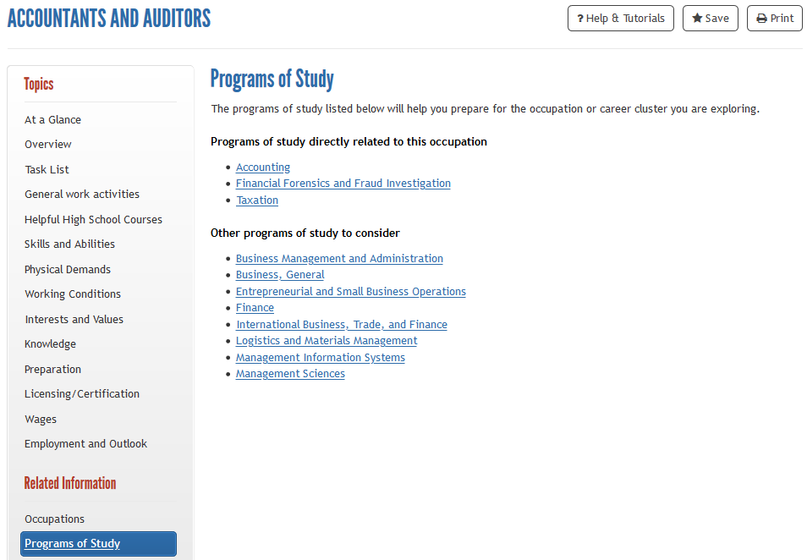
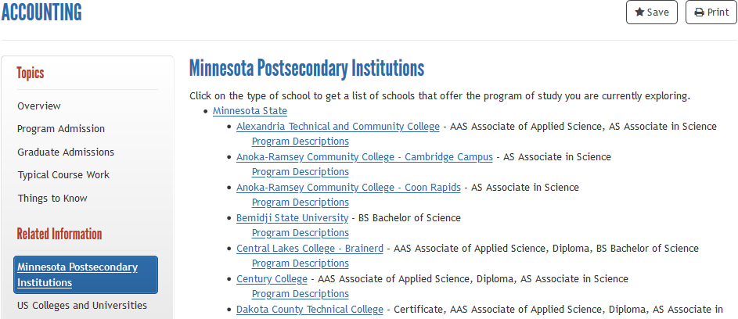
For more information, please contact MCIS at mcis.team@state.mn.us – 651-582-8321 or 800-599-6247.

