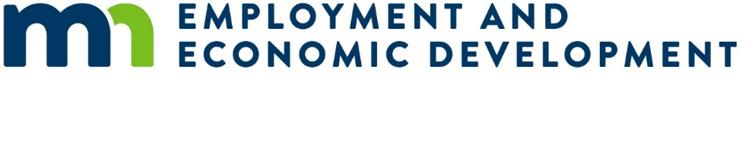
A Quick Start Guide for Organizations Receiving a Competitive Grant
Updated: 09/01/2020
Your organization has been awarded a grant from a competitive grant program. The following guide provides the steps needed to:
- Get a fully executed grant agreement in place
- Get your project started
- Start receiving grant payments
- Successfully close out your grant at the end of your project
All state grant policies, statues and forms can be found at the following link: https://mn.gov/admin/government/grants/policies-statutes-forms/

Executing a Grant Agreement and Starting your Project
Minnesota state agencies must use a written grant agreement for all grants made by the agency. No payments will be made to your organization until a grant contract is fully executed. Unless otherwise permitted you must not begin work under this grant contract until this contract is fully executed and you have been notified by the State’s Authorized Representative to begin the work.

Steps to Completing an Executed Grant Agreement
- Receive a notice via email that your organization has been approved for an award.
- Receive an official Award Letter approving your grant award.
- Register as a vendor with the State at https://mn.gov/admin/business/vendor-info/ if not previously registered.
- Complete and submit “Risk Assessment” worksheet. This form is used to determine if any special conditions need to be placed in the grant agreement. Any outcomes from this assessment do not affect the award decision or amounts.
- Submit an updated work plan to reflect final award amount (if different than what was requested).
- Receive/sign a finalized grant agreement and provide a copy via email to the State’s Authorized Representative.
- Receive a fully executed grant agreement and begin your project. Work must not begin under this grant contract until this contract is fully executed.
Time from award notification to fully executed grant agreement is approximately 4 weeks.

Grantee Payments
Grant payments will be processed on a reimbursement basis, using the Payment Request Form provided by the State. As you incur eligible expenses you may submit a Request for Payment form to the State’s Authorized Representative.
Requests for reimbursement must correspond to the approved grant budget line items (i.e. personnel costs, indirect costs, equipment costs). The State’s Authorized Representative will review each request for reimbursement against the approved grant budget, grant expenditures to-date and the latest grant progress report before approving payment. Grant payments shall not be made on grants with past due progress reports, unless the state agency has given the grantee a written extension.
Depending on the nature of your project you may submit payment requests on a monthly or quarterly basis. The maximum length of time that can be covered by a single payment request is three months. The payment request must be made within 30 days of the end of the period covered by the request.

Steps to Complete a Payment Request
- Incur and document eligible expenses based on the approved work plan and budget.
- Submit a complete and accurate Payment Request Form (provided by the State) to the State’s Authorized Representative along with a supporting documentation verifying the eligible expenses. Examples may include: a summary of program activities, a line item summary of expenses, summary of invoices, time and effort logs, etc.
- Receive approval for the request from the State’s Authorized Representative.
- Receive an Electronic Funds Transfer payment within 7-14 days.

Grant Progress Report
You will be required to submit written progress reports at least annually until all grant funds have been expended and all of the terms in the grant agreement have been met.
A grant progress report summarizes grant activities and outcomes for a given period. A progress report may have narrative, statistical and/or financial elements. Information requested in a grant progress report may include, but is not limited to: goals and objectives, activities, outcomes, challenges, lessons learned and financial information.
The State’s Authorized Representative will work with you to determine the report format and content requirements that best meet their needs in evaluating the outcomes of the grant program.

Monitoring Your Project
The State’s Authorized Representative is required to conduct at least one monitoring visit before final payment on all state grants of over $50,000 and to conduct at least annual monitoring visits on grants of over $250,000.
A grant monitoring visit involves both state granting agency staff and the grantee and occurs during the grant period. The purpose of grant monitoring visits is to review and ensure progress against the grant’s goals, to address any problems or issues before the end of the grant period and to build rapport between the state agency and the grantee. An effective grant monitoring visit may cover topics including but not limited to: statutory compliance, challenges faced by the grantee, modifications made to the grant program, program outcomes, grantee policies and procedures, grantee governance and training and technical assistance needs. Documentation from monitoring visits will be kept in the grant file.
The State’s Authorized Representative must also conduct a financial reconciliation of your project’s expenditures at least once before final payment is made on grants of over $50,000. A financial reconciliation involves reconciling a grantee’s request for payment for a given period with supporting documentation for that request, such as purchase orders, receipts and payroll records.

Finishing Your Project and Closing out The Grant
Unless otherwise specified in your grant agreement, you are required to submit your final payment request within 20 days of the end of the grant agreement. In addition to submitting the request you will be required to submit a final report on the outcomes your project. The final report summarizes grant activities and outcomes for the entire grant period. The final report may have narrative, statistical and/or financial elements. Information requested in a grant progress report may include, but is not limited to: goals and objectives, activities, outcomes, challenges, lessons learned and financial information.
The State’s Authorized Representative will review and approve your final payment request, review the final report and conduct a close-out evaluation of your performance in meeting the objectives of the grant. You will receive close-out notice confirming the successful completion of the grant and all documents will be placed in the grant file.
It is the policy of the State of Minnesota to consider a grant applicant’s past performance before awarding subsequent grants to them. State agencies must consider a grant applicant’s performance on prior grants from that agency before making a new grant award of over $5,000.

Minn. Stat. 16B.98

