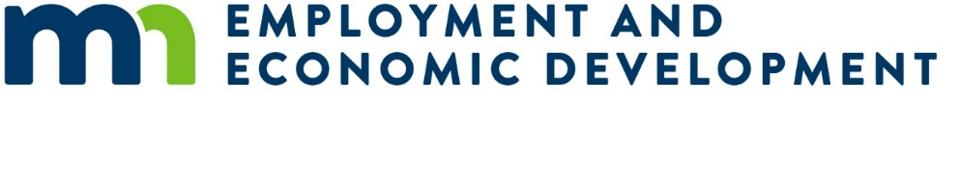
An Overview for Organizations Receiving a Legislatively Mandated Grant
Updated: 9/01/2020
Your organization has been awarded a legislatively mandated grant. The following is a guide on the steps necessary to fully execute a grant agreement, get your project started, start receiving grant payments, and successfully close out your grant at the end of your project.
All state grant policies, statues and forms can be found at the following link: https://mn.gov/admin/government/grants/policies-statutes-forms/

Executing a Grant Agreement and Starting your Project
Minnesota state agencies must use a written grant agreement for all grants made by the agency. No payments will be made to your organization until a grant contract is fully executed. Unless otherwise permitted you must not begin work under this grant contract until this contract is fully executed and you have been notified by the State’s Authorized Representative to begin the work.

Steps to Completing an Executed Grant Agreement
- Register as a vendor with the State (https://mn.gov/admin/business/vendor-info/)
- Submit documents for a financial review to ensure your organization is financially stable enough to carry out the purpose of the grant. Documents include one or more of the following: an internal financial statement, an IRS Form 990 or a certified financial audit.
- Carefully review the authorizing legislation and work with the State’s Authorized Representative to arrive at a common understanding of the legislative intent of the funding.
- Submit a grant work plan that identifies desired project or program activities, timelines and outcomes.
- Submit a grant budget that details all the expenses and revenues related to the grant. You are required to minimize administrative costs as a condition of your grant.
- Receive an official Award Letter approving your work plan and budget.
- Receive and review the draft grant agreement provided by the State’s Authorized Representative.
- Work with the Authorized Representative to finalize the details of the grant agreement.
- Receive and sign a finalized grant agreement and provide a copy to the State’s Authorized Representative.
- Receive a fully executed grant agreement and begin your project.
Depending on your project and your stage of development in your project it can take 1-2 months to complete.

Grantee Payments
Unless otherwise agreed upon grant payments will be made on a reimbursement basis. You may incur eligible expenses then submit a request for reimbursement for those expenses to the State’s Authorized Representative. You will be provided a Payment Request Form that you will use to request payment.
Requests for reimbursement must correspond to the line items in the approved grant budget (i.e. personnel costs, indirect costs, equipment costs). The State’s Authorized Representative will review each request for reimbursement against the approved grant budget, grant expenditures to-date and the latest grant progress report before approving payment. Grant payments shall not be made on grants with past due progress reports, unless the state agency has given the grantee a written extension.
Depending on the nature of your project you may submit a payment request on a monthly or quarterly basis. The maximum length of time that can be covered by a single payment request is three months. The payment request must be made within 30 days of the end of the period covered by the request.

Steps to Complete a Payment Request
- Incur and document eligible expenses based on the approved work plan and budget.
- Submit a complete and accurate Payment Request Form (provided by the State) to the State’s Authorized Representative along with supporting documentation verifying the eligible expenses. Examples may include: a summary of program activities, a line item summary of expenses, summary of invoices, time and effort logs, etc.
- Receive approval for the request from the State’s Authorized Representative.
- Receive an Electronic Funds Transfer payment within 7-14 days.

Grant Progress Report
You will be required to submit written progress reports at least annually until all grant funds have been expended and all of the terms in the grant agreement have been met.
A grant progress report summarizes grant activities and outcomes for a given period. A progress report may have narrative, statistical and/or financial elements. Information requested in a grant progress report may include, but is not limited to: goals and objectives, activities, outcomes, challenges, lessons learned and financial information.
The State’s Authorized Representative will work with you to determine the report format and content requirements that best meet their needs in evaluating the outcomes of the grant program.

Monitoring Your Project
The State’s Authorized Representative is required to conduct at least one monitoring visit before final payment on all state grants of over $50,000 and to conduct at least annual monitoring visits on grants of over $250,000.
A grant monitoring visit involves both state granting agency staff and the grantee and occurs during the grant period. The purpose of grant monitoring visits is to review and ensure progress against the grant’s goals, to address any problems or issues before the end of the grant period and to build rapport between the state agency and the grantee. An effective grant monitoring visit may cover topics including but not limited to: statutory compliance, challenges faced by the grantee, modifications made to the grant program, program outcomes, grantee policies and procedures, grantee governance and training and technical assistance needs. Documentation from monitoring visits must will be kept in the grant file.
The State’s Authorized Representative must also conduct a financial reconciliation of your project’s expenditures before final payment on grants of over $50,000. A financial reconciliation involves reconciling a grantee’s request for payment for a given period with supporting documentation for that request, such as purchase orders, receipts and payroll records.

Finishing Your Project and Closing out The Grant
Unless otherwise specified in your grant agreement, you are required to submit your final payment request within 20 days of the end of grant agreement. In addition to submitting the request you will be required to submit a final report on the outcomes of your project. The final report summarizes grant activities and outcomes for the entire grant period. The final report may have narrative, statistical and/or financial elements. Information requested in a final grant progress report may include, but is not limited to: goals and objectives, activities, outcomes, challenges, lessons learned and financial information.
The State’s Authorized Representative will review and approve your final payment request, review the final report and conduct a close-out evaluation of your performance in meeting the objectives of the grant. You will receive close-out notice confirming the successful completion of the grant and all documents will be placed in the grant file.
It is the policy of the State of Minnesota to consider a grant applicant’s past performance before awarding subsequent grants to the grantee. State agencies must consider a grant applicant’s performance on prior grants from that agency before making a new grant award of over $5,000.

Minn. Stat. 16B.98

