Navigating Reporting Tools

How to use Reports
Reports are run by modules. A module is any group of data or assessment, such as Occupations, Programs of Study, Schools, Checklists, Resume Creator, Interest Profiler, among others. When a report is run for a particular module it initially shows three things:
- All portfolios. How many total portfolios at your site contain saved information for that module. For example: how many students have saved results for the Interest Profiler?
- Portfolios in a date range. How many portfolios matching the criteria defined in the Report Settings contain saved information for that module. For example: how many students from a specific graduation year have saved results for the Interest Profiler?
- Percent. The percent of portfolios matching the report settings that have saved information for that module. For example: if there are a total of 400 portfolios with saved Interest Profiler results and 64 match the report settings, the percent is 16%.

You can then drill down within each report. When you drill down, there are broadly two types of reports:

- Summary reports: These reports show a list of all the items in a module. From here, you can select an individual item and see which users saved that item. For example: you can run the Occupations report and then click “Select” to see which users saved the “Physicians” occupation to their portfolio.
- Detailed reports: These reports have the option to create either a Summary or Detailed report. The Detailed report contains more detail and allows you to include more portfolio content. For example: you can use the Interest Profiler report to create a detailed report that contains user results for the assessment. These more detailed reports are found under the Planning Tools and the Assessments sections in the Reports tab.

Using the Dashboard
The Dashboard contains three quick reports to help you understand how MCIS is used at your location from a glance.
- Logins: This report shows how many people have logged in to MCIS within the defined date range.
- Portfolio Accounts: This report shows how many active portfolios there are at your site.
- Modules with Saved Records: This report shows how many portfolios have saved results from various assessments or exploration tools in MCIS.

Note: “Go to full report” is at the bottom of each section. After clicking on “Go to full report” you can set your own report settings. Click on the “Report Settings” button in the upper right corner of the screen to define a time period for your report.

When running a reports for your site, it is important to remember that what you set as a timeframe in the “Report Settings” will apply to all reports under the Reports tab, until you reset your report settings. Once you log out, all report settings will go back to the default.

Run a Report for a Module
Reports are grouped into seven categories:

- Summary: These reports are high-level and show the total number of logins for your site and the number of user, staff, and parent portfolios.
- Favorites: These reports show which occupations, programs, or schools have been marked as a favorite for a portfolio.
- Stored files and links: These reports show which Portfolio Users have uploaded résumés, files, or saved links.
- Sorts: These records show which Portfolio Users have completed a Financial Aid sort, Occupation sort, or School sort.
- Planning Tools (detailed reports): These reports show which Portfolio Users have used specific planning tools and what portfolio content they’ve saved.
- Related Accounts: These links take you to the Account Summary report.
- Assessments (detailed reports): These reports show which Portfolio Users have completed assessments and what the assessment results are.

When logged in as the site administrator or a staff account, hover over the “Reports” tab and click on the “Occupations” report under the “Favorites” header. Click on the “Report Settings” button in the upper right corner and enter the information:
- Select a report by Group, Graduation Year, or Entire Site.
- Select a date range.
Once you have chosen the report settings you want, click “Apply Settings.” From this screen you can click on “Occupations” and see the top occupations your students are looking at.

Click on “Select” and you will receive a list of the students associated with that occupations. From that list you could send the student(s) a message, such as: “Stop by the Education booth at the career fair and ask them some questions on how you can explore a career as an educator.”
Following the steps above you can pull reports of any of the stored files. Try to create a report of the schools that students are interested in, get the list of the top schools and send a message to those students.

Drill Down in a Module Report
If you drill down in a report from the Planning Tools or the Assessments sections, you have the choice of generating a Summary report or a Detail report. If you choose a Detail report, you can also choose whether it is generated in a print format or an Excel format.
Detailed reports contain saved portfolio content. For example: they might contain a portfolios user’s results from an assessment or a snapshot of a portfolio users Checklists.
To pull a Checklist report, hover over the “Reports” tab and in the second column under “Planning Tools” and click on “Checklist.” First you will see the following report showing how many students are using the checklists by number and percent, based on the timeframe you previously set.
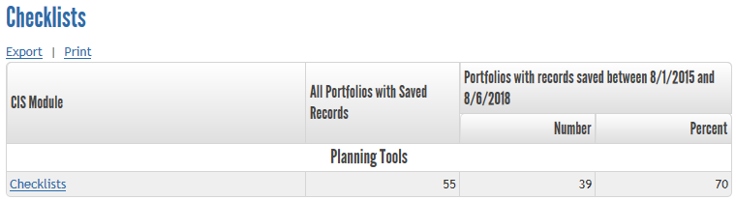
Now click on “Checklists.” You can select the group, grad year or entire site for students you want to view and apply settings. Then choose from the options shown below. A detail report will give you a printout to view all student checklists and check for completion. Each checklist will have the student name at the top of each page. Also remember to set the “Report Settings” for the timeframe you want for this report. You can view or print the report.
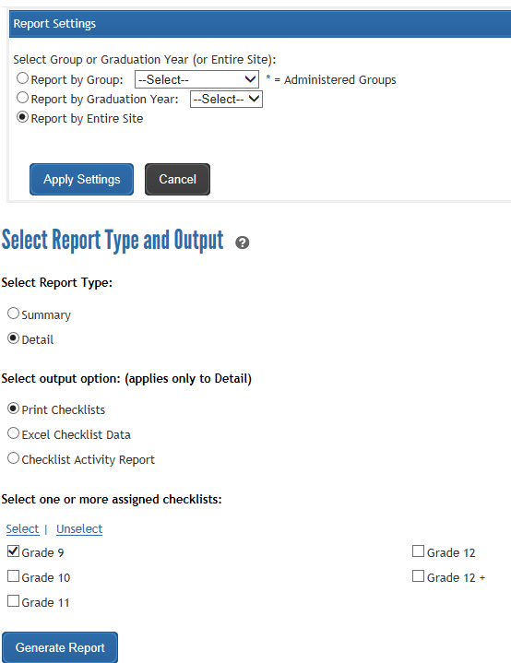
Next, repeat the same steps as above but choose “Checklist Activity Report.” As you can see below, you will have the option to receive a report based on individual checklist items. You can choose one or several activities at a time to view in this report. You can also choose which grade level you would like to view.
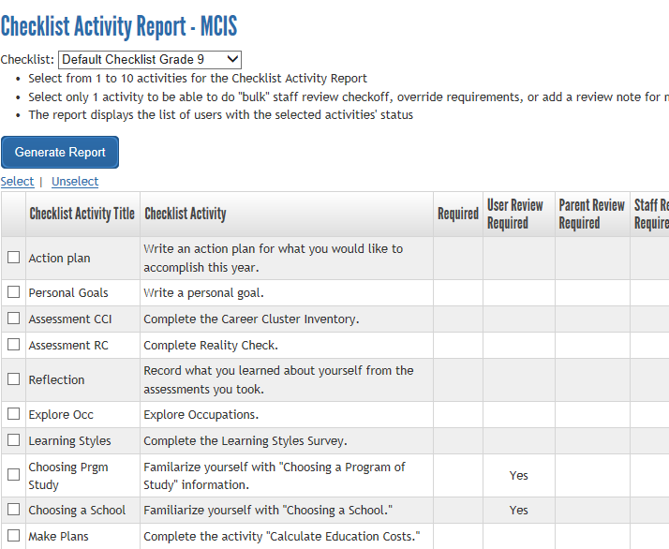
Your results will look the screen below. From this you will be able to see if the students completed the activities you have chosen and you can view individual checklists.
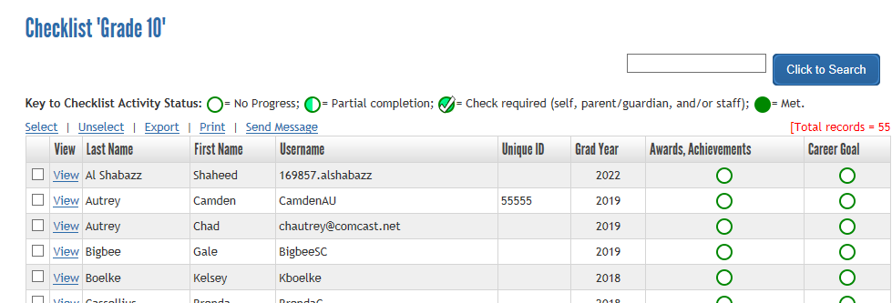

Custom Personal Learning Plan (PLP) Report
MCIS has created a standard state PLP report, but schools can also create their own. From the “Reports” tab, click on “Custom PLP” in the second column under “Planning Tools.” Click on “PLP Report.”
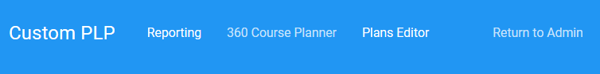
You can review the plans instant report (at the top) or apply filters more specific to your needs (left side menu).
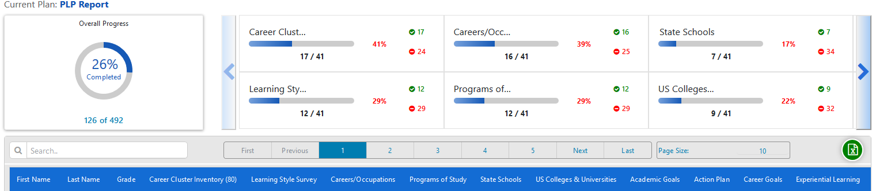
Additional filters are on the left side, you can choose individual activities or grade level.
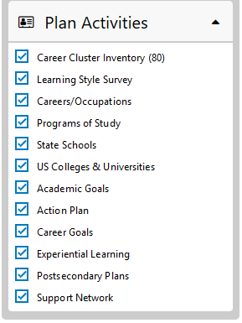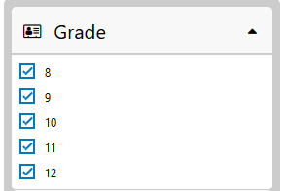
Below is a sample view of the report, note that there may be multiple pages. If you have a report with multiple categories, you may need to use the scroll bar to view the additional categories.
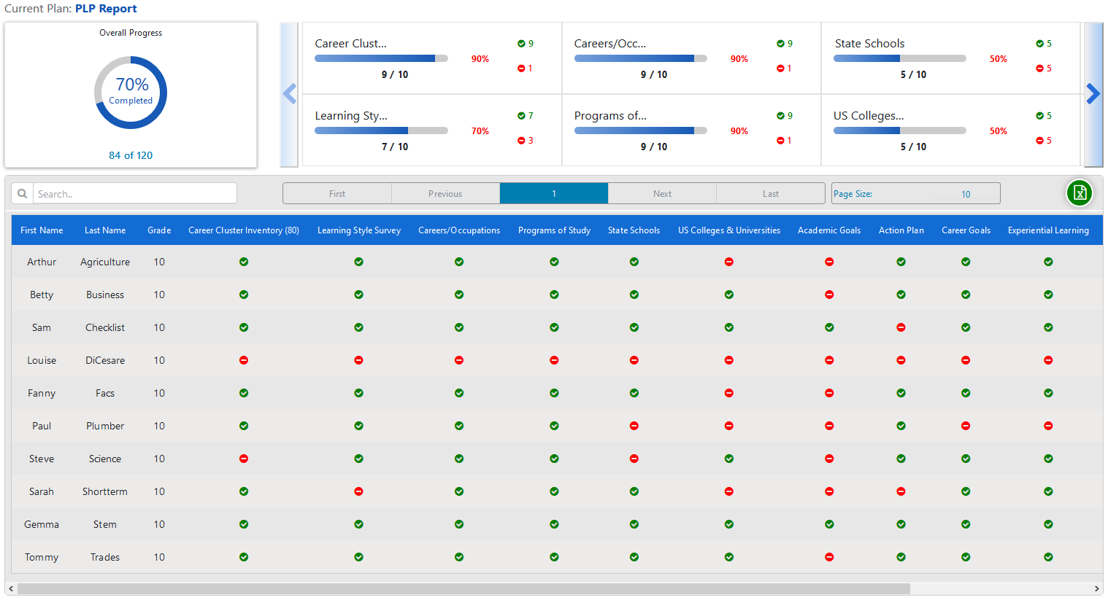
To create your own Custom PLP, click on “Plans Editor.”
Then click on “Create A New Plan.”
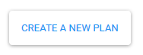
Begin by entering a name for your plan, then choosing a specific grade level (if applicable) and choose the “Enterprise” activity category.
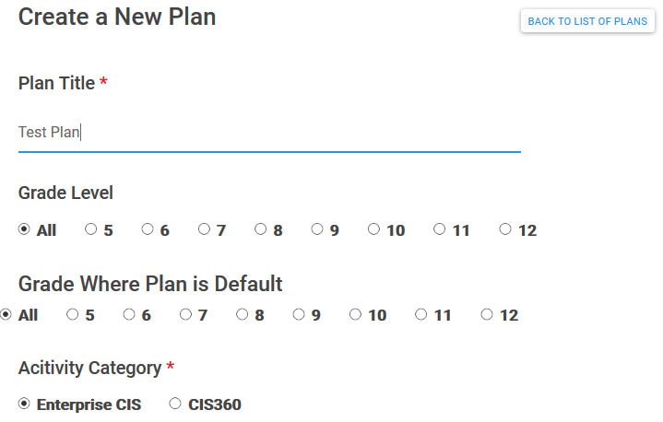
Once those choices have been made, you can start to put together your plan. Choose from the sections on the left side of the page, then check the box next to the activity you want to include. Once you have made all of the selections you want from the topics, click on “Create Plan.”
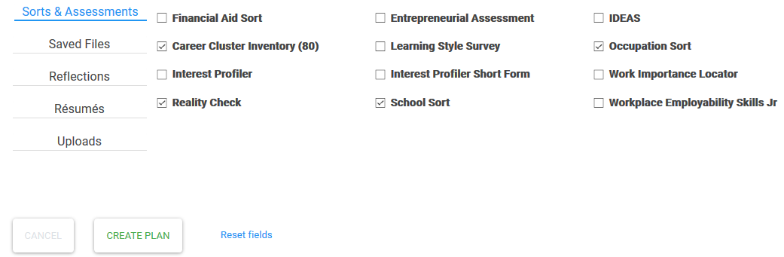
Once your plan has been created, you can choose to see that report (instead of the default report) from the Custom PLP dashboard and choosing the plan you created from the left “Active Plans” menu.
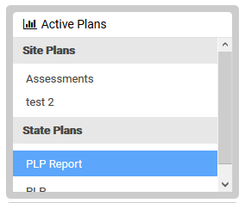
To exit the “Custom PLP Report” click on “Back to Amin” to go back to the full administration site and/or log out of the site completely.

Export or Print Report Results
In every report, you have the option to either export or print the report results. You can export or print the high-level reports, drill-down reports and the detailed reports. To export or print the report, simply click on the appropriate link in the top left corner of the report. For example: run a report for “Occupations” and click the “Occupations” link to drill down. You can print the results by clicking the “Print” link in the top left corner of the report.
For more information, please contact MCIS at mcis.team@state.mn.us – 651-582-8321 or 800-599-6247.

