SFY 2022 Juxtaposition Arts Community Development
Progress Report
11/14/2022

Minnesota Department of Employment and Economic Development
Employment and Training Programs Division
332 Minnesota Street, Suite E200
St. Paul, MN 55101
Nancy Waisanen/Larry Eisenstadt
Nancy.Waisanen@state.mn.us
mn.gov/deed
As requested by Minnesota Statute 3.197: This report cost approximately $492 to prepare, including staff time, printing and mailing expenses.
Upon request, this material will be made available in an alternative format such as large print, Braille or audio recording. Printed on recycled paper.

Contents
Contents 3
Introduction 4
Summary of Goals and Objectives Presented in the Work Plan 4
Participant Data 4
Outcome Data/Indicators of Performance 6
Expenditure Data 6
New Grant Funds for SFY2023 6
Success Stories 7

Introduction
The 2021 Minnesota Legislature (Laws of Minnesota, 2021, Chapter 10, Article 1, Section 2, Subdivision 3(ii)) appropriated state funds to Juxtaposition Arts (JXTA) for State Fiscal Years (SFYs) 2022 and 2023. The SFY 2022 allocation available to Juxtaposition Arts was $237,500 after DEED retained $12,500 (five percent of the appropriation) for administrative purposes.
The legislation directed the Department of Employment and Economic Development (DEED) to grant funds to Juxtaposition Arts to provide job training and workforce development services for underserved communities. This is a onetime appropriation.

Summary of Goals and Objectives Presented in the Work Plan
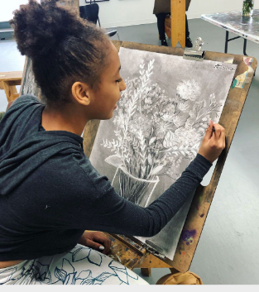
Juxtaposition Arts’ JXTALabs is a creative workforce development program designed to train and support youth and young adults who live primarily in North Minneapolis and come from BIPOC low- and moderate-income backgrounds. “It's a pretty unique program that doesn't really exist elsewhere nationally. One of the things we strive for is to show students that art isn't just a hobby, it's a way that you can make money and have a job,” states a former JXTALabs instructor.
JXTALabs employs youth as apprentices. They receive hands-on, college-level art and design training and mentorship from practicing artists, designers, and architects in one of five revenue-earning art production JTTALabs. These labs consist of Ceramics, Textile Design and Screen Printing, Graphic Design, Environmental Design, and Tactical Urbanism. Youth also build their professional networks and connect to post-secondary education and employment with support from mentors.
Youth gain real-world experience by producing high-quality art and design products and services for local and regional clients. Apprentices work nine to 16 hours a week year-round and earn wages of approximately $4,300 per year.
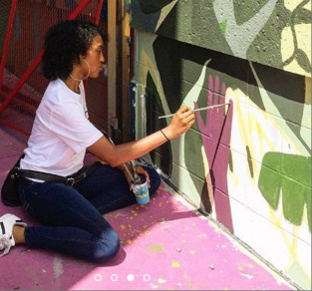
“My favorite part about working with JXTA participants is helping them overcome personal doubts towards their work. Believing is just the start. Hard work will get you where you want to be.” -JXTALabs instructor

“The Graphics Lab is a place where we can aspire, inspire, and push each other to our maximum potential.” – Patricio, apprentice

“JXTA has helped me find my voice as an artist in order to 'be the change I want to see in the world.'” - Makeda, apprentice

Participant Data
Totals from July 1, 2021 to September 30, 2022 |  | Number
1. Total Number of Group Participants Served |  | 85
2. Total Individual Participants Served |  | 235
(1) Gender
(1) Male |  | 102
(2) Female |  | 132
(3) Gender Non-Confirming |  | 1
(2) Age
(1) Under 14 |  | 8
(2) | 14-15 | 3
(3) | 16-17 | 0
(4) | 18-19 | 7
(5) | 20-21 | 17
(6) | 22-24 | 115
(7) Above 24 |  | 175
(3) Ethnicity/Race
(1) Hispanic/Latino |  | 3
(2) American Indian or Alaska Native |  | 2
(3) Asian/Pacific Islander |  | 1
(4) Black, African American, or African |  | 168
(5) White |  | 21
(6) Other or Multiracial |  | 40
(4) Education Level
(1) 8th grade and under |  | 30
(2) 9th Grade-12th Grade |  | 17
(3) High School graduate or equivalent |  | 111
(4) Post-Secondary Education |  | 80
(5) Other or Unknown |  | 2
(5) Other Demographics
(1) Limited English proficient |  | 181
(2) Participants who receive Public Assistance |  | 102
(3) Low-income (from family earning less than 200% of poverty) |  | 44
(4) Participants who report a disability |  | 9
(5) High school drop-out – all participants included |  | 21
(6) Participants who are justice involved |  | 34
(7) Pregnant or parenting youth |  | 1
(8) Person from first generation immigrant family |  | 4
(9) Participants showing as Homeless Participant/Runaway |  | 41
(10) Not employed at program enrollment |  | 160
(11) Veteran |  | 1

JXTALabs Program Services, Activities, and Other Related Assistance
 | Number
- Received Education or Job Training Activities | 85
- Received Work Experience Activities | 85
- Received Community Involvement and Leadership Development Activities | 85
- Received Post-Secondary Exploration, Career Guidance and Planning Services and Activities | 85
- Received Mentoring Activities | 85
- Received Support Services | 85

Outcome Data
During the past year, 235 participants were enrolled in programming and received employment group or individual employment training services. Of these, 85 youth enrolled in the JXTALabs program as apprentices with the following performance outcomes:
Indicators of Performance
 | Number
- Attained work readiness or education goals | 85
- Received academic credit or service-learning credit | 85
- Obtained high school diploma, GED, remained in school, obtained a certificate or degree, or dropout: returned to school | 85
- Entered post-secondary education, vocational/occupational skills training, apprenticeship, military, job search or employment | 22
- Obtained employment or entered post-secondary education/credentialed vocational/occupational skills training | 29
- Completed program objective | 85
COVID Impact on Programming
JXTA's fiscal year was heavily impacted by the COVID 19 pandemic and the racial justice uprisings, especially in the north Minneapolis community where services are delivered. JXTA was able to maintain strong programs and operations by quickly pivoting to a completely online service model and eventually a hybrid learning model for arts learning and arts training and employment programs for youth and young adults. Youth not only remained employed at JXTA but they gained important social-emotional space online for processing all that was happening in their world. During COIVD, the JXTA campus - specifically the corner skateable art plaza –became an important community asset for community members for safe gathering and sharing of resources in an outdoor recreational and social setting.
In September 2021, JXTA launched its back to campus schedule with modifications to keep staff and participants safe during the COVID-19 pandemic. For example, convenings were replaced with facilitated sessions hosted internally at JXTALabs to minimize COVID exposure.
Expenditure Data
Expenditures from July 1, 2021 through September 30, 2022:
SFY 2022 Budget Category | SFY 2022 Budget | SFY 2022 Expenditures to date
Administration | $21,590 | $16,509
Direct Services/Project Staff | $215,910 | $165,089
Total | $237,500 | $181,598

New Grant Funds
Juxtaposition Arts received an additional $237,500 in state direct appropriation grant funds for the period July, 1 2022 to June 30, 2023 (State Fiscal Year 2023). Juxtaposition Arts is on track to expend 100% of first year SFY 2021 funds by December 31, 20022 and plans to expend all second years funds by the end of the grant period.

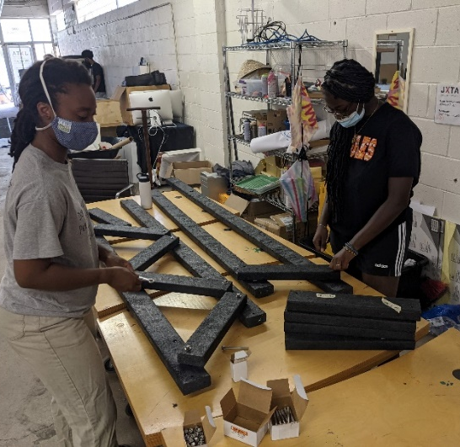
Success Story: Irene
When Irene first started at JXTA, she had an extremely long commute via public transportation to get from her home in West St. Paul to JXTA in North Minneapolis, and she did not have the funds to pay for the bus. With the help of her apprentice wage at JXTA, she was able to keep attending and learning at the JXTALab where she found new passions in the Environmental Design Lab. During her three years, she learned all aspects of design and building including planning, rendering, and fabrication.
As a result of her production work, Irene, now 23, received a significant scholarship to the University of Minnesota, where she is currently completing her Bachelor of Landscape Architecture degree and working as an independent contractor for the national organization, Forecast Public Art. Her JXTALabs mentor stated, “Irene has the excitement, curiosity, and talent to do great things in the fields of design, environment, and justice. I’m happy that she has settled on landscape architecture as her discipline to forge this path, as it suits her ability to focus on a real-world project while staying connected to the bigger picture.”

Success Story: Essence
Essence started at JXTA when they were 15 years old. At the time, living in far south Minneapolis, getting to JXTA’s campus in North was the biggest barrier. It was long and challenging, especially because they couldn’t afford a metro transit pass at first. Essence has been working at JXTA primarily in the Textile and Screen Printing Lab and is now assisting in the Graphic Design Lab. In their time at JXTA, Essence worked their way up through the lab including several mural projects, client printmaking jobs, creating and hand screen printing clothing lines for JXTA's store, selling personal and creating posters for JXTA, being a teaching assistant for a screen printing master class, being apart of the JXTA sales team, and now creating graphics and logos for clients.
With the support and training at JXTA, Essence has gained their Associate's degree in graphic design and is currently earning a Bachelor’s of Fine Arts. They have interned at Knock Inc., gotten several opportunities to showcase their work at galleries, and is currently the Art Director of Golden Magazine. “JXTA has seen me grow up and I have grown so much as a person and designer through the program. The knowledge and experiences they have provided me can't be measured and I am extremely grateful to be a part of this organization.”

Success Story: Qadiym
Qadiym has contributed to the design of a number of real community development projects in North Minneapolis with the support and training of mentors and artists at JXTALabs. This includes the popular skateable art plaza on JXTA’s campus located on the intersection of West Broadway and North Emerson Avenues. The plaza came into being when two older, structurally unsound JXTA buildings had to be demolished. Instead of leaving the corner lot fenced and empty during JXTA’s Capital and Legacy Campaign to raise new construction funds, JXTA’s Environmental Design youth apprentices and Lab Leads designed the new plaza. Instrumental in the design of the multi-use, environmentally conscious skateable plaza were City of Skate, West Broadway Business and Area Coalition, City of Minneapolis, University of Minnesota’s Landscape Architecture Department, and TENxTEN. The design features stormwater management strategies, skateable slopes and furniture, and an outdoor hand-washing station for plaza visitors. It’s one of the only formal recreational spaces along the West Broadway corridor. Since its grand opening, the plaza has seen nearly constant use by Northsiders and other visitors.
JXTALabs also connected Qadiym to an internship opportunity at KNOCK, Inc., a design firm located in the Near North area of Minneapolis. “While I was there, I got to look up different things I wanted to get better at and then created my own work with their support. I worked on an interior design project for their headquarters and contributed to the design of a pop-up shop for a hair salon rebranding project. These opportunities helped Qadiym become comfortable being himself as a young adult in the workforce and added to his professional experience and skill development. “I’ve been able to unlock a part of myself I never knew was there. Now I know that I can survive in a professional environment and that people need the skills that I have,” he says. “I have control over the work that I do and I’ll never have to give myself away to take advantage of an opportunity.” Qadiym is currently seeking an degree in architecture where he received a full scholarship. He attends the Dunwoody Institute of Technology.

from left to right): Qadiym, Gabrielle Grier, Managing Director of JXTA, and Niko Kubota, JXTA Environmental Design Lab Lead & Registered Architect

