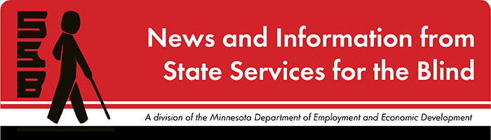

The Spectacle
-Dare to stand out
March 2024

Upcoming Events

Wilderness Inquiry on 3/16
SSB is partnering with Wilderness Inquiry for a Camping Skills event on March 16, 2024, from 1 to 4 p.m. at Fort Snelling State Park. Join us for an unforgettable experience as you learn and build community on our educational excursion. Students aged 14 to 22 will engage in hands-on activities that build valuable advocacy skills. Don’t miss this opportunity to make a difference, have fun, and enhance your skills as a budding community advocate in the outdoors! Contact Shane DeSantis at shane.desantis@state.mn.us to sign up!

Tools for School on 4/12
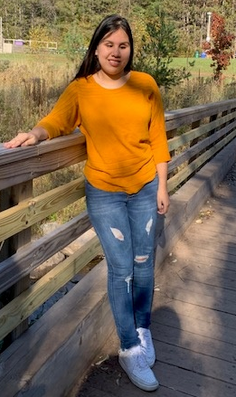
SSB is hosting a Tools for School workshop for students who are blind and visually impaired to learn about the technology skills needed for success in higher education. Please join us at the University of MN – Twin Cities campus for a day filled with multiple panels that will cover various assistive technologies that blind and visually impaired students use in college! This will be on Friday, April 12th, 2024, with registration starting at 8 a.m. and the workshop concluding at 4 p.m. Students, parents, and educators are invited! Register online for the Tools for School workshop signup to secure your seat!

Peer Ambassadors
Hi! My name is Amy. I’m eighteen years old, and I’m a freshman at the University of Minnesota Duluth majoring in social work. I love to read and listen to music, as well as perform in theater productions. I’m so excited to be working with Maddy to bring some really cool events and opportunities for transition students.
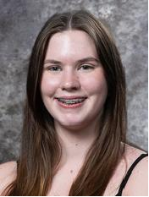
Hello everyone! My name is Maddy, and I am seventeen years old and a junior at Armstrong High School in Plymouth. Outside of school, I enjoy dancing and spending time with my friends and family. I look forward to being able to provide transition students with some new events and activities to participate in through SSB!
Joint statement: We are so excited to work together to bring opportunities to transition-aged students. We have compiled a short survey for programming ideas (link) to ask for your opinions on what you would like from us in the future. Feel free to contact us with any questions or ideas. Amy’s email is amyarias0508@gmail.com Maddy’s email is major.madeline7@gmail.com.

Twin Cities Blind Sailing Opportunities
This is for people who are blind and visually impaired to learn how to sail with guidance from trained sighted guides. In 2024, they have two youth programs through their partners with Minneapolis Sailing Center and the Wayzata Sailing School. A first-year membership is FREE. Please check out their website at www.twincitiesblindsailing.org, and if you have any questions or are interested in sailing, please contact Katy Boyd at kboyd@twincitiesblindsailing.org.

SSB Communication Center
The Communication Center is here to put your books into accessible formats that work for you. Custom audio, e-text, DAISY markup, and Braille - we can do it! The Communication Center is Minnesota’s Accessible Reading Source – we’re here for you. Email us at ssb.audioservices@state.mn.us

PACER
PACER Center “enhances the quality of life and expands opportunities for children, youth, and young adults with all disabilities and their families so each person can reach their highest potential. PACER operates on the principles of parents helping parents, supporting families, promoting a safe environment for all children, and working in collaboration with others.” For upcoming webinars and workshops, visit Pacer's workshops website.

Disability Hub MN
“Disability Hub MN is a free statewide resource network that helps you solve problems, navigate the system, and plan for your future. We can help you create your best life your way.” This website has a variety of resources that can guide topics such as disability benefits through the DB101 website, information on housing resources through their HB101 website, and a plethora of employment and transition resources for individuals with disabilities. Visit the Disability Hub website here to learn more.
Youth in Transition Toolkit – This toolkit will introduce you to Minnesota's transition framework. Explore tools and resources you can use with youth to plan for their best lives.

APH
APH CareerConnect is “an employment information resource offered by the American Printing House for the Blind for job seekers who are blind or visually impaired. CareerConnect provides employment information, career exploration tools, and job-seeking guidance for individuals with vision loss and the professionals who work with them.” Visit their website at aphcareerconnect.com to learn more. Upcoming webinars can be found at aphconnectcenter.org/webinars/. On April 4th, their Career Conversations webinar will feature a Senior Software Engineer at Apple! Archived APH webinars can be found on the APH ConnectCenter YouTube page.

Blind Abilities Podcasts
Check out Blind Abilities on the web at http://www.BlindAbilities.com. You can also download the app from the IOS or Google Play store or use the Blind Abilities Alexa skill on your Alexa device by saying, “Alexa, enable Blind Abilities.”
Here are some of the people and topics featured on Blind Abilities recently:
- APH Career Connect – Curated Information and Resources to Help You Choose the Career You Want. Learn About Career and K-9 Connections, Career Conversations, Internships and More!
- Wellness Wednesday: Asking for Reasonable Accommodations is Not Always the Easiest Thing to Do
If you know of a student who would be interested in sharing their achievements on their journey, Blind Abilities would like to include their perspectives on future shows. Send a note to mailto:info@blindabilities.com

Tech Tidbits

Attention all gamers! SSB’s assistive technologist, Jesse Anderson, was invited as a guest to talk about accessible gaming on the FSCast blog through Freedom Scientific. Feel free to check out the recording on Freedom Scientific’s blog if interested. FSCast Blog (link).

Building BRIDGEs

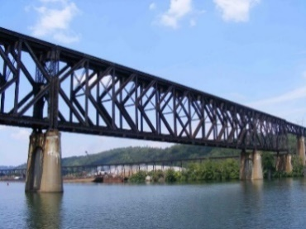
As students navigate the world of high school and begin thinking about the future, we offer services and resources that provide a foundation for success. Each of the core areas of our BRIDGE framework highlights an essential component that teenagers need in order to succeed after high school:

- Basic Skills
- Role Models
- Initiative
- Discovery
- Goal Setting
- Experiences

Looking Ahead in High School
Thinking about what comes after high school is an important skill. The links below offer steps to take to prepare and plan for life after graduation.
Freshman
Sophomore
Junior
Senior

Ideas?
We are always looking for ideas you’d like to see featured in this newsletter. Please email shane.desantis@state.mn.us with any suggestions or brainstorms.

