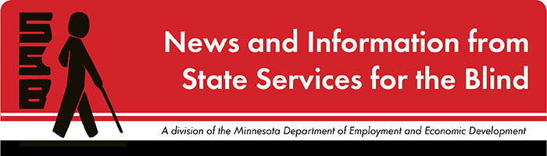

The Spectacle
-Dare to stand out
May 2021

Just for Fun
Plans are already being made for the summer—vacations, gatherings, work—people are longing for new and different things to do. Money Prodigy offers a list of 50 things for teens to do that are both fun and productive. https://www.moneyprodigy.com/things-to-do-this-summer-for-teens/
A few of the ideas include:
- Being in charge of the family garden
- Daydreaming a seasonal bucket list
- Creating an obstacle course for younger siblings
- Having a “survival” campout
- Updating a resume
- Playing Iron Chef Family Edition

Upcoming and Ongoing

Summer Programs
There are many programs this summer to help students build skills and confidence.

BLIND, Incorporated
“Spend part of your summer with us! This virtual program is for high school students (14-21). The STYLE program offers two separate, five-day, theme-based educational/recreational programs. It will be held anywhere and everywhere via Zoom. All of our programs are delivered by blind role models. Students will learn skills, gain confidence, and have fun! Attend one or both of the sessions! Session 1: June 14 – July 2: Adulting 101 Life After High School What’s next?

Students will explore the possibilities after high school. Whether it’s college, trade school, or a job; the possibilities are countless. Students will connect and learn about various paths other blind people have chosen. Topics will include: goal-setting, self-advocacy, career exploration, and more! Session 2: July 19 – August 6: Career Quest: What jobs can blind people do? Where do you want to work? Students will explore jobs held by blind people and learn what those jobs truly entail. Learn what skills are needed to reach your vocational goals. Topics include: resume building, interview skills, soft skills, finding jobs, qualifications/experience and more!

Contact Michell Gip, Youth Services Coordinator, at 612-872-0100, Ext. 231, or mailto:mgip@blindinc.org for more information or an application. We can assist you to work with your local vocational rehabilitation agency to attend the program.”

Duluth Center for Vital Living
“The Lighthouse Center for Vital Living will offer three remote summer camps in 2021, conducted via Zoom. All camps are eight-days long and a total of five online hours per day (except the first day); they each begin in the afternoon on a Friday, end the following Friday, and include one weekend.

A Week at Hogwarts: Friday, June 18 – Friday, June 25
This is the camp where potions are made in the kitchen, brooms are for sweeping, and magical maps are tactile. You will begin camp in the virtual Great Hall where you will learn about your class schedule, be sorted into your houses and learn how your house can earn points in the days ahead.

The Leader in Me: Friday, July 9 – Friday, July 16
Everyone has the potential to be a leader. That doesn’t mean you have to be the team captain or a boss in a big company. What it does mean is that you, first, lead yourself well so that you are happy and satisfied with your life, your choices and your actions. It also means you learn how to become a better team player with others in your life: in your family, at your school, in your work.

The Office: Friday, July 30 – Friday, August 6
Preferred application deadline: Friday, June 18
This camp is a simulated work week in a very virtual company called Giggle. Campers will complete an employment application and then be interviewed early at camp. Everyone will then be assigned to a job in the company. During the camp, the company team will work together toward completing a project. Each day will focus on understanding different types of job functions in the company, such as administrative, human resources, marketing, finance, operations and production; you will also learn about different jobs associated with those functions. Community mentors in different job roles will help campers explore those careers further.”

Summer Transition Program
“This program will be held virtually from June 14-18. Students will participate in “Blind & Socially Savvy”, job shadows, and mock interviews. They will also connect with other peers who have a vision loss. This program is a collaboration between SSB and local school districts, so it needs to be part of a student’s IEP to attend.

Vision Loss Resources (VLR)
“The Transition-Age Program provides training for blind/visually impaired students, ages 14 - 21 who are moving into post-secondary/adult life. Participating in a variety of courses and experiences, students will learn skills and strategies identified under the federal Workforce Innovation and Opportunities Act (WIOA).

Students can participate in the VLR Transition-Age Program as a full-time, part-time or special component student based on their transition needs. Program planning is done in collaboration with State Services for the Blind and the student. An initial functional assessment will be used to determine a student’s appropriate placement and accommodations.

In addition to VLR’s Adjustment to Blindness (ATB) Training, Students will have the option of two classes specifically designed for transitioning to post-secondary/adult life.
· Post-Secondary and Job Exploration
· Work-Based Learning Experience

Peer Educator Programming
SSB is excited to be in the process of again hiring peer educators for the summer. They will begin their work in June to plan fun student programs for July. Please email Sheila.koenig@state.mn.us to get updates.

Summer Conventions
Attending conventions hosted by the blind community can be a great way to meet people, learn about adaptive techniques, be a part of a larger organization of blind people, and have fun! Two well-known organizations are holding their conventions virtually this summer, and you are welcome to attend.
National Federation of the Blind Convention, July 6-10
American Council of the Blind Convention, July 16-23

SSB Communication Center
The Communication Center is here to put your books into accessible formats that work for you. Custom audio, e-text, DAISY markup, and Braille - we can do it! The Communication Center is Minnesota’s Accessible Reading Source – we’re here for you. Email us at ssb.audioservices@state.mn.us

PACER
“These are challenging times for everyone. As we all navigate this public health crisis, PACER is committed to being a valuable resource for families of children with disabilities and students who are bullied, as well as the professionals who serve them. Go to https://pacer.org/special/covid-19.asp for COVID-19 resources and to https://www.pacer.org/workshops/ for a list of upcoming workshops.
Call or email us! PACER’s parent advocates, assistive technology specialists, bullying prevention associates, and all staff are available to assist families and professionals. Call 952-838-9000 or email pacer@pacer.org for assistance.”

Disability Hub MN
Disability Hub MN is a free statewide resource network that helps you solve problems, navigate the system and plan for your future. We can help you create your best life, your way. https://disabilityhubmn.org/

Blind Abilities Podcasts
Check out Blind Abilities on the web at http://www.BlindAbilities.com. You can also download the app or use the Blind Abilities Alexa skill on your Alexa device just by saying, “Alexa, enable Blind Abilities.”
Here are just some of the people and topics featured on Blind Abilities recently:
- Easterseal Disability Film Challenge: Creatives Talk about the Experience, Challenges, and about Disability in Films
- Meet Sandhya Rao: Attorney in the United States District Court for the Southern District of Texas and VP of iBugToday
- iPhone101: Emoji in Text Replacement Made Easy. Yes, Double Demo Day!
If you know of a student that would be interested in sharing their achievements on their journey, we would like to include their perspectives on future shows. Send a note to mailto:info@blindabilities.com

Fast Forward: Potential and Possibilities
Robby Binns
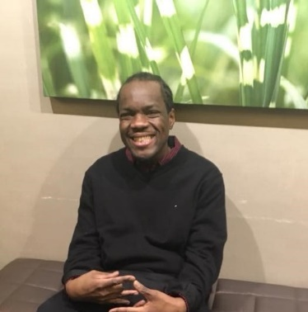
Robby Binns worked as a parcel assistant for FedEx and is now pursuing a degree in Human Services. Having completed his Associates degree, Robby is now completing a B.A. at metro State where he is maintaining a 4.0 GPA. Note that Robby’s thoughts have been slightly edited for space considerations

“Since going blind from diabetes in the later months of 2012, I have only been employed once. I began my job as a parcel assistant at FedEx in 2016. I was the first visually impaired individual to hold the parcel assistant position, and because of my stellar work ethic, FedEx employers felt comfortable with hiring other visually impaired individuals for the same position. I was able to hold this job down for 4 years before getting laid off at the beginning of the Covid19 pandemic. My time working with FedEx was fairly enjoyable and I appreciate the employment opportunity that they provided myself and other blind individuals like me.

I can’t say I have many hobbies other than being spontaneous and enjoying fun times with friends and family members. After going blind, I made a commitment to myself that I would explore the world, in the dark, and love every moment of it.

Apart from my love for spontaneous events, I have an unconditional love for fashion. I currently have over fifty pairs of sneakers and no more closet space for new clothes. People who know me say that I have an addiction. I like to think of myself as a collector who adores retro sneakers and who has a “passion for fashion”. And as the young folks tell me, “you got swag BOB”.

Besides the traditional white-cane, and the adaptive technologies that I use to help me complete everyday tasks, my most valuable technique stems from my exceptional communication skills. I’ve developed an educational technique to use with people who are ignorant about blindness. As I understand that most people know little to nothing about blindness, education about blindness from a blind person can go a far way in eradicating ignorance and biases.

High school is known for being that part of life when teenagers begin to figure themselves out while still being young, inexperienced, and most of all, impressionable. Sometimes this being impressionable can derail students from achieving their highest level of educational success. Respectfully speaking, most teenagers in high school that take this way of life for granted often find themselves wallowing in regret later on. I don’t mean to sound repetitive, but I think it’s crucial for high school students to understand the imperative role that their educational success plays in their lifelong success. Although high school is supposed to be a fun and educational four years, never forget that the more fun you have in high school that’s at the expense of your GPA, it may have severe consequences for your future. I point this out to say, live young, have fun, and always keep your future in mind the next time you make a conscious decision to be unproductive. I love to see young people succeed and reach their highest potential. To conclude, “Do what it do” (as the young folks say) and never take the future for granted because your future starts now. Trust and believe that!”

Tech Tidbits

The Windows 10 May 2021 update should be arriving sometime in May. This update does include some Magnifier and Narrator features and fixes. This update will be a staggered release, so some people may receive the update sooner than others. This is due to making sure the update works properly with different machines. Open Windows Update to check for this spring update.
Apple has also released IOS 14.5 with new features and fixes. One unique feature is the ability to unlock your iPhone with your Apple Watch when you are wearing a mask.
The Humanware Brailliant refreshable Braille display has officially been released. There is a 20 and 40 cell version. Both of these displays use a Perkins style keyboard and include some basic notetaking and reading features.
Brailliant BI 40x
https://store.humanware.com/hus/brailliant-bi-40x-braille-display.html
Brailliant BI 20x
https://store.humanware.com/hus/brailliant-bi-20x-braille-display.html
For anyone interested in choose-your-own-adventure or interactive fiction games, there are a couple of VoiceOver accessible apps that contain lots of these stories on many popular themes. These may also be a fun way to practice reading Braille with a refreshable Braille display over the summer.
Choice Of Games
https://apps.apple.com/us/app/choice-of-games/id1363309257
Hosted Games
https://apps.apple.com/us/app/hosted-games/id1302297731

Building BRIDGEs

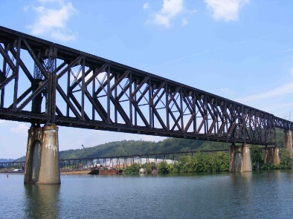
As students navigate the world of high school and begin thinking about the future, we offer services and resources that provide a foundation for success. Each of the core areas of our BRIDGE framework highlights an essential component that teenagers need in order to succeed after high school:

- Basic Skills
- Role Models
- Initiative
- Discovery
- Goal Setting
- Experiences

“Typing: an essential skill” Whether it’s for work or school, typing is a very important skill for students to learn. This article is a great place to get started with simple tips and tricks.
"Personal Values Assessment" is a fun way to discover, identify, and sort out core values. Personal values ​​are what people consider important in life. They affect our choices and can say a lot about ourselves. Although not everyone is aware of their values, they are always present in life and become visible in our attitude to the world around us and behavior in the face of various everyday situations.
"Bryan’s Quest" “In 2017, a project called ‘Sensing Nature’ carried out a UK wide survey and held a seminar and a series of workshops; one participant was inspired to bring Bryan’s Quest in to existence. Bryan’s quest is an independent, not-for-profit, social enterprise dedicated to developing ways of enjoying and learning about the natural world. The emphasis is on experiences that do not just rely on the sense of sight. In the natural world everyone can be exposed to sounds, textures, shapes, aromas and flavours.”
"Support: Online Blogs" Lived experience is a powerful teacher. To help students, parents, and professionals access this information, here is a list of online blogs written by young people living with a visual impairment.
"Bold Blind Beauty" “Real beauty transcends barriers. The mission is to improve humanity by changing the way we perceive one another. Everyone on the planet needs air to survive. Likewise, A.I.R. (Accessibility, Inclusion, and Representation) enables people with disabilities not only to survive but to thrive. I believe that by embracing and promoting A.I.R. we will change perceptions one person at a time.”

Looking Ahead in High School
Thinking about what comes after high school is an important skill. The links below offer steps to take to prepare and plan for life after graduation.
Freshman
Sophomore
Junior
Senior

Ideas?
We are always looking for ideas you’d like to see featured in this newsletter. Please email sheila.koenig@state.mn.us with any suggestions or brainstorms.

