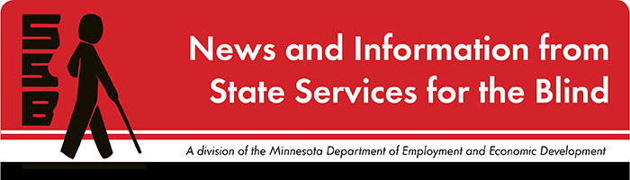

The Spectacle
-Dare to stand out
September 2021

Just for Fun
“For some, high school is the peak of their life: You’ve got prom and pep rallies, and homecoming and hormones. For others, it’s the pits because you’ve got…well, prom and pep rallies, and homecoming and hormones. And there to capture every awesome/awful moment are these high school movies which earned high grades from film critics.” A few examples from the Rotten Tomatoes list include:
- High School Musical
- Freedom Writers
- Pretty in Pink
- Ferris Bueller’s Day Off
- Clueless
- Friday Night Lights
- Love and Basketball
- Lady Bird
- Back to the Future
- Book Smart

Upcoming and Ongoing

A Note from SSB Counselors
Hi, students! We sure hope that the beginning of this school year is a smooth one for you! It’s the time of year that we double-check our records and make sure that we have the most current information about you. This helps us coordinate meetings with you, your family, your school, and your teachers. Please reach out and let us know if anything has changed since last year. We wish you all the best in the year ahead!

Year-Round Programs for Students
BLIND, Incorporated and Duluth Center for Vital Living offer opportunities for students to build skills and connect with peers throughout the school year. More information about these programs will be sent as soon as this year’s information is available. To request information, email Sheila.koenig@state.mn.us

SSB Communication Center
The Communication Center is here to put your books into accessible formats that work for you. Custom audio, e-text, DAISY markup, and Braille - we can do it! The Communication Center is Minnesota’s Accessible Reading Source – we’re here for you. Email us at ssb.audioservices@state.mn.us

Virtual Open-mic Coming this Fall!
Are you a musician, artist, comedian, or other performer? SSB is excited to feature a virtual open-mic event later this fall. Please email sheila.koenig@state.mn.us to receive more information as soon as it’s available!

PACER
PACER Center “enhances the quality of life and expands opportunities for children, youth, and young adults with all disabilities and their families so each person can reach his or her highest potential. PACER operates on the principles of parents helping parents, supporting families, promoting a safe environment for all children, and working in collaboration with others.” For upcoming webinars and workshops, visit https://www.pacer.org/workshops/

Disability Hub MN
“Disability Hub MN is a free statewide resource network that helps you solve problems, navigate the system and plan for your future. We can help you create your best life, your way.” https://disabilityhubmn.org/

APH ConnectCenter
Empowers people toward greater independence and lifelong success by providing curated information and resources to assist children, parents, job seekers, adults, and older people who are blind or visually impaired. Check out the ConnectCalendar to see upcoming opportunities.

Blind Abilities Podcasts
Check out Blind Abilities on the web at http://www.BlindAbilities.com. You can also download the app or use the Blind Abilities Alexa skill on your Alexa device just by saying, “Alexa, enable Blind Abilities.”
Here are just some of the people and topics featured on Blind Abilities recently:
- iPhone series
  - iPhone101: Hey Siri! What Can You Do? I’m Here to Help!
  - iPhone101: Lists, Lists and More Lists – Flicking and Swiping Be Gone,; A Couple of More Efficient Ways to Manage Your Way Out of a Long List
  - iPhone101: Period Shortcut and Auto Cap Shortcut
  - iPhone101: Emoji in Text Replacement Made Easy.
- Matthew Whitaker Musician Extraordinaire!
- Megan Hale is working with Microsoft and the Soundscape App to create an outdoor experience with Trail orienteering.
If you know of a student that would be interested in sharing their achievements on their journey, Blind Abilities would like to include their perspectives on future shows. Send a note to mailto:info@blindabilities.com

Fast Forward: Potential and Possibilities
2021 Summer Students
We asked our student workers to share 5 tips for a successful school year. Here is what they shared:

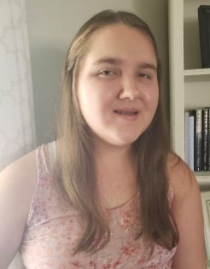
Arianna, Student Literacy Associate
- Have good sleep patterns.
- Wake up an hour before leaving. I do this so I can start my day without chaos.
- Do your homework after taking a break. I do this so I don’t get burnt out.
- I study consistently in small amounts to prepare myself for a test.
- I love exercising before school so I can concentrate better.

Grace, Peer Educator
- Stay organized!!! Getting folders and notebooks that are different colors and patterns helps with this!
- Stay on top of assignments! It can be easy to fall behind. But once you are behind it’s hard to catch up.
- Make friends! Friends are the best and they make great study buddies!
- Ask for help when you need it! It’s okay to ask teachers and your classmates for help they are a great resource!
- Have fun and try your best!

Jennifer, Peer Educator
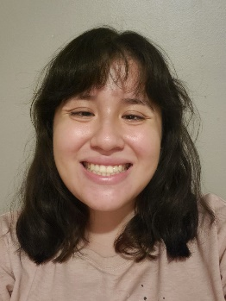
- Email your teachers before starting school. Let them know a little bit about yourself.
- Find a way to get organized. Whether that be a planner, google calendar, or any way that's worked for you.
- Fix your sleeping schedule. It's important to get 8-10 hours of sleep.
- Take a reusable water bottle to school. Staying hydrated is important.
- Don't be afraid to ask questions. Teachers are more than happy to help

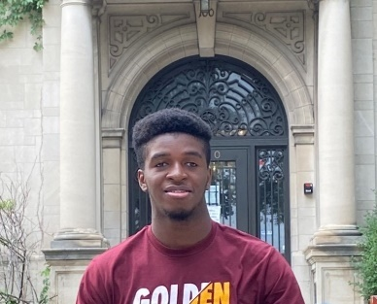
Joshua, Peer Educator
- Take time to take care of yourself.
- Listen to those who are more experience than you.
- Time management is crucial.
- Make sure to join clubs or groups that you can relate with.
- Do what makes you feel happy, And have a great time.

Phuong, Peer Educator
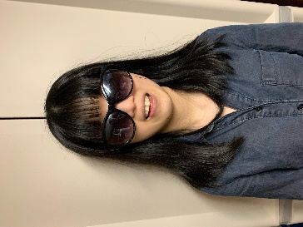
- Use all of the resources that your schools provide. Those resources include the tutoring center, disability center, etc.
- Meet new people and get connected with them because you will never know when they might become handy.
- Let professors/accessibility specialists and other people know if you need help. They will not come to you and ask what you need like they did in high school.
- Build some relationships with your professors. It is easier to tell them what you need if you feel comfortable with them. Also, it is easier for professors to write you recommendation letters if they know you.
- Spend some time to take care of yourself--both mental and physical health. Try to balance your meals between the things you like to eat and healthy ingredients. Spent about 5 to 10 minutes to relax and meditate if you can.

Rocky, Marketing & Outreach Associate
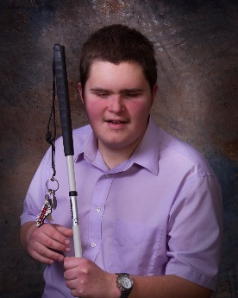
- Surround yourself with a network of other mentors who are blind upon whom you can lean for advice, guidance, and support.
- In both high school and college, self-advocacy is key to success. Always attend your IEP meetings and other meetings related to you to ensure that your needs are met.
- Be aware of what you need, but also what you do not need. Evaluate every suggestion for accommodation your support system provides to you and make an informed decision as to whether or not it is necessary.
- Maintain a healthy social life, and participate in recreation and leisure activities when you are able to do so.
5. Know that SSB is here to support you through all of your future endeavors.

Tech Tidbits
Whether you are a high school or college student, it's a good idea to make sure your Bookshare and Learning Ally memberships are up to date. If you don't yet have a Bookshare or Learning Ally account, please speak with your counselor, and they can help with the sign-up process.
If you are looking for a good reading app on both IOS and Android, Voice Dream Reader is recommended, as it can read Bookshare books, and many other types of files. It can also help with reading paper documents, and image PDF files.

Noted is an accessible note taking app for IOS that combines text and voice note recording into one app, and it's VoiceOver accessible:
https://apps.apple.com/us/app/noted-record-every-moment/id1149425482

For a study break, there are a couple of great accessible game possibilities available:

Hearthstone Access a mod for the popular card battle game from Blizzards that plays similar to something like Magic The Gathering. The PC version is accessible via this mod and works very well:
https://hearthstoneaccess.github.io/

The Vale is an accessible role playing game for both PC, and yes XBOX. The Vale is available via Steam or XBOX One, Series X/S.

For mobile, there's a fun and challenging game of Battleship, I mean Battle Fruit where you battle a rival chef to make your recipe first. This game is VoiceOver accessible.
https://apps.apple.com/us/app/battlefruit/id1549286440

Building BRIDGEs

As students navigate the world of high school and begin thinking about the future, we offer services and resources that provide a foundation for success. Each of the core areas of our BRIDGE framework highlights an essential component that teenagers need in order to succeed after high school:

- Basic Skills
- Role Models
- Initiative
- Discovery
- Goal Setting
- Experiences

“2021 Tokyo Paralympics: Blind sprinter David Brown found clarity in just 10.99 seconds” recounts the journey of David Brown from Missouri. It is the story of how sports gave him a new meaning in life.
"A Calendar of Opportunities" from American Printing House offers events for students, parents, and professionals. Their mission is to “empower people toward greater independence and lifelong success by providing curated information and resources to assist children, parents, job seekers, adults, and older people who are blind or visually impaired. “
“How does your garden grow?” is a blind mom’s reflection on keeping her family active and healthy during the last year.
Career Exploration Whether looking for a college program or career, this website will help students align skills with potential careers.

Looking Ahead in High School
Thinking about what comes after high school is an important skill. The links below offer steps to take to prepare and plan for life after graduation.
Freshman
Sophomore
Junior
Senior

Ideas?
We are always looking for ideas you’d like to see featured in this newsletter. Please email sheila.koenig@state.mn.us with any suggestions or brainstorms.

