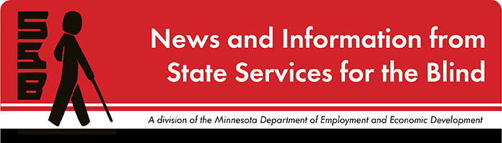

The Spectacle
-Dare to stand out
September 2023

Just for Fun
Happy start to the school year! We hope everyone had an enjoyable summer making memories and sleeping in if your household allowed that comfort. Here at SSB, our team worked diligently to provide an array of activities for students over the summer. This included assisting with programming at the Summer Transition Program at the University of St. Thomas, helping students gain valuable work experiences, facilitating adjustment to blindness training, connecting students to guide dog exploration, the Wilderness Inquiry canoe trip on the Mississippi, and more!! We look forward to connecting with you soon to hear about your summer!
For those in high school, feel free to check out this article Back to School: High School Edition (opens as a PDF) put together by the Minnesota Department of Education. This has helpful tips on areas to consider as students prepare for their goals after high school.
Below is a picture of two canoes filled with students and staff from this summer canoe trip with Wilderness Inquiry! Be on the lookout for additional outdoor activities SSB plans for the future.
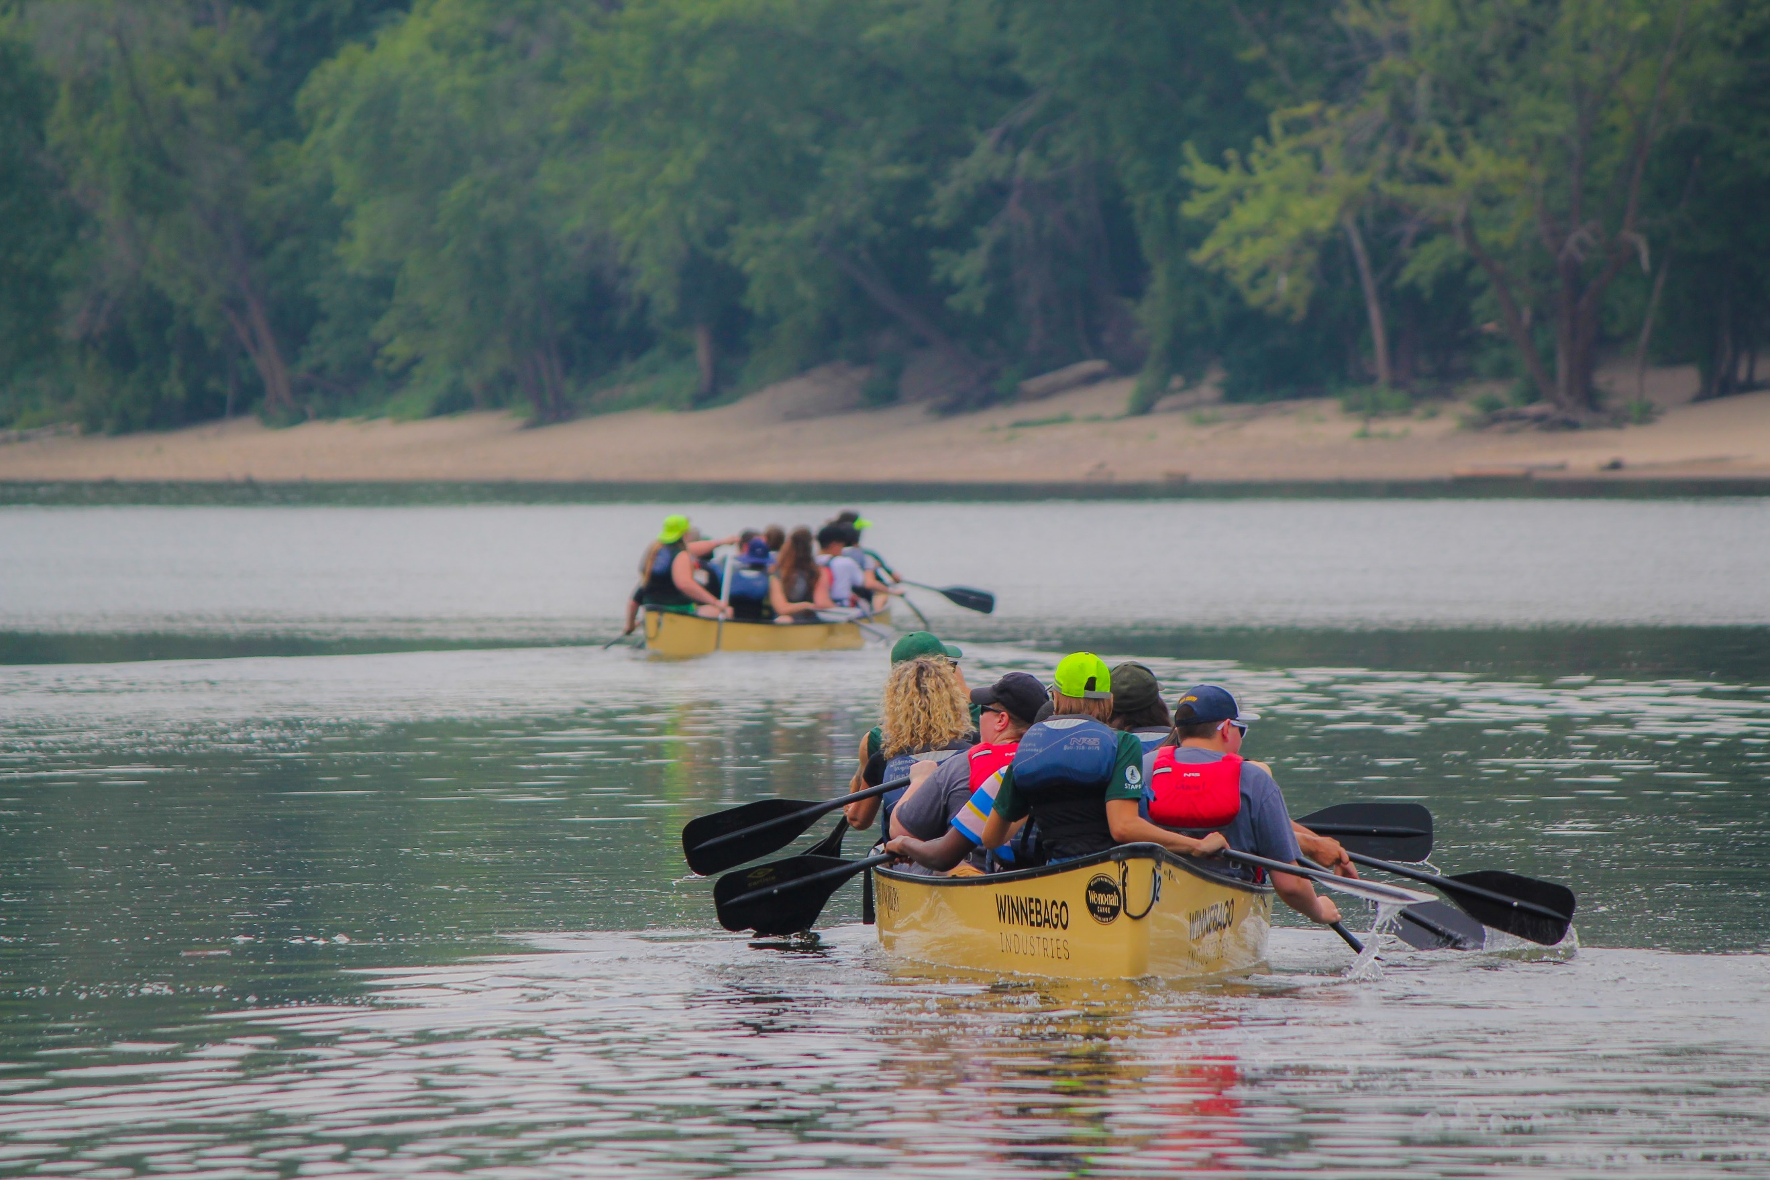

Upcoming and Ongoing

Learn Braille Music!
An introductory class for 7-12th graders who are blind and visually impaired.
When: Four classes on Saturdays, 9 am-12 pm October 28, November 4, 11, & 18, 2023
Where: State Services for the Blind, 2200 University Ave W # 240, St. Paul, MN
Cost: Free!
What students will learn (curriculum is flexible based on students’ needs and experience):
- Discover the importance of learning braille music, and its history.
- Learn an introduction to music theory (steps, intervals, octaves, etc.).
- Demonstrate the basics of solfege (through singing and playing).
- Recognize scale steps in numeric and braille music, Do through Ti.
- Read and write short braille music melodies.
- Use various instruments, braillers, music Tact-Tiles.

Prerequisites: Students must be in 7-12th grade, blind, DeafBlind, or visually impaired with an interest in music, experience with literary braille, and desire to pursue music through and/or after high school.
About the instructors:
Kaiti Shelton kaitlin.shelton@spps.org is a Board Certified Music Therapist with the St. Paul Public School District.
Beth McGarr bmcgarr@swmetro.k12.mn.us is a teacher of the Blind and Visually Impaired with Southwest Metro Intermediate District 288.
Jenny Pelletier jennifer.pelletier@state.mn.us is an Orientation and Mobility Specialist with State Services for the Blind and is a Board Certified Music Therapist.
Register here by October 1, 2023
* This project is carried out in collaboration with the Minnesota Department of Education *

A Note from SSB Counselors
Hello, students! We hope you had a great summer and the beginning of this school year is smooth! It’s the time of year that we double-check our records and make sure that we have the most current information about you and your team. This helps us coordinate meetings with you, your family, your school, and your teachers. We are excited to connect with you soon to update this information and chat about your goals this year. High school students, please remember to invite SSB to your IEP meetings this year!

SSB Communication Center
The Communication Center is here to put your books into accessible formats that work for you. Custom audio, e-text, DAISY markup, and Braille - we can do it! The Communication Center is Minnesota’s Accessible Reading Source – we’re here for you. Email us at ssb.audioservices@state.mn.us

PACER
PACER Center “enhances the quality of life and expands opportunities for children, youth, and young adults with all disabilities and their families so each person can reach his or her highest potential. PACER operates on the principles of parents helping parents, supporting families, promoting a safe environment for all children, and working in collaboration with others.” For upcoming webinars and workshops, visit Pacer's workshops website.

Disability Hub MN
“Disability Hub MN is a free statewide resource network that helps you solve problems, navigate the system, and plan for your future. We can help you create your best life, your way.” This website has a variety of resources that can guide topics such as disability benefits through the DB101 website, information on housing resources through their HB101 website, and a plethora of employment and transition resources for individuals with disabilities. Visit the Disability Hub website here to learn more. They have a great chat feature and a call-in number for anyone who has questions or is seeking specific resources.
Youth in Transition Toolkit – “This toolkit will introduce you to Minnesota's youth in transition framework. Explore tools and resources you can use with the youth you support to plan for their best lives.”

APH
APH CareerConnect is “an employment information resource offered by the American Printing House for the Blind for job seekers who are blind or visually impaired. CareerConnect provides employment information, career exploration tools, and job-seeking guidance for individuals with vision loss and the professionals who work with them.” Visit their website at aphcareerconnect.com to learn more. Upcoming events for early September can be found at this hyperlink to their flyer. Archived APH webinars can be found on the APH ConnectCenter YouTube page.

Blind Abilities Podcasts
Check out Blind Abilities on the web at http://www.BlindAbilities.com. You can also download the app from the Google Play store or use the Blind Abilities Alexa skill on your Alexa device just by saying, “Alexa, enable Blind Abilities.”
Here are some of the people and topics featured on Blind Abilities recently:
- Listen to the 18th episode of their Wellness Wednesday series, Teaching Someone Else What You’re OK With and Not OK With
- Hear from Nimer Jaber About What’s New with Google, from Talkback to Bard to Lookout and more!
- Tune into Carrie Morales, YouTube content creator with Carrie on Accessibility. Her YouTube page is filled with blindness and accessibility content, product reviews, self-advocacy, and more!
If you know of a student who would be interested in sharing their achievements on their journey, Blind Abilities would like to include their perspectives on future shows. Send a note to mailto:info@blindabilities.com

College 101 Event
SSB is planning to host a second virtual College 101 event in November. There will be a panel of current and past college students who will talk about their experiences at various post-secondary institutions and what tools they use for success. If you are interested in attending or being a panelist, please reach out to Shane DeSantis at shane.desantis@state.mn.us.

Calling all Mentors!
SSB is working on creating more mentorship opportunities for visually impaired, blind, and DeafBlind students fourteen and older statewide. Please let Shane DeSantis know if you are interested in becoming a mentor or being a mentee.

Tech Tidbits
For anyone new to their iPhone or iPad, VO Starter is a free app available in the IOS App Store that has been updated and re-released to teach beginner users how to use Apple's built-in screen reader. This app may be helpful for both blind and low-vision users.
For anyone returning to high school or college, make sure you have a Bookshare account, and that it is currently active. Bookshare is free for any high school or college student and contains thousands of textbooks, novels, magazines, and other reading materials. You can read Bookshare books from your computer's web browser from the Bookshare website, or via several accessible mobile apps like Voice Dream TTS for IOS, and Legere Reader for Android. Other apps like Bookshare Reader and Easy Reader are also available.
If you want a fun, challenging, and educational mobile game, Zanagrams is a new VoiceOver accessible anagrams game created by a blind developer. It is available from the IOS App Store now.

Building BRIDGEs

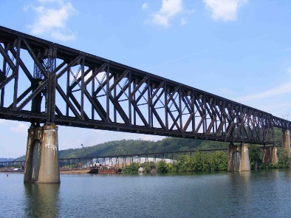
As students navigate the world of high school and begin thinking about the future, we offer services and resources that provide a foundation for success. Each of the core areas of our BRIDGE framework highlights an essential component that teenagers need in order to succeed after high school:

- Basic Skills
- Role Models
- Initiative
- Discovery
- Goal Setting
- Experiences

In the News and miscellaneous resources

4to24 App Available for Apple and Android Devices: The National Research and Training Center on Blindness and Low Vision out of Mississippi State University has created an app for students and parents. It aims to prepare youth for future employment and independence by providing targeted resources and suggesting age-appropriate activities to build skills and confidence.

“The Key to Independence: 8 Life Skills for Teens” summarizes skills teens need to live independently. This website from Positive Action offers suggestions to teachers and parents to help students become equipped with some essential independent living skills.

United Airlines becomes the first U.S. Airline to Add Braille to Aircraft Cabin Interiors.

Sam Seavey with The Blind Life. Sam has a website called theblindlife.net/ and a YouTube page youtube.com/@theblindlife where he engages in a variety of topics about blindness. “With more than 50,000 subscribers and over 700 informative videos, Sam helps people worldwide living with vision loss, offering tips for managing daily tasks, reviewing assistive devices, and hosting informative interviews with key stakeholders in the visually impaired community.”

“Teens with limited vision learn skills in Duluth.” Read about a summer camp at the Duluth Lighthouse Center for Living where students learn a variety of skills needed for success while engaging in fun activities with other students from around the state.

How a Senate aid and her guide dog made Capitol Hill more accessible for all

On Monday, September 11, at 7:00 p.m. Eastern time, the National Library Service Patron Engagement Section will host the quarterly Patron Corner. The topic for this program is Job Hunting: Dos, Don’ts, Whys, and Why nots. The session will be a panel of speakers who will address experiences with employees and employers. The session will run for 90 minutes. Visit the NLS website for additional information and the Zoom link to join!

Looking Ahead in High School
Thinking about what comes after high school is an important skill. The links below offer steps to take to prepare and plan for life after graduation.
Freshman
Sophomore
Junior
Senior

Ideas?
We are always looking for ideas you’d like to see featured in this newsletter. Please email shane.desantis@state.mn.us with any suggestions or brainstorms.

