Spotlight on Services to Youth Experiencing Homelessness
Across Minnesota, employment and training programs that serve youth and young adults (up to age 24) provide services to an increasing percentage of participants who are experiencing homelessness. Young people who lack a permanent home and basic necessities are likely to encounter barriers to participation in employment programs, such as not having required documentation and difficulties in obtaining transportation for meetings and employment. The Minnesota youth employment and training programs have developed service delivery strategies to address these barriers particular to youth experiencing homelessness. We spoke with three youth program providers across the state to learn more about how they’ve adapted their services to reach and better serve young adults who are experiencing homelessness. Across the Southeast region, an innovative approach to communication helps job counselors build relationships and connect with young adults. In Minneapolis, WIOA Youth programs set goals and measured progress in partnership with housing and service providers in a 100-day challenge. And in Anoka County, co-located services help job counselors provide a comprehensive approach to serving youth.

Background
Over the last two years, many local workforce development areas increased their services to youth experiencing homelessness. It is important to note that the Workforce Innovation and Opportunity Act of 2014 (WIOA) expanded the definition of homeless to include people living doubled-up or in a hotel, children of migrant workers, or youth awaiting foster care, in addition to the previous definition of homelessness.
This definition change allows for more youth in Minnesota to be counted as experiencing homelessness in the federal reporting data. However, even with the expanded definition, this count is believed to underestimate the true number of youth due to self-reporting omission and the frequent occurrence of intermittent housing instability which is not recorded.
WIOA limits the amount of services provided to in-school youth, in order to serve highest needs. However, in Minnesota, this limits providers from serving the many youth who are in school and experiencing homelessness. On June 12, 2018, Minnesota received approval of their waiver request to increase individualized services to Homeless In-School Youth. This allows providers to assist while youth are still attached to an educational institution and provides opportunity to prevent drop-outs as well as reduce racial disparities. Additional details regarding this policy change are available at https://mn.gov/deed/assets/wioa-chapter17_tcm1045-343259.docx.

Southeast Region
Delivering employment services to youth across multiple counties requires extensive coordination. In the Southeast region, a Youth Programs Coordinator manages twelve different sources of funding and coordinates activities for the ten Youth Career Planners, one for each county in the region.
The Youth Program Coordinator prioritizes communication between direct service staff. Staff use tools such as Skype and Slack to communicate with each other and reduce the geographic divide as well as foster relationships between programs, e.g. WIOA Adult and WIOA Youth. The Youth Career Planners are also required to develop relationships with other agencies such as housing and service providers. The Youth Career Planners participate in the Continuum of Care meetings which include housing providers, mental health service providers, schools and other organizations working to prevent and end homelessness. In these meetings, attendees share information about available resources and program eligibility requirements relevant to youth experiencing homelessness. When possible, staff make referrals in person, accompanying the youth and introducing them to the appropriate person at another agency. When not possible to accompany the youth, staff make efforts to ensure the youth feels comfortable approaching the referral service.
Transportation is a frequent barrier for youth across this large geographic area, so staff work to meet youth where they are, such as alternative learning centers or out in the community. They’ve found that flexibility in time and location for meetings fosters a deeper connection with youth participants and increases both the access to employment services as well as the comfort level for participants. When staff aren’t meeting face-to-face, which is time-intensive, they utilize various methods of youth-friendly communication to keep in touch. One of the primary means is through Facebook and other social media sites. Text messages and email are also used, while phone calls are rare. Staff communicate frequently, on a daily or weekly basis initially. The Southeast region also utilizes a cohort model for youth programming, where a group of young adults share their experiences and learn from each other. This strategy has helped to improve consistent attendance and build value for participants.

City of Minneapolis
The City of Minneapolis operates and funds a variety of youth employment programs: STEP-UP, Minneapolis Youth Works, BUILD Leaders, and PEACE (Pathways to Emergency and Academy Career Experiences). Minneapolis Youth Works (funded via the WIOA), sub-contracts with six non-profit service providers. During the past two years, providers have developed 91 paid internship placement sites in the community which are supported by one-on-one case management and an employment coach.
In addition to the variety of WIOA services available to Minneapolis Youth Works participants, service partners implement a variety of strategies to remove barriers for youth who experience employment challenges. One example is issuing pay cards to WIOA interns, where youth get paid every week and build financial literacy skills.
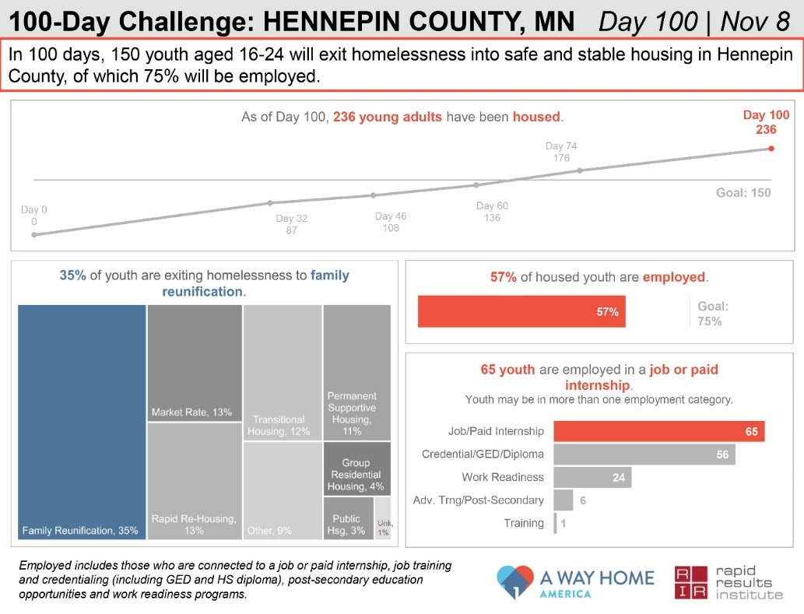
In one especially unique endeavor, the Minneapolis Youth Program Manager was selected to lead the employment goal for the “Hennepin County 100-Day Challenge on Youth Homelessness”. Hennepin County is one of thirteen communities across the country to participate in 100-Day Challenges. Hennepin County and its local partners set a goal to safely and stably house 150 youth ages 16-24 and connect 113 (75%) to employment; the first community in the nation to include an employment goal in their challenge. The City of Minneapolis Employment and Training prioritized Minneapolis Youth Works enrollments for youth experiencing homelessness.
The Hennepin County 100-Day Challenge team consisted of young adults with experiences of homelessness, housing providers, homeless service providers, city and county staff, and employment and training providers. Together, they set ambitious goals and developed a way to track progress between various housing and employment programs. Through weekly conversations, the group began to align the various systems and identified challenges or barriers within them. They engage youth and young adults to ensure their voices are included in the process and also work to reunite youth with their families, when appropriate.

Anoka County
Several years ago, there were few resources in Anoka County for young people experiencing homelessness, despite a growing need. In response to this, Brian Swanson founded an organization called HOPE 4 Youth and gathered diverse stakeholders to hold collaborative conversations about how to address the needs of homeless youth in the community. The Anoka County WorkForce Center participated in these early conversations and now provides an on-site part-time staff to offer employment and education services for the youth at the Drop-In Center located in Anoka and at their transitional housing located in Coon Rapids, HOPE Place. This partnership has helped more youth finish their educational goals, find internships and jobs, and move forward on their career, all of which are vital for the youth to secure housing and move forward with stability in their lives.
Another unique opportunity for co-locating youth employment services occurred when Anoka County designed a service hub in the 1990’s – a “one-stop shop” for all county services that someone might need, such as daycare assistance, Adult Basic Education, Vocational Rehab Services, services for seniors, legal assistance, financial assistance, food assistance, and health care. Now, federal policy requires collaboration among WIOA programs and Anoka County Youth staff take advantage of co-located services by scheduling regular meetings with other departments. A shared front desk reduces expenses and provides a streamlined point of access. County employees recognize that the services they provide serve many of the same clients. In order to best serve their clients, staff work together to provide effective person-centered services.
In youth programming, a job counselor helps the participant to develop and implement the individual employment plan and coordinates access to other services. Youth counselors may use support services to pay for clothing for job interviews and help with transportation to the store and to the interview. Staff act as mentors and work to develop meaningful relationships with young adults. Industry-specific specialized career pathway options in high-wage high-demand occupations are offered to young people. If a young adult decides to pursue a specialized career pathway option, they are assigned a navigator to assist them and provide even more individualized assistance.

Key Strategies and Common Themes
Across all three areas, several common themes emerged. Key strategies include:
Collaboration with other programs and agencies: Connections with other organizations allow youth employment programs to make referrals and gain referrals. Collaboration opens up doors, improves outreach, reduces systemic barriers, and creates access to new services. All three areas work with young adults who are aging out of foster care or involved with juvenile justice. In Anoka, counselors coordinate with juvenile justice officers in order to not duplicate efforts or requirements. Staff co-locate on-site at the Lino Lakes juvenile facility to assist with release planning. In all three areas, job counselors are regularly providing services on-site at various locations like youth drop-in centers, supportive housing, community colleges and alternative high schools.
In order to facilitate collaboration, all three areas request that participants sign a release of information so that job counselors can share appropriate information with other agencies and vice versa. Team case conferencing across areas and programs results in more effective services and better outcomes. It is also important to keep staff well-informed and connected with each other. Local areas spoke about the value of providing training to direct service staff, encouraging innovative practices and staff retention. They create opportunities to develop and strengthen relationships between job counselors and other service providers in order to share knowledge and resources and build community. Many rely on front-line staff to inform policy decisions around goals and the actions needed to achieve them.
Building relationships with young adults: Engagement with all young adults starts with an employment and training assessment, which identifies a variety of needs. Youth experiencing homelessness often prioritize a focus on stability, in particular housing and transportation, while starting to plan their employment and training goals. Job counselors guide holistic conversations with participants, and work to be a mentor or build a “family-like” relationship. Staff have flexible scheduling for appointments outside of typical business hours or offer services at various sites where young adults already are, so that travel is less of a barrier. Job counselors recognize and appreciate the skills young adults bring while working to help them develop other job-readiness skills. Building strong connections with youth increases their participation and likelihood of returning for employment and training services as well as referrals to other services.
Assist with the process of gathering required verifications or documentation. Different youth employment programs have different requirements, with the WIOA Youth program requiring documentation such as a birth certificate or social security card. This was cited as a barrier for young adults experiencing homelessness to gain access to the WIOA program. Across the state, youth program managers braid various funding sources, some with less restrictive documentation requirements in order to assist young adults on their first day. For example, the Minnesota Youth Program has a set-aside of funding for outreach to schools. Job counselors also assist youth with paperwork to apply for other services and gathering required verifications and documents.
Multiple methods of communication: Across the state, youth employment programs work to engage and serve youth where they are, both in physical location and methods of communication. Cohort models of service delivery build a team of young adults who share experiences and learn from each other.

Conclusion
For youth employment programs, oftentimes success is not the immediate connection to a job. A job may be well into the future for most youth program participants as they work to finish high school or GED and develop other job-readiness skills. In the short term, stability, safety and working to get on a path toward a future career is the definition of success for those youth who are experiencing homelessness. Staff join participants in celebrating small successes, critical steps and notable achievements. Another sign of success is that young adults and youth often refer their friends, or other youth, as well as return for additional services themselves. The longer that youth are enrolled in employment services, the more success they are likely to see. Housing resources for young adults continue to be in demand and short supply.

Additional Resources
Housing Benefits 101 (www.hb101.org) is a free website created by the Department of Human Services where people with disabilities can learn more about housing services and programs to help make informed decisions. It can help people explore goals related to housing and create a plan to help work towards achieving these goals. Disability Benefits 101 (www.db101.org) is a free website that helps people with disabilities understand how work impacts their disability benefits. These sites do this through robust content on disability and housing benefits and programs, interactive tools that show the impact of housing and work on benefits, short videos clearly explaining benefit programs, and the secure vault which allows a person to store information, share information with people helping them, and explore goals and plans through individualized paths and activities.
The Minnesota Interagency Council on Homelessness is comprised of eleven State agencies, the Metropolitan Council and the Governor’s Office and is accountable for leading the State’s efforts to achieve housing stability for all Minnesotans. The Council has recently published a new plan, Heading Home Together: Minnesota’s 2018-2020 Action Plan to Prevent and End Homelessness. In 2014, the Minnesota Interagency Council on Homelessness established five foundational service practices to improve how mainstream public programs serve individuals who are experiencing homelessness and continues to implement these practices across state services.
- Know the housing status of the people you are serving.
- Actively reach out to people experiencing homelessness.
- Limit requirements for in-person appointments at a particular location or office.
- Assist with the process of gathering required verifications or documentation.
- Allow for multiple methods to communicate about benefits and services.

WIOA Definition of Homelessness: An individual who lacks a fixed, regular, and adequate nighttime residence; • An individual who— (I) is sharing the housing of other persons due to loss of housing, economic hardship, or a similar reason; (II) is living in a motel, hotel, trailer park, or campground due to the lack of alternative adequate accommodations; (III) is living in an emergency or transitional shelter; (IV) is abandoned in a hospital; or (V) is awaiting foster care placement; • An individual who has a primary nighttime residence that is a public or private place not designed for or ordinarily used as a regular sleeping accommodation for human beings; or • Migratory children who qualify as homeless because the children are living in the circumstances described.
Continuum of Care (CoC) is a program federally funded by the Department of Housing and Urban Development (HUD) and is designed to promote communitywide commitment to the goal of ending homelessness.

