Local Workforce Development Area Industry Sectors

Partnerships by Region and Sectors in Common
Northwest | Northeast | Central | Metro | Southwest | Southeast
Education  Agriculture  Healthcare  Manufacturing  Wholesale Distribution | Construction & Skilled Trades  Healthcare  Transportation  Warehousing/Logistics and Manufacturing | Healthcare  Manufacturing | Business Services  Construction  Healthcare  Manufacturing  Public Sector  Information Technology | Agriculture  Construction  Healthcare  Manufacturing  Transportation and Warehousing | Construction/Carpentry  Healthcare  Information Technology  Public Sector  Advanced Manufacturing

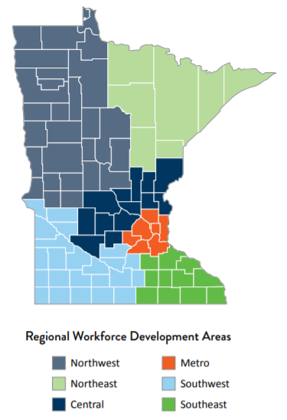
For Employment by Under-Represented Population, industries are defined using the North American Industry Classification System (NAICS) industry codes for
Agriculture: 111 (Crop Production), 112 (Animal production and aquaculture), 115 (Support activities for forestry and ag.)
Business Services: 5411 (Legal Services), 5412 (Accounting, Tax Prep., Bookkeeping, and Payroll Services), 5413 (Architectural, Engineering and Related Services), 5414 (Specialized Design Services), 5417 (Scientific Research & Development Services), 5418 (Advertising, Public Relations & Related Services), 5419 Other Scientific, Professional, and Technical Services), 55 (Management of Companies and Enterprises), 561 (Administration and Support Services)
Construction: 23 (Construction)
Education: 61 (Educational Services) Supervises
Health Care: 62 (Health Care and Social Assistance)
Informational Technology: 518 (Data Processing, Hosting & Related Services), 519 (Other Information Services), 5112 (Software Publishers), 5415 (Computer Systems Design and Related Services), 5416 (Management, Scientific, and Technical Consulting Services)
Manufacturing: 31-33 (Manufacturing)
Public Administration: 92 (Public Administration)
Services Sector: 72 (Accommodation and Food Service.), 81 (Other Services, except Public Admin)
Transportation: 48-49 (Transportation and Warehousing)

