Customer Connection Tools

Career Counseling
Career counseling is the cornerstone of the services we offer. We pride ourselves on offering individual Career Planning for each person who walks through our doors, providing a unique and tailored experience crafted with their goals and family needs in mind. These services continue to be offered through a wide array of technology tools based on the skill level of each participant. From a traditional phone call, through Google Voice calls and texts, to face-to-face conversations on Duo and Zoom, meeting with our participants in a way that is comfortable to them is our priority.
Based on the technology skills of our participants, the spectrum of offerings is as follows:
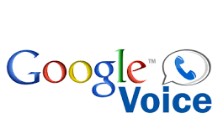

Assessments
Assessments are used to determine an individual’s areas of interest, as well as their academic skill levels when pursuing employment and education and training. Assessment are available for a customer to take in the comfort of their own home. After an assessment is complete the customer and the Career planner meet via one of our technology tools to go over the results, discuss the findings and use the information to determine the best course forward for each individual. The Strong Interest Inventory and the Wonderlic Basic Skills Test are both currently being used by Career Planners and Customers remotely.
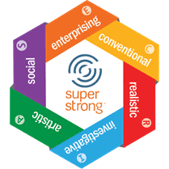

Labor Market Information
Labor Market Information is integral to the plans of our job seekers. Customers meet with their Career Planner on the phone and via Duo and Zoom. When using Zoom the Career Planner is able to screen share with the participant to do a deeper dive into the labor market information for the career pathways of their choosing. This information helps the participant visualize the data and make the best choice possible for moving forward.
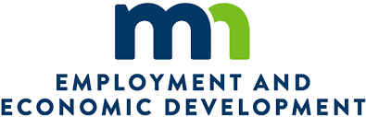

Support Services
Support services in the forms of gas vouchers, bus tokens, rent assistance, utility assistance, work tools and job supplies are invaluable to our participants as they enter and advance in the workplace. These services continue to be offered through our Career Counseling methods and using tools such as SignEasy we are able to get participants the support services they need, at a time when they need them the most.
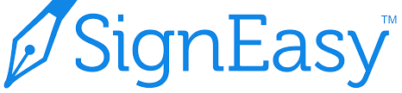

Job Clubs
Job clubs not only offer job seekers the chance to learn more about the employment needs in the community, but they also offer the chance for participants to connect with one another. At a time when social distancing is so very important, the chance to connect with other humans around a common theme is more vital than ever. Using Zoom, Career Planners can host events where customers can connect with one another through their smart phones, computers, laptops and tablets.

Essential Skill Building
Essential skill building is important for every job seeker, whether they are brand new to the workforce, or learning how to navigate the changing ways. Through tools like YouTube, LinkedIn and Instagram our Career Planners host training sessions on the following topics:

- Job Search and Networking
- Career Planning and Salary
- Beginning a New Career
- Careers Without College
- Job Success
- Workplace Basics
- Communication Skills
- Business Communication
- Cover Letters
- Interviewing Skills
- Job Applications
- Resume Writing

