Workforce One User Manual

MJSP Low Income Worker Training Program

November 24, 2014

Introduction
The Low Income Worker Training program was created in 2001 to help individuals with incomes at or below 200% of the federal poverty level receive training to acquire additional skills in order to move up the career ladder to higher paying jobs and economic self-sufficiency. This program is operated by the MJSP Board through the MJSP staff. This program is funded through the MJSP general allocation, or with Workforce Development funds when the board determines there are sufficient funds available to meet the needs of the Dislocated Worker program and transfers funds for MJSP programs.

Workforce One (WF1) will be the primary tool used to collect and manage participants' support services, career guidance, job search activities, and job placement.

State MJSP Low-Income Training Grant Contacts
For WF1 issues and questions:
Danielle Kressin
651-259-7509
danielle.kressin@state.mn.us

For program and policy guidance:

Vikki Palony
651-259-7524
vikki.palony @state.mn.us

Or

Danielle Kressin
651-259-7509
danielle.kressin@state.mn.us

Table of Contents

Snapshot of Essential Information Collection 4
Purpose 6
New Client Entry 7
Search for an Existing WF1 Record 7
If No Record Exists 9
Intake Entry 10
Enrollment 12
Entering Activities 15
Open a New Activity 15
Edit, Delete, or Copy an Activity 17
Entering Services 18
Closing a Case 19
Exiting a Person from the Program 19
Entering a Credential 23

Snapshot of Essential Information Collection
Workforce One (WF1) is the primary tool used to collect and manage participants' program activities. Use this page as a quick reference for the data to be entered into WF1. Please note that MJSP has modified some definitions and procedures to allow it to produce MJSP-specific process and outcome measures.

Required Field | Definition and Response Options
Enrollment
Program Enrollment | Participants should be enrolled in WF1 when they first access program services
Ethnicity | Yes or no; Indicates whether the participant is of Hispanic or Latino origin, regardless of race
Race | American Indian/ Alaska Native, Asian, Black/ African American, Hawaiian Native/ Other Pacific Islander, or White; Users may select multiple races
Disability Category | The person’s disability type
Disability Status | Indicate whether person has a disability and if so, whether it is a barrier to employment
Immigrant or refugee | Yes or no; “Yes” if the person was born in another country
Meets Income Guidelines | Yes or no; 200% Federal Poverty Guidelines or below
Veteran Status | Yes or no
Offender | Yes or no; Indicates whether or not the participant is an adult or juvenile who is or has been subject to any stage of the criminal justice process
SNAP Recipient | Yes or no
Supplemental Security Disability Income (SSDI) Recipient | Yes or no
Supplemental Security Income (SSI) Recipient | Yes or no
TANF/MFIP Recipient | Yes or no
Wage at Enrollment | Enter "0" if the participant was unemployed for the past 26 weeks. Leave blank ONLY IF the information is unavailable
Homeless | Yes or no; Indicates whether or not the participant lacks a fixed, regular, and adequate nighttime residence

Key Activities
Assessment/Testing | Used for intake activities
Employed Part-time | Used for participants who work less than 30 hours per week
Employed Full-time | Used for participants who work 30 hours or more per week
Job Placement | Used for both the initial job search and all subsequent periods of job search
Occupational Skills Training | Used for vocational education which is designed to provide individuals with the technical skills and information required to perform a specific job or group of jobs
Support Services
Add a New Service | Used to record instances when participants receive monetary support through MJSP. Allowable supports are: uniforms, school supplies, and tuition. If support services are being paid for by a separate program tracked in WF1, record those services in that program enrollment
Closing a Record
Exiting a Participant from the Program | Close the participant's MJSP record if they exited  voluntarily or involuntarily
Exit Reason | Indicates why a person left the program. A primary and tertiary exit reason can be included
Outcome | A participant is exited after an outcome is saved. MJSP does not require follow-ups. If a participant is co-enrolled in a program that requires these follow-ups, the guidelines for that program must be followed
Exit Reasons
Achieved Employment Outcomes | The employment outcome is in a training related field
Completed Program Objectives | Participant successfully completes training
Entered Post-Secondary Training | Participant continues education beyond MJSP initial training
Entered Registered Apprentice Training | Upon completion of training, participant continues with apprentice training
Chemical Dependency | Does not complete training due to issues with chemical dependency
Cannot Locate | Does not complete training; reason unknown because participant cannot be located
Failure to Cooperate | Does not complete training due to failure to cooperate
Family Care Problems | Does not complete training due to family care issues
Health Pregnancy | Does not complete training due to pregnancy
Moved From Area | Does not complete training due to moving from area
Transportation Problems | Does not complete training due to transportation issues
Voluntary Separation | Does not complete training due to voluntary separation
All Other Reasons | Does not complete training due to reasons other than listed above

Purpose
This guide is to assist MJSP Low Income Training Grant provider organizations add new applicants and update enrolled participants' activities and services into the Workforce One (WF1) case-management system in a consistent manner. The data supports state and local reporting, client case-management, and program evaluation.
Readers should have a Workforce One account and basic training on logging-in, searching for persons, enrolling new program participants, running reports, and other system features and functions. This manual italicizes field names and bolds tabs, links, and buttons. Carrots (>) indicate a drop-down or sidebar menu option, such as General > At-A-Glance.

New Client Entry

Search for an Existing WF1 Record
A potential participant may have a WF1 record from participating in another program also managed in WF1. You are unable to add a new record before searching for your participant’s name in the Person Search.

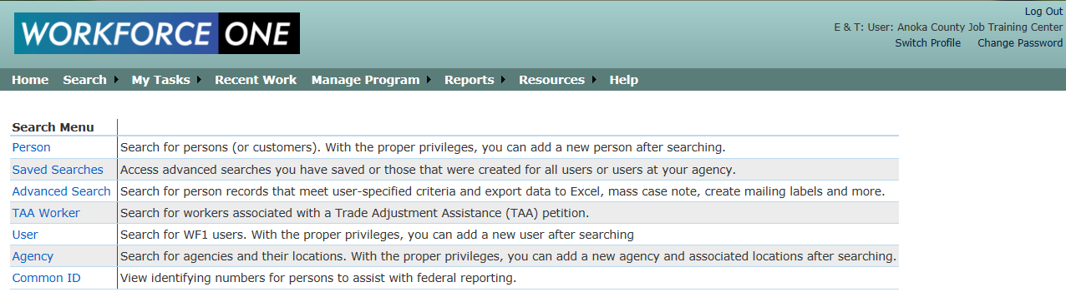
- After logging in, click on Search > Person.

- Enter your participant’s last name to determine whether s/he is in WF1. This search is required because it prevents duplicate records. Click Run Search.
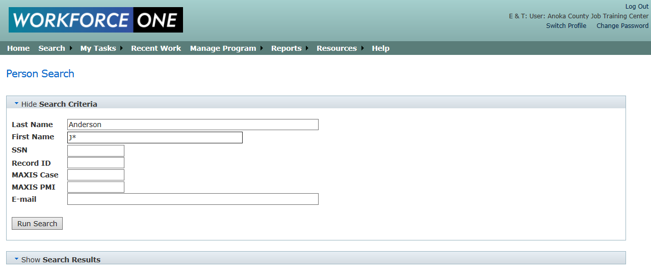
For common last names, enter the person’s first name or initial with a wildcard (*) to narrow search results.

- The Search Results box will then open. Click on your participant’s Name, if it appears in the results.

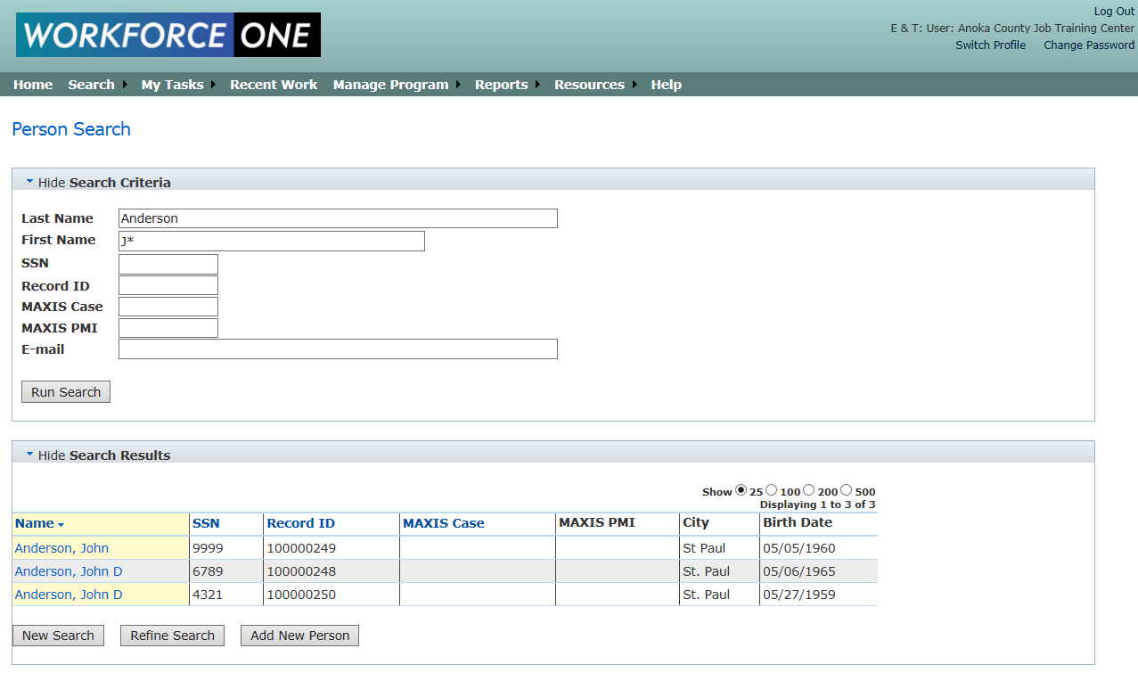

- If your participant is already in WF1, the General > At-A-Glance screen appears with your participant’s contact and program sequence information. Click on Cases > Program/New App on the green sidebar menu to begin the enrollment process.

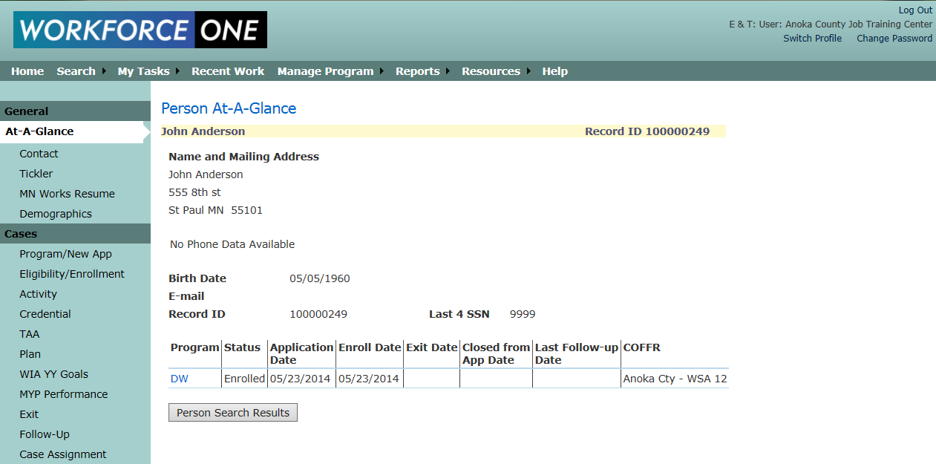

If No Record Exists

- Click Add New Person.
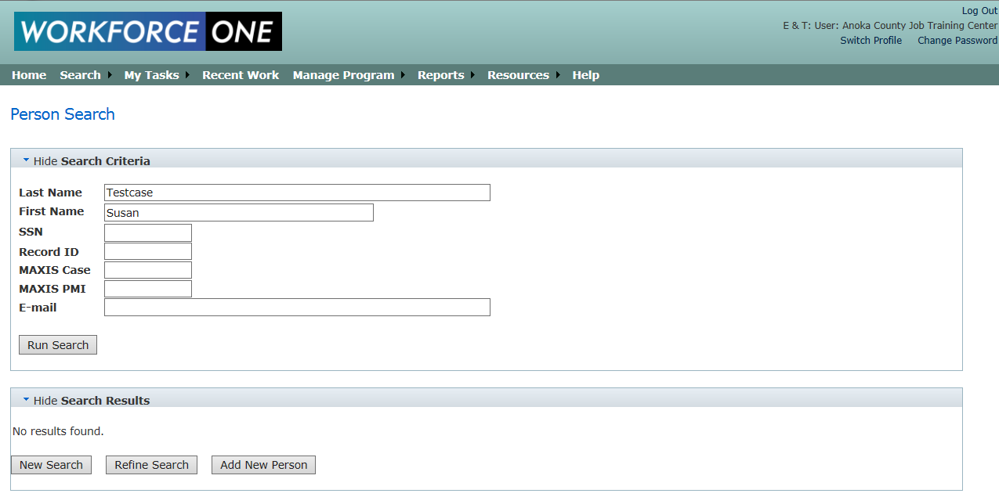

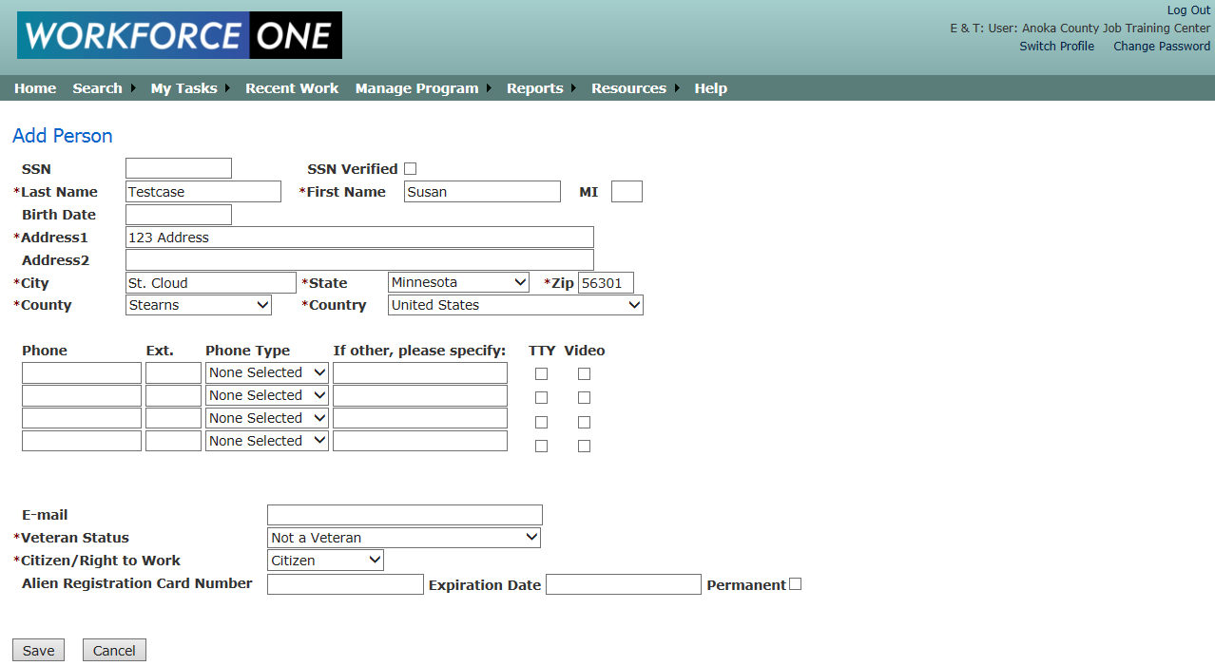
- Complete all required fields (*). A blank Add Person screen appears. Choose “Veteran”, “Spouse of a Veteran”, or “Veteran <180 Days of Active Service” only if the veteran was not dishonorably discharged. Click Save.

- The General > Contact screen appears with all of the information you filled in. Click on Cases > Program/New App on the green sidebar menu to begin the MJSP intake process.
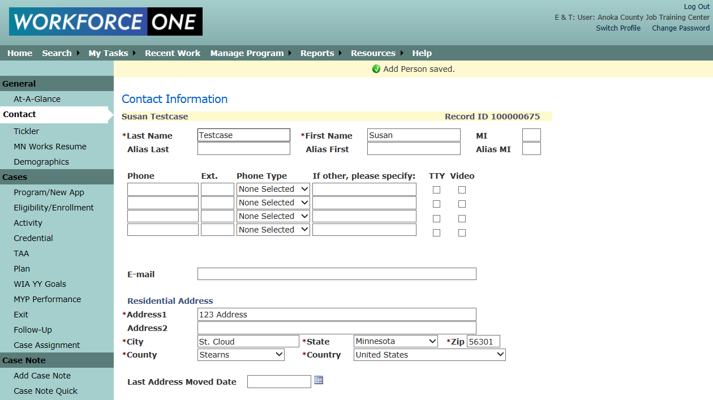

Intake Entry
Intake Entry covers a new MJSP application through approval and first activity. The steps include application, eligibility, and enrollment (including opening the first activity).

- Click Add New Application.

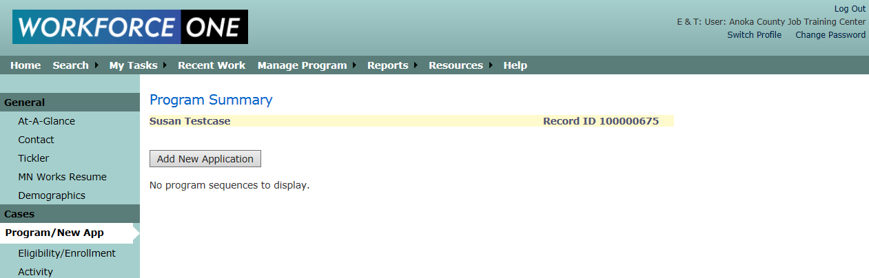

- Choose MJSP Low-Income Training Grant Program from the Program drop-down menu and enter an Application Date. The Application Date cannot be a future date or before 8/12/2014. You can also assign a staff person in the Primary Staff drop-down menu. Click Continue to Eligibility.
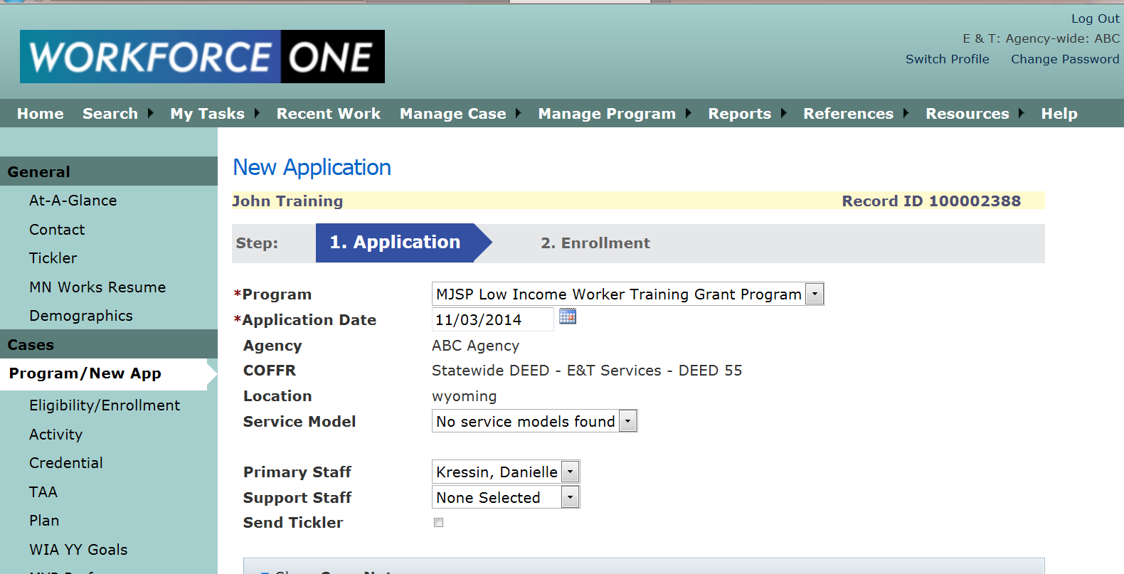

- The person’s Social Security Number is required at this point. Enter the required fields (*) and click Determine Results.

- If the person is eligible, the Save and Continue to Enrollment button will appear. Click it to continue.
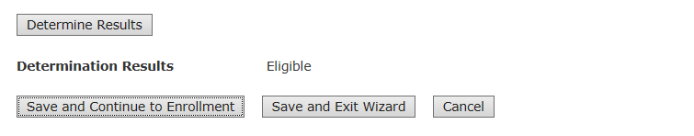

- If instead you wish to save your data entry and complete the enrollment later, click Save and Exit Wizard. When you wish to complete the enrollment process, go to the person’s record, click Cases > Eligibility/Enrollment on the green sidebar menu, and click the Complete Enrollment button.

Enrollment
The information you previously entered in the Contact Information screen automatically populates the Enrollment screen, but the person should verify that the information is correct. You must assign a staff person now if you have not yet done so. The Enrollment Date must be on or after the Eligibility/ Determination Date and cannot be a future date.

This is a comprehensive list of information you will enter on the enrollment page.

- First Name. Last Name. Address 1. City. Do not have a required format, but cannot be blank when you click Enroll.

- State: Choose "Out of Country" if Country is not the United States.

- County. Choose "Out of State" if State is not Minnesota.

- Zip- Five-digit number (nine-digit format is optional).

- Gender- Choose one of the following:
  - Female
  - Male
  - Not specified

- Ethnicity- Indicates whether the person is of Hispanic or Latino origin and can be any race.

- Race-Choose one or more of the following:
  - American Indian or Alaska Native: origins in North, Central and South America and maintains tribal affiliation or community attachment
  - Black or African American: origins in the black racial groups of Africa
  - Hawaiian Native or other Pacific Islander: origins in Hawaii, Guam, Samoa or other Pacific Island
  - White: origins in Europe, the Middle East, or North Africa (includes most people of Hispanic/Latino ethnicity)
  - Asian: origins in Far East, Southeast Asia, or the Indian subcontinent

- Immigrant or Refugee- "Yes" if the person was born in another country.

- Limited English Language Proficiency-"Yes" for English-as-a-Second-Language speakers whose language barriers impede employment (NOTE: a response is optional).

- Veteran Status- “Yes" if the person actively served in the United States Armed Forces and was not dishonorably discharged. NOTE: If the person is a spouse of a veteran, choose "Yes."

- SSI Recipient-"Yes" if the person receives federal Supplemental Security Income.

- TANF/MFIP Recipient- "Yes" if the person participates in Temporary Assistance for Needy Families/Minnesota Family Investment Program.

- SNAP Recipient. "Yes" if the person participates in Supplemental Nutrition Assistance Program (formerly called Food Stamps) through a county human services agency.

- Refugee Assistance Recipient- "Yes" if the person receives refugee assistance through a county human services agency.

- Disability Status- Is a self-reported physical, mental, or learning disability, emotional/behavioral disorder, or substance abuse that has an impact on employability. The choices are:
  - Not disabled.
  - Yes, and disability is an employment barrier.
  - Yes, disability not a barrier to employment.

- Homeless- "Yes" if the person lacks a fixed, regular, and adequate nighttime residence or whose nighttime residence is a supervised, temporary living accommodation or shelter.

- Offender- "Yes" if the person's arrest record or conviction is an employment barrier.

- Wage at Enrollment- Enter the person's latest hourly wage within the past 26 weeks. Enter "0" if the person was unemployed the entire 26 weeks.

- Activity Status Type- Enter the participant's initial MJSP activity. The choices at
enrollment are:
  - Assessment/Testing:
  - Employed Part-time:
- Employed Full-time
- Job Placement
- Occupational Skills Training

  - Case Note- Enter any additional information about this activity. NOTE: Comments do not appear on the printed enrollment form.

You cannot change the information you saved on the Enrollment page after you click Enroll, with these exceptions:

The Open Activity Status can be closed or case-noted in the Cases > Activity page.

- At the bottom of the screen, click Enroll when all the required fields are completed.
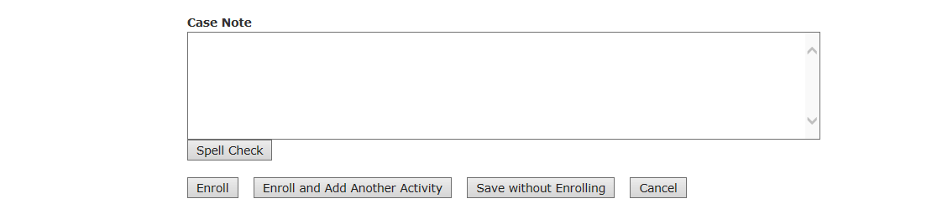

- If there are no errors when you click Enroll, you will be directed to the Eligibility – Enrollment Summary page. From there, click View/Print Enrollment to print a contract for the person’s signature.
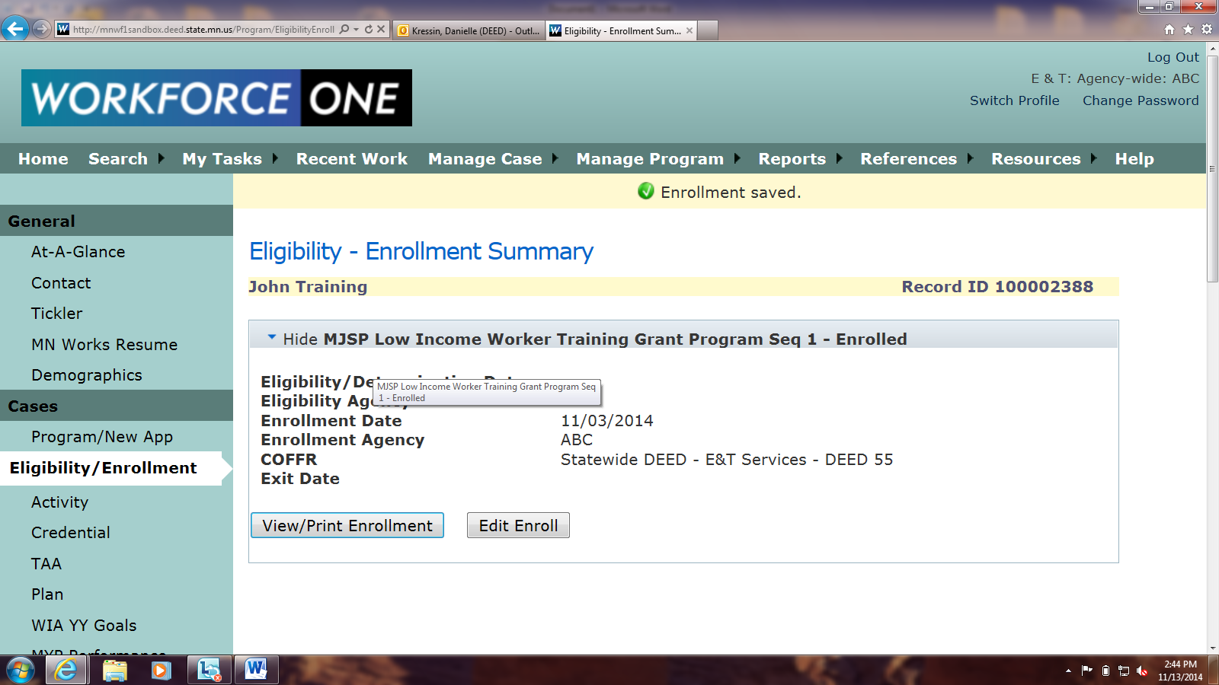

Entering Activities
Activities reflect the participant's MJSP progress or steps toward a goal, while Services are types of assistance that usually require payments.

See the Glossary of Activity Statuses and Support Services in Appendix A for complete list of definitions of all of the MJSP activities in WF1.

Open a New Activity

- Click on Cases > Activity on the green sidebar menu to view the Activity Summary page and to add a new activity. Click the Add New Activity button. Assign the activity to a staff person and choose the activity from the Activity Type drop-down menu, then click Next.

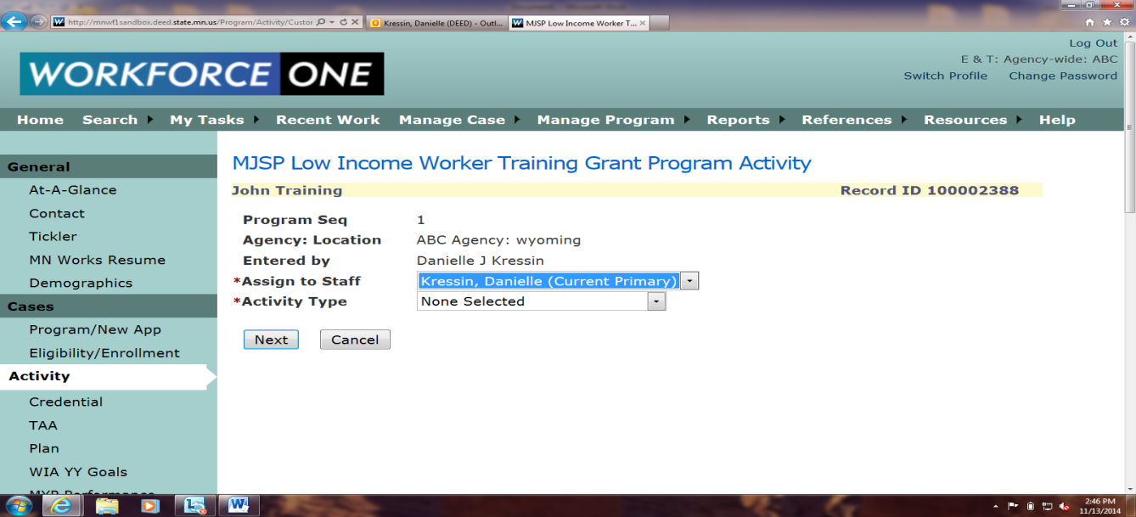

.
- Enter the required fields (*) in the Open Activity section of the page before clicking Save or Save and Open New Activity. Required fields vary by activity: training activities have more required fields than career guidance activities.

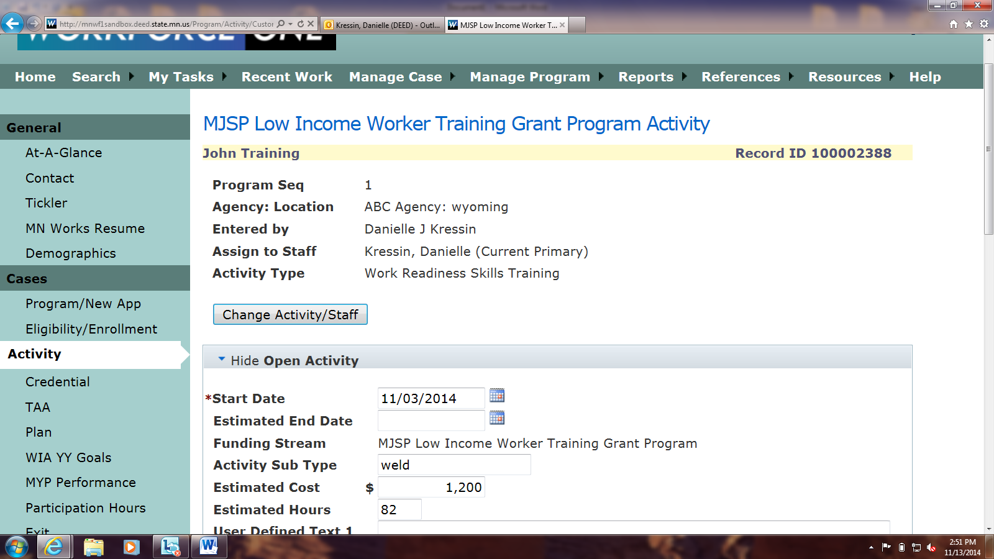

- You may also enter information in the Close Activity section at the same time. Completion Results is a required field if you enter an End Date. Then click Save or Save and Open New Activity.
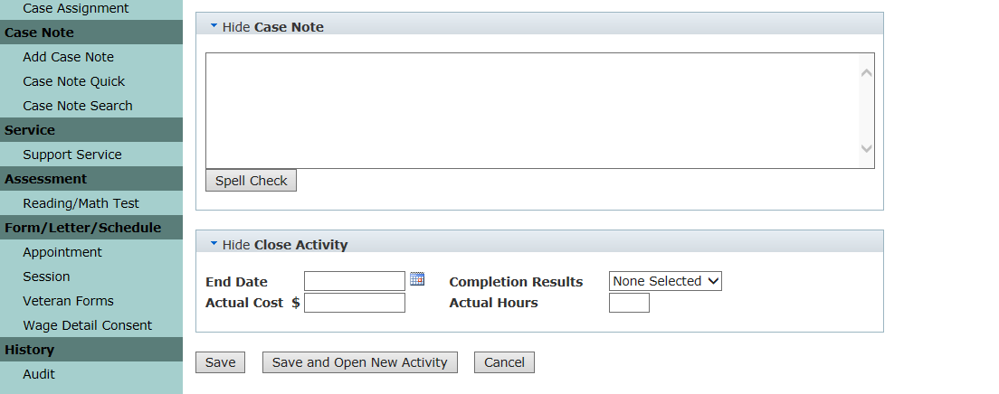

Start Date. Cannot be prior to Enrollment Date but can be a future date.

School. Enter the school's name using the Search/Validate School button. To use the search feature again when you have a valid entry in the field, you must delete the entry before clicking the button (NOTE: for training activities only).

Training Program Code (CIP). Enter the Classification of Instructional Programs identifier using the Search/Validate CIP button. To use the search feature again when you have a valid entry in the field, you must delete the entry before clicking the button (NOTE: for training activities only).

Occupational/Training Title. Enter the person's occupational or training program title using the Search/Validate O*NET button. To use the search feature again when you have a valid entry in the field, you must delete the entry before clicking the button (NOTE: for training activities only).

End Date. Cannot be prior to the activity’s start date and cannot be more than 14 days into the future.

Edit, Delete, or Copy an Activity
You can edit, delete, and copy activities using the Action links on the Activity Summary page. Click Edit to add information to an activity (such as end date and completion status, or a case note). Click Delete if you entered the activity in error. Click Copy to quickly open a new activity of the same type. Only the activity type (such as Classroom Training or Staff Assisted Assessment) will be prepopulated in the new activity.

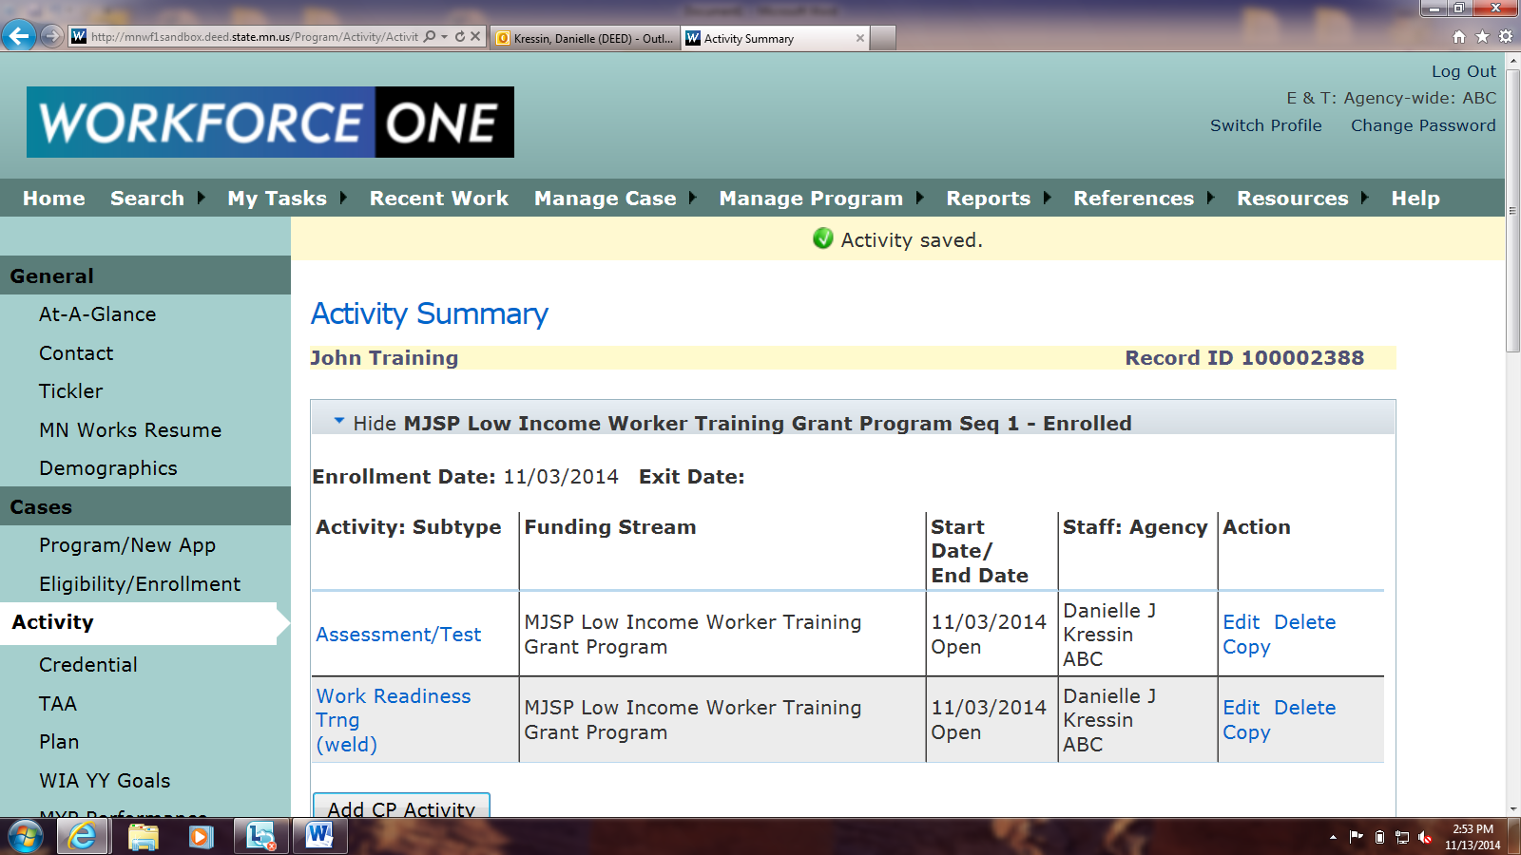

- When you click Delete, WF1 will give you the following confirmation message. Click OK or Cancel to continue.
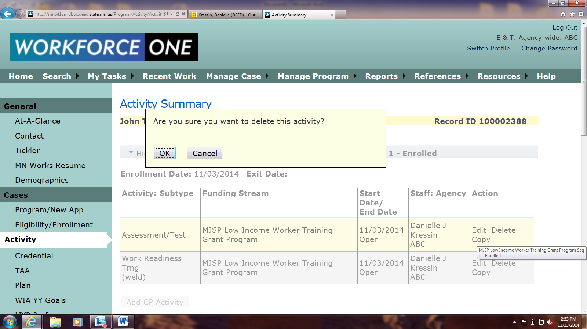

Entering Services
A service is different than an activity. Services are used to record instances when participants
receive monetary supports through the program. If support services are being paid for by a
separate program tracked in WF1, record those services in that program enrollment and select the
- Click Service > Support Service on the green sidebar menu for the Support Services Summary page. This page will show you previous support services this person received through the program and allow you to add new support services. To edit or delete existing support services, click the Edit or Delete links next to the appropriate support service. To add a new support service, click Add Support Service.

- Enter all required fields (*). Then click Save or Save and Add Support Service.

Support Service. See the Glossary of Support Services in Appendix A for service type definitions.

Service Date. Enter the date that you provided the service. This date cannot be before the enrollment date and cannot be a date in the future.

Actual Amount. Enter the dollar amount of the service, omitting the dollar sign ($). If the actual amount is an even dollar amount, you do not need to enter the cents (50 is the same as 50.00).

Add as Case Note. Check this box to add a summary of this service to the person’s case note history.

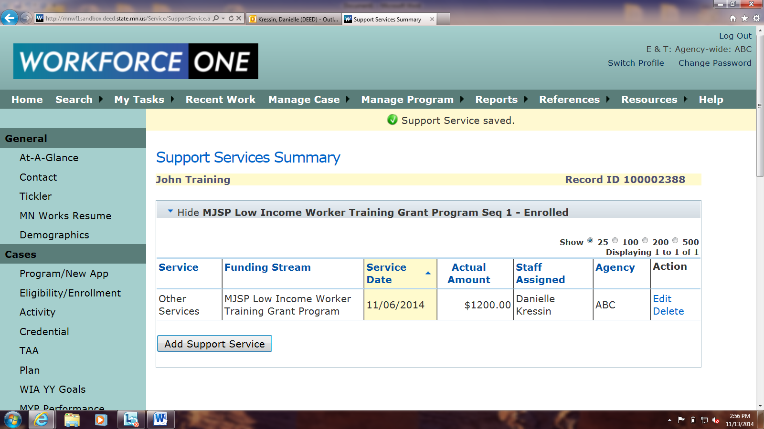

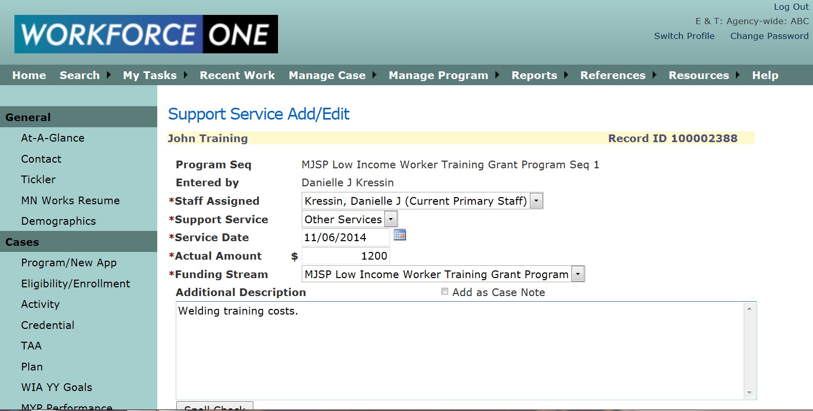

Closing a Case

Exiting a person from the program
Close the person’s MJSP Low Income Training case if he or she is no longer receiving services through the program, whether voluntarily or involuntarily.

- Click Cases > Exit on the green sidebar menu to view the Exit Summary page, which shows you all activities that will be closed when you close the program sequence. Click Exit Program Sequence if the person is no longer receiving services through the program.
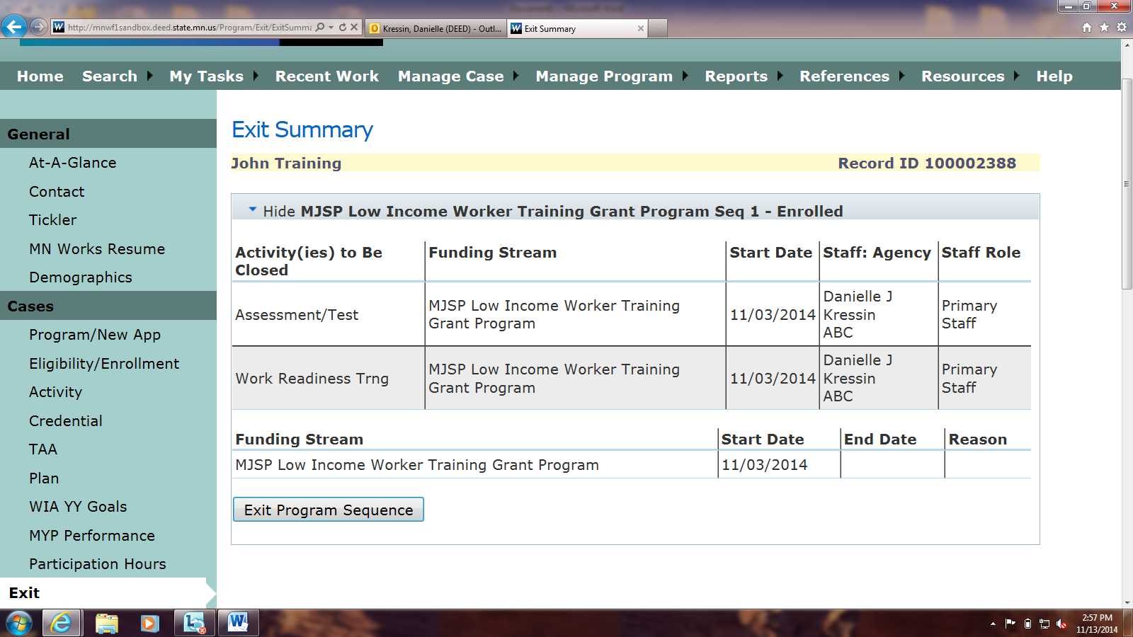

- Choose the Primary Exit Reason from the drop-down menu. The exit reason indicates why the person no longer receives services. Then click Next.

The exit reason options are:
- Achieved Employment Outcomes
- Completed Program Objectives
- Entered Post-Secondary Training
- Entered Registered Apprentice Training
- Chemical Dependency: withdraws due to chemical dependency issues.
- Cannot Locate
- Transportation Problems: Transportation is a barrier to completing training program.
- Family Care Problems: withdraws due to family care problems.
- Health/Pregnancy: withdraws for health reasons or pregnancy.
- Moved from area: is moving or has moved from the area.
- Other: leaves program for any other reason.
- Personal/Medical Problem: leaves program because of personal or medical barriers to participation.
- Voluntary Separation: chooses to discontinue receiving program services.
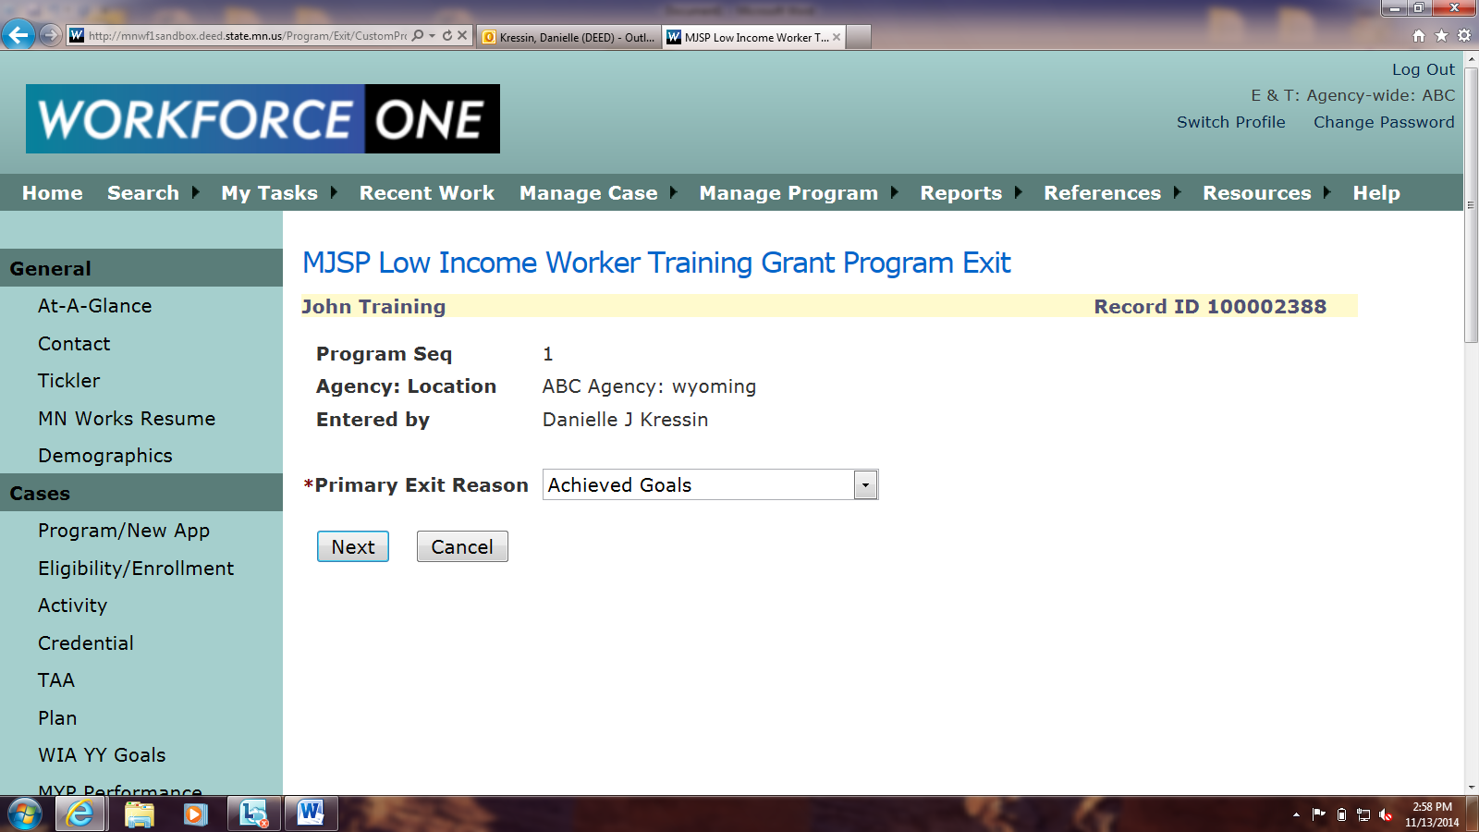

- Enter the required fields (*). The exit date is the last day the person received MJSP services, and cannot be a future date or a date prior to the start date of an activity. Required fields vary by exit reason: exits such as Cannot Locate require less information than Entered Unsubsidized Employment. If the person is employed at exit, add employer information by clicking Next in the Placement Information section.

- Enter all required fields (*) in the Placement Information section. Check the box next to Remove from Caseload to remove the person from their assigned staff when the exit is saved. CAUTION: once a person is removed from your caseload, you can no longer change or edit activities and outcomes or enter follow-up information. Click Save Final Exit.

The following fields in the Placement Information section are required if "Achieved Employment Outcomes" is selected as the exit reason:

- Employer. Name
- Employer. State
- Employer Industry (NAICS). Click the Search/Validate NAICS button to select the industry description.
- Occupational Title (O*NET). Click the Search/Validate O*NET button to select the person's occupational description.
- Job Sector. Public or Private
- Job Start Date. Indicates the approximate start date of the job
- Hourly Wage. Estimated hourly wage of the job, in dollars per hour
- Hours per Week. Estimated numbers of hours worked per week at the job
- Job is Training Related. Yes or No

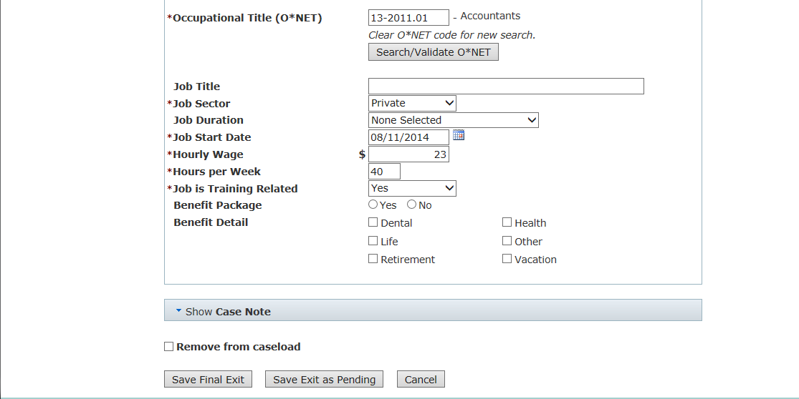

NOTE: After an outcome has been saved, MJSP considers an individual's participation complete and exited from the program. Because MJSP participant data are not being reported with other Workforce Investment Act IB programs, the State MJSP office does not require follow-ups. With various other programs, however, follow-ups are required and meant to capture credential attainment and/or employment, and wage information after an individual has left a program. If a participant is co-enrolled in a program that requires these follow-ups, the guidelines for that program must be followed. If co-enrollment is not occurring, it is up to the individual MJSP site to decide if there is program value in having a formal follow-up policy.

- You can edit the exit after you have saved it by clicking Cases > Exit on the green sidebar menu and then Edit Exit.
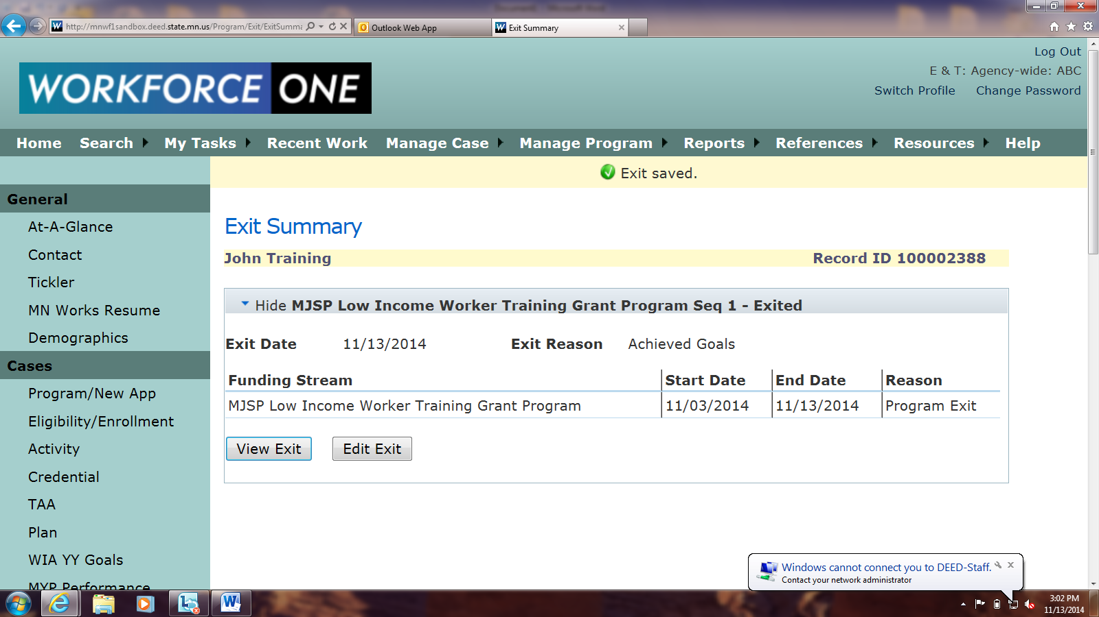

- You can reopen the program sequence by clicking Cases > Program/New App on the green sidebar menu and then Reopen Program Sequence in the MJSP program sequence section.

Reopening a program sequence deletes any information you entered in the Exit and Follow-Up screens. You will get the following warning message when you reopen a program sequence:

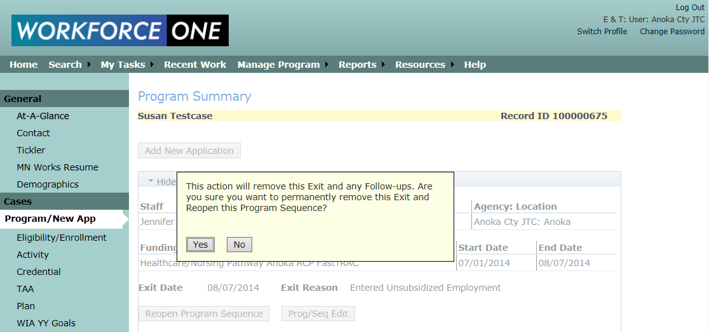

Entering a Credential

- You can enter a credential obtained through the program before or after you close the person’s case by going to Cases > Credential. If the person had a training activity open with an expected credential, you will get a warning message if you close that person’s case without recording a credential. Click OK and go to Cases > Credential in the green sidebar menu to enter a credential.

- The Credential Summary page allows you to view all credentials, including pending credentials not yet earned, associated with the person’s case. Check to see whether WF1 automatically opened a Credential Pending before creating a Credential Pending yourself. To update a Credential Pending to an earned credential, click the Edit link next to the Credential Pending. Enter all required fields (*) and click Save.

The following are options in the Credential Type drop-down menu:
- Occupational Skills Certificate/Credential
- Technical/Occupational Skills License
- AA or AS degree
- BA or BS degree
- Master’s Degree
- Doctorate Degree
- Other Recognized Credential
- Credential Pending
- No Credential Attained

Where to Get Further Help with WF1

- WF1 has a Resources page which includes a set of User How-To Guides and a Glossary. The User How-To Guides will show you features of the system not specific to this program, such as running reports on your program participants, setting up ticklers to help you manage a caseload, and more. We highly recommend that you read these guides so you can make the most out of your case management system. The Glossary is a reference that explains what each field in WF1 means. Access the Resources page by clicking Resources in the top menu.
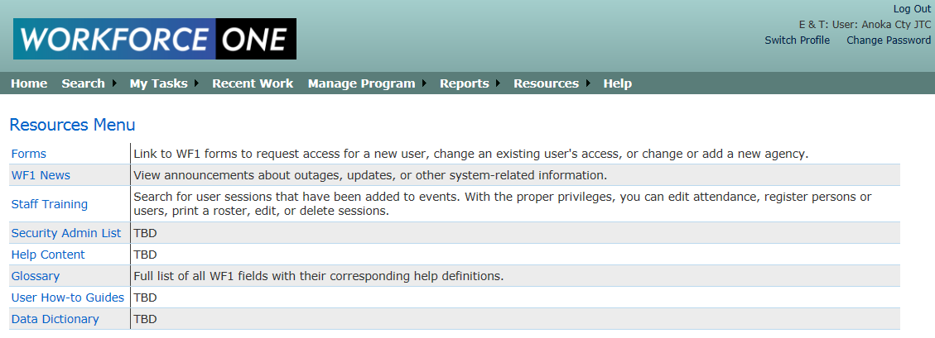

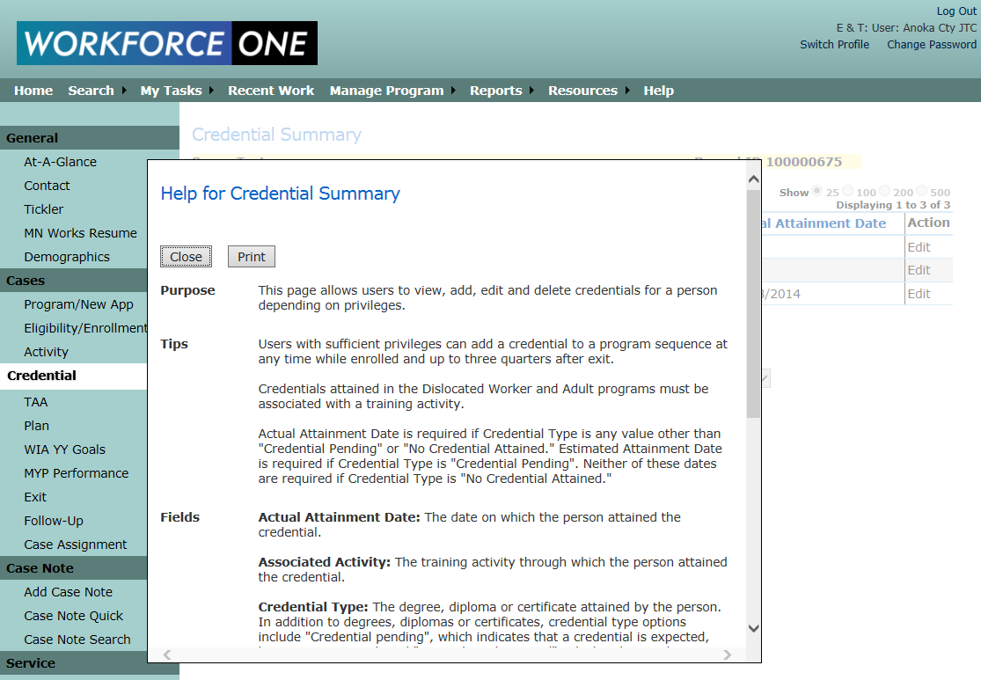
- Each page in WF1 has its own help content. View the help content for whatever page you are currently viewing by clicking Help in the top menu. A pop-up screen will then appear, providing a summary of the page, tips for entering information into the page, Glossary definitions for each field on the page, and actions you can take on the page. Click Close or Print to close the Help screen.

- Finally, if you have questions about WF1 that relate to this program, contact the program person listed on page 2 of this user manual.

