Workforce Program Uniform Outcomes Report Card
1/31/2022

Total cost of salaries, printing, and supplies in
developing/preparing this report is $1,425.83
(reported as required by Minn. Stat. 3.197)

Contents
What is the Uniform Outcomes Report Card? 4
How is data from the Report Card gathered? 4
What programs are included in the Report Card? 4
Programs Active in the Report Card in SFY 2022 4
Required Data Under §Minnesota Statutes 2022, section 116L.98, subdivision 3 5
How has the COVID-19 Pandemic Impacted Workforce Development Program Demographics and Short-Term Outcomes? 6
Methodology 6
Cohort Assignment 6
Results 7
Finding #1: Programs are serving a higher percentage of participants from targeted groups after the pandemic than before 7
A Higher Percentage of Participants Enrolling since the Start of the Pandemic Come from Target Groups, Particularly BIPOC and Greater Minnesota 7
Racial Breakdown of Cohort Members 8
Finding #2: Short-Term Outcomes are Comparable Across Cohorts 9
First Quarter After Exit Employment by Cohort 9
First Quarter After Exit Median Wage of Employed Participants by Cohort 10
How much do workforce programs cost? 11
Program Cost per Participant for Select Report Card Programs in SFY22 11
Limitations in Calculating Cost 12
Changing Policy in Response to the Pandemic, a Case Study 14
Background 14
Pathways to Prosperity's Approach 14
Integrating Basic Skills Education and Career Training 14
Focusing on Credentials and High-Demand Occupations 14
Meeting the Needs of Working Learners 14
Introduction 14
Methodology 15
Results 15
Uncredentialed Training Enrollment 15
Credentialed Training Enrollment 16
Training Completion 16
Post-Secondary Credential Attainment 16
Conclusion 17
Appendix A Cost Data from State Fiscal Year 2020 to 2022 18

What is the Uniform Outcomes Report Card?
The Uniform Outcomes Report Card (report card) is an online interactive dashboard that displays demographic and outcome-based data for adult workforce development programs administered by the Department of Employment and Economic Development (DEED). This reporting is required under Minnesota Statutes 2022, section 116L.98 subdivision 3. The report card is publicly available and is updated quarterly. All outcomes in the report card can be disaggregated by program as well as by:
- Educational attainment
- Gender
- Region
- Homeless status
- Race
By breaking down outcomes for these groups, stakeholders are able to see who programs are serving and if outcomes differ.

This report explores the impacts of the COVID-19 pandemic on report card program demographics and short-term outcomes. Select the following link to view the report card: https://mn.gov/deed/data/workforce-data.

How is data from the Report Card gathered?
Once enrolled in any report card program, individual demographic and training data is entered into the state's case management system, Workforce One. In addition, wage data is leveraged from Minnesota's Unemployment Insurance (UI) program (with exceptions noted below). Data is pulled from UI and Workforce One once per quarter. The following individuals are not included in the UI data:

- Self-employed individuals
- Railroad workers
- Family Farm Workers
- Full-Time Students working for their school
- Elected government officials
- Insurance and real estate salespeople
- Others who work only on a commission basis

What programs are included in the Report Card?
The following programs are included in the report card for State Fiscal Year (SFY) 2022

Programs Active in the Report Card in SFY 2022
Type | Name
Direct Appropriation | AccessAbility
Direct Appropriation | American Indian OIC
Direct Appropriation | Better Futures
Direct Appropriation | Center for Economic Inclusion
Direct Appropriation | Goodwill-Easter Seals
Direct Appropriation | Hmong American Partnership (HAP)
Direct Appropriation | Minnesota Diversified Industries
Direct Appropriation | Northgate Development
Direct Appropriation | Northwest Indian CDC
Direct Appropriation | Project for Pride in Living
Direct Appropriation | Workforce Development Inc (WDI)
Direct Appropriation | YMCA of the North
Direct Appropriation | YWCA Minneapolis
Direct Appropriation | YWCA St Paul
Federal Program | WIOA Adult
Federal Program | WIOA Dislocated Worker
State Program | Dislocated Worker Program
Competitive Grant | Adult Support Services Program
Competitive Grant | African Immigrant Community Grant Program
Competitive Grant | Displaced Homemaker Program
Competitive Grant | Minnesota Tech Training Pilot Program
Competitive Grant | Pathways to Prosperity
Competitive Grant | Southeast Asian Economic Relief Program
Competitive Grant | Women in Nontraditional Jobs Program
Table 1

Required Data Under §Minnesota Statutes 2022, section 116L.98, subdivision 3

All data elements, as required by Minnesota Statutes 2022, section 116L.98, subdivision 3, are available and updated every quarter at mn.gov/deed/data/workforce-data/.

How has the COVID-19 Pandemic Impacted Workforce Development Program Demographics and Short-Term Outcomes?

Methodology
For this report, three cohorts were created. To be in one of these cohorts, participants must have enrolled in a report card program between 07/01/2017 to present. Participants were then grouped into Pre-Covid, Peak Covid, or Post-Peak Covid as outlined in Table 1.

Cohort Assignment
Cohort Name | Enrolled Between | Number of Participants
Pre-Covid | 07/01/2017-03/31/2020 | 15,824
Peak Covid | 04/01/2020-07/30/2021 | 7,988
Post-Peak Covid | 08/01/2021-11/28/2022 | 8,328
Table 2
Demographics were compared across cohorts. For employment and wage outcomes, participants must have exited by 6/30/2022 to be considered for analysis.

Results

Finding #1: Programs are serving a higher percentage of participants from targeted groups after the pandemic than before

A Higher Percentage of Participants Enrolling since the Start of the Pandemic Come from Target Groups, Particularly BIPOC and Greater Minnesota
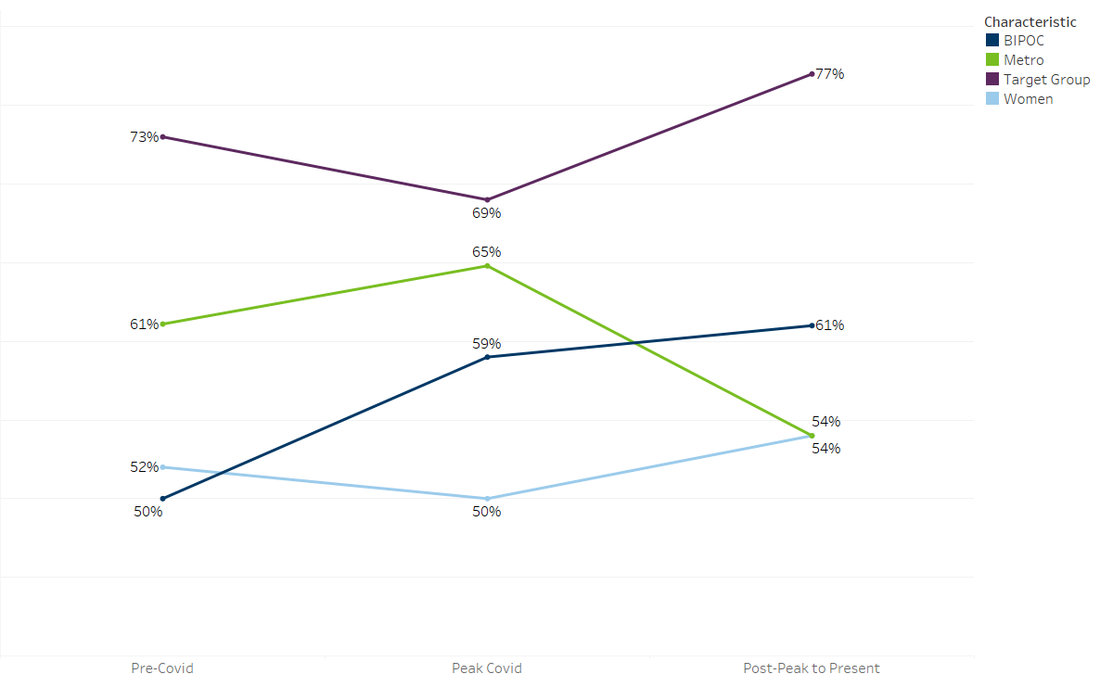
Figure 1

Figure 1 includes the characteristics of the three cohorts across four demographic measures: Black, Indigenous People of Color (BIPOC), Participants living in the seven-county Metro Area, Women, and Individuals from a Targeted Group. BIPOC were a much larger part of the Post-Peak Covid cohort than either the Post-Peak or Pre-Covid cohorts; however, from the beginning of the pandemic onward, the overall proportion of participants who are BIPOC has increased and maintained its increased presence. This increase can be attributed partly to intentional efforts by both the Legislature and DEED to invest funds in culturally-specific organizations and fund programs with an intentional racial equity focus (i.e. Southeast Asian Economic Relief program).
Women enrolled in programs at near equal rates before, during, and after the pandemic's peak. The consistency is likely due to women remaining in the workforce throughout the duration of the three cohorts in order to support dependents.
Metro participants saw a decline in representation in the post-peak cohort. This could be due to the metro's robust economic recovery, lack of services, or participants in the metro receiving training elsewhere (i.e., Minnesota State).
The figure below breaks down cohort characteristics by race.

Racial Breakdown of Cohort Members
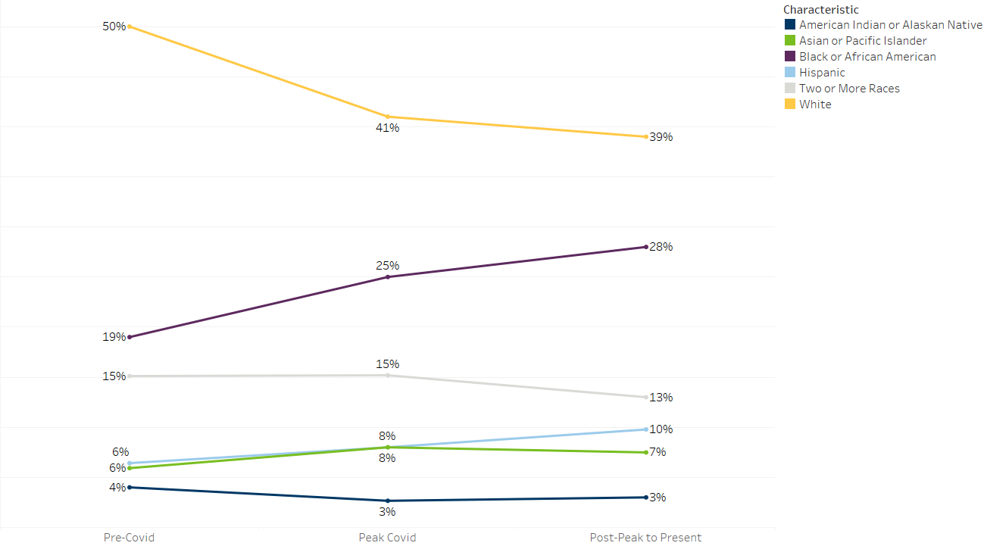

Figure 2
The increase in BIPOC participants in the Peak Covid and Post-Peak cohorts is driven by the rise in Black or African American, Asian or Pacific Islander, and Hispanic participants. American Indians or Alaskan Natives saw a slight decrease in their overall representation, along with multi-racial participants. However, this was minimal and likely due to natural fluctuations in program demographics.

Finding #2: Short-Term Outcomes are Comparable Across Cohorts
Figure 3 below compares participants' employment rates in the first quarter after exit across cohorts.

First Quarter After Exit Employment by Cohort
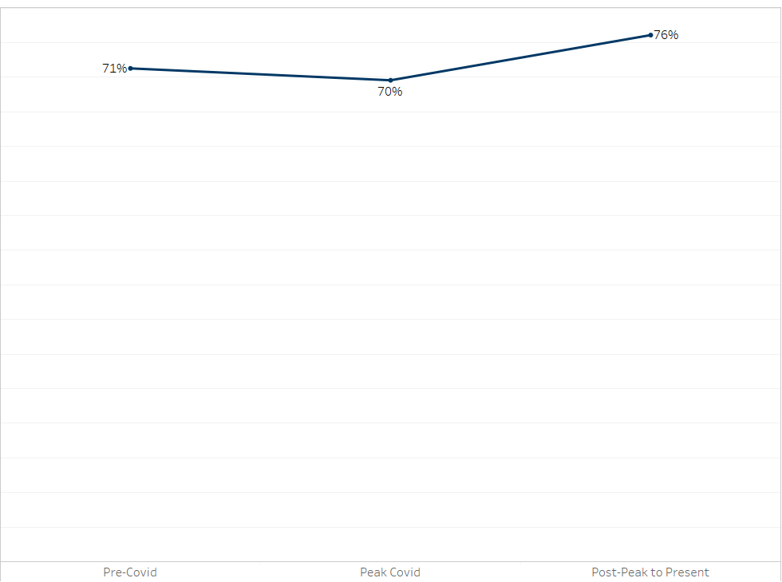
Figure 3
Employment rates from the Pre-Covid to Peak Covid stayed relatively flat. The Post-Peak cohort had the highest employment rate, though this could be due to missing data as individuals must have exited by 6/30/2022 to be included in the analysis.
Overall, about three out of four participants secure employment within 90 days after exiting the program.
A similar trend is also present with wages:

First Quarter After Exit Median Wage of Employed Participants by Cohort
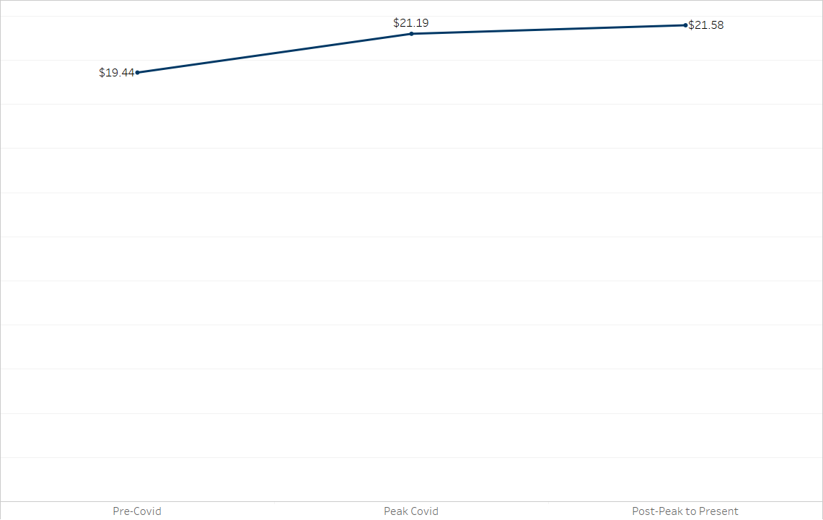

Figure 4
Figure 4 demonstrates that the median wage of participants in the Peak and Post-Peak cohorts are slightly higher than the Pre-Covid cohort. This likely reflects the strong economy and Minnesota's labor shortage.
Research done by our Labor Market Information Office shows that the increase in wages from switching employers, compared to working with the same employer, has increased the economic incentive for workers to change jobs in Minnesota post-COVID period. Workers who switched jobs saw a 6.1% increase in wages. In comparison, workers who stayed with the same employer saw a 1% wage decrease.
Participants in the pre-covid cohort had wages approximately eight percentage points lower than their peak Covid counterparts and ten percentage points lower than their post-peak peers. This is slightly higher than the most recent October 2022 Consumer Price Index, which shows a 7.4% increase in the cost of goods over the year. However, inflation still wiped out a large portion of wage increases in terms of real purchasing power.
The broader economic environment and unemployment rates are important to consider as they impact these outcomes. Previous research by DEED found that employer views of participants in workforce programs, like the Dislocated Worker Program (the largest report card program) are influenced by the broader economy. The study found that 27 percent of Minnesota employers were more likely to recruit from workforce programs in a hypothetical future with high unemployment than in a tight labor market.
As the economy continues to strengthen and Minnesota faces a historic labor shortage, employers might be less likely to view workforce programs as a place to source potential employees. This could be because of a bias in the perceived quality of participants. This bias could be due to perceptions that people using workforce programs face significant barriers to getting and maintaining employment.

How much do workforce programs cost?
Significant costs associated with workforce programs include training and other supportive services offered to participants (such as gas vouchers or tools needed to start a new job) as well as basic administrative costs necessary for an organization to function effectively, such as IT support, printing supplies, and rent. All costs are included in the total program costs presented here. Programs have a maximum percentage of administrative costs, set per their legislative statute, and in general range between 5 percent and 10 percent. The number of participants is divided by the total program cost to obtain a cost per participant.
Generally, funds appropriated by the Legislature can be spent over multiple years. The amounts presented represent what was actually spent in state fiscal year 2022. Appendix A includes cost data for state fiscal years 2020 – 2022.

Program Cost per Participant for Select Report Card Programs in SFY22
Program or Direct Appropriation | Program | Total Program Cost | Cost Per Participant
Direct Appropriation | AccessAbility | $40,449.54 | $1,617.98
Direct Appropriation | American Indian OIC | $1,041,359.15 | $4,285.43
Direct Appropriation | AVIVO* | $43,500.00 | $2,718.75
Direct Appropriation | Better Futures | $174,462.36 | $3,060.74
Direct Appropriation | Center for Economic Inclusion | $195,117.76 | $2,469.85
Direct Appropriation | Goodwill-Easter Seals | $91,000.00 | $1,750.00
Direct Appropriation | Hmong American Partnership (HAP) | $478,567.89 | $2,246.80
Direct Appropriation | Minnesota Diversified Industries | $450,000.00 | $4,455.45
Direct Appropriation | Northgate Development | $606,842.21 | $40,456.15
Direct Appropriation | Northwest Indian CDC | $51,080.97 | $429.25
Direct Appropriation | Project for Pride in Living | $249,952.66 | $3,424.01
Direct Appropriation | Workforce Development Inc (WDI) | $267,406.00 | $1,065.36
Direct Appropriation | YMCA of the North | $231,828.19 | $2,466.26
Direct Appropriation | YWCA Minneapolis | $139,401.67 | $2,733.37
Direct Appropriation | YWCA St Paul | $11,765.32 | $5,882.66
Program | Dislocated Worker (WIOA and State) | $24,670,110.22 | $4,180.67
Program | WIOA Adult | $8,240,878.67 | $4,946.51
Program | Adult Support Services Program | $214,058.37 | $688.29
Program | African Immigrant Community Grant Program | $275,262.88 | $2,646.76
Program | Minnesota Family Resiliency Partnership | $1,047,342.90 | $2,262.08
Program | Minnesota Tech Training Pilot Program | $273,198.09 | $4,268.72
Program | Pathways to Prosperity | $3,936,004.26 | $3,255.59
Program | Southeast Asian Economic Relief Program | $797,338.72 | $2,499.49
Program | Women in Nontraditional Jobs Program | $567,910.65 | $3,360.42
Table 3
Program spending varied quite a lot across programs. In total programs spent over $43 million with an average cost of under $2,909 per participant.

Limitations in Calculating Cost
There are a multitude of factors which make calculating cost difficult. The first is the presence of co-enrollment or individuals enrolling in multiple programs concurrently. Program participants are not restricted to only attending one workforce program. In fact, programs might actually encourage co-enrollment in programs which might serve the participant’s needs in ways that one program cannot. In addition, programs might use multiple funding streams to provide services to the individual. If these funding streams come from federal or private dollars not captured here, then the true cost as reported in the above table is cheaper than it actually is to successfully serve a participant.

Changing Policy in Response to the Pandemic, a Case Study

Background
Pathways to Prosperity (P2P) is a collaboration between state, local, and national partners, and part of a broader career pathways movement. With a shared vision for success, P2P partners are changing the way they do business to align limited resources towards meaningful long-term outcomes for adult learners. P2P is managed by the office of Adult Career Pathways (ACP).

Pathways to Prosperity's Approach
Pathways to Prosperity's approach includes a number of innovations that have proven effective in improving educational outcomes for educationally under-prepared adults.

Integrating Basic Skills Education and Career Training
Many adults seeking career-specific training also need to build their basic academic skills. P2P addresses both by teaming up Adult Basic Education and post-secondary career and technical instructors in the classroom. This allows students to learn basic skills like literacy and math in the context of their career interests, making learning more relevant. By starting with basic skills, P2P is able to serve a broader array of students and ensure that they have the academic foundation to succeed in a post-secondary setting.

Focusing on Credentials and High-Demand Occupations
P2P's mission is to ensure students receive a post-secondary credential valued by employers. Research shows that students who earn one year of post-secondary credits and a credential earn significantly higher wages.
P2P targets high-demand occupations and tunes into the needs of local employers when implementing local programs. This means P2P is an effective supply chain for local businesses who need skilled labor. It also ensures that students find a job at the end of their program.

Meeting the Needs of Working Learners
P2P is tailored to adults who are managing many other responsibilities, from working full-time to raising a family. Programs make attaining a post-secondary education manageable by breaking up the educational journey into smaller steps that build off one another and each lead to a "stackable credential." Working learners are able to move forward at their own pace while building practical on-the-job skills at each step. Along the way, P2P programs offer intensive career and academic advising and support services like childcare and transportation.

Introduction
During the Pandemic, the Office of Adult Career Pathways (ACP) waived a requirement that mandated participants in their programs (which includes P2P) complete an academic assessment before they enroll in training. The requirement was mandated under the presumption that the assessment could help match participants to their needed training level and prevent them from being sent to classes that are too advanced for them. ACP staff received feedback that this assessment requirement was particularly onerous during the pandemic, so they decided to waive it. When the waiver was about to expire, ACP contacted DEED's Office of Performance and Technical Management (PTM) to discuss evaluating the impact of this waiver. The assumption behind the evaluation was that if outcomes are nearly identical or better, the waiver should be kept.

Methodology
PTM pulled data from Workforce One including participants who enrolled in Pathways to Prosperity. Participants were then divided into two cohorts, those who enrolled before the waiver and those who enrolled after. The following measures were compared:
- Uncredentialed Training Enrollment (table 4)
- Credentialed Training Enrollment (table 5)
- Training Completion (table 6)
- Post-Secondary Credential Attainment (table 7)

Results
Results indicated nearly identical enrollment, training completion rates, and a slight decrease in post-secondary credential attainment.

Uncredentialed Training Enrollment
Cohort | Enrolled in Uncredentialed Training
Pre-Waiver | 23%
Post-Waiver | 23%
Table 4

Credentialed Training Enrollment
Cohort | Enrolled in Credentialed Training
Pre-Waiver | 61%
Post-Waiver | 61%
Table 5

Training Completion
Cohort | Completed Training
Pre-Waiver | 67%
Post-Waiver | 68%
Table 6

Post-Secondary Credential Attainment
Cohort | Completed Training
Pre-Waiver | 37%
Post-Waiver | 40%
Table 7
Overall results indicate minimal to no negative impact from the waiver. The drop off in credential attainment is likely due to multiple factors. Results support keeping the waiver in place.

Conclusion
The COVID-19 pandemic substantially impacted how Minnesotans live, shop, and work. Trends in the report card data set indicate a shifting, more diverse population. As DEED and its partners continue to serve those historically marginalized, attention must be paid to removing barriers to training enrollment. DEED and the Legislature should continue to work together to identify and eliminate potential barriers to workforce training and enrollment. In doing so, programs can continue to deliver high-quality services and aid in the strive for a stronger Minnesota Economy.

Appendix A Cost Data from State Fiscal Year 2020 to 2022
Year | Program | Funds Expended | Cost Per Participant | Cost Per Credential | DEED Admin Percent | Provider Admin Percent
SFY20 | AccessAbility | $150,952.06 | $4,574.30 | $1,511.17 | 6% | 8%
SFY21 | AccessAbility | $184,598.40 | $2,637.12 | $169.39 | 5% | 10%
SFY22 | AccessAbility | $40,449.54 | $1,617.98 | N/A | 9% | 0%
SFY20 | American Indian OIC | $867,897.74 | $3,981.18 | $973.07 | 4% | 10%
SFY21 | American Indian OIC | $1,144,435.50 | $3,457.51 | $23.76 | 5% | 9%
SFY22 | American Indian OIC | $1,041,359.15 | $4,285.43 | N/A | 5% | 11%
SFY20 | Avivo | $250,000.00 | $3,846.15 | $44.03 | 5% | 6%
SFY21 | Avivo | $250,000.00 | $5,555.56 | N/A | 5% | 8%
SFY22 | Avivo | $43,500.00 | $2,718.75 | N/A | 75% | 0%
SFY20 | Better Futures | $87,466.65 | $1,619.75 | N/A | 9% | 10%
SFY21 | Better Futures | $212,533.35 | $2,724.79 | N/A | 4% | 9%
SFY22 | Better Futures | $174,462.36 | $3,060.74 | N/A | 9% | 9%
SFY20 | Workforce Development Inc. | $249,901.00 | $1,967.72 | $1,174.99 | 5% | 4%
SFY21 | Workforce Development Inc. | $250,099.00 | $1,984.91 | N/A | 5% | 4%
SFY22 | Workforce Development Inc. | $267,406.00 | $1,065.36 | $153.66 | 9% | 5%
SFY22 | Center for Economic Inclusion | $195,117.76 | $2,469.85 | N/A | 6% | 4%
SFY20 | Emerge | $772,162.20 | $3,431.83 | $591.41 | 2% | 12%
SFY21 | Emerge | $564,312.43 | $4,950.11 | $1,437.78 | 2% | 6%
SFY22 | Emerge | $155,965.31 | N/A | N/A | 8% | 9%
SFY22 | Goodwill Easter Seals | $91,000.00 | $1,750.00 | N/A | 27% | 0%
SFY20 | Hmong American Partnership | $216,633.72 | $3,233.34 | $254.16 | 14% | 16%
SFY21 | Hmong American Partnership | $623,839.20 | $2,888.14 | $1,138.60 | 5% | 8%
SFY22 | Hmong American Partnership | $478,567.89 | $2,246.80 | N/A | 7% | 5%
SFY20 | Latino Economic Development Center | $98,735.36 | $2,742.65 | N/A | 14% | 7%
SFY21 | Latino Economic Development Center | $113,177.89 | $1,594.05 | N/A | 4% | 10%
SFY22 | Latino Economic Development Center | N/A | N/A | N/A | 0% | 0%
SFY20 | Minnesota Diversified Industries | $100,000.00 | $892.86 | N/A | 5% | 10%
SFY21 | Minnesota Diversified Industries | $100,000.00 | $719.42 | N/A | 5% | 10%
SFY22 | Minnesota Diversified Industries | $450,000.00 | $4,455.45 | N/A | 5% | 10%
SFY20 | Minneapolis Foundation | $1,490,140.57 | $4,027.41 | $5,441.74 | 1% | 9%
SFY21 | Minneapolis Foundation | $358,983.75 | $2,458.79 | $984.24 | 6% | 9%
SFY22 | Minneapolis Foundation | $76,993.43 | $6,416.12 | N/A | 0% | 9%
SFY22 | Northgate Development | $606,842.21 | $40,456.15 | N/A | 21% | 38%
SFY20 | Northwest Indian CDC | $78,917.05 | $181.42 | N/A | 6% | 12%
SFY21 | Northwest Indian CDC | $81,865.51 | $191.72 | N/A | 6% | 9%
SFY22 | Northwest Indian CDC | $51,080.97 | $429.25 | N/A | 23% | 4%
SFY22 | Project for Pride in Living | $249,952.66 | $3,424.01 | N/A | 10% | 18%
SFY20 | Summit Academy OIC | $1,091,103.92 | $2,160.60 | $1,927.77 | 6% | 9%
SFY21 | Summit Academy OIC | $1,043,300.07 | $2,495.93 | $1,987.14 | 5% | 9%
SFY22 | Summit Academy OIC | $1,372,465.16 | N/A | N/A | 5% | 9%
SFY22 | YMCA of the North | $231,828.19 | $2,466.26 | N/A | 6% | 12%
SFY20 | YWCA of Minneapolis | $116,231.51 | $3,141.39 | $1,744.93 | 5% | 9%
SFY21 | YWCA of Minneapolis | $56,352.24 | $1,374.44 | $49.76 | 11% | 9%
SFY22 | YWCA of Minneapolis | $139,401.67 | $2,733.37 | N/A | 5% | 9%
SFY20 | YWCA of St. Paul | $171,991.21 | $3,127.11 | $1,567.95 | 19% | 10%
SFY21 | YWCA of St. Paul | $129,464.57 | $4,794.98 | $415.98 | 5% | 9%
SFY22 | YWCA of St. Paul | $11,765.32 | $5,882.66 | N/A | 64% | 1%
SFY20 | Adult Support Services | $726,227.87 | $3,883.57 | $1,926.40 | 7% | 9%
SFY21 | Adult Support Services | $1,056,589.43 | $3,746.77 | $2,345.34 | 4% | 7%
SFY22 | Adult Support Services | $214,058.37 | $688.29 | N/A | 12% | 6%
SFY22 | African Immigrant Community Grant | $275,262.88 | $2,646.76 | N/A | 18% | 11%
SFY20 | Minnesota Family Resiliency Partnership | $1,377,384.83 | $1,706.80 | $ 11,520.78 | 9% | 9%
SFY21 | Minnesota Family Resiliency Partnership | $1,134,215.55 | $2,073.52 | $3,349.29 | 7% | 8%
SFY22 | Minnesota Family Resiliency Partnership | $1,047,342.90 | $2,262.08 | N/A | 11% | 9%
SFY20 | Dislocated Worker | $ 25,413,849.37 | $3,199.53 | $3,736.75 | 12% | 8%
SFY21 | Dislocated Worker | $ 28,656,671.76 | $4,233.52 | $4,190.80 | 13% | 8%
SFY22 | Dislocated Worker | $ 24,670,110.22 | $4,180.67 | $4,291.04 | 12% | 9%
SFY20 | Minnesota Tech Training Pilot | N/A | N/A | N/A | 0% | 0%
SFY21 | Minnesota Tech Training Pilot | $19,038.29 | N/A | N/A | 100% | 0%
SFY22 | Minnesota Tech Training Pilot | $273,198.09 | $4,268.72 | N/A | 14% | 5%
SFY20 | Pathways to Prosperity | $8,026,147.62 | $ 10,263.62 | $1,029.08 | 3% | 11%
SFY21 | Pathways to Prosperity | $6,126,581.43 | $5,600.17 | $311.19 | 4% | 8%
SFY22 | Pathways to Prosperity | $3,936,004.26 | $3,255.59 | $680.51 | 9% | 8%
SFY20 | Southeast Asian Economic Relief Program | $798,962.92 | $2,813.25 | $280.51 | 7% | 8%
SFY21 | Southeast Asian Economic Relief Program | $908,573.77 | $2,625.94 | $293.21 | 5% | 8%
SFY22 | Southeast Asian Economic Relief Program | $797,338.72 | $2,499.49 | $514.70 | 6% | 8%
SFY20 | Women in Nontraditional Jobs Program | $639,772.26 | $3,534.65 | $397.90 | 6% | 7%
SFY21 | Women in Nontraditional Jobs Program | $759,199.55 | $3,796.00 | $271.79 | 5% | 9%
SFY22 | Women in Nontraditional Jobs Program | $567,910.65 | $3,360.42 | N/A | 7% | 6%
SFY20 | WIOA Adult | $8,342,941.45 | $4,794.79 | $3,352.69 | 13% | 8%
SFY21 | WIOA Adult | $7,620,941.76 | $4,987.53 | $3,779.32 | 11% | 9%
SFY22 | WIOA Adult | $8,240,878.67 | $4,946.51 | $5,955.28 | 13% | 8%
Table 8

https://www.revisor.mn.gov/statutes/2015/cite/116L.98/subd/116L.98.1#stat.116L.98.1
Targeted groups include: BIPOC, women, people with a disability, veterans, or people from Greater Minnesota.
https://mn.gov/deed/newscenter/publications/trends/september-2022/mobility.jsp
https://www.bls.gov/regions/mountain-plains/news-release/consumerpriceindex_midwest.htm
Includes significant expenditures on capital.
Formerly known as Displaced Homemaker.
Excluding Northgate Development
Assessments tend to be given close to enrollment date, so it was the best indicator.
These include a recovering economy where post-secondary education is disincentivized and considered less needed.
Includes significant expenditures on capital that were not spent on participants.

